Supplementary Figures

ALWPs improve cognitive function and regulate Aβ plaque and tau hyperphosphorylation in a mouse model of Alzheimer’s disease

Youngpyo Nam^{1,5}, Bitna Joo^{1,4,5}, Ju-Young Lee¹, Kyung-Min Han^{1,4}, Ka-Young Ryu¹, Young Ho Koh², Jeongyeon Kim^{1,}, Ja Wook Koo^{1,4}, Young-Man We^{3,*}, Hyang-Sook Hoe^{1,4,*}

¹Department of Neural Development and Disease, Korea Brain Research Institute (KBRI), 61 Cheomdan-ro, Dong-gu, Daegu, Korea, 41068; ²Division of Brain Disease, Center for Biomedical Sciences, Center for Infectious Diseases, Korea National Institute of Health, Osong-eup, Heungdeok-gu, Republic of Korea; ³College of Korean Medicine, Wonkwang University, Iksandae-ro, Iksan, Jeonbuk, Korea, 54538; ⁴Department of Brain & Cognitive Sciences, Daegu Gyeongbuk Institute of Science & Technology (DGIST), 333 Techno Jungang-daero, Hyeonpung-myeon, Dalseong-gun, Daegu, Korea, 42988. ⁵These authors contributed equally to this work.

*Corresponding author

Hyang-Sook Hoe, Ph.D.: Department of Neural Development and Disease, Korea Brain Research Institute (KBRI), 61 Cheomdan-ro, Dong-gu, Daegu, Korea, 41068

E-mail: sookhoe72@kbri.re.kr

Young-Man We, M.D., Ph.D.: Hyoo Medical Clinic Center, Teheran-ro, Gangnam-gu, Seoul, Korea, 06134
E-mail: hyooclinic@naver.com

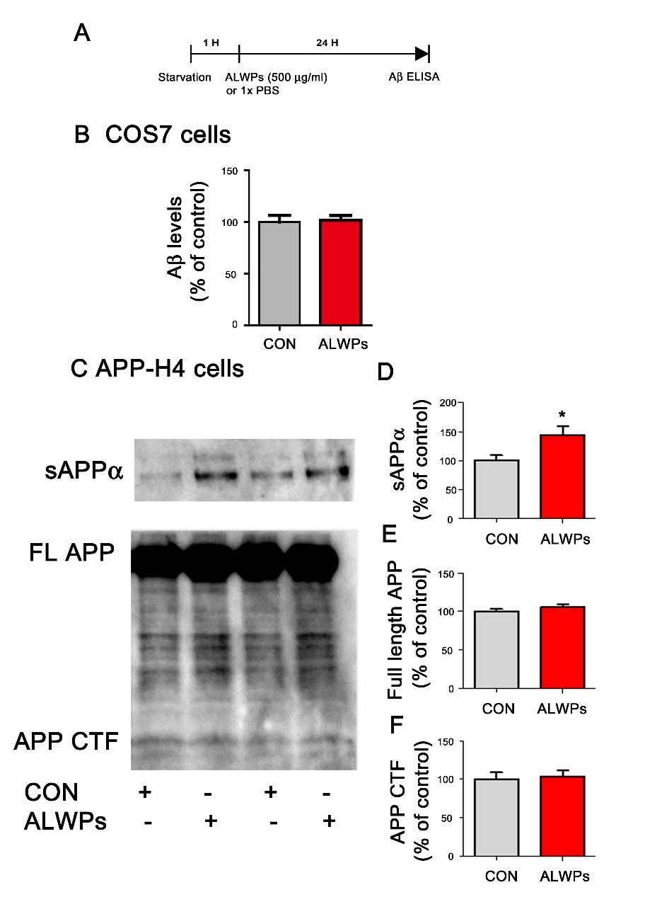
Supplementary Figure. 1. ALWPs significantly increase secreted APP alpha (sAPPα) levels in APP-H4 cells. (A-B) COS7 cells were transiently transfected with a construct expressing human APP for 24 hr and then treated with ALWPs (500 μg/ml) or PBS for 24 hr before performing Aβ ELISA (con, n = 16; ALWPs, n = 16). (C) APP-H4 cells were treated with ALWPs (500 μg/ml) or PBS for 24 hr, conditioned medium and cell lysates were collected, and western blotting was performed. (D-F) Quantification of data from C (con, n = 24; ALWPs, n = 24). *p < 0.05.

Supplementary Figure. 2. ALWPs do not alter BACE1 levels in primary hippocampal neurons. (A) Primary hippocampal neurons were transfected with GFP plasmid DNA for 24 hr, treated with ALWPs (500 μg/ml) or PBS for 24 hr, and immunostained with an anti-BACE1 antibody. (B) Quantification of data from A (con, n = 97 dendrites; ALWPs, n = 94 dendrites). (C) Primary hippocampal neurons were transfected with GFP plasmid DNA for 24 hr, treated with ALWPs (500 μg/ml) or PBS for 24 hr, and immunostained with an anti-NEP antibody. (D) Quantification of data from C (con, n = 90 dendrites; ALWPs, n = 90 dendrites). (E) 5x FAD mice were orally administered ALWPs (200 mg/kg, p.o.) or PBS daily for 2 weeks and immunostained with an anti-NEP antibody. Representative images of the cortex of 5x FAD mice are shown. (F) Quantification of data from E (con, n = 3 mice; ALWPs, n = 3 mice). (G) Representative images of the hippocampus of 5x FAD mice are shown. (H-I) Quantification of data from E (CA1 and DG; con, n = 3 mice; ALWPs, n = 3 mice). *p < 0.05, *p < 0.001.

Supplementary Figure 3. ALWPs regulate dendritic spine morphology in hippocampus CA1 AO dendrites of 5x FAD mice. (A-B) The cumulative distribution percentage of spine length (A) and spine head width (B) in hippocampal CA1 AO dendrites of 5x FAD mice (n = 8 mice/group, Kolmogorov–Smirnov test). (C-D) The cumulative distribution percentage of spine length (C) and spine head width (D) in hippocampal CA1 BS dendrites of 5x FAD mice (n = 8 mice/group, Kolmogorov–Smirnov test). (E-F) The cumulative distribution percentage of spine length (E) and spine head width (F) in cortical layer V AO dendrites of 5x FAD mice (Kolmogorov–Smirnov test). (G-H) The cumulative distribution percentage of spine length (G) and spine head width (H) in cortical layer V BS dendrites of 5x FAD mice (n = 8 mice/group, Kolmogorov–Smirnov test).

Supplementary Figure 4. ALWPs do not alter Rap signaling pathways. Primary cortical neurons were treated with ALWPs (500 μg/ml) or PBS for 24 hr and immunoblotted with anti-PLK2 (A-B), anti-RapGEF (C-D), and anti-p-JNK/JNK (E-G) antibodies (PLK2, n = 4; RapGEF, n = 4; p-JNK, n = 8; JNK, n = 4).

