Supplementary Material

Autoimmune-mediated retinopathy in CXCR5-deficient mice as the result of accumulation of age-related macular degeneration associated proteins
Anton Lennikov, Madhu Sudhana Saddala, Anthony Mukwaya, Shibo Tang, Hu Huang

Supplementary Figures
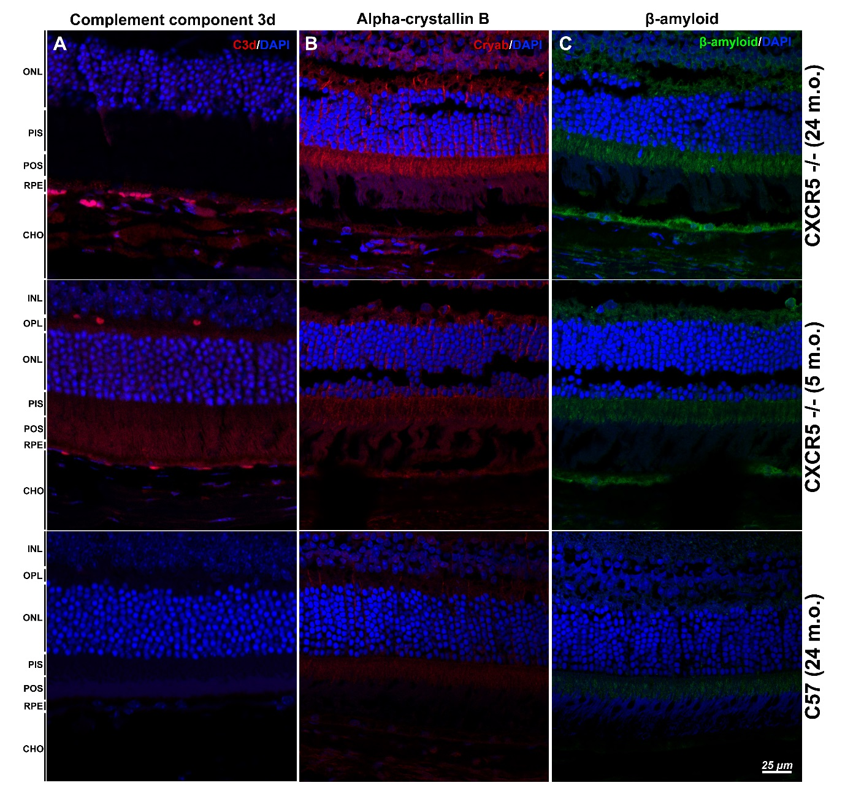
Supplementary Figure 1. Immunofluorescent analysis of AMD-associated proteins.
(A) Complement component 3d (red); (B) Alpha-crystallin B (red); (C) Amyloid beta (green) staining in mouse eye sections. Nuclear counterstaining by DAPI (blue) in fluorescent images. Samples were obtained from 24, 5 m.o. CXCR5^{-/-} and 24 m.o. C57 control female mice. Retinal layer designations: INL–inner nuclear layer, OPL–outer plexiform layer, ONL–outer nuclear layer, PIS–photoreceptors inner segments, POS–photoreceptors outer segments, RPE–retinal pigment epithelia, and CHO–choroid.

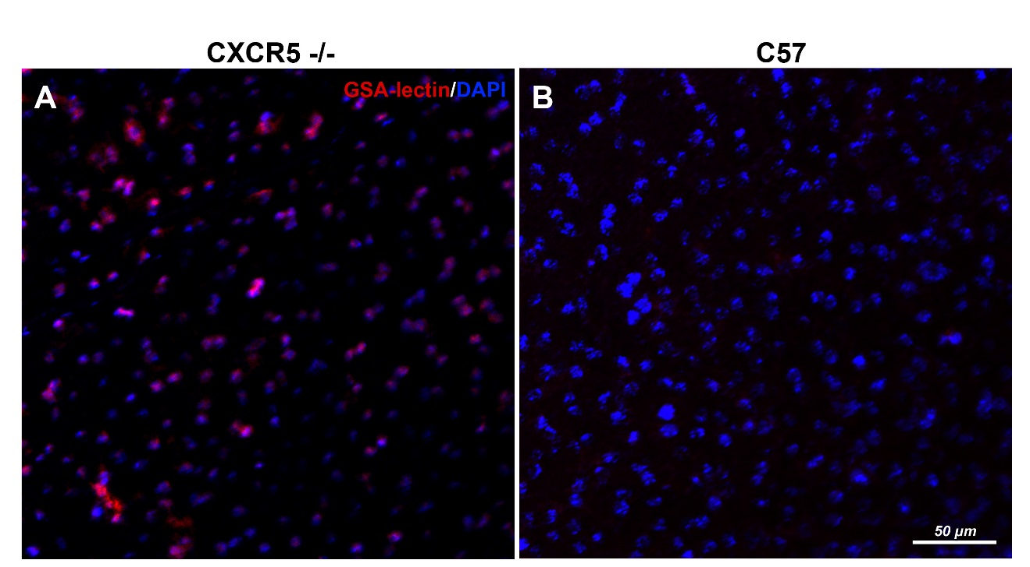
Supplementary Figure 2. Griffonia simplicifolia lectin (GSA) staining (red) of RPE/choroid complexes. (A) The presence of marked GSA-lectin-positive cell infiltration in RPE/choroid complexes of CXCR5^{-/-} mice; (B) No GSA lectin signals are detected in C57 RPE/choroid. Samples were obtained from 24 m.o. female mice.

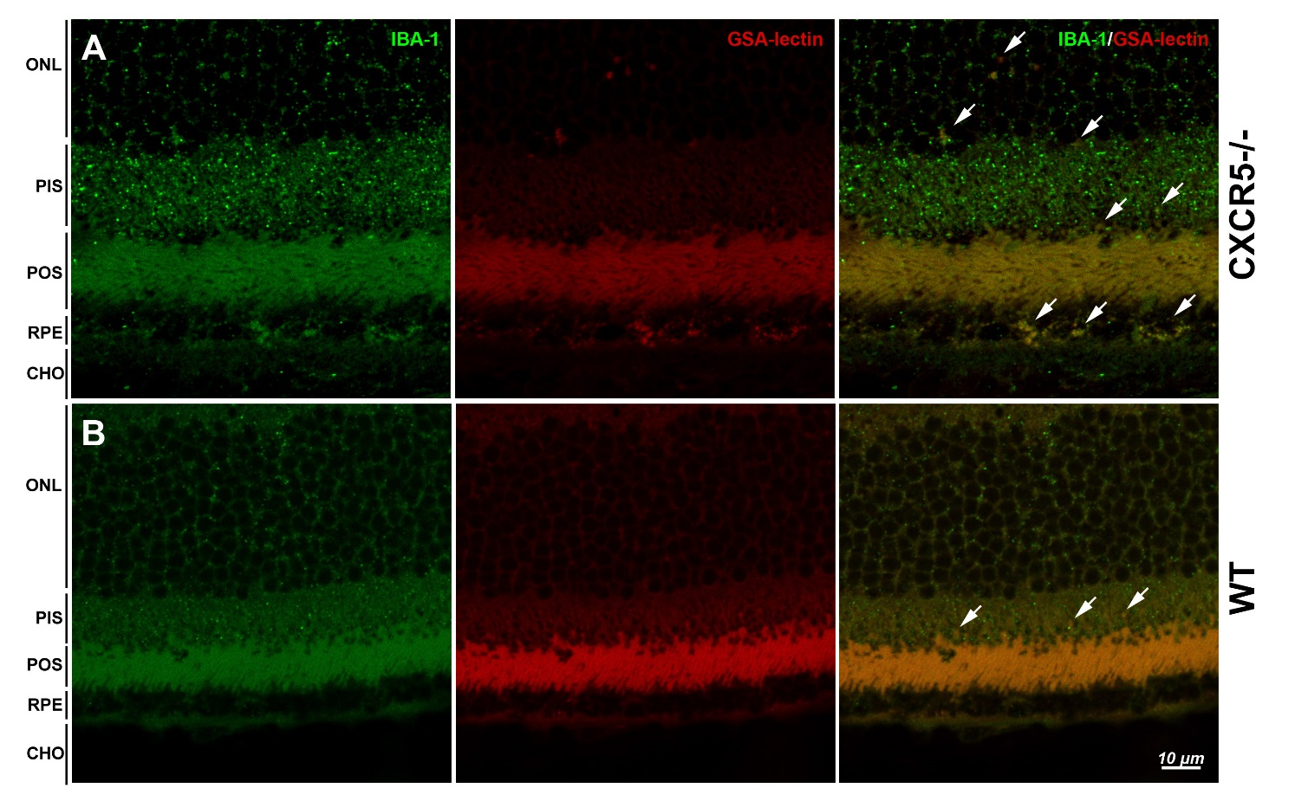
Supplementary Figure 3. IBA-1 (green) and Griffonia simplicifolia lectin (GSA) staining (red) of CXCR5 and WT histological sections. (A) Sections from CXCR5^{-/-} mice indicate multiple double-positive signals in sub-retinal space; (B) Few double positive cells identified in the retina of WT controls with no sub-retinal infiltration. Arrows indicate the double-labeled cells in the merged images. Samples were obtained from 24 m.o. CXCR5^{-/-} and age-matched WT control female mice. Retinal layer designations: ONL–outer nuclear layer, PIS–photoreceptors inner segments, POS–photoreceptors outer segments, RPE–retinal pigment epithelia, and CHO–choroid.

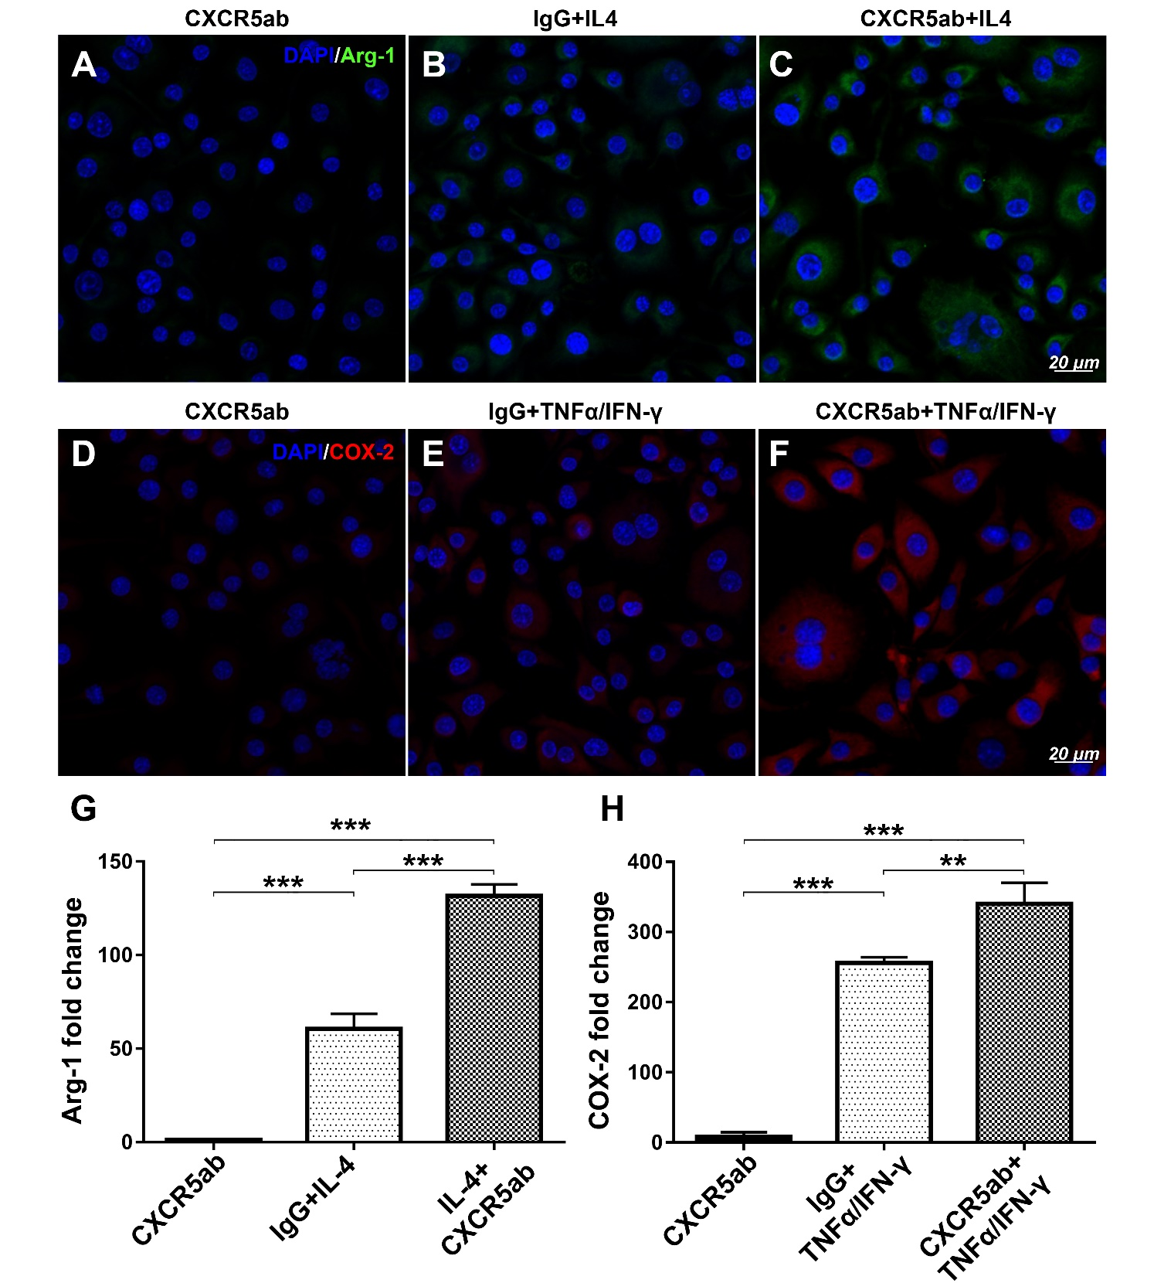
Supplementary Figure 4. In vitro response of BV-2 cells activation when treated with CXCR5 antibodies. The effects of CXCR5 blockade on Arg-1 and COX-2 expression in BV-2 cells under IL-4 and rmTNFα/rmIFNγ stimulation. (A) Immunofluorescence images of Arg1 (green) pretreated with CXCR5 antibody alone; (B) Positive control of IgG pretreatment, stimulated with recombinant mouse interleukin 4 (rmIL-4); (C) CXCR5 antibody pretreatment with rmIL-4 stimulation; (D) COX-2 (red) pretreated with CXCR5 antibody alone; (E) Positive control of IgG pretreatment, stimulated with recombinant mouse rmTNFα/rmIFNγ; (F) CXCR5 antibody pretreatment with rmTNFα/rmIFNγ stimulation. The cell nuclei were visualized with DAPI staining (blue); (G) Quantitative qRT-PCR analysis of Arg-1; and (H) COX-2 expression. (n = 3). A one-way ANOVA test with Tukey multiple comparisons was used to determine statistical significance. **p < 0.01; ***p < 0.001

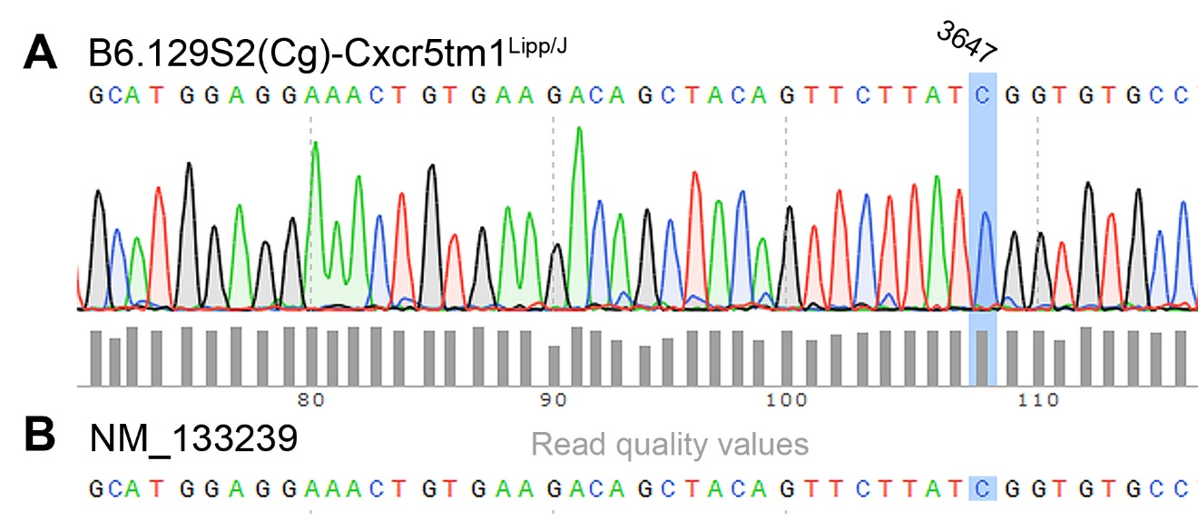
Supplementary Figure 5. Sanger sequencing identification of CRB1-RD8 mutation in CXCR5-/- animals. (A) Representative fragment of the CRB-1 Sanger sequence from CXCR5-/- mouse; (B) Aligned with the canonical sequence of CRB-1 gene NM_133239. Grey bars indicate read quality values.

