Supplementary Material

Supplementary Figures

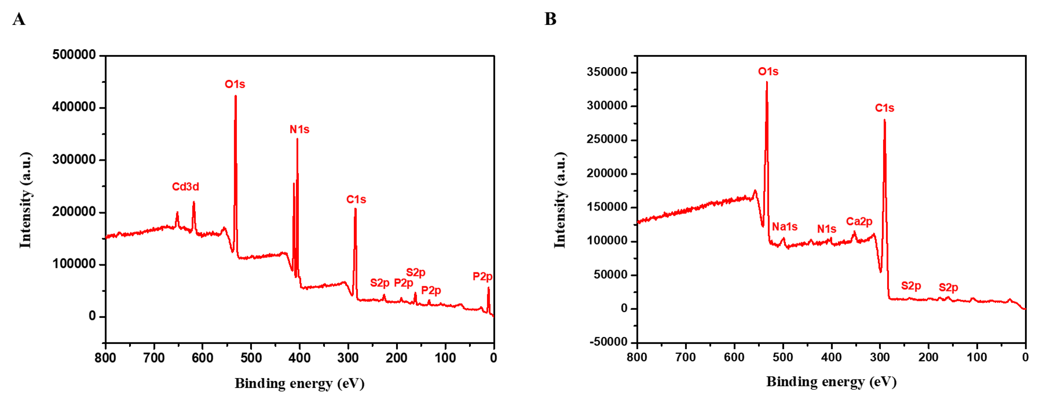
Supplementary Figure S1. XPS survey spectra of CdS nanoparticles obtained with (A) Cys, (B) Met.

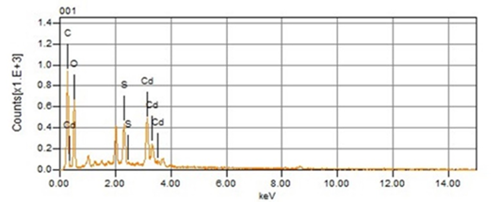
Supplementary Figure S2. EDX graph of CdS QDs biosynthesized by P. fragi GC01 with Cys for 3h (orange).

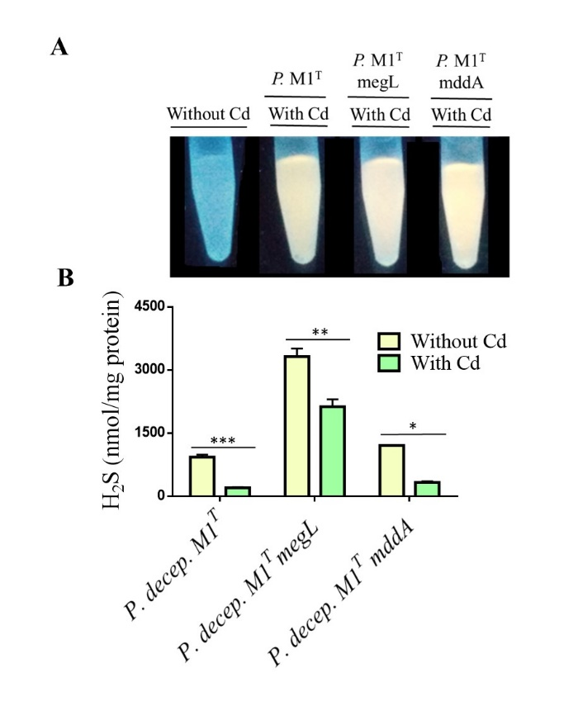
Supplementary Figure S3. VSCs produced by Pseudomonas deceptionensis M1^{T} strains under biosynthesis conditions with Cys. (A) Fluorescence of bacterial supernatants under biosynthesis conditions during 1 h after UV light exposure. (B) Quantiﬁcation of H₂S by GC after 1 h incubation. Bacterial strains were grown under biosynthesis conditions in M9 medium with 2mM cysteine, in presence or absence of CdCl₂ 20 µg mL at 28°C. Error bars represent standard deviation (n=3). Student’s t-test (P<0.05): Comparison between treatments without and with cadmium (Cd). *Statistically significant differences.

