Supplementary Material
- Model parameters
  - Chemical module
Table S1. Diffusion coefficients for the soluble compounds
Chemical substance | Diffusion coefficients * 10⁹ m² s⁻¹ | Reference
NH₃ | 1.64 | Yaws (2009)
NO₂ | 1.91
NO₃ | 1.9
O₂ | 2.1
CO₂ | 1.92
H₂ | 4.5
C₆H₁₂O₆ | 0.67
CH₃COOH | 1.29
CH₄ | 1.49
NaOH | 1.33
HCl | 1.4

Table S2. Dissociation reactions for the soluble compounds
Chemical species | Dissociation reactions
NH₃ | NH₃ + H₂O ↔ NH₄⁺ + OH⁻
NO₂ | HNO₂ + H₂O ↔NO₂⁻ + H₃O⁺
NO₃ | HNO₃ + H₂O↔NO₃⁻ + H₃O⁺
O₂ | --
CO₂ | CO2 + H₂O ↔H₂CO₃  H₂CO₃+ H₂O ↔ HCO₃⁻ + H₃O⁺  HCO₃⁻ + H₂O ↔ CO₃²⁻ + H₃O⁺
H₂ | -----
C₆H₁₂O₆ | ----
CH₃COOH | CH₃COOH + H₂O ↔ CH₃COO⁻ + H₃O⁺
CH₄ | ----
NaOH* | NaOH → Na⁺ + OH⁻
HCl* | HCl → H⁺ + Cl⁻

The equilibrium constants ${(K}_{eq})$are computed using eq. (S1)
$K_{eq}=e^{-\frac{{∆G}_{dissociation}}{RT}}$ (S1)
where ${∆G}_{dissociation}$ is the free Gibbs energy corresponding to the dissociation reaction, computed using the standard free energies of formation, presented in Table S3, R is the ideal gas constant (kJ/mole/K) and T is the temperature (K).

Table S3. Gibbs free energy of formation for chemical compounds
Chemical substance | Free Gibbs energy of formation (kJ/mole) | Reference
NH₃ | ΔG_{f,} _{NH3} = -26.57  ΔG_{f,} _{NH4+} = -79.37 | Perry and Green (2008)
NO₂ | ΔG_{f, HNO2} = -50.60  ΔG_{f,} _{NO2-} = -32.20
NO₃ | ΔG_{f, HNO3} = -103.70  ΔG_{f,} _{NO3-} = -111.30
CO₂ | ΔG_{f,} _{hydrolysis} = -386.00  ΔG_{f,} _{H2CO3} = -623.16  ΔG_{f,} _{HCO3-} = -586.85  ΔG_{f,} _{CO32-} = -527.8
CH₃COOH | ΔG_{f,} _{CH3COOH} = -396.5  ΔG_{f,} _{CH3COO-} = -369.3
For the computation of the dissociation constants and the Gibbs energy of the anabolic and catabolic reactions the standard Gibbs energies listed in Table S3 are corrected for temperature, using eq. (S2).
$∆G_{r}=∆G_{r}^{o }+RTlnQ$ (S2)
where Q – reaction quotient; R – ideal gas constant, T – temperature;
1.1.4. Reactor specifications
Table S4. Design parameters for the bioreactor
Parameter | Value | Reference
Reactor volume | 1.25 L | Picioreanu et al. (2004)
Biofilm surface area | 0.1 m²
Volume flow rate | 0.83 L h⁻¹

  - Biological module
Table S5. Parameters for the biological agents
Cell parameter | Value
density | 290 kg/m³
division diameter | 1.25 µm
inert diameter | 0.58 µm

  - Mechanical module
The friction force between two particles uses the already existing LAMMPS module, (https://lammps.sandia.gov/doc/pair_gran.html ). The parameters for cell-cell and cell–wall interactions are presented in Table S6.
Table S6. Cell – cell interaction parameters
Parameter |  | Cell – cell interactions | Cell – wall interactions
k_{n} | elastic constant for normal particle repulsion | 10⁻⁴ N/m | 2000 N/m
k_{t} | elastic constant for tangential contact | 2/7 * k_{n} | 2/7 * k_{n}
γ_{n} | damping coefficient in normal direction | 10⁻⁵ s⁻¹ | 500 s⁻¹
γ_{t} | damping coefficient in tangential direction | ½ * γ_{n} | ½ * γ_{n}
γ_{F} | damping force coefficient | 10⁻⁵ s⁻¹ | 1 s⁻¹

- Thermodynamic calculations
An example calculation for the yield of ammonia oxidizing micro-organisms is presented below.
- catabolic reaction
For the catabolic reaction R_{Cat}, we assume that the ammonia is oxidised to produce energy
NH₃ + 1.5O₂ → NO₂⁻ + H₂O + H⁺ R_{Cat}
The free Gibbs energy of the catabolic reaction is thus, in standard conditions (assuming the reaction quotient is 1):
$∆G_{cat}=-267.4\frac{kJ}{mole {NH}_{3}}$
- anabolic reaction
The half reaction for biomass formation:
0.2 NH₃ + HCO₃⁻ + 5.2H⁺ + 4.2e⁻ → CH_{1.8}O_{0.5}N_{0.2} + 2.5H₂O R_{1/2 – 1}
The half reaction for the electron donor (must supply the required electrons):
NH₃ + 2H₂O → NO₂⁻ + 7H⁺ + 6e⁻ R_{1/2 – 2}
The full anabolic reaction is assembled by combining the two reactions in such a manner that electrons are balanced between the two. Formally, we write this as:
R_{Ana} = R_{1/2 – 1} + 0.7 R_{1/2 – 2} (S3)
The full anabolic reaction R_{Ana} becomes
0.9 NH₃ + HCO₃⁻ + 0.3H⁺ → CH_{1.8}O_{0.5}N_{0.2} + 1.1 H₂O + 0.7 NO²⁻ R_{Ana}
The free Gibbs energy of the anabolic reaction is thus:
$∆G_{cat}=260.2\frac{kJ}{mole {NH}_{3}}$
Because both ammonia and nitrite oxidisers are autotrophic species and their metabolism involves reverse electron transfer, for the dissipation energy we used the value of 3500 kJ/mole, proposed by (Heijnen et al., 1992).
We can now compute the maximum growth yield by combining the catabolic, anabolic and dissipation free energies
$Y_{XS}=\frac{{∆G}_{cat}}{{∆G}_{ana}+{∆G}_{dis}}$ = 0.067 C-mole biomass/ mole NH₃
The overall growth reaction (R_{OVG}) is obtained by running the catabolism λ (1/Y_{XS}) times and adding it to the anabolism:
R_{OVG} = R_{Ana} + λ R_{Cat} (S4)
15.86 NH₃ + HCO₃⁻ + 22.46O₂→ CH_{1.8}O_{0.5}N_{0.2} + 15.96 H₂O + 15.66NO²⁻ + 14.66H⁺ R_{OVG}
- Supplementary Results
  - Nitrification
    - Reactor coupling
The effect of using fixed top boundary conditions vs. updating them function of the biofilm activity is apparent from Fig. S1. The biomass concentration profiles differ significantly between the two cases, showing a thriving active biomass population in case of the latter simulation.
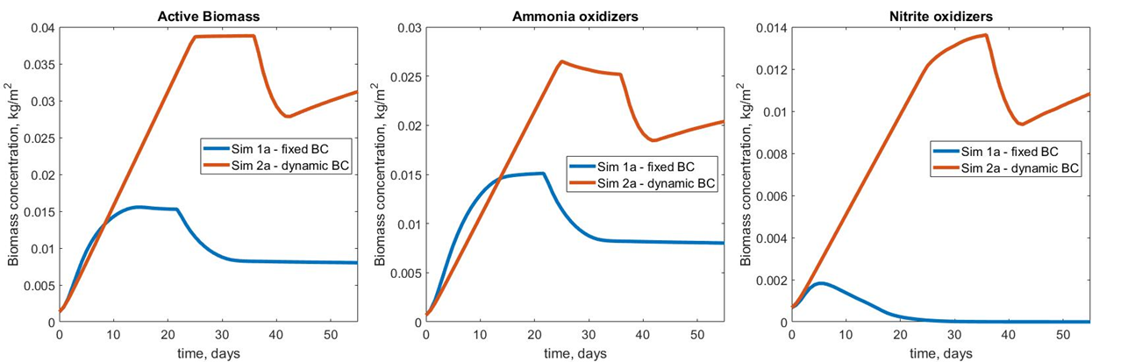
Figure S1. Biomass concentrations vs. time for simulation 1a and 2a
    - pH influence
The pH has a strong influence on the overall growth rate of the biofilm and a less pronounced one on the biofilm composition. The three systems are reaching the 250 µm-imposed height at different time steps, while the biomass concentration and the ratio between the two agent types were similar for all cases.
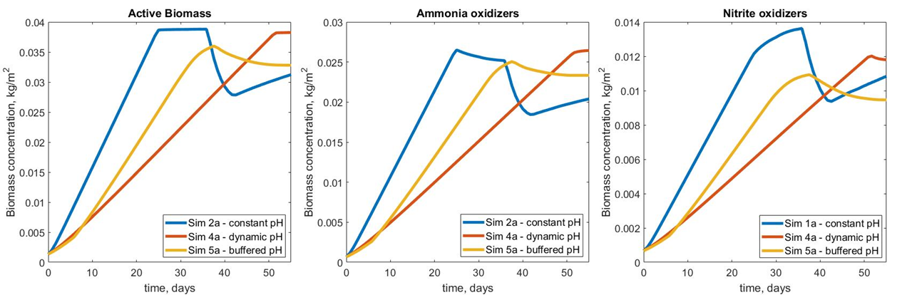
Figure S2. Biomass concentrations vs. time for simulation 2a, 4a and 5a
  - Anaerobic digestion
    - pH influence
Unlike the nitrification case, the pH control strategy (i.e. allowing the pH to vary naturally and attempting to maintain a constant pH in the biofilm – Fig. S3) does not produce large differences in biomass concentrations or soluble species profiles.
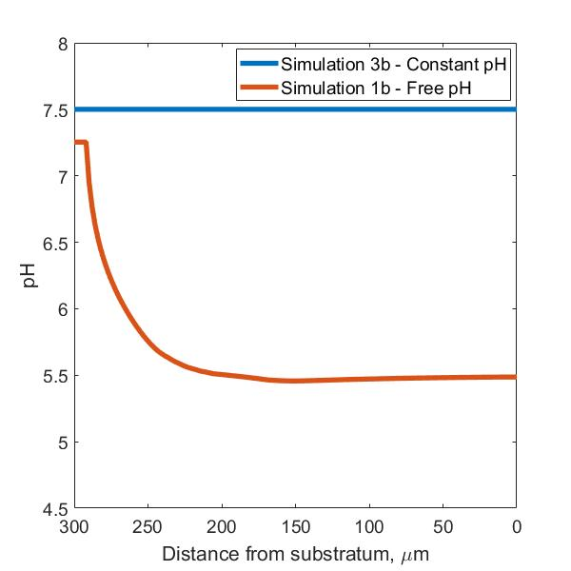
Figure S3. pH profiles – in the Oz direction at coordinates x = 50 µm and y = 10 µm inside the anaerobic biofilm
The soluble species concentrations differ subtly between the two simulations; Fig. S4 presents the percentage variation, computed using eq. (S5), between them.
${variance}_{\%}=\frac{S_{x,y,z}^{Sim 1b}-S_{x,y,z}^{Sim 3b}}{S_{x,y,z}^{Sim 1b}}∙100$ (S5)
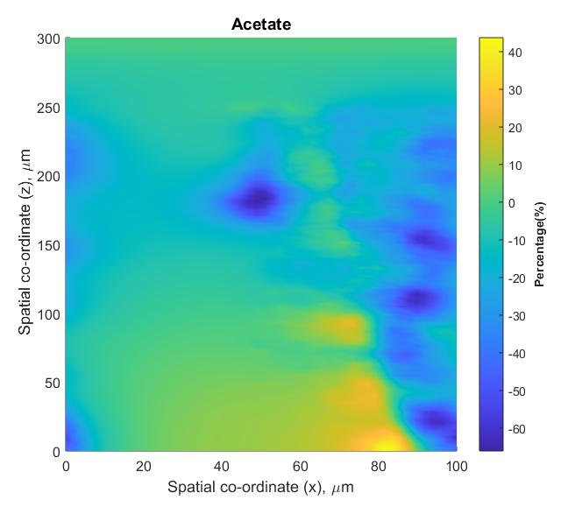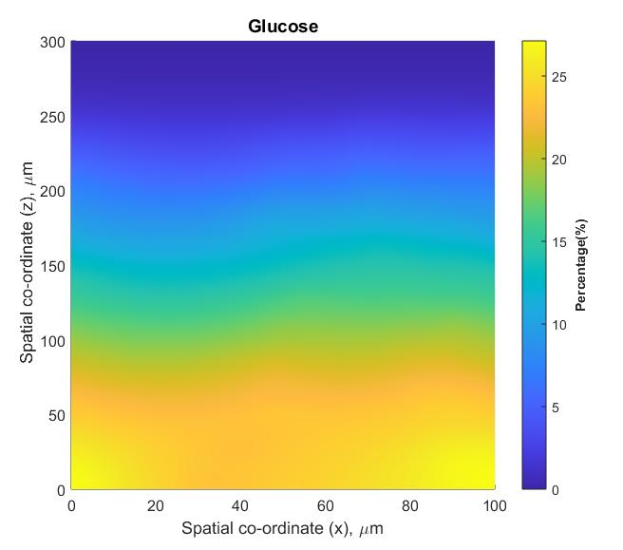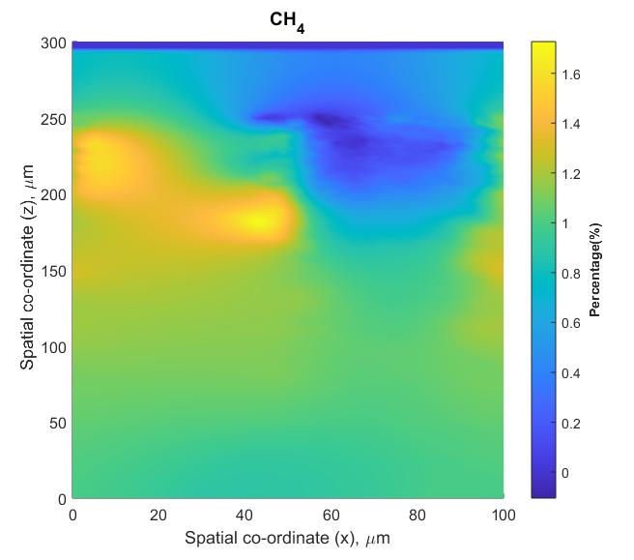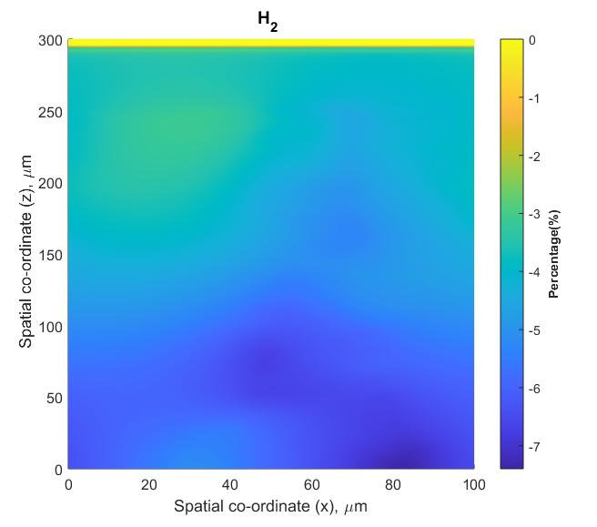
Figure S4. The percent variance for glucose, acetate, hydrogen and methane for simulations 1b (free-varying pH) and 3b (constant pH) at t = 1000 h, as 2D slices through the computational domain, normal to the substratum at width y = 10 µm
    - Thermodynamics influence
For the simulations performed with (5b) and without (4b) the thermodynamics module, the total active biomass concentration was similar (Fig. S5). The fixed yield biofilm (4b) is richer in methanogens, having twice as many hydrogen utilisers compared to simulation 5b and approximately 25% less acetoclastic methanogens.
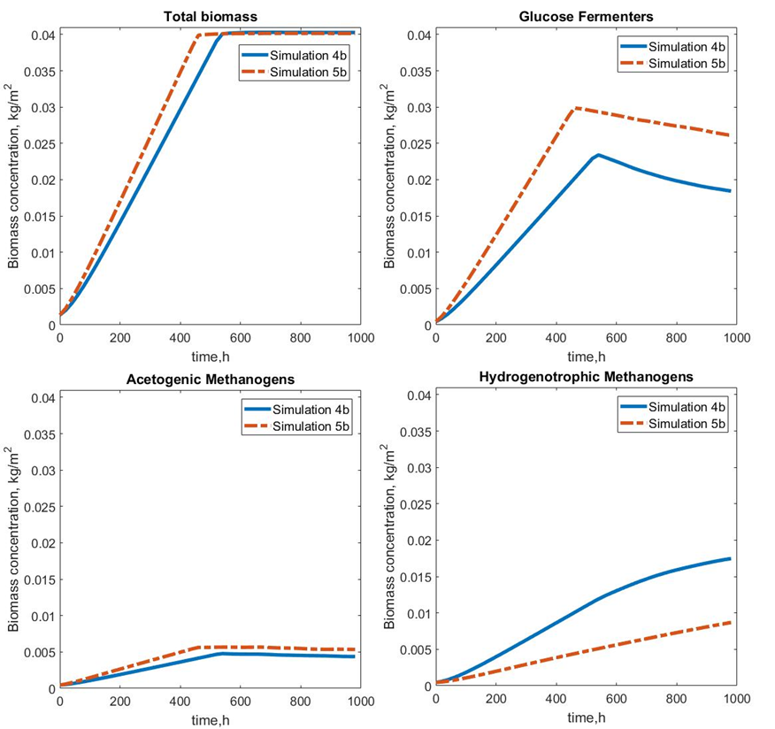
Figure S5. The concentration profiles for total biomass and each bacterial species present in the biofilm for simulations performed with (simulation 5b) and without (simulation4b) the thermodynamics module
References
Heijnen, J. J., Loosdrecht, M. C. M. v. and Tijhuis, L. (1992). "A Black Box Mathematical Model to Calculate Auto- and Heterotrophic Biomass Yields Based on Gibbs Energy Dissipation." Biotechnology and Bioengineering 40(1992): 1139-1154.
Perry, R. H. and Green, D. W. (2008). Perry's chemical engineers' handbook. New York, New York : McGraw-Hill.
Picioreanu, C., Kreft, J. U. and van Loosdrecht, M. C. M. (2004). "Particle-based multidimensional multispecies Biofilm model." Applied and Environmental Microbiology 70(5): 3024-3040.
Yaws, C. L. (2009). Transport Properties of Chemicals and Hydrocarbons. Boston, William Andrew Publishing.

