Supplementary Figures and tables
Table S1. ESKAPE relatives used to screen for antibacterial activity
ESKAPE pathogen | Safe ESKAPE relative | ATCC
Enterococcus faecium | Enterococcus raffinosus | 49464
Staphylococcus aureus | Staphylococcus epidermidis | 14990
Klebsiella pneumoniae | Escherichia coli | 11775
Acinetobacter baumannii | Acinetobacter baylyi | 33305
Pseudomonas aeruginosa | Pseudomonas putida | 12633
Enterobacter spp. | Enterobacter aerogenes | 51697

Table S2. Antibiotic resistant strains comprising the dereplication platform used in this study [13].
Antibiotic class | Antibiotic | Resistance Gene | Plasmid | Promoter | Parent E. coli strain
Aminoglycosides | Streptomycin | aph(3’)-Ia | pGDP3 | P_{bla} | ΔbamΔtolC BW25113
 | 2-Deoxystreptamine | rmtB | pGDP3 | P_{bla} | ΔbamΔtolC BW25113
 | Apramycin | apmA | pGDP3 | P_{bla} | ΔbamΔtolC BW25113
 | Spectinomycin | Aph(9)-Ia | pGDP3 | P_{bla} | ΔbamΔtolC BW25113
Β-lactams | Penicillin | NDM-1 | pGDP1 | P_{bla} | ΔbamΔtolC BW25113
 | Cephalosporin | NDM-1 | pGDP1 | P_{bla} | ΔbamΔtolC BW25113
 | Carbapenam | NDM-1 | pGDP1 | P_{bla} | ΔbamΔtolC BW25113
Lincosamides | Lincosamides | ermC | pGDP4 | P_{lac} | ΔbamΔtolC BW25113
Macrolides | Macrolides | ermC | pGDP4 | P_{lac} | ΔbamΔtolC BW25113
Type B Streptogramins | Type B Streptogramins | ermC | pGDP4 | P_{lac} | ΔbamΔtolC BW25113
Type A Streptogramins | Type A Streptogramins | vatD | pGDP3 | P_{bla} | ΔbamΔtolC BW25113
Streptothricin | Streptothricin | STAT | pGDP1 | P_{bla} | ΔbamΔtolC BW25113
Tetracyclines | Tetracycline | tet(A) | pGDP4 | P_{lac} | ΔbamΔtolC BW25113
Chloramphenicols | Chloramphenicols | CAT | pGDP3 | P_{bla} | ΔbamΔtolC BW25113
Fosfomycins | Fosfomycins | fosA | pGDP1 | P_{bla} | ΔbamΔtolC BW25113
Rifamycins | Rifamycins | arr | pGDP3 | P_{bla} | ΔbamΔtolC BW25113
Polymyxins | Polymyxins | MCR-1 | pGDP1 | P_{bla} | Wild-type BW25113
Echinomycins | Echinomycins | uvrA | pGDP1 | P_{bla} | ΔbamΔtolC BW25113
Sideromycins | Albomycin | fhuB mutant | - | - | ΔbamΔtolC BW25113
Tuberactinomycins | Viomycin | vph | pGDP1 | P_{bla} | ΔbamΔtolC BW25113

Table S3. Assessing growth of Arctic isolates that inihibited the ARP at various temperatures.
Isolate name | Closest matching taxon | Closest matching strain | 37°C  t= 48hrs | 25°C  t= 48hrs | 10°C  t= 20 days | 5°C  t= 20 days | 0°C  t= 20 days | -5°C  t= 20 days
GHHS.3.LBZX.4 | Flavobacterium panaciterrae | DCY69(T) |  | + | + | + | +
GHS.8.NWYW.5 | Paenibacillus terrae | AM141(T) | + | + | + | + | + | +
AALPS.10.MNAAK.13 | Pseudomonas prosekii | LMG 26867 |  | + | + | + | + | +
MAL.10.WYTK.25 | Pseudomonas extremaustralis | 14-3(T) |  | + | + | + | + | +
GHCE.5.JVZL.12 | Pseudomonas fluorescens | DSM 50090(T) | + | + | + | +
AALPS.4.MSMB.5 | Pseudomonas mandelii | NBRC 103147(T) |  | + | + | + | + | +
MAL.4.ABES.21 | Pseudomonas frederikbergensis | JAJ28(T) |  | + | + | + | +
C11E23 | Bacillus tequilensis | KCTC 13622(T) |  | + | + | + | + | +
(+) Visible growth

Table S4. Genomic sequencing statistics
Isolate | Contigs | Scaffolds | Genome Size | Longest Scaffold | N50 | Raw reads | Error-corrected Reads | % reads passing Error-correction | Raw nucleotides | Error-corrected nucleotides | % nt passing Error-correction | Raw coverage | Median coverage | 10th percentile coverage | Bases  >= Q40
GHHS.3.LBZX.4 | 69 | 53 | 6116726 | 806308 | 501802 | 1145402 | 1129059 | 98.57 | 320233758 | 267677262 | 83.59 | 43.76 | 51 | 39 | 6112985
GHS.8.NWYW.5 | 73 | 55 | 5662149 | 609831 | 274348 | 3038748 | 2928247 | 96.36 | 889616513 | 647752279 | 72.81 | 114.4 | 149 | 126 | 5660236
AALPS.10.MNAAK.13 | 36 | 32 | 6090438 | 798849 | 523870 | 1272094 | 1192269 | 93.72 | 338765113 | 248848688 | 73.46 | 40.86 | 50 | 38 | 6084513
MAL.10.WYTK.25 | 62 | 60 | 6826261 | 442973 | 256343 | 676206 | 665502 | 98.42 | 179401430 | 138717033 | 77.32 | 20.32 | 25 | 16 | 6807762
GHCE.5.JVZL.12 | 48 | 44 | 4977715 | 625630 | 423958 | 1259932 | 1207488 | 95.84 | 332870865 | 244986609 | 73.6 | 49.22 | 62 | 48 | 4974582
AALPS.4.MSMB.5 | 79 | 60 | 6323405 | 523195 | 223859 | 1837634 | 1800987 | 98.01 | 506142769 | 380213292 | 75.12 | 60.13 | 76 | 60 | 6321054
MAL.4.ABES.21 | 23 | 21 | 6812670 | 1022152 | 638679 | 972954 | 945125 | 97.14 | 268813615 | 194890214 | 72.5 | 28.61 | 37 | 27 | 6809466
C11E23 | 25 | 18 | 4271209 | 2223793 | 2223793 | 1675208 | 1637939 | 97.78 | 485678175 | 416677039 | 85.79 | 97.55 | 110 | 90 | 4265909

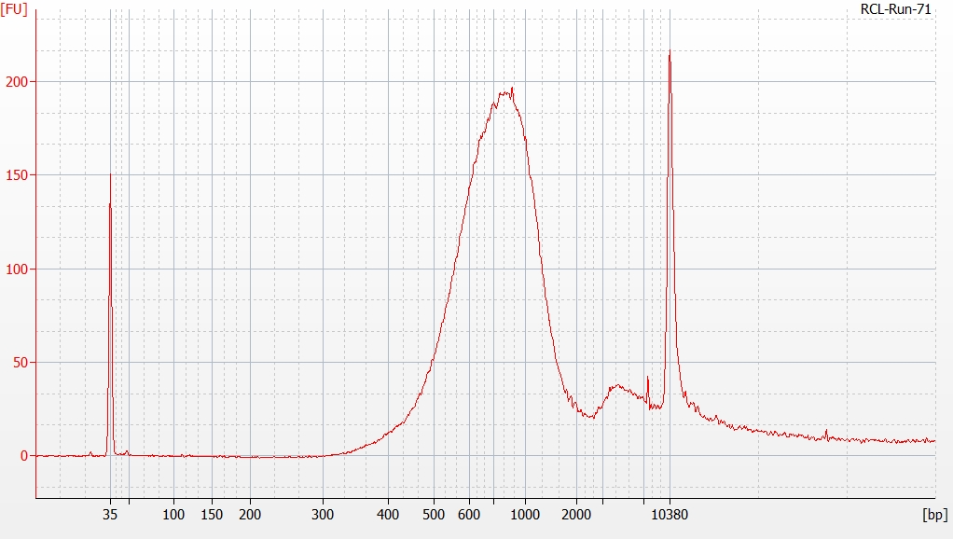
Figure S1. High sensitivity DNA electropherogram of the pooled Illumina MiSeq library The electropherogram was obtained from an Agilent High Sensitivity DNA Chip on a Agilent 2100 Bioanalyzer.. The x-axis represents DNA fragment size, the y-axis represents fluorescence units.

