Topical administration of a soluble TNF inhibitor reduces infarct volume after focal cerebral ischemia in mice
Minna Yli-Karjanmaa^{†1}, Bettina Hjelm Clausen^{†1,2}, Matilda Degn³, Hans Gram Novrup¹, Ditte Gry Ellman¹, Peter Toft-Jensen¹, David E. Szymkowski⁴, Allan Stensballe⁵, Morten Meyer^{1,2}, Roberta Brambilla^{1,2,6}, Kate Lykke Lambertsen*^{1,2,7}

¹Department of Neurobiology Research, Institute of Molecular Medicine, University of Southern Denmark, Odense, Denmark
²BRIDGE – Brain Research Inter-Disciplinary Guided Excellence, Department of Clinical Research, University of Southern Denmark, Odense, Denmark
³Pediatric Oncology Laboratory, Department of Pediatrics and Adolescent Medicine, University Hospital Rigshospitalet, Copenhagen, Denmark

⁴Xencor Inc, Monrovia, CA, USA

⁵Department of Health Science and Technology, University of Aalborg, Aalborg, Denmark
⁶The Miami Project to Cure Paralysis, University of Miami Miller School of Medicine, Miami, FL, USA
⁷Department of Neurology, Odense University Hospital, Odense, Denmark

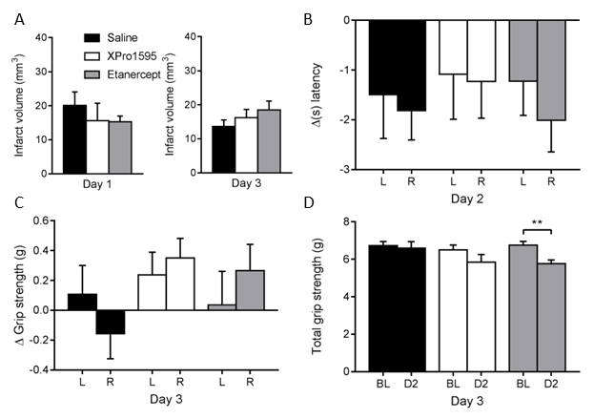
Supplementary Figure 1. Infarct volume and functional outcome after i.c.v. administration. (A) Infarct volume 1 and 3 days after i.c.v administration of TNF inhibitors n(day 1)= 3-5/group, n(day 3)=15-17/group. (B) Withdrawal latency after nociceptive stimuli measured by Hargreaves test two days after pMCAO; n=13-17/group. (C) Grip strength test of neuromuscular function measured as asymmetry between the right and left side three days after pMCAO; n=16-18/group. (D) Grip strength test of neuromuscular function measured as total grip strength of both paws three days after pMCAO; n=16-17/group. **p≤0.01, Student’s paired t-test.

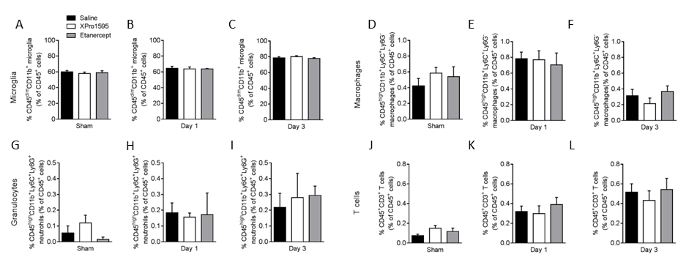
Supplementary Figure 2. Flow cytometric analysis of contralateral hemispheres in sham and pMCAO mice after topical saline, XPro1595, or etanercept treatment. (A-C) Changes in CD45^{dim}CD11b⁺ microglia presented as % of CD45⁺ cells after sham surgery or 1 or 3 days after pMCAO. (D-F) Changes in CD45^{high}CD11b⁺Ly6C⁺Ly6G⁻ macrophages presented as % of CD45⁺ cells after sham surgery or 1 or 3 days after pMCAO. (G-I) Changes in CD45^{high}CD11b⁺Ly6C⁺Ly6G⁺ granulocytes presented as % of CD45⁺ cells after sham surgery or 1 or 3 days after pMCAO. (J-L) Changes in CD3⁺ T cells presented as % of CD45⁺ cells after sham surgery or 1 or 3 days after pMCAO. n(sham)=4-5/group; n(day 1)=4-5/group; n(day 3)=5/group.

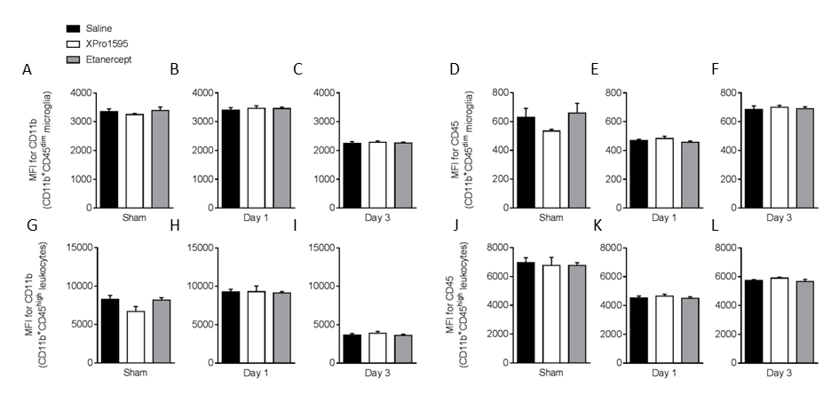
Supplementary Figure 3. Mean fluorescence intensity (MFI) of CD11b and CD45 in the ipsilateral cortex of mice treated topically with saline, XPro1595, or etanercept. (A-C) MFI for CD11b of CD11b⁺CD45^{dim} microglia after sham surgery or 1 or 3 days after pMCAO. (D-F) MFI for CD45 of CD11b⁺CD45^{dim} microglia after sham surgery or 1 or 3 days after pMCAO. (G-I) MFI for CD11b of CD11b⁺CD45^{high} leukocytes after sham surgery or 1 or 3 days after pMCAO. (J-L) MFI for CD45 of CD11b⁺CD45^{high} leukocytes after sham surgery or 1 or 3 days after pMCAO. N(sham)=4-5/group; n(day 1)=4-5/group; n(day 3)=5/group.

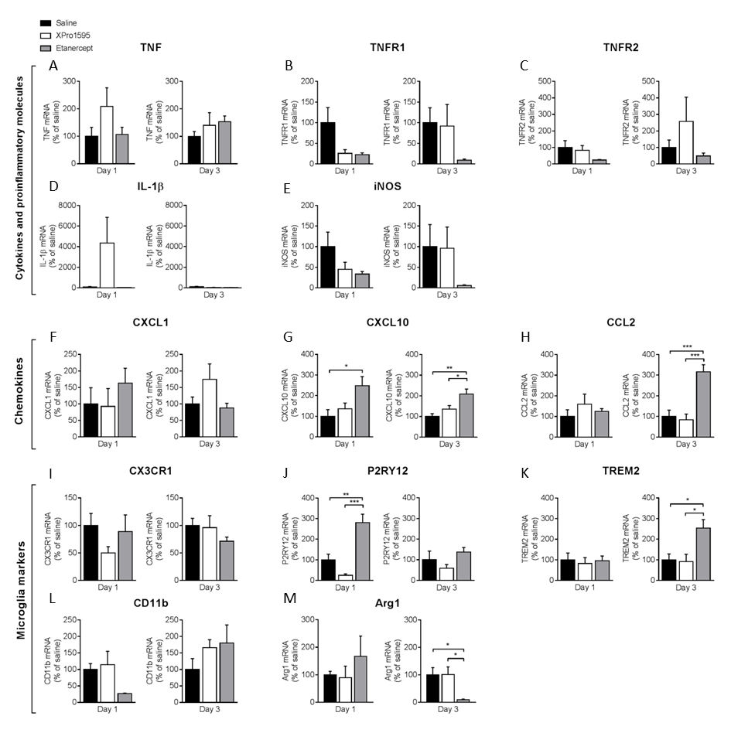
Supplementary Figure 4. Inflammatory gene profile 1 and 3 days after pMCAO in mice treated i.c.v. with saline, XPro1595, or saline. mRNA expression of cytokines, pro-inflammatory molecules, chemokines, and microglial markers presented as % of gene expression in saline-treated animals (A-M). (A) Expression of Tnf mRNA. (B) Expression of Tnfrsf1a (TNFR1) mRNA. (C) Expression of Tnfrsf1b (TNFR2) mRNA. (D) Expression of Il1β mRNA. (E) Expression of iNOS mRNA. (F) Expression of Cxcl1 mRNA. (G) Expression of Cxcl10 mRNA. (H) Expression of Ccl2 mRNA. (I) Expression of Cx3cr1 mRNA. (J) Expression of P2ry12 mRNA. (K) Expression of Trem2 mRNA. (L) Expression of Cd11b mRNA. (M) Expression of Arg1 mRNA. N(day 1)=3-5/group, n(day 3)=4-6/group;*p≤0.05, **p≤0.01, ***p≤0.001; one-way ANOVA followed by Tukey’s post hoc test.
Supplementary Figure 5. Cytokine and receptor protein expression in brain tissue 1 and 3 days after pMCAO in mice treated i.c.v. with saline, XPro1595, or etanercept. (A) Expression of TNF. (B) Expression of TNFR1. (C) Expression of TNFR2. (D) Expression of IL-1β. (E) Expression of Cxcl1. (F) Expression of IL-6. (G) Expression of IL-10. (H) Expression of IL-4. (I) Expression of IL-5. (J) Expression of IL-12p70. N=3-6/group, **p≤0.01; one-way ANOVA with Tukey’s post hoc test.

Supplementary Figure 6. Proteomics of neurons from tmTNF^{Δ/Δ} and tmTNF^{wt/wt} mice. Up- and downregulated proteins in neurons from tmTNF^{Δ/Δ} and tmTNF^{wt/wt} mice. N(tmTNF^{wt/wt})= 4, n(tmTNF^{Δ/Δ})= 6.

