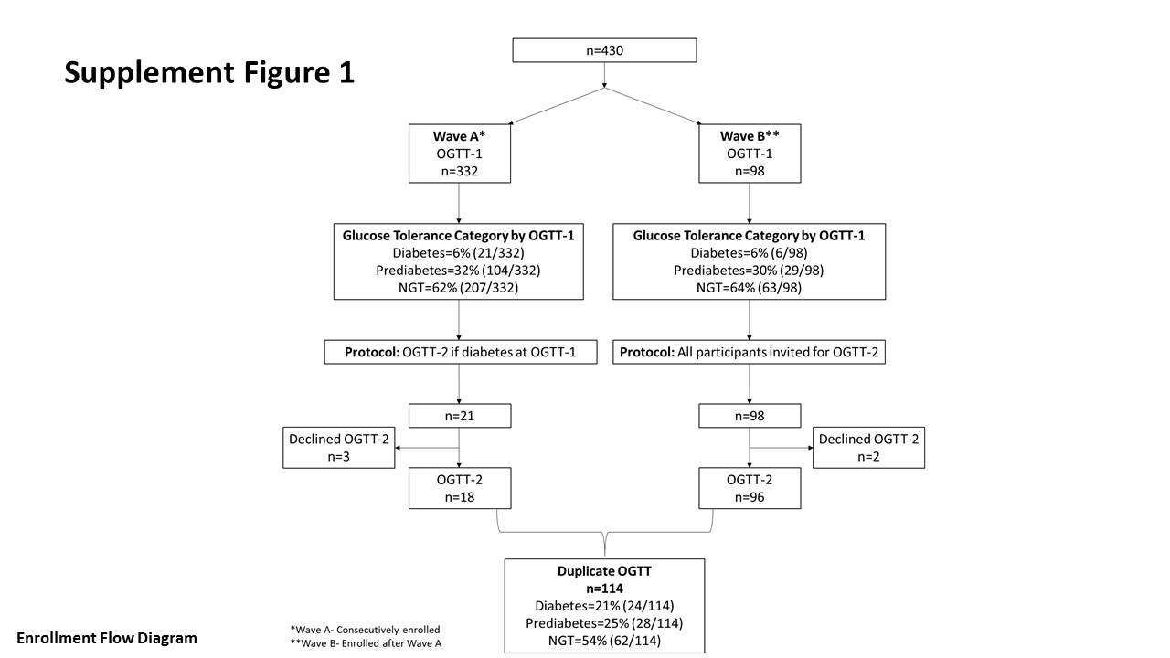

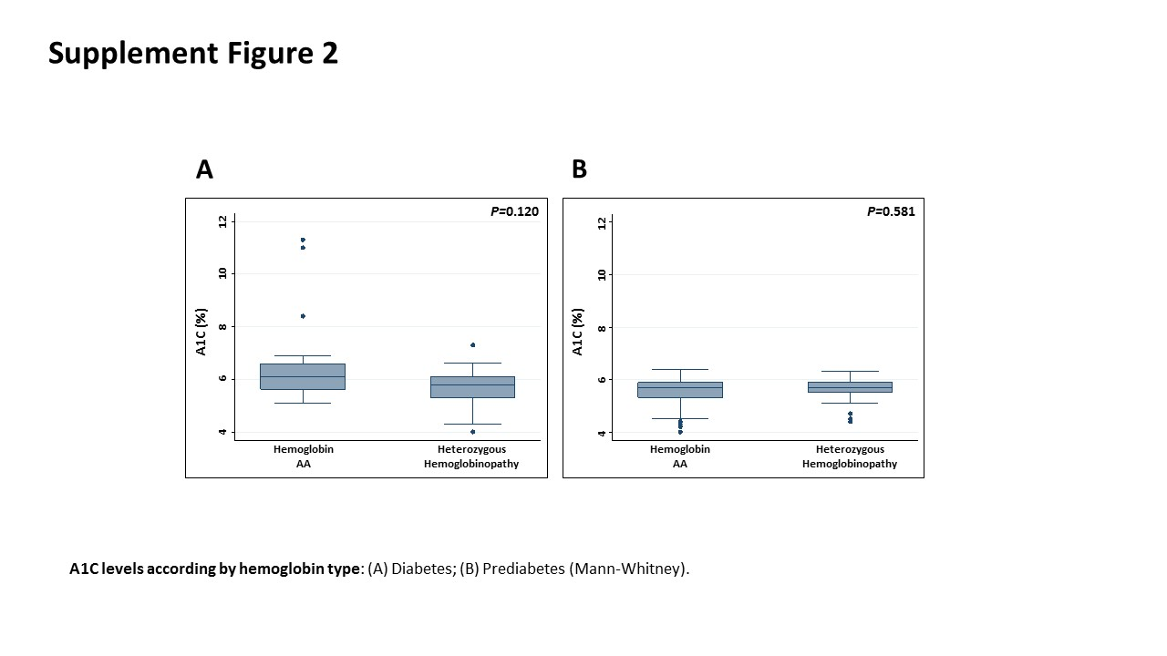

Supplement Table 1: Characteristics of Participants with Diabetes
Parameter¹ | Diabetes  Dx byA1C  A1C (≥6.5%)  n=10 | Diabetes  Dx by OGTT  A1C (5.7 to 6.4%)  n=11 | Diabetes  Dx by OGTT  A1C (<5.7%)  n=11 | P-value²
AUC-Glucose | 890±301 | 807±83 | 762±99 | 0.291
Matsuda Index | 3.61±2.73 | 3.05±2.01 | 3.18±1.64 | 0.847
Insulinogenic Index | 0.49±0.42 | 0.63±0.25 | 0.69±0.22 | 0.315
A1C (%) | 7.8±1.9 | 6.1±0.2 | 5.1±0.5 | <0.001, a**; b***
Fasting glucose (mg/dL) | 139±52 | 109±18 | 105±11 | 0.066
2h glucose (mg/dL) | 238±92 | 241±28 | 225±24 | 0.784
Age (y) | 44±10 | 48±10 | 40±8 | 0.120
BMI (kg/m²) | 30.5±6.3 | 29.2±4.7 | 28.9±3.9 | 0.749
WC (cm) | 98±16 | 102±13 | 98±9 | 0.785
VAT (cm²) | 167±107 | 151±42 | 150±63 | 0.862
AST (U/L) | 30±20 | 23±10 | 32±28 | 0.589
ALT (U/L) | 37±24 | 34±24 | 37±16 | 0.917
eGFR (mL/min/1.73m²)³ | 97±24 | 111±24 | 107±24 | 0.413
SCT (%) | 30% | 36% | 27% | 0.895
Hgb (g/dL) | 13.8±1.3 | 14.3±1.3 | 14.5±1.6 | 0.476
¹Results presented as mean±SD
² Comparison by one-way ANOVA: a: Column 1 vs. Column 2; b: Column 1 vs. Column 3; c: Column 2 vs. Column 3 * P<0.05; **P<0.01; ***P<0.001
³MDRD Equation

Supplement Table 2: Participants with Diabetes rank-ordered by A1C: (A) Hemoglobin type AA; (B) Heterozygous Hemoglobin
A B
 | Birth Country | A1C (%) | Hb Type | Diabetes Diagnosed  by A1C |  |  | Birth Country | A1C (%) | Hb  Type | Diabetes Diagnosed  by A1C
1 | Ghana | 11.3 | AA | Yes |  | 1 | Ghana | 7.3 | AS | Yes
2 | Nigeria | 11.0 | AA | Yes |  | 2 | Liberia | 6.6 | AS | Yes
3 | Ghana | 8.4 | AA | Yes |  | 3 | Nigeria | 6.5 | AS | Yes
4 | Ghana | 6.9 | AA | Yes |  | 4 | Ghana | 6.1 | AS | No
5 | DRC* | 6.6 | AA | Yes |  | 5 | Cameroon | 6.2 | AS | No
6 | DRC* | 6.6 | AA | Yes |  | 6 | Nigeria | 6.0 | AS | No
7 | Cameroon | 6.5 | AA | Yes |  | 7 | Ghana | 5.8 | AS | No
8 | Rwanda | 6.4 | AA | No |  | 8 | Nigeria | 5.5 | AS | No
9 | Rwanda | 6.3 | AA | No |  | 9 | Uganda | 5.4 | AS | No
10 | Cameroon | 6.1 | AA | No |  | 10 | Uganda | 5.3 | AS | No
11 | Ethiopia | 6.0 | AA | No |  | 11 | Ghana | 5.2 | AC | No
12 | Ethiopia | 6.0 | AA | No |  | 12 | Ghana | 4.3 | AC | No
13 | Cameroon | 5.9 | AA | No |  | 13 | Uganda | 4.0 | HH² | No
14 | Gambia | 5.9 | AA | No |  | ¹Heterozygous hemoglobinopathy type: Unknown
15 | Uganda | 5.6 | AA | No
16 | Somalia | 5.5 | AA | No
17 | Nigeria | 5.4 | AA | No
18 | Cameroon | 5.3 | AA | No
19 | DRC¹ | 5.1 | AA | No
*Democratic Republic of the Congo

