Supplementary Material

Supplementary Figures and Tables

Supplementary Figures

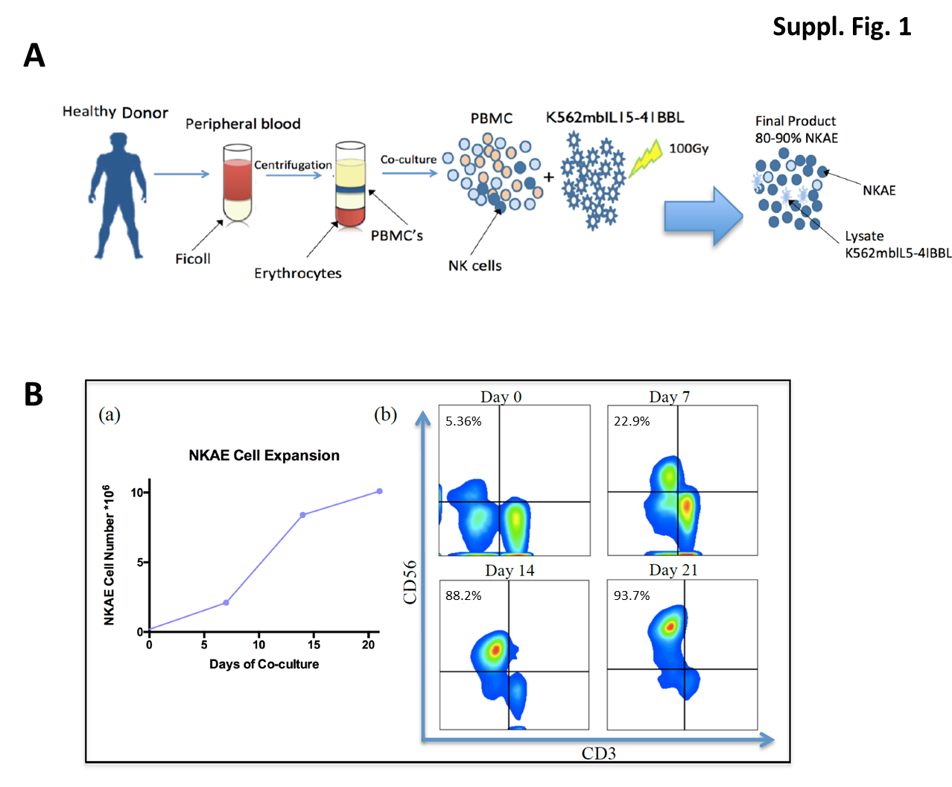
Supplementary Figure 1. Activation and expansion of NK cells
A. NK cells obtained from the peripheral blood of healthy volunteers are co-cultured for two to three weeks with irradiated K562-mb15-41BBL cells, to obtain large numbers of NKAE cells. B. Exponential growth in the number of NK cells (a) and the purity of the preparation (b) over time. The coculture contained 85-90% NKAE cells by day 14.

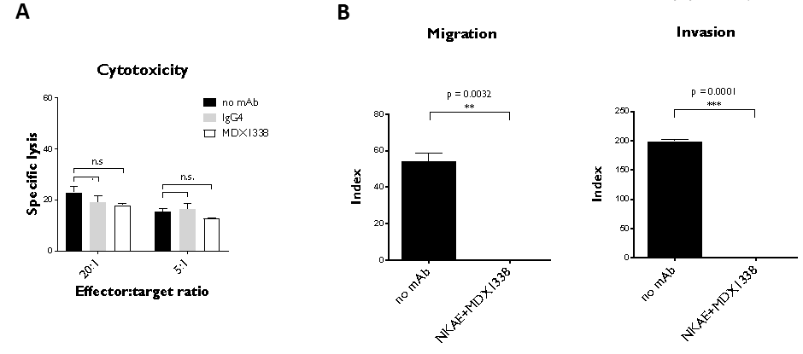
Supplementary Figure 2. Rhabdomyosarcoma cells cytotoxicity and inhibition of migration and invasion capacity by a combination of NKAE cells and MDX1338 in vitro
A. MDX1338 did not induce antibody-dependent cellular cytotoxicity in NKAE cells, which retained their capacity to lyse RH30 cells. Specific lysis in the absence of antibody, with IgG4 control or anti-CXCR4 MDX1338 mAb (100 µg/ml) was assessed at the indicated RH30:NKAE E:T ratios. B. The combination of MDX1338 and NKAE cells completely abolished the migration and invasion of RH30 cells towards CXCL12. We assessed the ability of RH30 cells to migrate along a gradient towards human recombinant CXCL12 on Transwell plates. We used an antibody concentration of 100 µg/ml and the RH30:NKAE E:T ratio was 5:1. Invasion capacity was measured in the same conditions, with Matrigel-coated Transwell membranes.

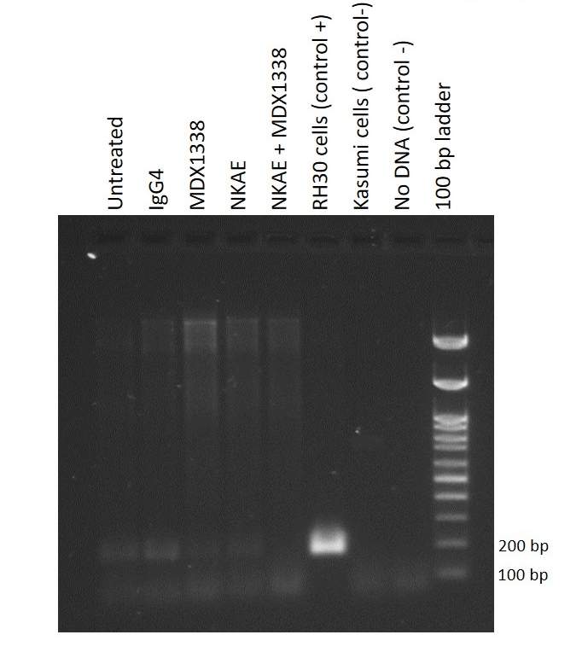

Supplementary Figure 3. RT-PCR to detect specific chimeric gene transcript PAX3-FOXO1, present in RH30 cells and absent in NKAE cells in cDNA from one mice of each treatment group.
Primers: PAX3/7-a 5’-CAGACAGCAGCTCTGCCTAC-3’; FOXI1 5’-ATGAACTTGCTGTGTA GGGACAG-3’. Programmable temperature cycling was performed using the following profiles: 95°C for 5 minutes, followed by 40 cycles of 94°C for 1 minute, 62°C for 1 minute, and 72°C for 2 minutes. Expected amplicon size in fusion transcript positive samples: 171 bp.

Supplementary Tables
Supplementary Table 1. List of labeled antibodies used in this study.
Specificity | Clone | Isotype | Fluorochrome | Manufacturer
CD3 | UCHT1 | mIgG1 | PE/Cy7 | Biolegend
CD45 | J33 | mIgG1 | FITC | Beckman Coulter
CD56 | B159 | mIgG1 | APC | BD Bioscience
CXCR4 | 12G5 | mIgG2a | APC | BD Biosciences
Isotype control | 20102 | mIgG2a | APC | R&D

Supplementary Table 2. Pediatric rhabdomyosarcoma patients’ characteristics and CXCR4 staining score of their samples.
Characteristics at diagnosis |  |  |  |  | Treatment |  |  |  | Outcome |  | CXCR4 expression
Patient | Sex | Age at diagnosis (years) | Tumor  type | Metastasis at diagnosis | Protocol | Treatment group  (risk) | Response to chemotherapy | Post chemotherapy treatment | Relapse | Exitus | Sample type | CXCR4 score
#1 | M | 5.4 | Embryonal | No | SIOP 95 | A | PR | CH+RT | Yes | Yes | D | 4.5
#2 | M | 11.1 | Alveolar | No | SIOP 95 | B | PR | CH+RT | Yes | Yes | D | 4.5
#3 | F | 9.9 | Alveolar | NA | NA | NA | NA | NA | NA | NA | D | 0
#4 | M | 8.5 | Embryonal | Yes | SIOP 95 | A | PR | CH+RT | Yes | Yes | D | 4.75
#5 | M | 4.5 | Embryonal | No | SIOP 95 | A | PR | CH+RT | No | No | D | 4.75
#6 | F | 2.4 | Embryonal | No | EpSSG RMS2005 | C (standard) | PR | CH | No | No | D | 5.75
#7 | F | 7.6 | Alveolar | No | EpSSG RMS2005 | G  (high) | PR | CH+RT | Yes | Yes | D | 3
#8 | M | NA | NA | NA | EpSSG RMS2005 | D (standard) | SD | CH | NA | NA | D | 0
#9 | F | 6.6 | Undifferentiated | Yes | EpSSG RMS2005 | H  (very high) | CR | CH | No | No | D | 0
#10 | F | 7.1 | Embryonal | No | EpSSG RMS2005 | F (high) | PR | CH+RT | No | No | D | 0
 |  |  |  |  |  |  |  |  |  |  | Post CH | 5
#11 | F | 6.7 | Embryonal | No | EpSSG RMS2005 | E  (high) | PR | CH+RT | No | No | D | 4.5
 |  |  |  |  |  |  |  |  |  |  | Post CH | 4
#12 | M | 7.5 | Alveolar | Yes | EpSSG RMS2005 | H  (very high) | PR | CH+RT | No | No | D | 1.5
#13 | F | 2.5 | Embryonal | No | EpSSG RMS2005 | D (standard) | PR | CH+RT | No | No | D | 1.5
#14 | F | 3.9 | Embryonal | No | EpSSG RMS2005 | B (standard) | CR | CH | No | No | D | 0
#15 | M | 13.0 | Embryonal | No | EpSSG RMS2005 | C (standard) | PR | CH+RT | Yes | No | D | 4.5
 |  |  |  |  |  |  |  |  |  |  | R | 4.5
#16 | M | 2.0 | Embryonal | No | EpSSG RMS2005 | D (standard) | PR | CH+RT | No | Yes | D | 0
#17 | F | 1.7 | Embryonal | No | EpSSG RMS2005 | G  (high) | PR | CH+RT | No | No | D | 0
 |  |  |  |  | EpSSG RMS2005 |  |  |  |  |  | Post CH | 5
#18 | M | 3.8 | Embryonal | No | SIOP 95 | A | PR | CH+RT | Yes | Yes | R | 6.5
#19 | M | 12.9 | Alveolar | No | EpSSG RMS2005 | G  (high) | CR | CH+RT | Yes | Yes | R | 12
#20 | M | 0.2 | Embryonal | No | EpSSG RMS2005 | F  (high) | PR | CH+RT | Yes | Yes | R | 1.5
#21 | F | 4.4 | Embryonal | No | EpSSG RMS2005 | A  (low) | PR | CH | No | No | Post CH | 3.5
#22 | M | 10.6 | Embryonal | No | EpSSG RMS2005 | NA  (high) | NA | CH+RT | No | No | Post CH | 4.25

Table abbreviations: M: Masculine; F: Feminine; SIOP 95: International Society of Paediatric Oncology 95; EpSSG RMS2005: The European paediatric Soft tissue sarcoma Study Group (EpSSG) Rhabdomyosarcoma (RMS) 2005; PR: Partial Response; SD: Stable Disease; CR: Complete Response; CH: Chemotherapy; RT: Radiotherapy; D: Diagnosis; R: Relapse; NA: Not Available.

