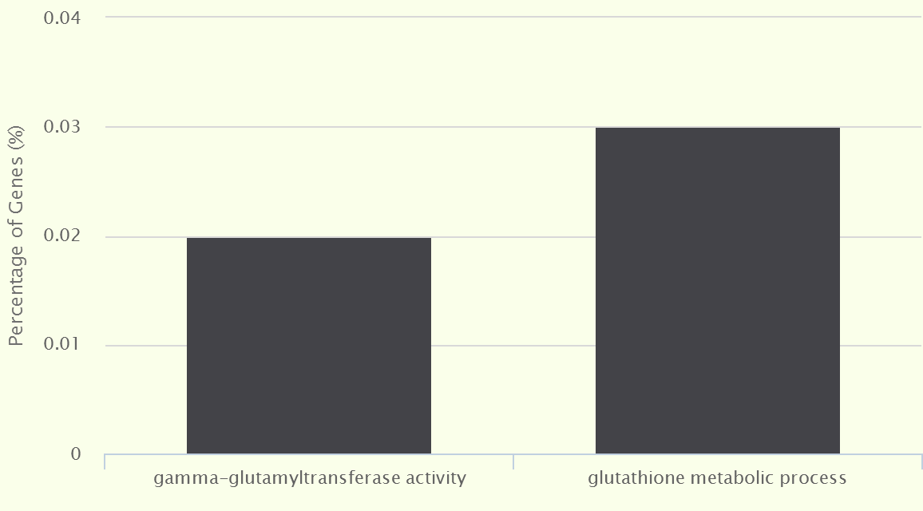
Figure S1 The GO enrichment analysis of 42 genes

