Mechanisms of ash generation at basaltic volcanoes: the case of Mount Etna, Italy
Margherita Polacci^{1*}, Daniele Andronico², Mattia de’ Michieli Vitturi³, Jacopo Taddeucci⁴, Antonio Cristaldi²
1) School of Earth and Environmental Sciences, University of Manchester, Manchester M13 9PL, UK
2) Istituto Nazionale di Geofisica e Vulcanologia, Sezione di Catania, Osservatorio Etneo, Catania 95125, Italy.
3) Istituto Nazionale di Geofisica e Vulcanologia, Sezione di Pisa, Pisa 56126, Italy.
4) Istituto Nazionale di Geofisica e Vulcanologia, Sezione di Roma1, Roma 00143, Italy.

*Corresponding author at: School of Earth and Environmental Sciences, University of Manchester, Manchester M13 9PL, UK, email: margherita.polacci@manchester.ac.uk

Supplementary Material
The results presented in Figures 10 and 11 are based on the assumption of fully developed Newtonian laminar flow and the consequent parabolic profile of velocity in the conduit. In most of magma ascent conduit models, this assumption is a common practice to describe the viscous term in 1D equations (Melnik and Sparks, 1999; de’ Michieli Vitturi et al., 2008), but rarely the derivation is presented. In this appendix, we briefly present the derivation of this term for cylindrical conduits, starting from the Cauchy momentum equation, describing momentum transport in any continuum:

$$\frac{Du}{Dt}=\frac{1}{ρ}∇∙σ+g.$$

Here, u is the flow velocity vector field, which depends on time and space, ρ is the density at the point considered in the continuum, σ is the stress tensor and g is the gravitational acceleration. In the equation above, the stress tensor can be decomposed in the isotropic part p (the pressure) and the deviatoric tensor τ:

$$σ=-pId+τ$$

For an incompressible fluid with constant viscosity, the shear tensor can be written as τ = μ(∇u+∇u^{T}).
When dealing with conduit models, most of the time it is assumed that magma ascent flow is axisymmetric; for this reason, it is better to write the terms of Equation S1 in cylindrical coordinates, with the axis of symmetry coinciding with the axis of the conduit (here denoted with z) and the gravitation acceleration. First of all, we write the flow velocity vector in cylindrical coordinates as

$u\left(r,θ,z,t\right)=u_{r}\left(r,θ,z,t\right)e_{r}+u_{θ}\left(r,θ,z,t\right)e_{θ}+u_{z}\left(r,θ,z,t\right)e_{z}$ S1

where {e_{r}, e_{θ}, e_{z}} is a right-handed triad of unit vectors.
It is important to remind that, when using cylindrical coordinates and differentiating the velocity vector, the unit vectors must also be differentiated, because they are not fixed and the following relations hold:

$$\frac{∂e_{r}}{∂r}=\frac{∂e_{θ}}{∂r}=\frac{∂e_{z}}{∂r}=0,$$
$$\frac{∂e_{r}}{∂θ}=e_{θ},$$
$$\frac{∂e_{θ}}{∂θ}=-e_{r}.$$

Expanding the terms in Equation S1, we can write the momentum equations in cylindrical coordinates as:

$$\frac{∂u_{r}}{∂t}+u_{r}\frac{∂u_{r}}{∂r}+\frac{u_{θ}}{r}\frac{∂u_{r}}{∂θ}-\frac{u_{θ}^{2}}{r}+u_{z}\frac{∂u_{r}}{∂z}=-\frac{1}{ρ}\frac{∂p}{∂r}+\frac{μ}{ρ}\left\{-\frac{u_{r}}{r^{2}}+\frac{1}{r}\frac{∂}{∂r}\left(r\frac{∂u_{r}}{∂r}\right)+\frac{1}{r^{2}}\frac{∂^{2}u_{r}}{∂θ^{2}}+\frac{∂^{2}u_{r}}{∂z^{2}}-\frac{2}{r^{2}}\frac{∂u_{θ}}{∂θ}\right\}$$
$$\frac{∂u_{θ}}{∂t}+u_{r}\frac{∂u_{θ}}{∂r}+\frac{u_{θ}}{r}\frac{∂u_{θ}}{∂θ}+\frac{{u_{r}u}_{θ}^{}}{r}+u_{z}\frac{∂u_{θ}}{∂z}=-\frac{1}{ρ}\frac{∂p}{∂θ}+\frac{μ}{ρ}\left\{-\frac{u_{θ}}{r^{2}}+\frac{1}{r}\frac{∂}{∂r}\left(r\frac{∂u_{θ}}{∂r}\right)+\frac{1}{r^{2}}\frac{∂^{2}u_{θ}}{∂θ^{2}}+\frac{∂^{2}u_{θ}}{∂z^{2}}-\frac{2}{r^{2}}\frac{∂u_{r}}{∂θ}\right\}$$

$$\frac{∂u_{z}}{∂t}+u_{r}\frac{∂u_{z}}{∂r}+\frac{u_{θ}}{r}\frac{∂u_{z}}{∂θ}=-\frac{1}{ρ}\frac{∂p}{∂z}+\frac{μ}{ρ}\left\{\frac{1}{r}\frac{∂}{∂r}\left(r\frac{∂u_{z}}{∂r}\right)+\frac{1}{r^{2}}\frac{∂^{2}u_{z}}{∂θ^{2}}+\frac{∂^{2}u_{r}}{∂z^{2}}\right\}+g_{z}.$$

For a more detailed derivation of the equations, the reader can refer to (de’ Michieli Vitturi, 2016).
As previously stated, for magma ascent models a very common assumption is axisymmetric flow with no swirl velocity (u_{θ} = 0) and where the remaining quantities are independent of θ. In this case the equations for the two remaining velocity components u_{r} and u_{z} write as:

$$\frac{∂u_{r}}{∂t}+u_{r}\frac{∂u_{r}}{∂r}+u_{z}\frac{∂u_{r}}{∂z}=-\frac{1}{ρ}\frac{∂p}{∂r}+\frac{μ}{ρ}\left\{-\frac{u_{r}}{r^{2}}+\frac{1}{r}\frac{∂}{∂r}\left(r\frac{∂u_{r}}{∂r}\right)+\frac{∂^{2}u_{r}}{∂z^{2}}\right\}$$

$$\frac{∂u_{z}}{∂t}+u_{r}\frac{∂u_{z}}{∂r}=-\frac{1}{ρ}\frac{∂p}{∂z}+\frac{μ}{ρ}\left\{\frac{1}{r}\frac{∂}{∂r}\left(r\frac{∂u_{z}}{∂r}\right)+\frac{∂^{2}u_{r}}{∂z^{2}}\right\}+g_{z}.$$

If we now assume that (1) flow is steady ($\frac{∂}{∂t}=0$), (2) the only velocity component is the vertical one ($u_{r}=0$), and (3) the flow is fully developed ($\frac{∂}{∂z}=0$), then momentum equation for the radial component reduces to:
$$\frac{∂p}{∂r}=0,$$
while the vertical momentum equation is:

$$\frac{1}{r}\frac{∂}{∂r}\left(r\frac{∂u_{z}}{∂r}\right)=\frac{1}{μ}\frac{∂p}{∂z}.$$

The equation can be integrated twice with respect to r and, assuming that $\frac{∂u_{z}}{∂r}=0$ for r=0 and $u_{z}=0$ for r=R (with R the conduit radius), we have:

$$u_{z}\left(r\right)=-\frac{1}{4μ}\frac{∂p}{∂z}\left(R^{2}-r^{2}\right).$$

The maximum velocity occurs at the conduit axis (r=0):

$$u_{z,max}=-\frac{R^{2}}{4μ}\frac{∂p}{∂z}$$

Now, dividing the velocity u_{z}(r) by maximum velocity, we can write:

$$\frac{u_{z}\left(r\right)}{u_{z,max}}=1-{\left(\frac{r}{R}\right)}^{2}$$
or introducing the nondimensional scaled velocity $\overline{u}=\frac{u_{z}\left(r\right)}{u_{z,max}}$ and the nondimensional scaled radius $\overline{r}=\frac{r}{R}$:

$$\overline{u}=1-{\overline{r}}^{2}.$$

The total volumetric flow rate can be obtained by integrating the velocity profile over the conduit cross section and is given by:

$$Q=\int_{0}^{R}{u_{z}(r)2πr}dr=-\frac{{πR}^{4}}{8μ}\frac{∂p}{∂z},$$

while the cumulative volumetric flow rate through the portion from the centre up to a distance $r$ from the axis (represented in grey in the left panel of Figure 10) is given by:

$$Q(r)=\int_{0}^{r}{u_{z}(r)2πr}dr=-\frac{π}{8μ}\frac{∂p}{∂z}\left[{2R}^{2}r^{2}-r^{4}\right].$$

For a dike with width R and length L, integrating in a similar way from the centre to the walls, it is possible to obtain:
$$Q(r)=2\int_{0}^{r}{u_{z}(r)L}dr=-\frac{1}{2μ}\frac{∂p}{∂z}\left[R^{2}r-\frac{r^{3}}{3}\right].$$

When the radius, the velocity and the cumulative flow rates are normalised dividing by the maximum values, the relationships described in section 5 are obtained, and the results are presented in Figure S1.

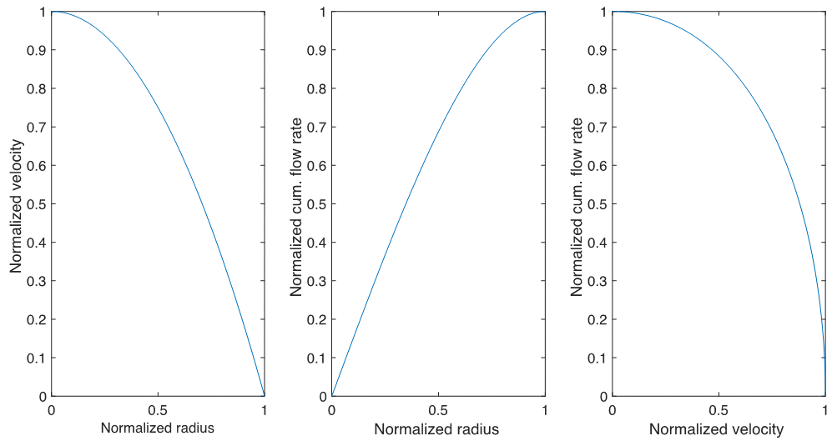
Supplementary Figure S1 Relationships between normalised radius, velocity and cumulative flow rate for a fully-developed laminar flow in a cylindrical conduit (top) and in a dike (bottom).

References
Melnik, O., Sparks, R.S.J., 1999. Nonlinear dynamics of lava dome extrusion. Nature, 402(6757), p.37, doi:10.1038/46950.
de’ Michieli Vitturi, M., Clarke, A. B., Neri, A., Voight, B., 2008. Effects of conduit geometry on magma ascent dynamics in dome-forming eruptions. Earth and Planetary Science Letters, 272(3-4), 567–578.
de’ Michieli Vitturi, M., 2016. Navier-Stokes equations in cylindrical coordinates. https://vhub.org/resources/4126.

