Supplementary materials for

Cysteine-rich peptide fingerprinting as a general method for herbal analysis to differentiate Radix Astragali and Radix Hedysarum

Jiayi Huang, Ka H. Wong, Stephanie V. Tay, Adrian How and James P. Tam*

School of Biological Sciences, Nanyang Technological University, Singapore, Singapore

*Correspondence:

Professor James P. Tam

[jptam@ntu.edu.sg]

Supplementary Table S1. List of plants and their extraction methods
Scientific name | Form | Extraction method
Abrus precatorius | Dried herb | 50% ethanol
Abutilon indicum | Fresh plant | 50% ethanol
Achyranthes aspera | Fresh plant | 50% ethanol
Achyranthes bidentate | Dried herb | water
Alternanthera ficoidea | Fresh plant | 50% ethanol
Alternanthera paronychiodes | Fresh plant | 50% ethanol
Alternanthera sessilis | Fresh plant | 50% ethanol
Angelica sinensis | Granules | water
Armeniacae amarum | Granules | water
Artemisia argyi | Fresh plant | water
Brassica alboglabra | Fresh plant | 50% ethanol
Brucea javanica | Dried herb | water
Calandrinia umbellata | Fresh plant | 50% ethanol
Camellia sinensis | Dried herb | water
Cannabis sativa | Dried herb | water
Cassia occidentalis | Fresh plant | 50% ethanol
Celosia argentea | Dried herb | 50% ethanol
Cerbera odollam | Fresh plant | 50% ethanol
Citrus aurantium | Fresh plant | water
Clematis chinensis | Dried herb | 50% ethanol
Clitoria ternatea | Fresh plant | water
Codonopsis pilosula | Dried herb | 50% ethanol
Coix lacryma-jobi | Fresh plant | water
Curcuma alba | Fresh plant | water
Cuscuta chinensis | Granules | water
Cyathula officinalis | Dried herb | 50% ethanol
Dichondra repens | Fresh plant | 50% ethanol
Dioscorea polystachya | Dried herb | 50% ethanol
Dolichos lablab | Dried herb | 50% ethanol
Drynaria fortunei | Granules | 50% ethanol
Eleutherococcus senticousus | Dried Herb | Water
Ephedra sinica | Dried herb | water
Euchresta japonica | Dried herb | 50% ethanol
Eucommia ulmoides | Granules | water
Foeniculum vulgare | Fresh plant | water
Folium ginseng | Dried herb | 50% ethanol
Ganoderma lucidum | Dried herb | water
Ginkgo biloba | Dried herb | 50% ethanol
Glycine max | Fresh plant | 50% ethanol
Gomphrena globose | Fresh plant | 50% ethanol
Gynostemma pentaphyllum | Dried herb | 50% ethanol
Heduotis chrysotricha | Fresh plant | 50% ethanol
Hedyotis auricularia | Fresh plant | 50% ethanol
Hedyotis biflora | Fresh plant | 50% ethanol
Hedyotis congesta | Fresh plant | 50% ethanol
Hedyotis corymbosa | Fresh plant | 50% ethanol
Hedyotis dichotoma | Fresh plant | 50% ethanol
Hedyotis microphylla (Ariel) | Fresh plant | 50% ethanol
Hedyotis microphylla (Roots) | Fresh plant | 50% ethanol
Hibiscus sabdariffa | Fresh plant | 50% ethanol
Hordei germinates | Granules | water
Impatiens balsamina | Dried herb | 50% ethanol
Jasminum grandiflorum | Dried herb | 50% ethanol
Lasianthus tomentosus | Fresh plant | water
Ligusticum wallichii | Granules | water
Lilium brownii | Granules | water
Liquidambar formosana | Dried herb | water
Lycium barbarum | Dried herb | 50% ethanol
Lycium chinense | Dried herb | 50% ethanol
Millettia speciosa | Dried herb | water
Momordica charantia | Fresh plant | water
Morinda officinalis | Granules | water
Morus alba | Dried herb | 50% ethanol
Nelumbo nucifera | Dried herb | 50% ethanol
Oldenlandia affinis | Fresh plant | water
Oryza sativa | Dried herb | 50% ethanol
Oxalis corniculata | Fresh plant | 50% ethanol
Panax ginseng | Dried herb | 50% ethanol
Panax notoginseng | Dried herb | 50% ethanol
Panax quinquefolius | Dried herb | 50% ethanol
Pereskia bleo | Fresh plant | 50% ethanol
Perilla frutescens | Dried herb | 50% ethanol
Phaseolus vulgaris | Fresh plant | 50% ethanol
Phragmite communis | Dried herb | 50% ethanol
Plantago asiatica | Granules | 50% ethanol
Platycladus orientalis | Dried herb | 50% ethanol
Polygonum cuspidatum | Fresh plant | 50% ethanol
Polygonum multiflorum | Dried herb | 50% ethanol
Portulaca grandiflora | Fresh plant | 50% ethanol
Portulaca oleracea | Fresh plant | 50% ethanol
Portulaca pilosa | Fresh plant | 50% ethanol
Prinsepia uniflora | Dried herb | water
Prunella vulgaris | Fresh plant | 50% ethanol
Pruni Semen | Dried herb | water
Prunus persica | Dried herb | 50% ethanol
Pseudostellaria heterophylla | Dried herb | water
Psoralea corylifolia | Granules | water
Setaria italic | Dried herb | 50% ethanol
Smilax glabra | Granules | water
Talinum triangulare | Fresh plant | 50% ethanol
Taraxacum mongolicum | Granules | 50% ethanol
Trichosanthes kirilowii | Dried herb | 50% ethanol
Tripterygium wilfordii | Dried herb | water
Typhonium divaricatum | Fresh plant | 50% ethanol
Vernonia cinerea | Fresh plant | 50% ethanol
Vigna umbellate | Dried herb | 50% ethanol
Viola yedoensis | Granules | water
Zea mays | Dried herb | 50% ethanol
Zingiber officinale | Fresh plant | 50% ethanol
Ziziphus jujuba | Dried herb | 50% ethanol

Supplementary Table S2. The sample code and collection location of the RH and RA samples.
H. polybotrys |  |  | A. membranaceus
Sample code | Collection location |  | Sample code | Collection location
RH1 | Gansu, China |  | RA1 | Anhui, China
RH2 | Gansu, China |  | RA2 | Anhui, China
RH3 | Gansu, China |  | RA3 | Anhui, China
RH4 | Gansu, China |  | RA4 | Anhui, China
RH5 | Guangdong, China |  | RA5 | Anhui, China
RH6 | Gansu, China |  | RA6 | Anhui, China
RH7 | Gansu, China |  | RA7 | Jiangsu, China
RH8 | Anhui, China |  | RA8 | Anhui, China
RH9 | Gansu, China |  | RA9 | Anhui, China
RH10 | Jiangsu, China |  | RA10 | Anhui, China
RH11 | Guangdong, China |  | RA11 | Anhui, China
RH12 | Gansu, China |  | RA12 | Anhui, China
RH13 | Anhui, China |  | RA13 | Anhui, China
RH14 | Gansu, China |  | RA14 | Jiangsu, China
RH15 | Guangdong, China |  | RA15 | Gansu, China
RH16 | Anhui, China |  | RA16 | Gansu, China
RH17 | Guangdong, China |  | RA17 | Gansu, China
RH18 | Gansu, China |  | RA18 | Gansu, China
RH19 | Gansu, China |  | RA19 | Jiangsu, China
RH20 | Gansu, China |  | RA20 | Inner Mongolia, China
RH21 | Inner Mongolia, China |  | RA21 | Guangdong, China
RH22 | Gansu, China |  | RA22 | Hong Kong, China
RH23 | Gansu, China |  | RA23 | Gansu, China
RH24 | Anhui, China |  | RA24 | Guangdong, China
RH25 | Jiangsu, China |  | RA25 | Guangdong, China
RH26 | Shanxi, China |  | RA26 | Shanxi, China
RH27 | Guangdong, China |  | RA27 | Heilongjiang. China
RH28 | Guangdong, China |  | RA28 | Inner Mongolia, China
RH29 | Sichuan, China |  | RA29 | Ningxia, China
RH30 | Sichuan, China |  | RA30 | Beijing, China
RH31 | Beijing, China |  | RA31 | Yunnan, China
RH32 | Jiangxi, China, |  | RA32 | Yunnan, China
RH33 | Zhejiang, China |  | RA33 | Shangdong, China
RH34 | Hong Kong, China |  | RA34 | Qinghai, China
RH35 | Hebei, China |  | RA35 | Shanxi, China
RH36 | Hebei, China |  | RA36 | Shanxi, China
RH37 | Hubei, China |  | RA37 | Shanxi, China
RH38 | Hong Kong, China |  | RA38 | Jilin, China
RH39 | Shanghai, China |  | RA39 | Jilin, China
RH40 | Gansu, China |  | RA40 | Jilin, China
 |  |  | RA41 | Jilin, China
 |  |  | RA42 | Fujian, China
 |  |  | RA43 | Sichuan, China
 |  |  | RA44 | Sichuan, China
 |  |  | RA45 | Hebei, china
 |  |  | RA46 | Xinjiang, China
 |  |  | RA47 | Xinjiang, China
 |  |  | RA48 | Xinjiang, China
 |  |  | RA49 | Liaoning, China
 |  |  | RA50 | Liaoning, China
 |  |  | RA51 | Singapore

Supplementary Table S3. The calibration curve parameters, LOD, LOQ of five standard compounds.
 | Linear range (µg/mL) | Correlation  Coefficient (r²) | Slope | y-intercept | LOD (µg/mL) | LOQ (µg/mL)
calycosin | 0.02-800 | 0.9990 | 51896 | 165802 | 0.01 | 0.04
calycosin-7-O-beta-D-glucoside | 0.24-1200 | 0.9990 | 39371 | -18677 | 0.11 | 0.32
medicarpin | 0.49-1000 | 0.9990 | 28886 | 8705 | 0.14 | 0.43
ononin | 0.24-3000 | 0.9993 | 23079 | 389359 | 0.10 | 0.31
formononetin | 0.06-250 | 0.9991 | 45118 | 10206 | 0.02 | 0.07

Supplementary Table S4. COW pre-processing parameters and reference chromatograms or mass spectrum for UPLC and MALDI-TOF MS data matrices.
Data matrices | Sample | Segment length | Slack number | Reference chromatograms or mass spectrums
UPLC | H. polybotrys | 148 | 1 | RH15
UPLC | A. membranaceus | 149 | 22 | RA3
MALDI-TOF MS | H. polybotrys | 150 | 5 | RH28
MALDI-TOF MS | A. membranaceus | 151 | 4 | RA40

Supplementary Figure S1. MALDI-TOF mass spectra of 100 herbs and herbal products.
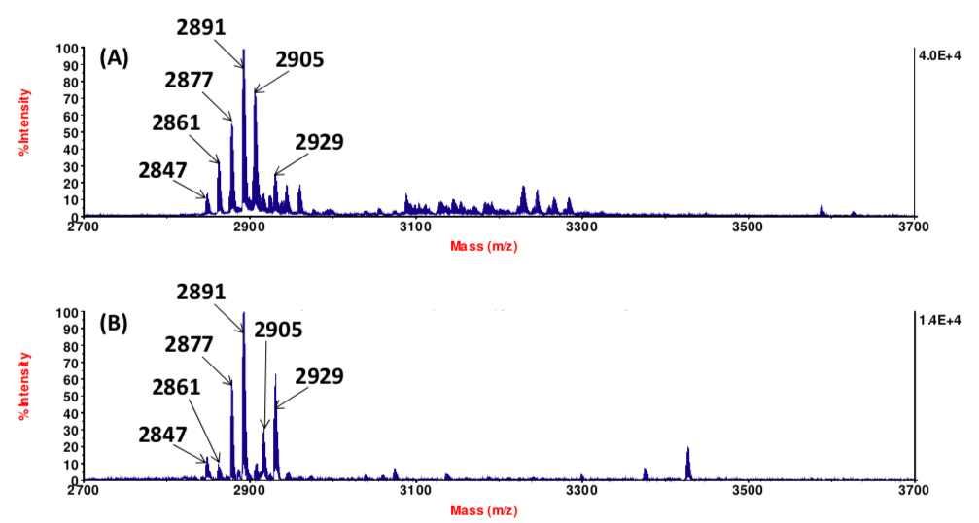
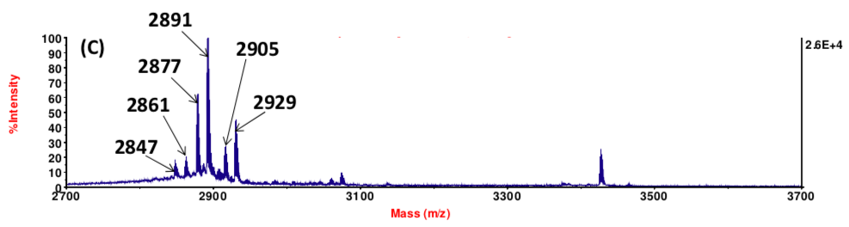
Supplementary Figure S2. MALDI-TOF mass spectra of Viola yedoensis in three different forms: (A) fresh herb, (B) dried herb and (C) granules.

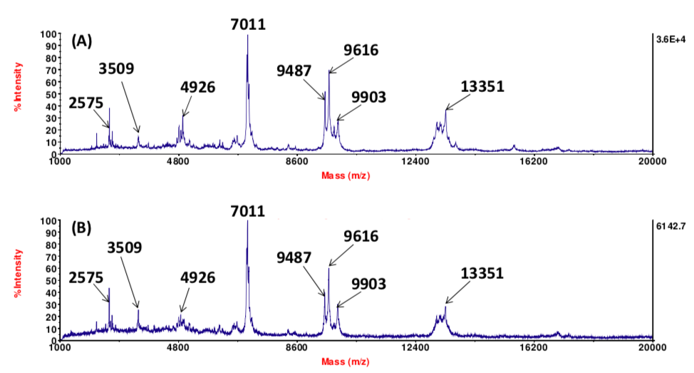
Supplementary Figure S3. MALDI-TOF mass spectra of the crude extract of Triticum aestivum: (A) before and (B) after heat treatment for 1 h.

Supplementary Figure S4. MS profiles of achyrantide aB1 from A. bidentate. The mass spectra of aB1 (A) before and (B) after S-reduction, which showed a mass shift of 6 Da.

Supplementary Figure S5. MS/MS sequencing of hP1. (A) Trypsin digestion of heditide hP1 which yielded three fragments with m/z values 3416 and 550 Da; (B−C) MS/ MS spectra of digested fragments.
Supplementary Figure S6. MS/MS sequencing of hP2. (A) Trypsin digestion of heditide hP2 which yielded three fragments with m/z values 1433, 2272, and 1121 Da; (B−D) MS/ MS spectra of digested fragments.

