Supplementary Material
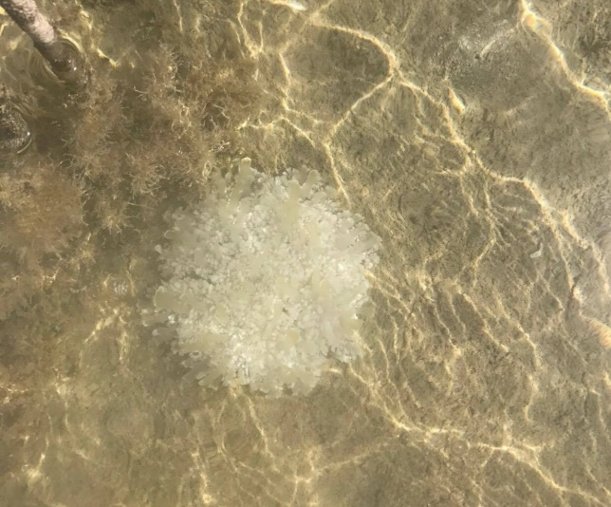
(a)
(b)
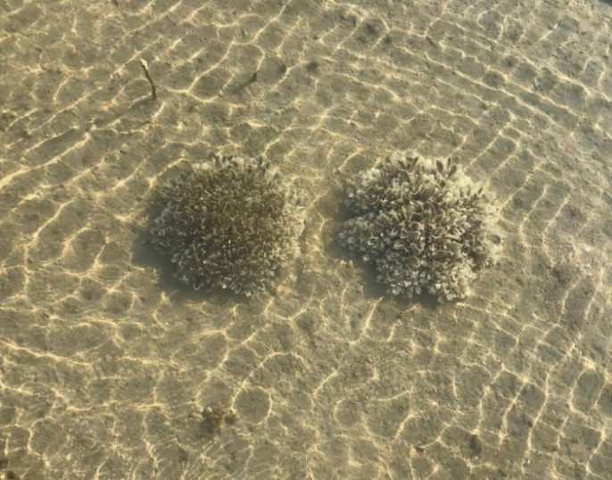Figure S1 (a) Non-bleached (typical) Cassiopea sp. observed prior to bleaching event and, (b) representative example of bleached Cassiopea sp. population observed 12th September, 2017 in a shallow, semi-enclosed lagoon ecosystem (0.2-1m depth, 22.39°N, 39.13°E) in the central Red Sea.
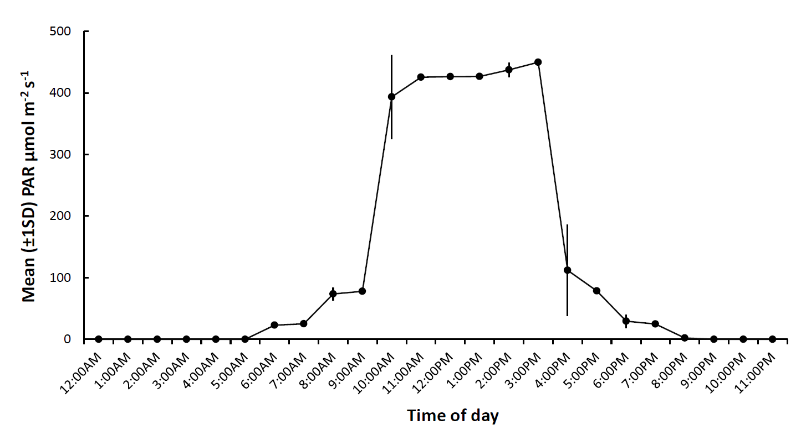
Figure S2 Mean (±1SD) Photosynthetic Active Radiation (PAR) regime over a 24h cycle across all five experimental treatments during the experiment.
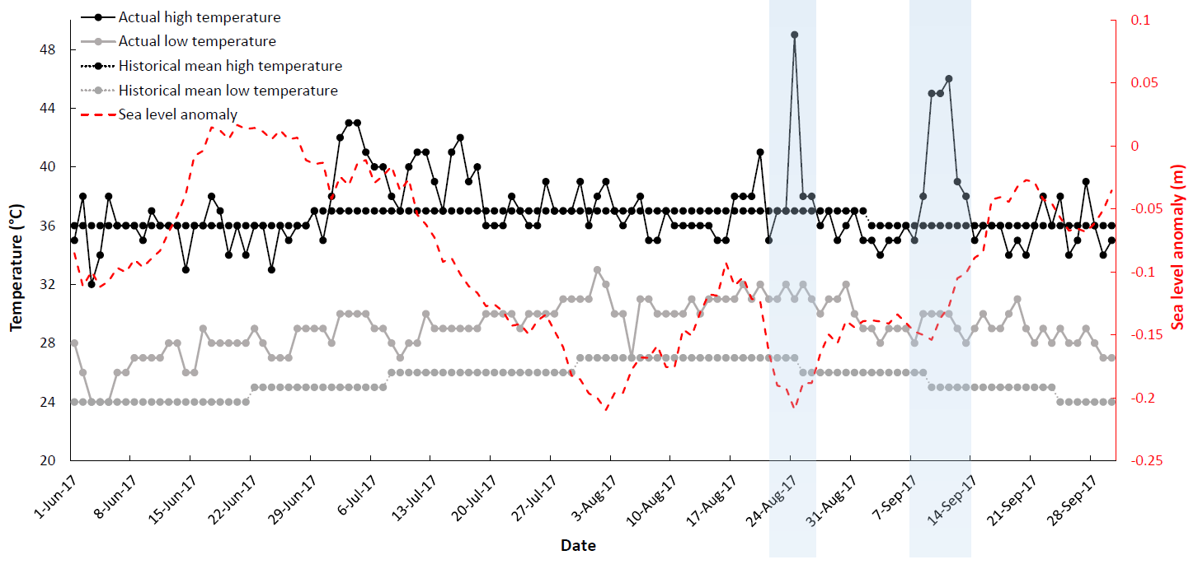

Figure S3 Actual and historical (mean) atmospheric maximum temperature data for Thuwal, Saudi Arabia for 1st June – 28th September, 2017 (obtained from AccuWeather©). Near-real-time (NRT) sea level anomaly data for the same period and location were generated using E.U Copernicus Marine Service Information (http://marine.copernicus.eu/). Orange arrow indicates when Cassiopea sp. medusae bleaching was observed and blue (shaded) panels represent extreme temperature anomalies preceding the bleaching event.

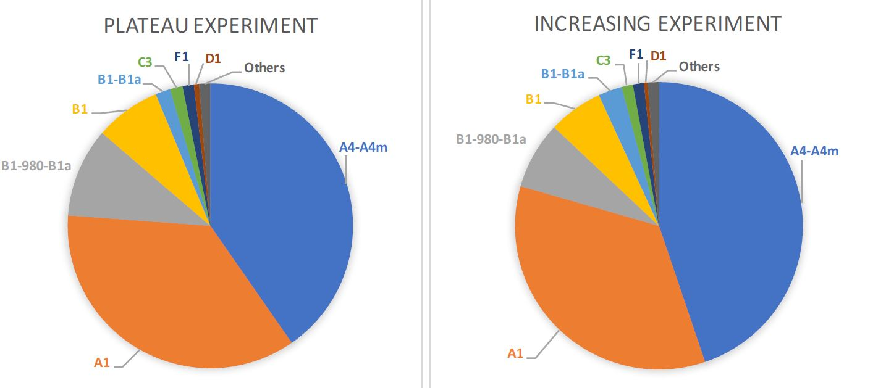
(a)
(b)

Figure S4 Typical, mean percent (%) composition of Symbiodiniaceae ITS2 types within holobionts in (a) the ‘Plateau’ experiment (Part II: control, S_{Plat}, O_{Plat}, n=33) and (b) the ‘Increasing’ experiment (Part III: control, S_{Incr}, O_{Incr}, n= 31) sampled at Day 1, Day 13, and post-bleaching, identified using SymPortal [see, 1].

Table S1 Sizes of medusae (mm) allocated to each treatment in Experiment Part I and II, including mean medusae size and ± 1SE (standard error) for each treatment. A one-way ANOVA (dependent variable = size (mm), factor = treatment (five levels: control, S_{Plat}, O_{Plat}, S_{Incr}, O_{Incr}) revealed no significant difference between medusae sizes among the five treatments (P = 0.776, F= 0.444, Df = 4) in this study.
Replicate medusae | Control | Stable Plateau (S_{Plat}) | Oscillating Plateau (O_{Plat}) | Stable Increasing (S_{Incr}) | Oscillating Increasing (O_{Incr})
1 | 61 | 72 | 61 | 94 | 81
2 | 68 | 87 | 72 | 78 | 62
3 | 88 | 89 | 85 | 78 | 68
4 | 73 | 78 | 64 | 88 | 82
5 | 75 | 50 | 73 | 80 | 82
6 | 65 | 95 | 72 | 69 | 68
7 | 85 | 62 | 79 | 48 | 76
8 | 43 | 42 | 82 | 84 | 59
9 | 71 | 89 | 75 | 68 | 77
10 | 81 | 86 | 51 | 50 | 77
11 | 66 | 91 | 59 | 81 | 80
Mean ± 1SE | 70.54 ± 3.76 | 70.27 ± 3.14 | 76.45 ± 5.38 | 74.36 ± 4.39 | 73.81 ± 2.47

Table S2 Summary of results for three repeated LMMs comparing bell contractions (min⁻¹), medusae size (% change), and maximum photochemical efficiency (F_{v}/F_{m}) between treatments in the ‘Plateau’ experiment (Part II: control, S_{Plat}, O_{Plat}) during the first 14 days of exposure (Days 1-14). Df= degrees of freedom. AIC =Akaike information criterion, BIC = Bayesian information criterion. P values in bold are statistically significant (P<0.05).
Variable |  |  | Bell contractions (min⁻¹) | Medusae size (% change) | Maximum photochemical efficiency (F_{v}/F_{m})
Transformation |  |  | Ln | Ln(x + a* +1) | None
Repeated covariance type |  |  | AR(1) | AR(1) | CS
Information Criterion |  |  | _{BIC= 114.959}  _{AIC= 109.540} | _{BIC= 14.741}  _{AIC= 9.322} | _{BIC= -287.275}  _{AIC= -292.694}
Source of variation | Df | Denominator Df | P | P | P
Treatment | 2 | 32.748 | 0.004  _{F=6.409} | <0.001  _{F=24.498} | <0.001  _{F=49.257}
Exposure time | 5 | 79.254 | 0.009  _{F=3.350} | <0.001  _{F=23.462} | <0.001  _{F=26.718}
Treatment × Exposure time | 10 | 79.254 | 0.001  _{F=3.404} | <0.001  _{F=23.202} | <0.001  _{F=13.500}
*a=min value of the dependent variable.

Variable |  |  | Bell contractions (min⁻¹) | Medusae size (% change) | Maximum photochemical efficiency (F_{v}/F_{m})
Transformation |  |  | None | None | None
Information Criterion |  |  | _{BIC= 44.850}  _{AIC= 45.058} | _{BIC= 37.063}  _{AIC= 37.271} | _{BIC= -15.709}  _{AIC= -15.500}
Source of variation | Df | Denominator Df | P | P | P
Treatment | 1 | 5 | 0.306  _{F=1.254} | 0.017  _{F=10.594} | 0.001  _{F=41.092}

Table S3 Summary of results for three LMMs comparing bell contractions (min⁻¹), medusae size (% change), and maximum photochemical efficiency (F_{v}/F_{m}) between treatments in the ‘Plateau’ experiment (Part II: Control and O_{Plat}) that remained after 16 days of exposure. Df= degrees of freedom. AIC =Akaike information criterion, BIC = Bayesian information criterion. P values in bold are statistically significant (P<0.05).

Table S4 Summary of results for five two-way LMMs comparing Symbiodiniaceae cell density (µg⁻¹ total protein) and total chlorophyll content cell⁻¹ (pg) between treatments in the ‘Plateau’ experiment (Part II: control, S_{Plat}, O_{Plat}) after 1 and 13 days of exposure. Df= degrees of freedom. AIC =Akaike information criterion, BIC = Bayesian information criterion. P values in bold are statistically significant (P<0.05).
Variable |  |  | Symbiodiniaceae cell density  (µg⁻¹ total protein) | Total Chl content  (pg cell⁻¹)
Transformation |  |  | None | Ln
Information Criterion |  |  | _{BIC= 47.177}  _{AIC= 46.469} | _{BIC= 10.296}  _{AIC= 9.588}
Source of variation | Df | Denominator Df | P | P
Treatment | 2 | 15 | 0.646  _{F=0.449} | 0.222  _{F=1.668}
Exposure time | 1 | 15 | 0.843  _{F=0.041} | 0.231  _{F=1.556}
Treatment × Exposure time | 2 | 15 | 0.810  _{F=0.214} | 0.719  _{F=0.338}

Variable |  |  | Symbiodiniaceae cell density  (µg⁻¹ total protein) | Total Chl content  (pg cell⁻¹)
Transformation |  |  | Ln (x + 1) |  | Ln( x+ 1)
Information Criterion |  |  | _{BIC= 12.115}  _{AIC= 11.917} |  | _{BIC= 17.422}  _{AIC= 17.225}
Source of variation | Df | Denominator Df | P |  | P
Treatment | 2 | 9 | 0.001  _{F=14.634} |  | 0.068  _{F=3.682}
Table S5 Summary of results for five LMMs comparing Symbiodiniaceae cell density (µg⁻¹ total protein) and total chlorophyll content cell⁻¹ (pg) between treatments in the ‘Plateau’ experiment (Part II: control, S_{Plat}, O_{Plat}), post-bleaching. Df= degrees of freedom. AIC =Akaike information criterion, BIC = Bayesian information criterion. P values in bold are statistically significant (P<0.05).

*a=min value of the dependent variable.
Table S6 Summary of results for three repeated LMMs comparing bell contractions (min⁻¹), medusae size (% change), and maximum photochemical efficiency (F_{v}/F_{m}) between treatments in the ‘Increasing’ experiment (Part III: control, S_{Incr}, O_{Incr}) during the first 14 days of exposure (Days 1-14). Df= degrees of freedom. AIC =Akaike information criterion, BIC = Bayesian information criterion. P values in bold are statistically significant (P<0.05).
Variable |  |  | Bell contractions (min⁻¹) | Medusae size (% change) | Maximum photochemical efficiency (F_{v}/F_{m})
Transformation |  |  | Ln | Ln(x + a* +1) | Ln(x + 1)
Repeated covariance type |  |  | AR(1) | AR(1) | AR(1)
Information Criterion |  |  | _{BIC=120.522}  _{AIC= 115.103} | _{BIC= 81.682}  _{AIC= 76.263} | _{BIC= -367.961}  _{AIC= -373.380}
Source of variation | Df | Denominator Df | P | P | P
Treatment | 2 | 30.322 | 0.105  _{F=2.429} | 0.016  _{F=4.973} | <0.001  _{F=26.221}
Exposure time | 5 | 78.463 | <0.001  _{F=8.411} | 0.002  _{F=4.355} | <0.001  _{F=17.336}
Treatment × Exposure time | 10 | 78.463 | 0.020  _{F=2.307} | <0.001  _{F=4.956} | <0.001  _{F=11.668}
*a=min value of the dependent variable.

Variable |  |  | Bell contractions (min⁻¹) | Medusae size (% change) | Maximum photochemical efficiency (F_{v}/F_{m})
Transformation |  |  | None | None | Ln (x +1)
Information Criterion |  |  | _{BIC= 36.612}  _{AIC= 37.003} | _{BIC= 40.508}  _{AIC= 40.898} | _{BIC= -18.773}  _{AIC= -18.383}
Source of variation | Df | Denominator Df | P | P | P
Treatment | 2 | 8 | 0.010  _{F=15.973} | 0.049  _{F=6.732} | <0.001  _{F=294.056}
Table S7 Summary of results for three LMMs comparing bell contractions (min⁻¹), medusae size (% change), and maximum photochemical efficiency (F_{v}/F_{m}) between treatments in the ‘Increasing’ experiment (Part III: control and O_{Incr}) that remained after 16 days of exposure. Df= degrees of freedom. AIC =Akaike information criterion, BIC = Bayesian information criterion. P values in bold are statistically significant (P<0.05).

Table S8 Summary of results for five two-way LMMs comparing Symbiodiniaceae cell density (µg⁻¹ total protein) and total chlorophyll content cell⁻¹ (pg) between treatments in the ‘Increasing’ experiment (Part III: control, S_{Incr}, O_{Incr}) after 1 and 13 days of exposure. Df= degrees of freedom. AIC =Akaike information criterion, BIC = Bayesian information criterion. P values in bold are statistically significant (P<0.05).
Variable |  |  | Symbiodiniaceae cell density  (µg⁻¹ total protein) | Total Chl content  (pg cell⁻¹)
Transformation |  |  | None | Ln
Information Criterion |  |  | _{BIC= 39.559}  _{AIC= 38.851} | _{BIC= 16.368}  _{AIC= 15.660}
Source of variation | Df | Denominator Df | P | P
Treatment | 2 | 15 | 0.251  _{F=1.517} | 0.731  _{F=0.320}
Exposure time | 1 | 15 | 0.961  _{F=0.002} | 0.702  _{F=0.152}
Treatment × Exposure time | 2 | 15 | 0.638  _{F=0.463} | 0.393  _{F=0.995}

Table S9 Summary of results for five LMMs comparing Symbiodiniaceae cell density (µg⁻¹ total protein) and total chlorophyll content cell⁻¹ (pg) between treatments in the ‘Increasing’ experiment (Part III: control, S_{Incr}, O_{Incr}), post-bleaching. Df= degrees of freedom. AIC =Akaike information criterion, BIC = Bayesian information criterion. P values in bold are statistically significant (P<0.05).
Variable |  |  | Symbiodiniaceae cell density  (µg⁻¹ total protein) | Total Chl content  (pg cell⁻¹)
Transformation |  |  | Ln(x + 1) | Ln(x + 1)
Information Criterion |  |  | _{BIC= 9.797}  _{AIC= 9.851} | _{BIC= 6.942}  _{AIC= 6.978}
Source of variation | Df | Denominator Df | P | P
Treatment | 2 | 7 | 0.007  _{F=10.905} | 0.152  _{F=2.500}

*a=min value of the dependent variable.

Variable |  | % composition of Symbiodiniaceae ITS2 types in Plateau exp. (Day 1 & 13) | % composition of Symbiodiniaceae ITS2 types in Plateau exp. (post-bleaching)
Transformation |  | None | None
Number of permutations |  | 999 | 999
Source of variation | Df | P (Perm) | P (Perm)
Treatment | 2 | 0.460  _{F=0.98055} | 0.168  _{F=1.5178}
Exposure time | 1 | 0.937  _{F=0.21141} | -
Treatment × Exposure time | 2 | 0.700  _{F=0.70574} | -
Table S10 Summary of results for two separate PERMANOVA analyses used to analyse percent (%) composition of Symbiodiniaceae ITS2 types within holobionts between treatments in the ‘Plateau’ experiment (Part II: control, S_{Plat}, O_{Plat}). The % composition of Symbiodiniaceae genetic types at Day 1 & Day 13 were first analysed using two-way (PERMANOVA) and second, a one-way PERMANOVA multivariate analysis was used to compare % composition of Symbiodiniaceae ITS2 types within holobionts among treatments post-bleaching.

Variable |  | % composition of Symbiodiniaceae ITS2 types in Increasing exp. (Day 1 & 13) | % composition of Symbiodiniaceae ITS2 types in Increasing exp. (post-bleaching)
Transformation |  | None | None
Number of permutations |  | 999 | 999
Source of variation | Df | P (Perm) | P (Perm)
Treatment | 2 | 0.736  _{F=0.72536} | 0.335  _{F=0.232}
Exposure time | 1 | 0.473  _{F=0.95417} | -
Treatment × Exposure time | 2 | 0.404  _{F=1.0595} | -
Table S11 Summary of results for two separate PERMANOVA analyses used to analyse percent (%) composition of Symbiodiniaceae ITS2 types within holobionts between treatments in the ‘Increasing’ experiment (Part II: control, S_{Incr}, O_{Incr}). First, the % composition of Symbiodiniaceae genetic types at Day 1 & Day 13 were first analysed using two-way (PERMANOVA) and second, a one-way PERMANOVA multivariate analysis was used to compare % composition of Symbiodiniaceae ITS2 types within holobionts among treatments post-bleaching.

Days of exposure | Control | Constant Increasing (C_{Incr}) | Oscillating Increasing (O_{Incr}) | Constant Plateau  (C_{Plat}) | Oscillating Plateau  (O_{Plat})
1 | 28.116 | 28.204 | 28.131 | 28.055 | 28.263
2 | 28.072 | 28.967 | 28.548 | 29.049 | 28.99
3 | 28.268 | 29.844 | 29.214 | 30.009 | 29.145
4 | 28.267 | 30.8975 | 29.632 | 31.050 | 30.381
5 | 28.258 | 32.0256 | 30.489 | 32.163 | 30.678
6 | 28.294 | 33.129 | 31.463 | 33.071 | 30.897
7 | 28.229 | 34.026 | 32.584 | 34.137 | 31.037
8 | 28.048 | 34.801 | 33.426 | 35.123 | 33.433
9 | 28.199 | 35.109 | 33.328 | 35.084 | 33.324
10 | 28.054 | 35.262 | 33.054 | 35.150 | 33.143
11 | 28.361 | 35.198 | 33.116 | 35.080 | 33.0505
12 | 28.291 | 35.183 | 33.250 | 35.434 | 33.589
13 | 28.266 | 37.074 | 34.890 | 37.098 | 34.559
14 | 28.248 | 38.846 | 37.212 | 37.0223 | 34.889
15 | 28.314 |  | 39.290 |  | 35.213
16 | 28.088 |  | 40.548 |  | 35.716
Table S11 Mean daily temperature (°C) conditions for each of the five treatments throughout the experiment. Temperature values in bold represent mean daily temperature conditions under which medusae bleaching in their respective treatments.

Reference List
[1] Hume B.C. C., S.E.G., Ziegler M., Warrington H. J. M., Burt J. A., LaJeunesse T. C., Wiedenmann J. & Voolstra C. R. 2018 SymPortal: a novel analytical framework and platform for coral algal symbiont next-generation sequencing ITS2 profiling. (Submitted).
[2] Maynard, J.A., Turner, P.J., Anthony, K., Baird, A.H., Berkelmans, R., Eakin, C.M., Johnson, J., Marshall, P.A., Packer, G.R. & Rea, A. 2008 ReefTemp: An interactive monitoring system for coral bleaching using high‐resolution SST and improved stress predictors. Geophysical Research Letters 35.

