Supplemental information
FIGURE S1
COG feature annotations from sensitive strain (A) and resistance strains chosen randomly from the 2MIC (B) and 8MIC (C) of amoxicillin-containing MH agar plates. 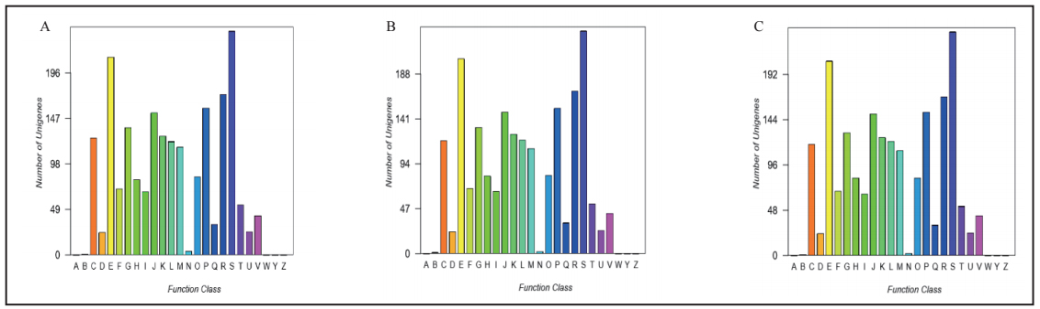A: RNA processing and modification; B: Chromatin structure and dynamics; C: Energy production and conversion; D: Cell cycle control, cell division, and chromosome partitioning; E: Amino acid transport and metabolism; F: Nucleotide transport and metabolism; G: Carbohydrate transport and metabolism; H: Coenzyme transport and metabolism; I: Lipid transport and metabolism; J: Translation, ribosomal structure, and biogenesis; K: Transcription; L: Replication, recombination, and repair; M: Cell wall/membrane/envelope; N: Cell motility; O: Posttranslational modification, protein turnover, chaperones; P: Inorganic ion transport and metabolism; Q: Secondary metabolite biosynthesis, transport, and catabolism; R: General function prediction only; S: Function unknown; T: Signal transduction mechanisms; U: Intracellular trafficking, secretion, and vesicular transport; V: Defense mechanisms; W: Extracellular structures; Y: Nuclear structure; Z: Cytoskeleton.

