NOVEL METHODS OF INCORPORATING TIME IN LONGITUDINAL MULTIVARIATE ANALYSIS REVEALS HIDDEN ASSOCIATIONS WITH DISEASE ACTIVITY IN SYSTEMIC LUPUS ERYTHEMATOSUS

Hieu T. Nim^{1,2^}, Kathryn Connelly^{2^}, Fabien B. Vincent², François Petitjean¹, Alberta Hoi², Rachel Koelmeyer², Sarah E. Boyd², Eric F. Morand^{2*}

¹Data Science & AI, Faculty of Information Technology, Monash University, Clayton, Victoria, 3800, Australia

²Centre for Inflammatory Diseases, Monash University School of Clinical Sciences at Monash Health, Melbourne, Victoria, 3168, Australia

^ Equal contributions

Correspondence:
Professor Eric Morand
Telephone: +61 3 8572 2650. Fax: + 61 3 9594 6437
Email: eric.morand@monash.edu

Supplementary Tables
Table S1. SLE patient demographic, clinical and biological characteristics at baseline in subgroups 1 and 2.

Parameter | SLE Group 2 (n=110) |  | Association of Group Label with Parameter  OR (95% CI; P value)
 | SLE Group 1  (n = 101) | SLE Group 2 2  (n = 9)
Sociodemographic characteristics
Sex  Female  Male | 83 (82%)  18 (18%) | 8 (89%)  1 (11%) | 1.735 (0.291 - 33.214; 0.614)  0.576 (0.03 - 3.435; 0.614)
Ethnicity  Caucasian  Asian  Other/Missing | 51 (50%)  46 (46%)  4 (4%) | 2 (22%)  7 (78%)  0 (0%) | 0.28 (0.04 - 1.225; 0.123)  (0.956 - 29.021; 0.083)  Too few data points
Disease characteristics
Age at diagnosis (years)  <18 years  ≥18 - <45 years  ≥45 years | 11 (11%)  70 (69%)  20 (20%) | 2 (22%)  7 (78%)  0 (0%) | 2.338 (0.322 - 11.23; 0.325)  1.55 (0.351 - 10.802; 0.598)  <0.001 (0 – 0.001; <0.001) | *
Time since diagnosis of SLE (years)  <10 years  ≥10 years | 36 (36%)  65 (64%) | 4 (44%)  5 (56%) | 1.444 (0.339 - 5.792; 0.601)  0.692 (0.173 - 2.949; 0.601)
Disease characteristics continued
SLEDAI-2k organ domain  Neurological  Vascular  Musculoskeletal  Renal  Mucocutaneous  Serosal  Immunological  Fever  Haematological | 6 (6%)  4 (4%)  17 (17%)  10 (10%)  31 (31%)  2 2%)  41 (41%)  1 (1%)  7 (7%) | 1 (11%)  0 (0%)  5 (56%)  3 (33%)  8 (89%)  0 (0%)  9 (100%)  0 (0%)  1 (11%) | 1.979 (0.099 - 13.765; 0.55)  Too few data points  6.176 (1.491 - 27.313; 0.012)  4.55 (0.86 - 20.338; 0.053)  18.065 (3.125 - 342.551; 0.008)  Too few data points  >1000 (>1000 - ∞; <0.001)  Too few data points  1.679 (0.084 - 11.282; 0.647) | *  *  *
Adverse outcomes during observed period  SFI Flare  SLICC-SDI ≥ 1  SLEDAI-2k > 4  AMS in 1st quartile (>4.96)  Medications during observed period^  Prednisolone  Prednisolone>7.5 mg/day  Hydroxychloroquine  Immunosuppressants  Biologics | 73 (72%)  57 (56%)  73 (72%)  26 (26%)  83 (82%)  69 (68%)  97 (96%)  78 (77%)  7 (7%) | 7 (78%)  7 (78%)  9 (100%)  2 (22%)  9 (100%)  7 (78%)  9 (100%)  7 (78%)  0 (0%) | 1.342 (0.302 - 9.377; 0.723)  2.702 (0.617 - 18.739; 0.229)  >1000 (>1000 - ∞; <0.001)  0.824 (0.118 - 3.672; 0.817)  >1000 (>1000 - ∞; <0.001)  1.623 (0.368 - 11.305; 0.559)  >1000 (>1000 - ∞; <0.001)  1.032 (0.23 - 7.247; 0.97)  <0.001 (0 – 0.001; <0.001) | *  *  *
Odds ratio (OR) calculated using penalized maximum likelihood logistic regression. OR is not calculated for rare events, where “Too few data points” is shown.
^Restricted to medications taken by ≥10% of patients.

Supplementary Figures
Figure S1. A heat map based on the pairwise Euclidean distances of the patient pathology profiles (n=110). Dissimilarity values were normalised to [0-1], and plotted as a yellow-red heat map.
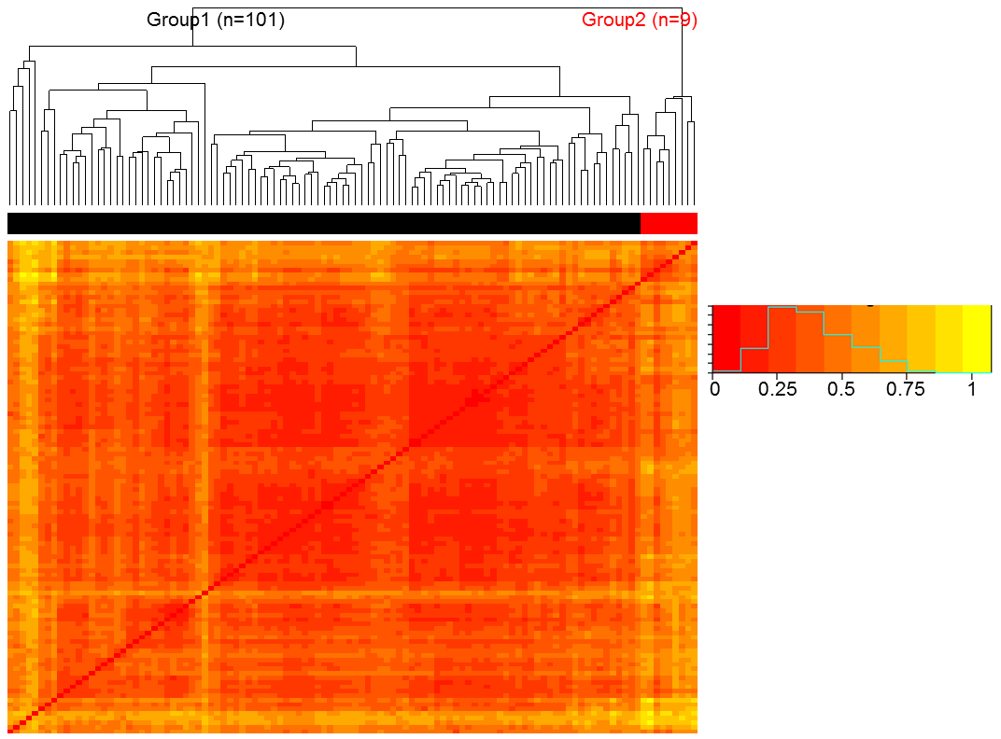

Figure S2. Boxplot comparison between the two patient subgroups (Group 1 and 2), based on 13 z-normalised blood and urinary parameters (excluding serum cytokines). Both t-test and Fisher’s exact test showed no statistical significance between Group 1 and Group 2 (p≥0.05).
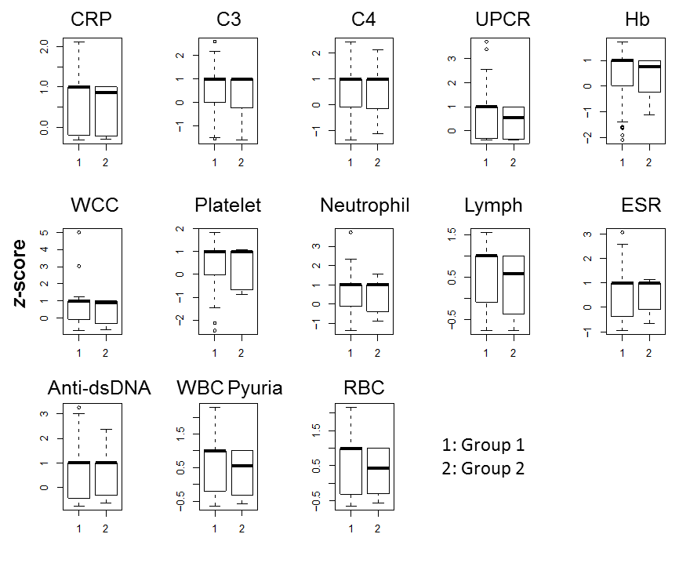

Figure S3. Results from LOPO multiple linear regression to predict the disease activity (SLEDAI-2K) of each patient visit based on the blood and urinary parameters, performed on (A) all patients versus (B) patients from Group 1. (C) Comparison of prediction error of Group 1 patients versus all patients without grouping information. n.s.: not statistically significant.
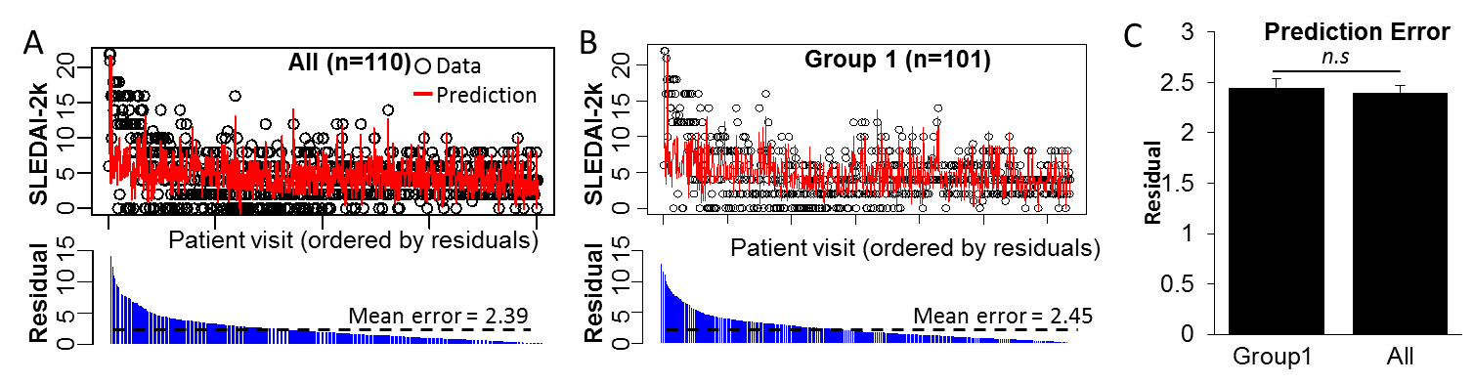

Figure S4. Boxplot comparison between the two patient subgroups (Group 1A and 1B), based on 13 z-normalised blood and urinary parameters (excluding serum cytokines). Both t-test and Fisher’s exact test showed no statistical significance between Group 1 and Group 2 (p≥0.05).
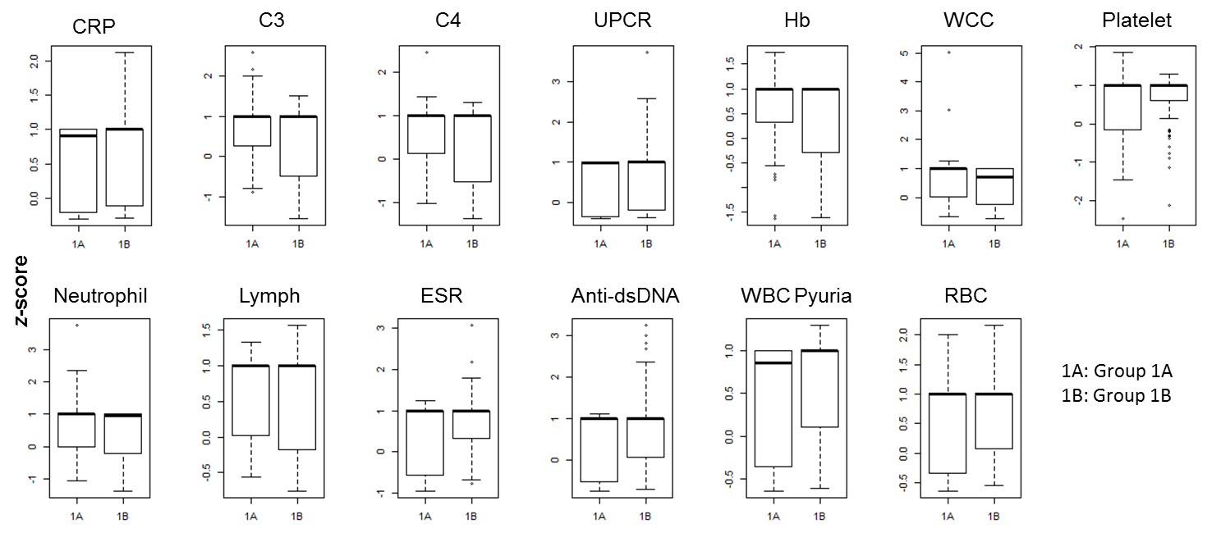

Figure S5. Ensemble clustering (using Ward, McQuitty, Centroid, and Median methods) as applied as the whole SLE patient cohort (n=110). All 4 clustering methods showed the highest likelihood of having 2 clusters.
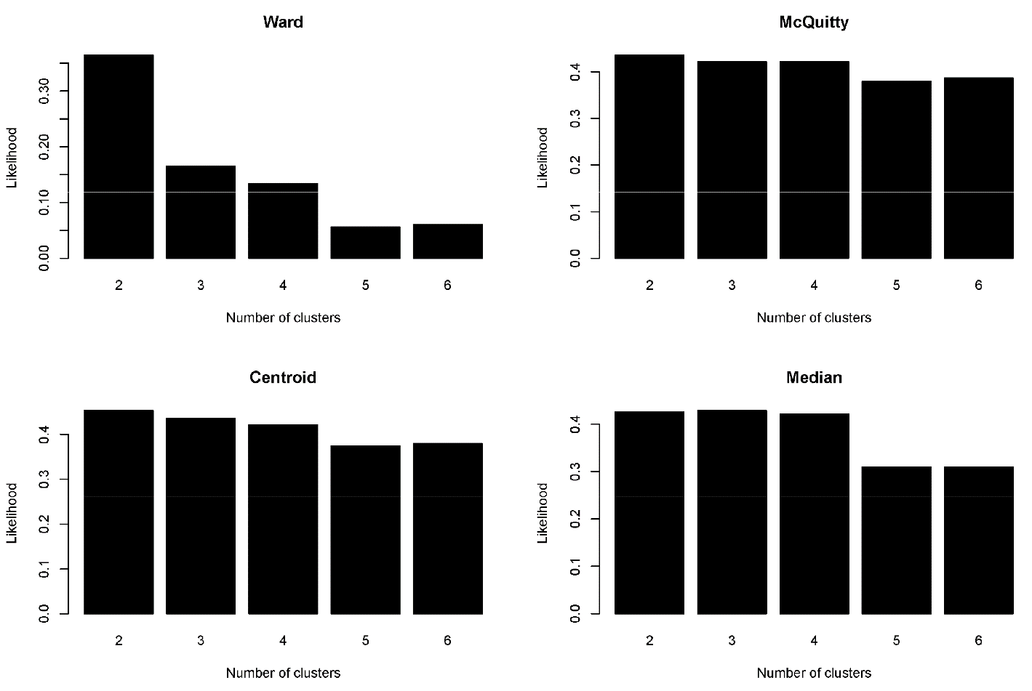

Figure S6. Ensemble clustering (using Ward, McQuitty, Centroid, and Median methods) as applied as Group 1 (n=101). Three out of four clustering methods showed the highest likelihood of having 2 sub-clusters within Group 1.
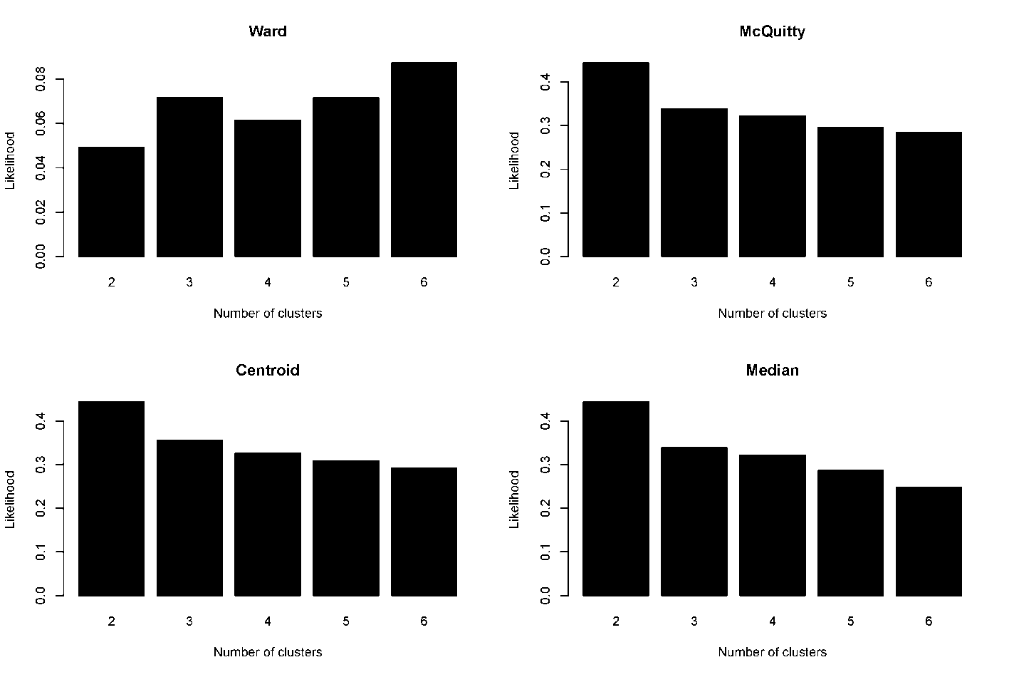

Figure S7. Results from boostrapping for multiple linear regression (80% training, 20% test data, 1000 iterations) to predict the disease activity (SLEDAI-2K) of each patient visit based on the blood and urinary parameters, performed on (A) All patients, (B) Group 1, (C) Group 2, (D) Subgroup 1A, and (E) Subgroup 1B.

