Supplementary Material

Supplementary Figures and Tables

Supplementary table 1.
Supplementary table 1. Characteristics of HIV-1-infected patients and controls.
Characteristics | HIV-1 infectious | Healthy
Number | 50 | 30
Sex ratioª | 42/8 | 25/5
Age (years)^{b} | 40.18 (13.9) | 35.70 (13.2)
Anti-HIV | Positive | Negative
CD4 cells/μl^{b} | 307.22(251) | NA^{C}
CD8 cells/μl^{b} | 598.70 (359) | NA
HBsAg | Negative | Negative
Anti-HCV | Negative | Negative
HCV RNA | Negative | Negative
HAART^{d}, n (%)
Occasional | 3(6) | NA
Intermittent | 5(10) | NA
Regular | 41(82) | NA
Unclear | 1(2) | NA
Duration, median years (IQR^{e}) | 8.5(6.5-10.4) | NA
ª Sex ratio (male/female); ^{b} Mean ± standard deviation (SD); ^{c} NA: Not applicable. ^{d} The first-line highly active antiretroviral therapy (HAART) regimes consisting of two nucleoside reverse transcriptase inhibitors (NRTIs) AZT/ddI (~60%) or d4T/3TC (~40%), and one NNRTIs NVP, which were supported by the China CARES (Community AIDS Resource and Education Services) program; ^{e}IQR, Interquartile range.

Supplementary Figures
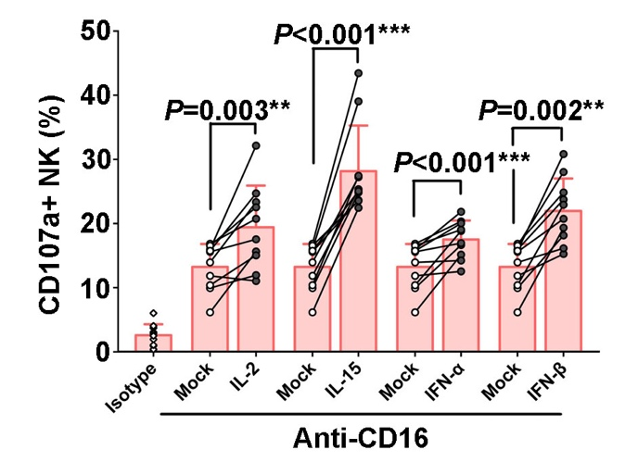
Supplementary Figure 1. Activation of nonspecific NK cell-mediated ADCC by CD16 cross-linking upon the stimulation of different cytokines. PBMCs in healthy controls (n=10) were incubated with IL-2, IL-15, IFN-α or IFN-β (50ng/ml, 12h). CD107a expression of NK cells in response to CD16 cross-linking with anti-CD16, or isotype antibodies were detected. Data is shown as mean+ SD. All P values are two-tailed and significantly different with P less than 0.05.
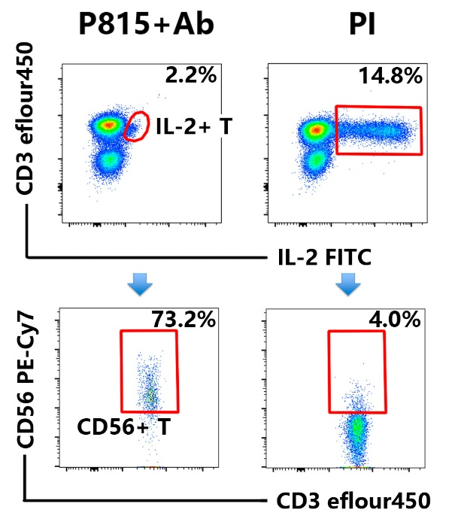
Supplementary Figure 2. Representative flow plots of IL-2 expression cells of CD56+T cells during the process of ADCC triggered by Ab-opsonized P815 cells (P815+Ab) and with the stimulation of PMA plus Ionomycin (PI).

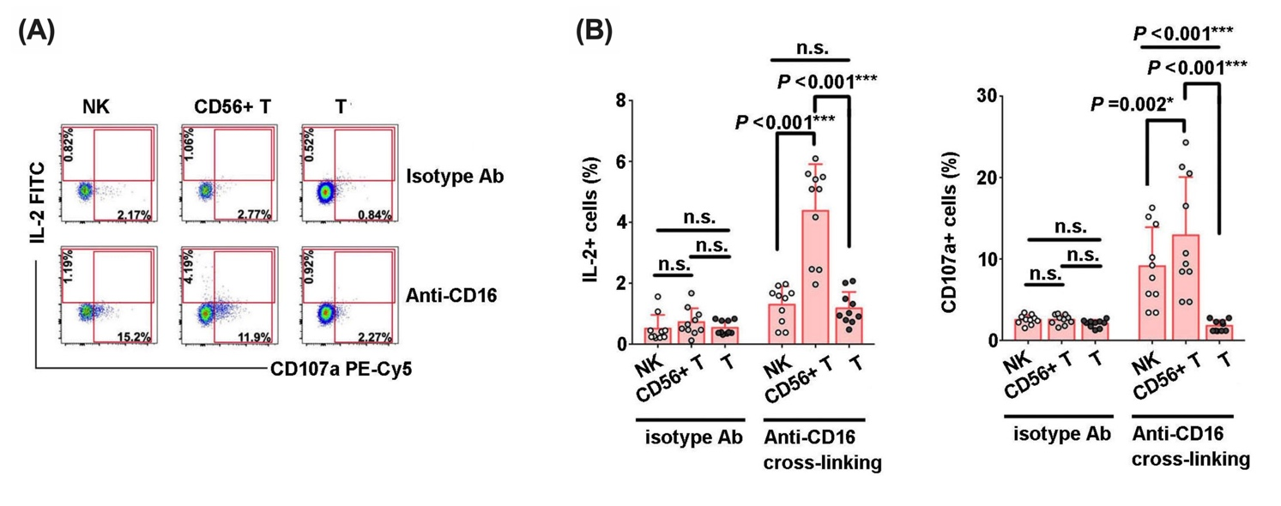
Supplementary Figure 3. (A) Representative flow plots of IL-2 and CD107a expressions in T cells, CD56⁺ T cells and NK cells that were triggered by CD16-cross linking. (B) Comparison of the abilities of IL-2 secretions and CD107a expressions among NK cells, CD56⁺ T cells and T cells that were triggered by CD16-cross linking (n=10). Data is shown as mean+ SD. All P values are two-tailed and significantly different when the value is less than 0.05.

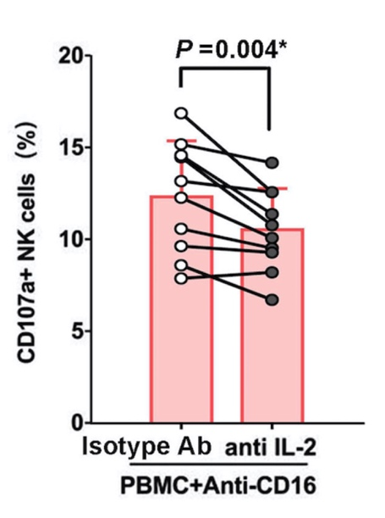
Supplementary Figure 4. Comparison of CD107a expression in NK cells triggered by CD16 cross-linking with or without blockade of IL-2 antibody(n=10).

