**Supplementary Material**

**1. NRLMOL results for vibrational modes of Pyramidal and Quasi-tetrahedral local structures in binary As–S glasses**

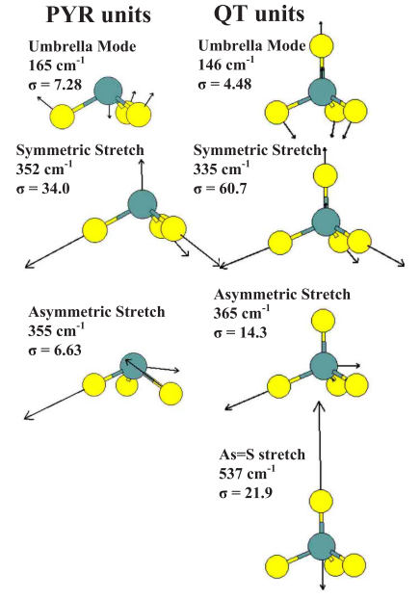

**Fig S1.** Eigenvectors of the Raman- and IR active vibrational modes of PYR and QT local structures obtained by NRLMOL calculations. The figure is taken from ref. P. Chen et al. (Chen et al., 2008)

**2. Compositional trends in Population of S=As(S1/2)3 QT local structures in AsxS100-x glasses**

We have tracked the scattering strength variation of the 537 cm-1 Raman mode QT S=As(S1/2)3 local structures in AsxS100-x glasses as a function of glass composition in the present homogenized and then Tg cycled glasses. The FT-Raman spectra were normalized to the highest scattering strength mode near 335 cm-1. These trends are plotted in **Figure S2a**, and compared with the corresponding trends in the signal of the QT Se=P(Se1/2)3 local structure from 31P NMR signal from the work of Lathrop et al. (Lathrop and Eckert, 1991). In fig S2 (a) and (b) we have also projected the Intermediate Phase (IP) composition range in respective binary glasses. The Quasi-Tetrahedral local structures in both group V chalcogenides are formed precursive to the IP. The IP is stabilized by the high configurational entropy (Sc) resulting from presence of both Pyramidal (As(S1/2)3) and Quasi-Tetrahedral (Se=P(Se1/2)3) local structures in the resulting network backbone as illustrated in **Fig. 13b** (shows Sc maximizing in the IP) of the main paper.

It is difficult to analyze the Raman lineshapes at higher As content (x >24%) in the present glasses, in large part because of the overlap of the Orpiment-like modes formed at higher x (> 24%) from the modes of the QT ones formed at x < 24%, as discussed in the text associated with **Fig.8.**

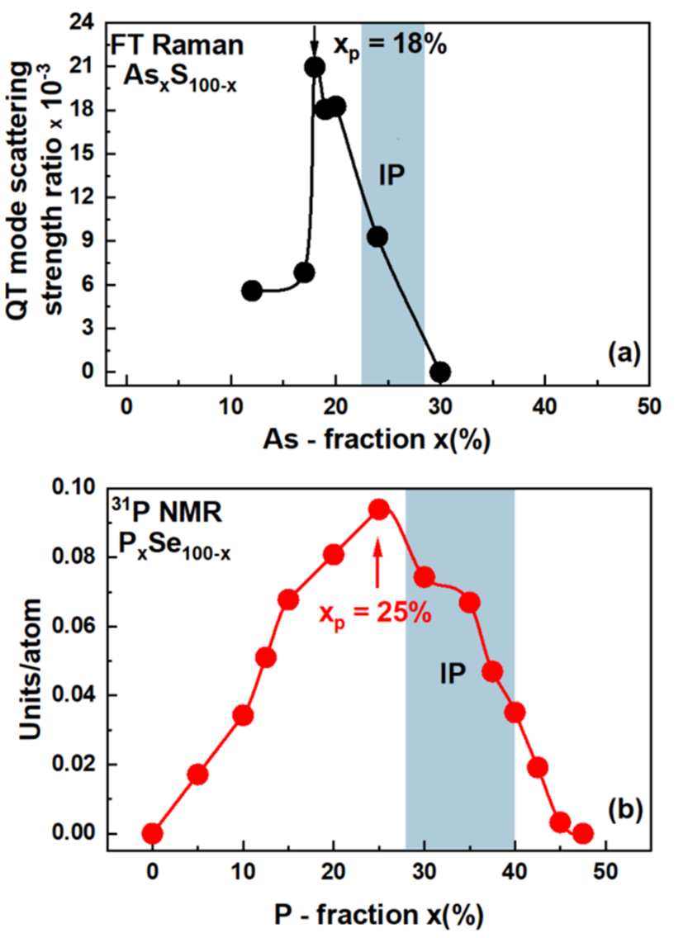

**Fig.S2.** Compositional trends in **(a)** the normalized Raman Scattering strength of the 537 cm-1 of the Quasi-Tetrahedral (Se=P(Se1/2)3) local structures and (b) 31P NMR signal of Quasi-Tetrahedral (Se=P(Se1/2)3) local structures in binary P-Se glasses. Note both maxima are precursive to respective Intermediate Phases. (Georgiev et al., 2003a)

**3. The Molecular origin of the 490 cm-1 vibrational excitation in AsxS100-x glasses**

The molecular origin of the 490 cm-1 mode in Raman scattering on AsxS100-x glasses has been speculative. Several researchers (Bychkov et al., 2006; Golovchak et al., 2010; Hannon, 2015) have suggested that the mode be identified with S–S dimer in AsxS100-x glasses, and have referenced the work of Ward (Ward, 1968). In the paper of Dr. Ward, only comment we have on the mode is, “*The broad, near – featureless band centered at 340 cm-1 in the spectra of the arsenic-sulfur glasses is clearly attributable to a polymeric species probably related to the layer lattice existing in As2S3 crystal. The weaker peaks at 140, 189, 230, and 490 cm-1 are probably also associated with this polymeric lattice*”. There is no explicit identification of the 490 cm-1 to S–S dimer.

Here we analyze our Raman scattering results on As–S glasses to establish scattering strength ratio R(x) of the 490 cm-1 mode to the Sn chain mode near 461 cm-1 as a function of As-content x in **Fig. S2.** The red data points describe the observed trend. The blue line describes how the normalized scattering strength of 1/I(Sn) would vary with x, with that data normalized to match the result x = 33%. Clearly as x increases to 40%, the Sn chain mode scattering strength, I(Sn) vanishes leading the 1/Sn to display a singularity. In fact, the increase in the observed ratio R at x>28%, can be seen as resulting due to the term in the denominator of the ratio R decreasing. The black curve represents the difference signal between the red and blue curves. The black curve shows the scattering strength variation of the numerator in the ratio R, and it displays a maximum near x = 25%.

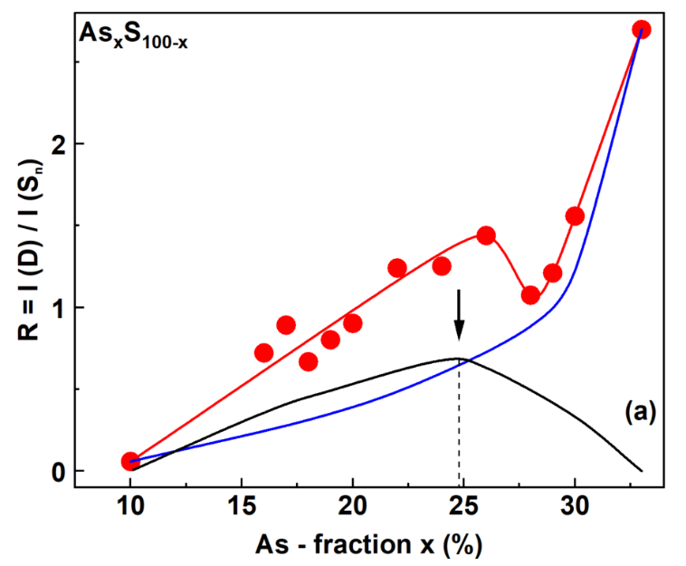

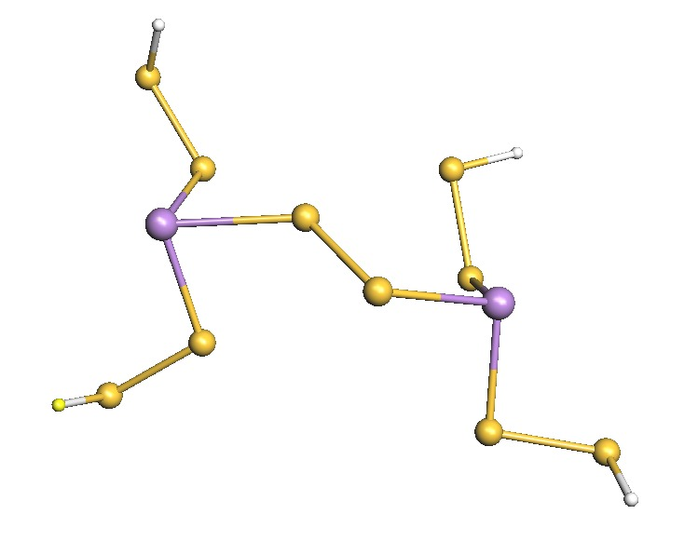

**(b)**

**Fig.S3a.** The observed scattering strength ratio R = I(D)/I(Sn) of modes centered 490cm-1 and near 461 cm-1 shown by the (●) data points and the smooth red line in FT–Raman scattering of AsxS100-x glasses as a function of As content of glasses. Raman lineshape deconvolution of spectra of these glasses are available in **Fig. 9.** The ratio R increases with x as x increases to 33%. The blue curve plots the chain fraction I(Sn) normalized to the value at x = 33% concentration, and its rapid increase reflects the loss of Sn chains as x increases to the near stoichiometric composition (x = 33%). The black line is the difference between the red- and blue- line and gives the contribution of the D – mode scattering strength. The latter displays a local maximum near x = 25%. We obtain the blackline which shows a maximum near 25%. **Fig.S3b** illustrates S-S contacts evolving between AsS3 pyramidal units in the glass backbone. See text.

On purely statistical considerations, one expects the S–S pair contacts to display a maximum near x = 25% corresponding to a glass composed largely of AsS3 pyramids linked by S–S contact. Thus, the observation of the peak in the black curve near x = 25% is suggestive that the 490 cm-1 mode originates from the S–S mode between the AsS3 pyramids.

**4. The Molecular origin of the 490 cm-1 vibrational excitation in GexS100-x glasses**

Stimulated by the results of **Fig.S3**, we have also examined the scattering strength variation of a parallel mode observed in Raman scattering of GexS100-x glasses examined recently by S.

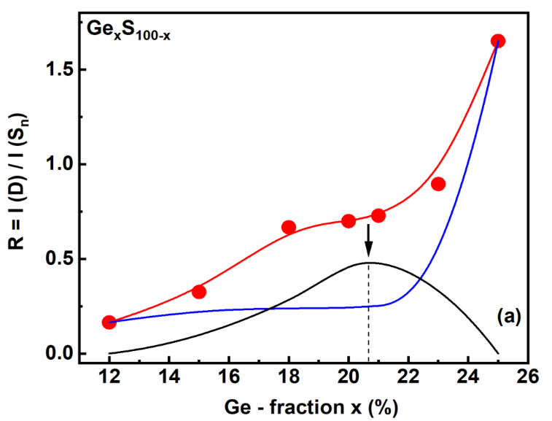

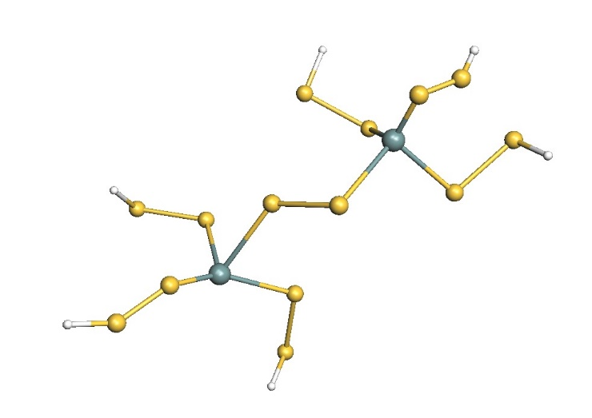

**(b)**

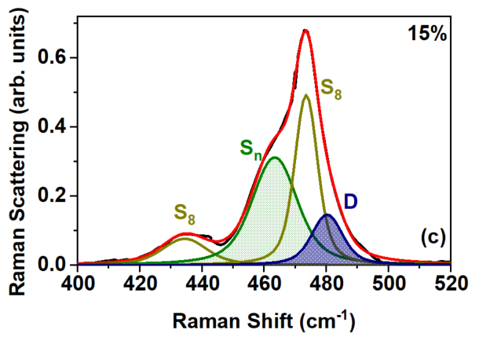

**Fig. S4a.** The observed scattering strength ratio R = I(D)/I(Sn) of modes centered near 490cm-1 and near 461 cm-1 shown by the (●) data points and the smooth red line in FT–Raman scattering of GexS100-x glasses as a function of Ge content of glasses. The ratio R increases with x as x increases to 25%. The blue curve plots the chain fraction I(Sn) normalized to the x = 25% concentration, and its rapid increase reflects the loss of Sn chains as x increases to the composition x = 25%. The black line is the difference between the red- and blue-line and gives the contribution of the D-mode scattering strength. The latter displays a local maximum near x = 20%. (**b**) illustrates S-S contacts emerging between GeS4 tetrahedra while (**c**) illustrates the Raman spectrum of a Ge15S85 bulk glass taken from Chakraborty and Boolchand (Chakraborty and Boolchand, 2014) and the results appear in **Fig. S4** below.

On statistical considerations one expects the S–S contacts in the GexS100-x binary to show a maximum near x = 20%, since such a glass may be viewed as made up of GeS4 tetrahedra linked by S–S contacts. The observed results of a maximum in the contribution of the I(D) near x = 20% is in harmony with that expectation and serves to confirm that the 490 cm-1 mode is, indeed, a mode related to the S–S dimer mode in binary Ge–S glasses. These Raman scattering results on both Ge–S and As–S binary glasses are persuasive in suggesting the molecular origin of the 490 cm-1 mode does come from S–S contacts in both binary glasses

**5. Dilatometric measurement of fragility index of As2S3 melt**

Several groups have reported Tg of As2S3 glass, and a summary of these results appears in the plot Fig.S5.

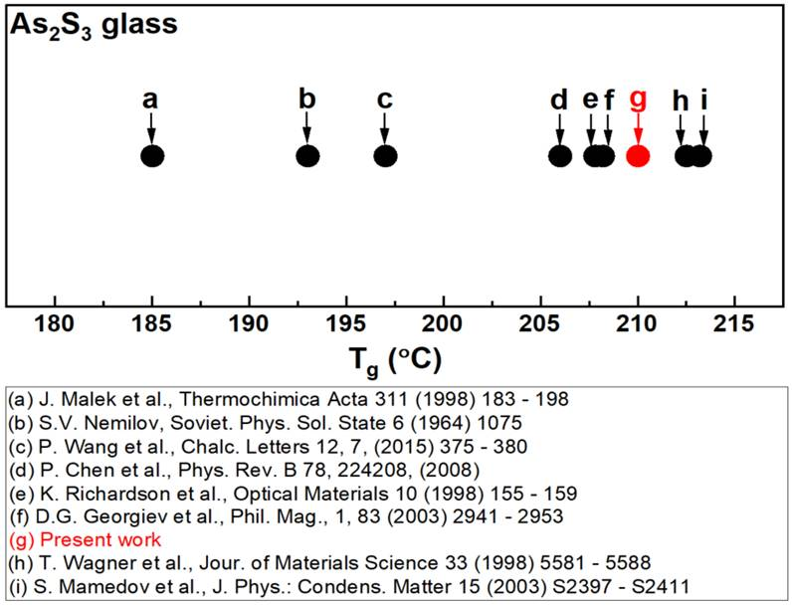

**Fig S5.** The comparison of Tg’s for As2S3 glass samples from present work with previously reported Tg values of (a) (Malek, 1997) (b) (Nemilov, 1964) (c) (Wang et al., 2015) (d) (Chen et al., 2008) (e) (Cerqua-Richardson et al., 1998) (f) (Georgiev et al., 2003b) (g) Present work (h) (Wagner et al., 1998) and (i) (Mamedov et al., 2003)

The results **d-i** (except **e**) have emerged from MDSC measurements, and one can see these center around the presently measured value of 210˚C in red with a spread of about 5˚C. The spread is largely due to whether one measured the mean value of Tg from a heating followed by a cooling scan, or merely the Tg was recorded from the heating scan. The measurements **c** emerged from a DSC measurement. Its low value in relation to the MDSC results does suggest the sample is As-deficient. The measurement **a** and **b** have come from Dilatometric measurements and are measurably lower. In the present work, melts were quenched from 50˚C above the liquidus (Tl = 310˚C). Melts quenched from T far above Tl will display increasing amounts of As4S4 monomer decoupled from the backbone rendering the latter S-rich, or As deficient, thus possessing a lower Tg. A simple Raman scattering measurement would directly establish the degree of NSPS.

In the dilatometric experiments of Malek (Malek, 1997), melts were alloyed at 950˚C for 12 hours and then air cooled. The resulting glass was thermally equilibrated at 188˚C for 1 hour after the air quench. It is unclear if the lower Tg of 185˚C is due to NSPS or intrinsic to the definition of Tg used in dilatometric measurements. The results of the dilatometric measurements revealed a fragility index, m = 31 for As2S3 glass. This may be compared to a value of m = 25 deduced from the MDSC experiments in the present work as shown in the plot of Fig. 12A.

**REFERENCES**

Bychkov, E., Miloshova, M., Price, D. L., Benmore, C. J., and Lorriaux, A. (2006). Short, intermediate and mesoscopic range order in sulfur-rich binary glasses. *Journal of Non-Crystalline Solids* 352, 63–70. doi:10.1016/j.jnoncrysol.2005.11.002.

Cerqua-Richardson, K. A., McKinley, J. M., Lawrence, B., Joshi, S., and Villeneuve, A. (1998). Comparison of nonlinear optical properties of sulfide glasses in bulk and thin film form. *Elsevier* 10, 155–159.

Chakraborty, S., and Boolchand, P. (2014). Topological Origin of Fragility, Network Adaptation, and Rigidity and Stress Transitions in Especially Homogenized Nonstoichiometric Binary GeS Glasses. *J. Phys. Chem. B* 118, 2249–2263. doi:10.1021/jp411823j.

Chen, P., Holbrook, C., Boolchand, P., Georgiev, D. G., Jackson, K. A., and Micoulaut, M. (2008). Intermediate phase, network demixing, boson and floppy modes, and compositional trends in glass transition temperatures of binary As-S system. *Phys. Rev. B* 78, 224208. doi:10.1103/PhysRevB.78.224208.

Georgiev, D. G., Boolchand, P., Eckert, H., Micoulaut, M., and Jackson, K. (2003a). The self-organized phase of bulk P *x* Se  1 − *x* glasses. *Europhysics Letters (EPL)* 62, 49–55. doi:10.1209/epl/i2003-00361-2.

Georgiev, D. G., Boolchand, P., and Jackson, K. A. (2003b). Intrinsic nanoscale phase separation of bulk As 2 S 3 glass. *Philosophical Magazine* 83, 2941–2953. doi:10.1080/1478643031000151196.

Golovchak, R., Shpotyuk, O., Mccloy, J. S., Riley, B. J., Windisch, C. F., Sundaram, S. K., et al. (2010). Structural model of homogeneous As–S glasses derived from Raman spectroscopy and high-resolution XPS. *Philosophical Magazine* 90, 4489–4501. doi:10.1080/14786435.2010.510455.

Hannon, A. (2015). The Structure of Arsenic Sulphide Glasses: Evidence for Tetrahedral Units? in (University of Cambridge, Murray Edwards College). Available at: http://www.annualmeeting.sgthome.co.uk/Ab-AlexHannon.htm [Accessed October 15, 2018].

Lathrop, D., and Eckert, H. (1991). Quantitative determination of the structural units in phosphorus-selenium glasses by P 31 dipolar and magic-angle-spinning NMR spectroscopy. *Phys. Rev. B* 43, 7279–7287. doi:10.1103/PhysRevB.43.7279.

Malek, J. (1997). Dilatometric study of structural relaxation in arsenic sulfide glass. *Thermochimica Acta* 311, 183–198. doi:doi.org/10.1016/S0040-6031(97)00466-8.

Mamedov, S., Georgiev, D. G., Qu, T., and Boolchand, P. (2003). Evidence for nanoscale phase separation of stressed–rigid glasses. *Journal of Physics: Condensed Matter* 15, S2397.

Nemilov, S. (1964). The relation between the free activation energy of viscous flow and the energy of chemical bonds in glasses. *Soviet Physics-Solid State* 6, 1075–1078.

Wagner, T., Kasap, S. O., Vlcˇek, M., Sklenaˇr, A., and Stronski, A. (1998). The structure of AsxS100-x glasses studied by temperature-modulated differential scanning calorimetry and Raman spectroscopy. 5.

Wang, P., Qiao, A., Zhou, L., Zhong, C., and Xiao, J. (2015). RELAXATION BEHAVIOR OF As2S3 GLASS CAUSED BY MECHANOCHEMICAL PROCESSING. *Chalcogenide Letters* 12, 375–380.

Ward, A. T. (1968). Raman spectroscopy of sulfur, sulfur-selenium, and sulfur-arsenic mixtures. *The Journal of Physical Chemistry* 72, 4133–4139. doi:10.1021/j100858a031.