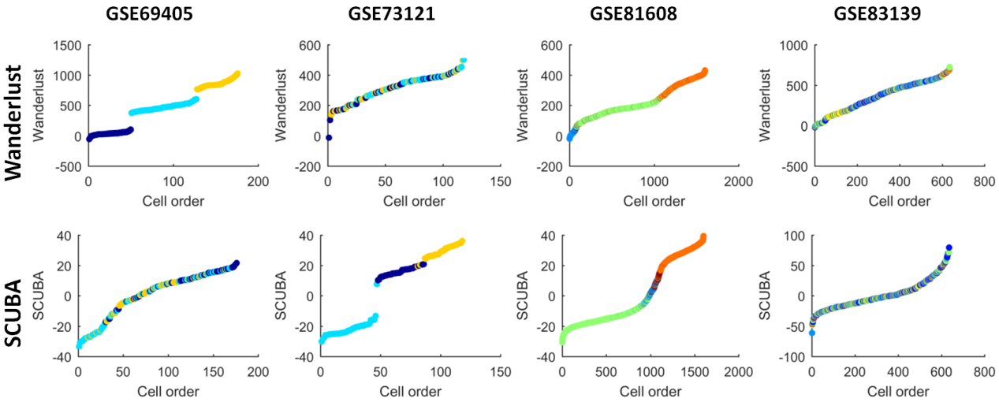

We have carried on two additional pseudo-time methods Wanderlust [1] and SCUBA [2] to reconstruct the pseudo trajectory of single cells without branch respectively. The difference of the two methods is more obvious than the results discussed in main text:
- For cancer cells, Wanderlust shown clear cell types/groups on the cell order in data GSE69405, meanwhile, SCUBA shown better discrimination of cell types on cell order in data GSE73121;
- For Diabetes cells, Wanderlust and SCUBA seem to both have better performance on data GSE81608 than those on data GSE83139.
Thus, these additional results supported again, in the pseudo-time analysis, consensus performance of dissimilar methods is low.

Parameters:
Wanderlust:
Preprocessed by PCA to reduce the dimensions to: 50
Other parameters: Default

SCUBA:
All parameters: Default

References:
[1] Bendall, S. C., Davis, K. L., Elad, A., Tadmor, M. D., Simonds, E.F., Chen, T. J., et al. (2014). Single-cell trajectory detection uncovers progression and regulatory coordination in human b cell development. Cell, 157(3), 714-25.
[2] Marco, E., Karp, R. L., Guo, G., Robson, P., Hart, A. H.,Trippa, L., et al. (2014). Bifurcation analysis of single-cell gene expression data reveals epigenetic landscape. Proceedings of the National Academy of Sciences of the United States of America, 111(52), 5643-50

