Supplementary Information

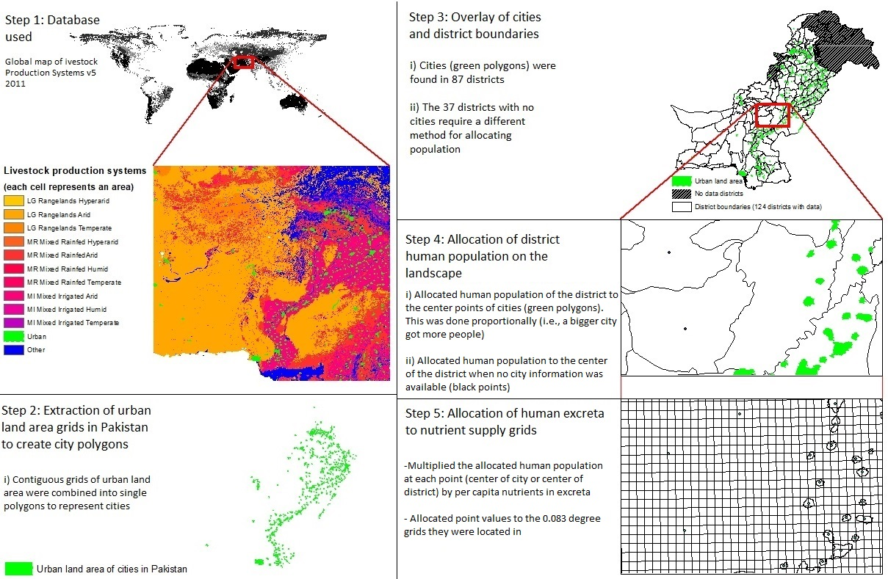

SI Figure 1. Step by step explanation of how Pakistan district human population data was transformed to nutrients and assigned to grids.
Step 1: We obtained the global map of livestock production systems from Robinson and Conchedda (2011) which contains data about land use under different livestock production systems and the extent of urban human settlements across the globe (0.0083 decimal degree resolution). Step 2: The extent of urban areas, which was derived from a combination of the GRUMP dataset and the GLC 2000 urban class based on night satellite imagery, was used to create polygons of cities. Step 3: The city layer (green) was overlayed with a layer representing the boundaries of political districts in Pakistan (University of California, 2015), resulting in 37 districts with no urban areas (hashed area was not included in any analyses because of a lack of data). Step 4: Data on the human population within districts (BOS 2010, 2011, 2013, 2014) was allocated to the center points of cities (green polygons), proportionally to the area extent, or to the geographical center in districts lacking an urban area. Step 5: The resulting distribution of human population was converted to nutrient supply using the per capita excretion rates given by Jönsson and Vinnerås (2004), and then these nutrient amounts were allocated to the 0.083-degree grids in which the respective center points were located.

- Crop fertilizer recommendations in Pakistan
We obtained province specific fertilizer recommendations of N, P₂O_{5,} and K₂O for crops; wheat, rice, cotton sugarcane, maize, and pulses from FAO (2004). We converted P₂O₅ and K₂O fertilizer recommendations to elemental P and K.
These fertilizer recommendations were given as a range: low for fertile soil and high for low fertility soil. We used an average value calculated from the range of fertilizer recommendations of each crop/crop group in a province.
We used an average value calculated from fertilizer recommendations of individual crops in a crop group; oilseeds, vegetables, fruits, and fodders (Ashiq, 2010). We also used fertilizer recommendations for sorghum, and tobacco from Ashiq (2010). These fertilizer recommendations were specific to the Punjab province. We assumed the same fertilizer recommendations of these crops/crop groups for other provinces.
For the “other crops” group we used the average value of fertilizer recommendation of all crops.
We assumed that N fixation by legumes and previous crops were already accounted for in fertilizer recommendations.
We did not account for the effects of multi-crop rotations.
We did not consider nutrient need from rangelands used for grazing (we assumed they were not usually fertilized) or informal grazing areas for animals.
As a general note, the descriptions above follow the methods and assumptions put forth in Akram et al. (2018), where we simply try and be more accurate from a spatial perspective when possible. One such instance was with wheat. Rain fed and irrigated wheat usually have different yields and thus different fertilizer recommendations. We were able to overlay data on irrigation type (FAO, 2004), with wheat production area (FAO/IIASA, 2010) in order to more accurately map crop nutrient needs.

SI Table 1. Fertilizer needs (expressed as recommended application rates in kg/ha) to produce crops in four provinces of Pakistan from Ashiq (2010) and FAO (2004) that were used to calculate crop nutrient needs.
 | Punjab |  |  | KPK/NWFP |  |  | Sindh |  |  |  | Baluchistan
Crops | N | P | K | N | P | K | N | P | K | N |  | P | K
Barley | 86 | 56 | 86 | 86 | 56 | 86 | 86 | 56 | 86 | 86 |  | 56 | 86
Cottons | 145 | 26 | 50 | - | - | - | 115 | 26 | 42 | - |  | - | -
Fodder | 91 | 65 | 5 | 91 | 65 | 5 | 91 | 65 | 5 | 91 |  | 65 | 5
Maize | 75 | 26 | 0 | 105 | 33 | 37 | 75 | 26 | 0 | 105 |  | 33 | 37
Pulses | 25 | 33 | 0 | 37 | 35 | 0 | 105 | 26 | 0 | 37 |  | 35 | 0
Oilseeds | 73 | 63 | 26 | 73 | 63 | 26 | 73 | 63 | 26 | 73 |  | 63 | 26
Rice | 117 | 29 | 50 | 135 | 39 | 50 | 157 | 36 | 42 | 120 |  | 26 | 42
Sugarcane | 220 | 37 | 75 | 147 | 44 | 83 | 250 | 49 | 112 | - |  | - | -
Sorghum | 57 | 57 | 0 | 57 | 57 | 0 | 57 | 57 | 0 | 57 |  | 57 | 0
Wheat irrigated | 117 | 37 | 50 | 135 | 33 | 42 | 150 | 33 | 42 | 105 |  | 26 | 42
Wheat rainfed | 83 | 29 | 24 | 80 | 20 | 0 | - | - | - | 60 |  | 13 | 0
Tobacco | 84 | 84 | 84 | 84 | 84 | 84 | 84 | 84 | 84 | 84 |  | 84 | 84
Fruits | 129 | 55 | 75 | 129 | 55 | 75 | 129 | 55 | 75 | 129 |  | 55 | 75
Vegetable | 40 | 45 | 46 | 40 | 45 | 46 | 40 | 45 | 46 | 40 |  | 45 | 46

- Annual nutrient excretion rate of different types of livestock and humans in Pakistan
We obtained the coefficients of N, P₂O₅ and K₂O excretions for livestock from Gerber et al. (2005). We converted P₂O₅ and K₂O excretions rate to elemental P and K. The coefficients were given, for different intensity classes of an animal type, per animal per year and subsequently converted to an elemental form for P and K. We used an average value of coefficients calculated from different intensity classes of an animal type.
We assumed nutrient excretion for camels was the same as it is for cows.
We obtained the coefficients of N, P and K excretions for human from Jönsson and Vinnerås (2004). The coefficients were given per human per year for Indian individuals, which we assume are the same for Pakistani individuals.
SI Table 2. Annual excretions of N, P, and K and fresh weight of manure/sludge by indivudal livestock types and human. These rates were used to calculate the excreta nutrient supply in Pakistan (BIS, 1993; Gerber et al., 2005; Jönsson and Vinnerås, 2004; NPCS, 2008).

 | Excretion per individual per year (kg)
Category | N | P | K | Manure/sludge
Dairy cows | 49.38 | 8.62 | 40.99 | 16143.95
Young dairy stock | 22.68 | 3.96 | 18.82 | 7482.5
Bulls and bullocks | 19.88 | 2.89 | 13.74 | 5183
Buffalo | 41.5 | 7.42 | 34.45 | 9092.15
Small ruminants | 3.2 | 0.52 | 3.98 | 448.59
Horses/mule/asses | 23 | 5.02 | 28.64 | 2419.95
Laying hens | 0.56 | 0.15 | 0.14 | 16.79
Other chicken | 0.46 | 0.09 | 0.12 | 16.79
Turkeys | 1 | 0.22 | 0.25 | 16.79
Ducks | 0.6 | 0.13 | 0.15 | 16.79
Human sludge | 2.7 | 0.4 | 1.5 | 55.3

- Crop fertilizer recommendations in Sweden
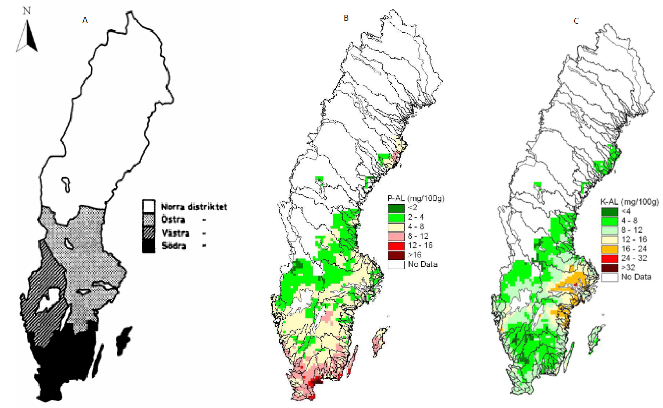
SI Figure 2. Biophysical information used to allocate fertilizer recommendation rates on the Swedish landscape as A) production regions, B) plant available phosphorus soil concentrations, and C) as plant available potassium concentrations. Reproduced from Ericsson (1988) and Paulsson et al. (2015).
For majority of the crops given in SI Table 3A, we obtained agro-climate specific fertilizer recommendations of N, and soil class specific fertilizer recommendations of P, and K from Albertsson (2007). To match the N fertilizer recommendations from Albertsson (2007), we categorized agricultural blocks into three production regions based on the agricultural research districts given in (Ericsson, 1988) where we merged the Östra and Västra districts into the Norra Götaland & Svealand region (SI Figure 2). In Albertsson (2007) there were no N recommendation to winter wheat, rye, oats, and triticale for Norrland. For these crops, we used the same recommendations as for Norra Götaland & Svealand. Also, because we used fertilizer recommendations and not crop demand, we implicitly accounted for N fixation by legumes. P and K recommendations from Albertsson (2007) were based on the concentrations of plant-available P and K (P-AL and K-AL), which were expressed as seven soil classes of P and five soil classes of K Albertsson (2007). We categorized the agricultural blocks into soil classes (Figure 2 B and C) using a gridded database where 13,000 samples were used to determine the concentration of P-AL and K-AL at a 10 km² resolution (Swedish Board of Agriculture, 2017). When a grid had No data for soil classes of P-AL and K-AL, we used average fertilizer recommendations of a crop for all soil classes combined.
For the crops given in Table 3B, we had to use other sources or a different strategy/source to select a fertilizer recommendation. Please note that for a crop group we used the fertilizer recommendation given for one of the crop species of the group and applied to the group as a whole. For example, we used fertilizer recommendation for apples to calculate the nutrient need for all fruit trees. For all recommendations and calculations, because we only looked at one year, we did not account for multi-crop or multi-year rotations (e.g., green fertilizers).

SI Table 3A. Fertilizer recommendation (kg/ha) to produce crops in Sweden that are used to calculate crop nutrient need.

Crop  code  (JBV. 2018) | Nitrogen kg/ha |  |  | Phosphorous kg/ha |  |  |  |  |  |  | Potassium kg/ha
 | For blocks in production region |  |  | For blocks in soil class P-AL |  |  |  |  |  |  | For blocks in soil class K-AL
 | Södra Götaland | Norra Götaland & Svealand | Norrland | I | II | III | IVA | IVB | V | Avg. | I | II | III | IV | V | Avg.
1 | 110 | 110 | 110 | 30 | 20 | 15 | 5 | 0 | 0 | 12 | 65 | 45 | 25 | 5 | 0 | 28
2 | 90 | 95 | 80 | 30 | 20 | 15 | 5 | 0 | 0 | 12 | 65 | 45 | 25 | 5 | 0 | 28
3 | 85 | 90 | 90 | 30 | 20 | 15 | 5 | 0 | 0 | 12 | 65 | 45 | 25 | 5 | 0 | 28
4 | 145 | 155 | 155 | 30 | 20 | 15 | 5 | 0 | 0 | 12 | 65 | 45 | 25 | 5 | 0 | 28
5 | 150 | 150 | 150 | 30 | 20 | 15 | 5 | 0 | 0 | 12 | 65 | 45 | 25 | 5 | 0 | 28
7 | 132 | 142 | 142 | 30 | 20 | 15 | 5 | 0 | 0 | 12 | 65 | 45 | 25 | 5 | 0 | 28
8 | 110 | 115 | 115 | 30 | 20 | 15 | 5 | 0 | 0 | 12 | 65 | 45 | 25 | 5 | 0 | 28
9 | 150 | 150 | 150 | 55 | 50 | 45 | 40 | 20 | 20 | 38 | 190 | 170 | 150 | 110 | 0 | 124
10 | 122 | 126 | 124 | 30 | 20 | 15 | 5 | 0 | 0 | 12 | 65 | 45 | 25 | 5 | 0 | 28
11 | 122 | 126 | 124 | 30 | 20 | 15 | 5 | 0 | 0 | 12 | 65 | 45 | 25 | 5 | 0 | 28
12 | 122 | 126 | 124 | 30 | 20 | 15 | 5 | 0 | 0 | 12 | 65 | 45 | 25 | 5 | 0 | 28
13 | 230 | 230 | 230 | 30 | 20 | 15 | 5 | 0 | 0 | 12 | 73 | 53 | 33 | 8 | 0 | 33
14 | 100 | 100 | 100 | 30 | 20 | 15 | 5 | 0 | 0 | 12 | 73 | 53 | 33 | 8 | 0 | 33
15 | 150 | 150 | 150 | 55 | 50 | 45 | 40 | 20 | 20 | 38 | 190 | 170 | 150 | 110 | 0 | 124
16 | 210 | 210 | 210 | 30 | 20 | 15 | 5 | 0 | 0 | 12 | 73 | 53 | 33 | 8 | 0 | 33
17 | 0 | 0 | 0 | 30 | 20 | 15 | 5 | 0 | 0 | 12 | 73 | 53 | 33 | 8 | 0 | 33
20 | 130 | 130 | 130 | 30 | 25 | 15 | 10 | 0 | 0 | 13 | 60 | 40 | 20 | 0 | 0 | 24
21 | 110 | 110 | 110 | 30 | 25 | 15 | 10 | 0 | 0 | 13 | 60 | 40 | 20 | 0 | 0 | 24
22 | 130 | 130 | 130 | 30 | 25 | 15 | 10 | 0 | 0 | 13 | 60 | 40 | 20 | 0 | 0 | 24
23 | 110 | 110 | 110 | 30 | 25 | 15 | 10 | 0 | 0 | 13 | 60 | 40 | 20 | 0 | 0 | 24
24 | 120 | 120 | 120 | 30 | 25 | 15 | 10 | 0 | 0 | 13 | 60 | 40 | 20 | 0 | 0 | 24
25 | 120 | 120 | 120 | 30 | 25 | 15 | 10 | 0 | 0 | 13 | 60 | 40 | 20 | 0 | 0 | 24
27 | 120 | 120 | 120 | 30 | 25 | 15 | 10 | 0 | 0 | 13 | 60 | 40 | 20 | 0 | 0 | 24
28 | 120 | 120 | 120 | 30 | 25 | 15 | 10 | 0 | 0 | 13 | 60 | 40 | 20 | 0 | 0 | 24
30 | 0 | 0 | 0 | 30 | 20 | 15 | 5 | 0 | 0 | 12 | 80 | 60 | 40 | 10 | 0 | 38
31 | 0 | 0 | 0 | 30 | 20 | 15 | 5 | 0 | 0 | 12 | 80 | 60 | 40 | 10 | 0 | 38
32 | 0 | 0 | 0 | 30 | 20 | 15 | 5 | 0 | 0 | 12 | 80 | 60 | 40 | 10 | 0 | 38
33 | 0 | 0 | 0 | 30 | 20 | 15 | 5 | 0 | 0 | 12 | 80 | 60 | 40 | 10 | 0 | 38
34 | 58 | 58 | 58 | 30 | 20 | 15 | 5 | 0 | 0 | 12 | 73 | 53 | 33 | 8 | 0 | 33
35 | 0 | 0 | 0 | 30 | 20 | 15 | 5 | 0 | 0 | 12 | 80 | 60 | 40 | 10 | 0 | 38
36 | 0 | 0 | 0 | 30 | 20 | 15 | 5 | 0 | 0 | 12 | 80 | 60 | 40 | 10 | 0 | 38
38 | 0 | 0 | 0 | 30 | 20 | 15 | 5 | 0 | 0 | 12 | 80 | 60 | 40 | 10 | 0 | 38
39 | 0 | 0 | 0 | 30 | 20 | 15 | 5 | 0 | 0 | 12 | 80 | 60 | 40 | 10 | 0 | 38
40 | 60 | 60 | 60 | 35 | 25 | 15 | 5 | 0 | 0 | 13 | 65 | 45 | 25 | 5 | 0 | 28
41 | 0 | 0 | 0 | 35 | 25 | 15 | 5 | 0 | 0 | 13 | 65 | 45 | 25 | 5 | 0 | 28
42 | 125 | 125 | 125 | 30 | 20 | 10 | 0 | 0 | 0 | 10 | 100 | 80 | 60 | 40 | 0 | 56
45 | 125 | 125 | 125 | 80 | 60 | 50 | 30 | 20 | 20 | 43 | 260 | 210 | 160 | 110 | 0 | 148
46 | 160 | 160 | 160 | 80 | 60 | 50 | 30 | 20 | 20 | 43 | 260 | 210 | 160 | 110 | 0 | 148
47 | 120 | 120 | 120 | 40 | 35 | 25 | 20 | 20 | 0 | 23 | 90 | 65 | 40 | 20 | 0 | 43
48 | 120 | 120 | 120 | 40 | 35 | 25 | 20 | 20 | 0 | 23 | 90 | 65 | 40 | 20 | 0 | 43
49 | 0 | 0 | 0 | 0 | 0 | 0 | 0 | 0 | 0 | 0 | 0 | 0 | 0 | 0 | 0 | 0
50 | 77 | 77 | 77 | 25 | 15 | 10 | 3 | 0 | 0 | 9 | 113 | 78 | 48 | 15 | 0 | 51
51 | 77 | 77 | 77 | 28 | 18 | 13 | 4 | 0 | 0 | 10 | 139 | 96 | 61 | 23 | 0 | 64
52 | 0 | 0 | 0 | 0 | 0 | 0 | 0 | 0 | 0 | 0 | 0 | 0 | 0 | 0 | 0 | 0
53 | 0 | 0 | 0 | 0 | 0 | 0 | 0 | 0 | 0 | 0 | 0 | 0 | 0 | 0 | 0 | 0
54 | 17 | 17 | 17 | 7 | 6 | 5 | 0 | 0 | 0 | 3 | 11 | 9 | 7 | 0 | 0 | 5
55 | 0 | 0 | 0 | 0 | 0 | 0 | 0 | 0 | 0 | 0 | 0 | 0 | 0 | 0 | 0 | 0
56 | 0 | 0 | 0 | 0 | 0 | 0 | 0 | 0 | 0 | 0 | 0 | 0 | 0 | 0 | 0 | 0
57 | 213 | 213 | 213 | 30 | 20 | 15 | 5 | 0 | 0 | 12 | 165 | 115 | 75 | 30 | 0 | 77
58 | 130 | 130 | 130 | 30 | 20 | 15 | 5 | 0 | 0 | 12 | 165 | 115 | 75 | 30 | 0 | 77
59 | 130 | 130 | 130 | 30 | 20 | 15 | 5 | 0 | 0 | 12 | 165 | 115 | 75 | 30 | 0 | 77
60 | 0 | 0 | 0 | 0 | 0 | 0 | 0 | 0 | 0 | 0 | 0 | 0 | 0 | 0 | 0 | 0
61 | 0 | 0 | 0 | 0 | 0 | 0 | 0 | 0 | 0 | 0 | 0 | 0 | 0 | 0 | 0 | 0
63 | 75 | 75 | 75 | 15 | 15 | 15 | 0 | 0 | 0 | 8 | 80 | 60 | 40 | 10 | 0 | 38
65 | 110 | 110 | 110 | 30 | 25 | 20 | 0 | 0 | 0 | 13 | 80 | 60 | 40 | 10 | 0 | 38
67 | 17 | 17 | 17 | 7 | 6 | 5 | 0 | 0 | 0 | 3 | 11 | 9 | 7 | 0 | 0 | 5
68 | 67 | 67 | 67 | 19 | 16 | 13 | 0 | 0 | 0 | 8 | 46 | 35 | 24 | 5 | 0 | 22
69 | 0 | 0 | 0 | 0 | 0 | 0 | 0 | 0 | 0 | 0 | 0 | 0 | 0 | 0 | 0 | 0
70 | 73 | 73 | 73 | 20 | 10 | 5 | 0 | 0 | 0 | 6 | 117 | 82 | 52 | 19 | 0 | 54
71 | 125 | 125 | 125 | 20 | 10 | 5 | 0 | 0 | 0 | 6 | 100 | 65 | 30 | 0 | 0 | 39
72 | 72 | 72 | 72 | 20 | 10 | 5 | 0 | 0 | 0 | 6 | 150 | 105 | 60 | 30 | 0 | 69
74 | 134 | 134 | 134 | 49 | 39 | 28 | 19 | 9 | 0 | 24 | 173 | 149 | 124 | 76 | 0 | 104
77 | 0 | 0 | 0 | 0 | 0 | 0 | 0 | 0 | 0 | 0 | 0 | 0 | 0 | 0 | 0 | 0
78 | 0 | 0 | 0 | 0 | 0 | 0 | 0 | 0 | 0 | 0 | 0 | 0 | 0 | 0 | 0 | 0
79 | 134 | 134 | 134 | 49 | 39 | 28 | 19 | 9 | 0 | 24 | 173 | 149 | 124 | 76 | 0 | 104
80 | 86 | 86 | 86 | 30 | 20 | 15 | 5 | 0 | 0 | 12 | 165 | 115 | 75 | 30 | 0 | 77
81 | 0 | 0 | 0 | 0 | 0 | 0 | 0 | 0 | 0 | 0 | 0 | 0 | 0 | 0 | 0 | 0
82 | 0 | 0 | 0 | 0 | 0 | 0 | 0 | 0 | 0 | 0 | 0 | 0 | 0 | 0 | 0 | 0
83 | 17 | 17 | 17 | 7 | 6 | 5 | 0 | 0 | 0 | 3 | 11 | 9 | 7 | 0 | 0 | 5
85 | 17 | 17 | 17 | 7 | 6 | 5 | 0 | 0 | 0 | 3 | 11 | 9 | 7 | 0 | 0 | 5
86 | 0 | 0 | 0 | 0 | 0 | 0 | 0 | 0 | 0 | 0 | 0 | 0 | 0 | 0 | 0 | 0
87 | 0 | 0 | 0 | 0 | 0 | 0 | 0 | 0 | 0 | 0 | 0 | 0 | 0 | 0 | 0 | 0
88 | 0 | 0 | 0 | 0 | 0 | 0 | 0 | 0 | 0 | 0 | 0 | 0 | 0 | 0 | 0 | 0

Table 3B. Crops nutrient recommendation values which were taken from a different source than those from Albertsson (2007).
Crop code (JBV, 2018) | Source of fertilizer recommendation values
10, 11, 12 | Average of all cereals
13, 16 | (Yara, 2018b)
31, 32 | Same as peas
34 | Average of cereals and legumes
40 | (Albertsson, 2013)
42 | (Sundberg and Westlin, 2005)
48 | Same as sugar beet
50, 51 | Average of the cut and the grazed (more recommendation is different for different clover % we took an average of all these values)
57, 58, 59 | Average of recommended values
63 | (Landström and Wik, 1997)
65 | (Albertsson, 2013)
54, 67, 83, 85 | (Yara, 2017)
70 | (Yara, 2018a)
71 | (Winter et al., 2013)
72 | (Jordbruksverket, 2018)
74 | (Yara, 2017)
79 | (Yara, 2017)
80 | Average of hay, linseed, field beans, and rape seed

- Annual nutrient excretion rates of different types of livestock and humans In Sweden
We obtained Swedish specific coefficients of N, P and K excretion for most livestock from Albertsson (2007). The coefficients were given per animal per year. We obtained the nutrient excretion rates of fowls and breeding boars from CBS (2012). We obtained the Swedish specific coefficients of N, P and K for human excreta from Jönsson and Vinnerås (2004). The coefficients were given per human per year.
SI Table 4. Annual excretion of N, P, and K and fresh weight of manure/sludge for livestock types and humans.
 | Excretion per individual per year (kg)
Category | N | P | K | Manure/sludge
Dairy Cows | 117 | 16 | 104 | 26100
Cows for Calf Production | 63 | 12 | 75 | 12200
Heifers. Bulls and Steers | 47 | 8 | 54 | 10300
Calves. Under 1 Year | 21 | 3 | 28 | 6000
Sheep | 14 | 2 | 19 | 800
Breeding Boars | 27.3 | 5.4 | 9.7 | 3200
Breeding Sows | 36 | 10 | 13 | 7800
Fattening Pigs. 20 Kg and Over | 11 | 2.3 | 4.3 | 2600
Poultry | 0.22 | 0.06 | 0.06 | 25
Laying Chickens | 0.52 | 0.13 | 0.17 | 96
Broilers | 0.28 | 0.06 | 0.11 | 7
Turkeys | 0.69 | 0.24 | 0.31 | 17
Horses | 48 | 9 | 58 | 4950
Human Excreta (Dry Mass) | 4.6 | 0.55 | 1.3 | 32

- Human population in Sweden
Detailed spatial data on t human population was not available for 2008 (our target year) but it was available for 2010, where the location, the built-area, and the population of a human settlements over 200 people was reported (SCB, 2010). However, no spatial data was available for human settlement with less than 200 individuals. In 2010, the sum of the total population of the reported human settlements was 8 296 888 individuals. However, for the same year, the total population reported for the country was 9 415 570 individuals. Meaning, in 2010, there was no spatial location information for 1 118 682 individuals in the country.
In order to use the 2008 statistics and to include the total human population, we used the built-area of human settlements (SCB, 2010) and proportionally allocated the 2008 municipal human population to the respective human settlements of a municipality. SI Table 5 shows different values of human population (reported and calculated) on human settlements in Linköping municipality in 2010 and 2008 as an example of the effect of our assumptions on the allocation of population spatially.
SI Table 5. Population of human settlements in Linköping reported in the detailed 2010 spatial data and the calculated population of these settlements in 2010 and 2008.
Human settlement name | 2010 reported human population | 2010 calculated human population | 2008 calculated human population
Askeby | 518 | 1085 | 1051
Bankekind | 405 | 657 | 637
Berg | 1278 | 2529 | 2450
Bestorp | 475 | 1256 | 1217
Brokind | 502 | 1424 | 1380
Ekängen | 2037 | 3083 | 2987
Gistad | 288 | 958 | 928
Linghem | 2804 | 3856 | 3736
Linköping | 104232 | 94424 | 91488
Ljungsbro | 6620 | 9534 | 9237
Malmslätt | 5214 | 5795 | 5615
Nykil | 321 | 811 | 786
Rappestad | 235 | 723 | 700
Sjögestad | 300 | 937 | 908
Skeda udde | 283 | 809 | 783
Slaka | 592 | 2473 | 2396
Sturefors | 2229 | 2317 | 2245
Vikingstad | 2096 | 3555 | 3444
Västerlösa | 206 | 993 | 962
Ulrika | 200 | 813 | 788
Bjärka-Säby | 137 | 700 | 678
Björkeberg | 152 | 835 | 809
Fruktåker och Ängen | 58 | 310 | 300
Stensätter | 113 | 864 | 837
Kränge | 80 | 256 | 248
Kransberg + Fryshem | 59 | 394 | 382
Maspelösa | 143 | 368 | 357
Nysätter | 52 | 118 | 114
Ringstorp | 68 | 193 | 187
Roxenbaden | 110 | 624 | 605
Roxtuna | 67 | 324 | 314
Rystad | 96 | 227 | 220
Skeda | 68 | 140 | 136
Svartmåla | 116 | 1169 | 1133
Sättuna | 177 | 341 | 331
Södra Kränge | 140 | 396 | 384
Västerby | 74 | 341 | 331
Gälstad-Lundby | 162 | 593 | 575
Örtomta | 106 | 189 | 183
TOTAL | 132813 | 146416 | 141862

- Intensity of agricultural production
SI Table 6. Total cropped area and nutrient needs and excreta in Sweden and Pakistan.
 |  |  | N |  | P |  | K
 | Cropped area |  | Total  (M Tons) | Per Ha | Total  (M Tons) | Per Ha | Total  (M Tons) | Per Ha
Sweden | 3 (M ha) | Need | 0.23 | 75 | 0.03 | 9 | 0.10 | 31
 |  | Supply | 0.11 | 34 | 0.03 | 8 | 0.13 | 41
Pakistan | 27 (M ha) | Need | 3.10 | 115 | 1.06 | 39 | 1.11 | 41
 |  | Supply | 1.81 | 67 | 0.46 | 17 | 2.17 | 80

SI Table 7. Numeric representation of the concentration of nutrient supply and crop needs on the landscape for Sweden and Pakistan at the decimal degree resolution. Ranges represent binning of the intensity of crop need and supply in kg per ha for each nutrient and each bin represents 2 of the bins visualized in figure 1 of the main text. For each bin we show the total area of arable land that is covered nationally by that value range. We then also express each bin as a percentage of total national arable land and as a percentage of the total crop nutrient need or supply through excreta. The discrepancy between the percentage of arable land versus total supply or crop need shows how concentrated supply and demand are on the territory.
 |  | Sweden |  |  |  |  |  |  |  | Pakistan
 |  | Area |  | Need |  | Area |  | Supply |  | Area |  | Need |  | Area |  | Supply
Nutrient | Range (Kg/Ha) | Ha | % | Tons | % | Ha | % | Tons | % | Ha | % | Tons | % | Ha | % | Tons | %
N | 0 | 15544 | 0 | 0 | 0 | 79852 | 3 | 2662 | 3 | 0 | 0 | 0 | 0 | 941436 | 3 | 158361 | 9
 | 1-48 | 341168 | 11 | 12619 | 5 | 2525816 | 80 | 57087 | 54 | 141134 | 1 | 5616 | 0 | 14324157 | 53 | 368128 | 21
 | 49-96 | 2209052 | 70 | 162400 | 69 | 458849 | 14 | 29683 | 29 | 5619718 | 21 | 457182 | 15 | 7894373 | 30 | 529830 | 29
 | 97-144 | 566243 | 18 | 59486 | 25 | 41379 | 1 | 4686 | 4 | 19863749 | 74 | 2429307 | 78 | 2331323 | 9 | 272392 | 15
 | 145- >169 | 101 | 0 | 17 | 0 | 26213 | 1 | 11348 | 11 | 1389209 | 5 | 210142 | 7 | 1522521 | 6 | 477683 | 27
 | TOTAL | 3132108 | 99 | 234522 | 99 | 3132108 | 99 | 105466 | 101 | 27013810 | 101 | 3102248 | 100 | 27013810 | 101 | 1806394 | 101
P | 0 | 19761 | 1 | 0 | 0 | 79852 | 3 | 497 | 2 | 0 | 0 | 0 | 0 | 1576559 | 6 | 40213 | 9
 | 1--15 | 3066655 | 98 | 27800 | 97 | 2774111 | 89 | 17273 | 68 | 44137 | 0 | 607 | 0 | 16877158 | 62 | 139766 | 30
 | 16-30 | 45346 | 1 | 821 | 3 | 242110 | 7 | 5023 | 20 | 1268668 | 4 | 35655 | 3 | 6162297 | 23 | 131099 | 28
 | 31-45 | 339 | 0 | 13 | 0 | 21117 | 1 | 760 | 3 | 20188040 | 74 | 718942 | 68 | 1460898 | 6 | 52791 | 12
 | 46->54 | 7 | 0 | 0 | 0 | 14918 | 0 | 1792 | 7 | 5512965 | 21 | 303268 | 28 | 936898 | 3 | 94379 | 20
 | TOTAL | 3132108 | 100 | 28635 | 100 | 3132108 | 100 | 25346 | 100 | 27013810 | 99 | 1058472 | 99 | 27013810 | 100 | 458248 | 99
K | 0 | 15544 | 0 | 0 | 0 | 79852 | 3 | 1176 | 1 | 31976 | 0 | 3 | 0 | 952990 | 4 | 198648 | 9
 | 1--31 | 1858839 | 59 | 42128 | 44 | 1428019 | 46 | 24240 | 19 | 5417099 | 20 | 102333 | 10 | 6430016 | 24 | 109667 | 5
 | 32-62 | 1205946 | 38 | 51600 | 53 | 994009 | 32 | 45539 | 35 | 21428917 | 79 | 995925 | 89 | 8538719 | 32 | 399382 | 18
 | 63-93 | 51690 | 2 | 3511 | 3 | 470322 | 15 | 35663 | 28 | 135800 | 0 | 9673 | 1 | 5254351 | 20 | 399211 | 18
 | 94->110 | 89 | 0 | 9 | 0 | 159907 | 6 | 21673 | 17 | 18 | 0 | 2 | 0 | 5837734 | 21 | 1060488 | 49
 | TOTAL | 3132108 | 99 | 97248 | 100 | 3132108 | 102 | 128291 | 100 | 27013810 | 99 | 1107937 | 100 | 27013810 | 101 | 2167397 | 99

- Effect of spatial resolution
SI Table 8. Breakdown of the areas characterized with surplus and deficits of nutrients in relation to their share of arable land, crop nutrient needs, and nutrients in excreta at the national level in Pakistan.
 |  | N |  | P |  | K
 |  | Decimal | Political | Decimal | Political | Decimal | Political
Surplus  (% of total) | No. of districts/grids | 43 | 25 | 35 | 18 | 67 | 94
 | Harvested area | 10 | 6 | 6 | 4 | 64 | 96
 | Crop need | 10 | 6 | 6 | 3 | 63 | 96
 | Excreta supply | 43 | 17 | 36 | 11 | 90 | 98
Deficit  (% of total) | No. of districts/grids | 37 | 75 | 39 | 82 | 19 | 6
 | Harvested area | 90 | 94 | 94 | 96 | 36 | 4
 | Crop need | 90 | 94 | 94 | 97 | 37 | 4
 | Excreta supply | 57 | 83 | 64 | 89 | 10 | 2
Total | No. of districts/grids | 11171 | 124 | 11171 | 124 | 11171 | 124
 | Harvested area (million ha) | 27 | 27 | 27 | 27 | 27 | 27
 | Crop need (million tons) | 3.1 | 3.2 | 1.1 | 1.1 | 1.1 | 1.2
 | Excreta supply (million tons) | 1.8 | 1.8 | 0.5 | 0.5 | 2.2 | 2.2

SI Table 9. Breakdown of the areas characterized with surplus and deficits of nutrients in relation to their share of arable land, crop nutrient needs, and nutrients in excreta at the national level in Sweden. *The N gas loss factor is based on Bouwman et al. (1997), which is different in than in Akram et al. (in review) which was based on Jakobsson and Steineck (2012).
 |  | N |  |  | P |  |  | K
 |  | 5Km | Decimal | Political* | 5Km | Decimal | Political | 5Km | Decimal | Political
Surplus (% of total) | No. of municipalities/grids | 7 | 7 | 19 | 14 | 15 | 42 | 19 | 20 | 81
 | Harvested area | 10 | 8 | 5 | 34 | 36 | 34 | 53 | 58 | 77
 | Crop need | 7 | 6 | 5 | 24 | 25 | 25 | 51 | 55 | 72
 | Excreta supply | 37 | 29 | 16 | 69 | 65 | 54 | 83 | 82 | 88
Deficit (% of total) | No. of municipalities/grids | 39 | 41 | 81 | 33 | 34 | 58 | 28 | 28 | 19
 | Harvested area | 90 | 92 | 95 | 65 | 64 | 66 | 46 | 41 | 23
 | Crop need | 93 | 94 | 95 | 76 | 75 | 75 | 49 | 45 | 28
 | Excreta supply | 63 | 71 | 84 | 31 | 35 | 46 | 17 | 18 | 12
Total | No. of municipalities/grids | 21891 | 13783 | 290 | 21891 | 13783 | 290 | 21891 | 13783 | 290
 | Harvested area (million ha) | 3.13 | 3.13 | 2.58 | 3.13 | 3.13 | 2.58 | 3.13 | 3.13 | 2.58
 | Crop need (million tons) | 0.23 | 0.23 | 0.19 | 0.03 | 0.03 | 0.03 | 0.1 | 0.1 | 0.11
 | Excreta supply (million tons) | 0.11 | 0.11 | 0.15 | 0.03 | 0.03 | 0.03 | 0.13 | 0.13 | 0.13

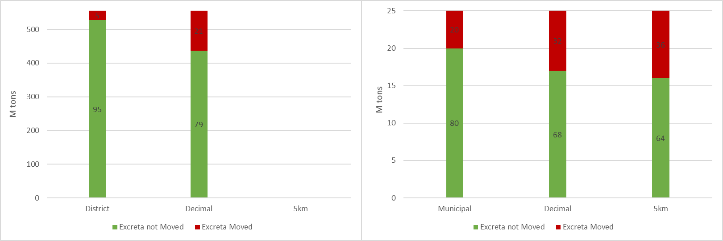
SI Figure 3. The weight of excreta that can be locally recycled (green) and requiring transport (red) at different resolutions in Pakistan in the left panel according to N crop nutrient needs and in Sweden in the right panel according to P crop nutrient needs. Numbers on the bars represent the percentage of the total excreta in each country.
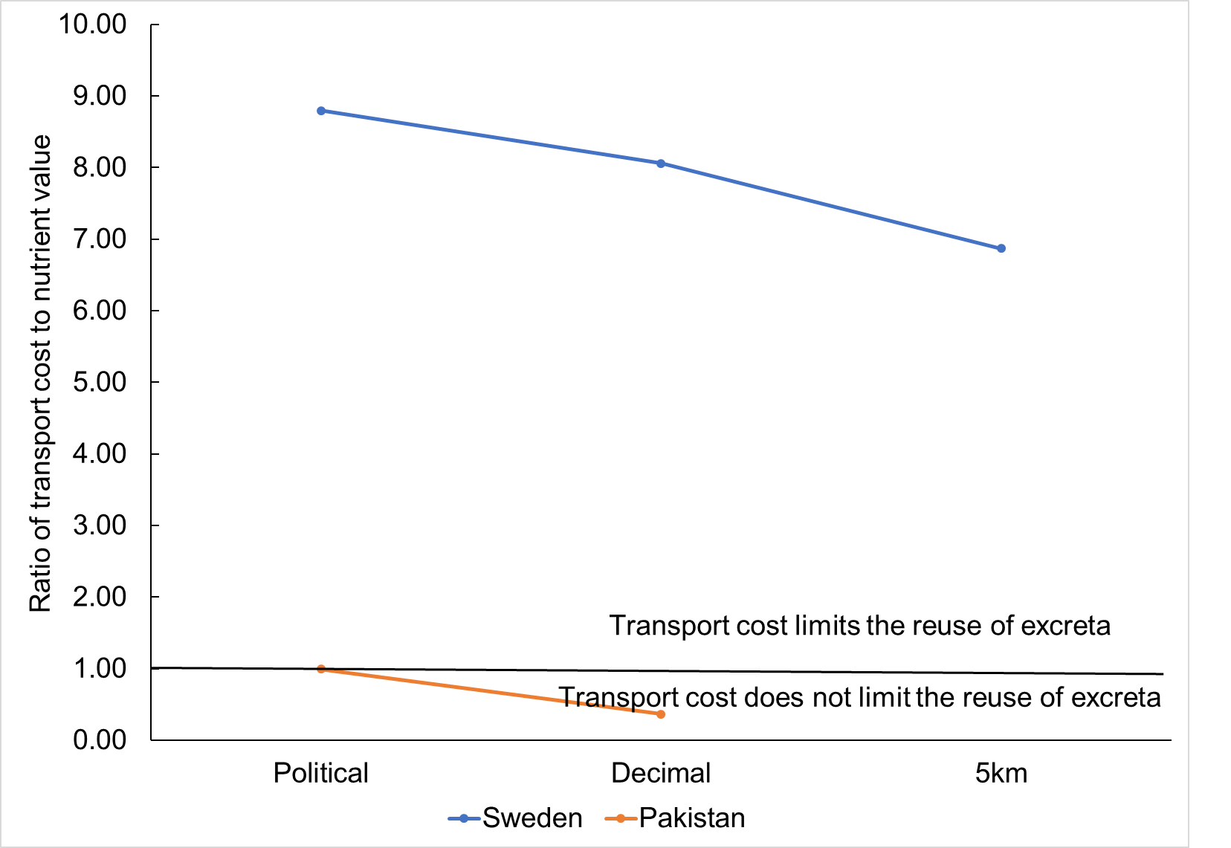
SI Figure 4. Effect of increasing spatial resolution on the relative transport costs of surplus excreta nutrient to the value of that nutrient if that was purchased as synthetic fertilizer P in Sweden (blue, higher line) and N in Pakistan (orange, lower line).

References
Akram, U., Metson, G. S., Quttineh, N., and Wennergren, U. (2018). Closing Pakistan’s Yield Gaps Through Nutrient Recycling. Front. Sustain. Food Syst. 2, 1–14. doi:10.3389/fsufs.2018.00024.
Albertsson, B. (2006). Riktlinjer för gödsling och kalkning 2007. Gjuterigatan 4, 553 18 Jönköping.
Albertsson, B. (2013). Riktlinjer för gödsling och kalkning 2013. Gjuterigatan 4, 553 18 Jönköping.
Ashiq, M. (2010). Punjab main 75 faslon key Munafah bakhash kashat kari (Profitable cultivation of 75 crops in Punjab). Plant physiology section, Nizamat Amoor-e-kashat kari (Agronomy), Ayub Agriculture Research Institute, Faisalabad, Pakistan.
BIS (1993). Code of practice for installation of septic tanks. Manak bhavan. 9 bahadur shah zafar marg new delhi 110002.
Bouwman, A. F., Lee, D. S., Asman, W. A. H., Dentener, F. J., Hoek, K. W. Van Der, Olivier, J. G. J., et al. (1997). A global high-resolution emission inventory for ammonia. Global Biogeochem. Cycles 11, 561–587.
CBS (2012). Standardised calculation methods for animal manure and nutrients: Standard data 1990–2008. Henri Faasdreef 312 2492 JP The Hague The Netherlands.
Ericsson, j (1988). Kväve och kvävegödsling. Uppsala.
FAO (2004). Fertilizer use by crop in Pakistan. Rome.
Gerber, P., Chilonda, P., Franceschini, G., and Menzi, H. (2005). Geographical determinants and environmental implications of livestock production intensification in Asia. Bioresour. Technol. 96, 263–276. doi:10.1016/j.biortech.2004.05.016.
Jakobsson, C., and Steineck, S. (2012). “Management of manure on the Farm: One of the Keys to the Future,” in Sustainable Agriculture Ecosystem Health and Sustainable Agriculture 1, ed. C. Jakobsson (The Baltic University Programme, Uppsala University, 2012), 505.
JBV (2018). Grödkoder 2018.
Jönsson, H., and Vinnerås, B. (2004). Adapting the nutrient content of urine and faeces in different countries using FAO and Swedish data. Ecosan–Closing loop, 623–626.
Jordbruksverket (2018). Näringsomsättning i äppleodling.
Landström, S., and Wik, M. (1997). Rörflen: Odling, skörd och hantering Rörflen.
NPCS (2008). The Complete Book on Organic Farming and Production of Organic Compost. Asia Pacific Business Press Inc.
Paulsson, R., Djodjic, F., Ross, C. C., and Hjerpe, K. (2015). Nationell jordartskartering: Matjordens egenskaper i åkermarken. Vallgatan 8, 551 82 Jönköping.
Robinson, T., and Conchedda, G. (2011). Global Livestock Production Systems v.5.
SCB (2010). avgränsningar av koncentrerad bebyggelse.
Sundberg, M., and Westlin, H. (2005). Hampa som bränsleråvara.
Swedish Board of Agriculture (2017). Jordart och växtnäringstillstånd i åkermarken. Vallgatan 8, 551 82 Jönköping.
University of California (2015). Global Administrative Areas. Digital geospatial data (version 2.8).
Winter, T. C., Håkansson, T., and Caspersen, S. (2013). Gödsling av trädgårdsblåbär – tre gårdsexempel.
Yara (2017). Gödslingsråd Säsongen 2017. Box 4505 203 20 Malmö.
Yara (2018a). Jordgubbar frilandsodling: Växtnäringsbehov.
Yara (2018b). Viktiga näringsämnen och deras funktion.

