Supplementary Tables and Figures

OoNAC72, a NAC-type Oxytropis ochrocephala Transcription Factor， Conferring Enhanced Drought and Salt Stress Tolerance in Arabidopsis
Huirui Guan†, Xin Liu†, Fei Niu, Qianqian Zhao, Na Fan, Duo Cao, Dian Meng, Wei He, Bin Guo, Yahui Wei*, Yanping Fu*
Department of Life Science, Key Laboratory of Resource Biology and Biotechnology in Western China, Northwest University, Xi’an, China
* Correspondence: Yahui Wei: weiyahui@nwu.edu.cn;
Yanping Fu: fuyanping@nwu.edu.cn;

Supplementary Tables
Supplementary Table 1 | Primers used for cloning cDNA of OoNAC72 from O. ochrocephala
Gene Name | Forward/Reverse primers (5'-3') | Tm
OoNAC72 | F: CACAGTGATTTAGAATGGGAGTT | 56℃
 | R: ATTAAATGGTGGCATCATTAACT
Supplementary Table 2 | Primers used for qRT-PCR analysis of OoNAC72 gene expression
Gene Name | Forward/reverse primers (5'-3') | Tm
OoNAC72 | F: CAACTAGCTCCACTCCACCTAC | 56℃
 | R: AACTCCCATTCTAAATCACTGTG
Histone H3 | F: ATGGGCTTGGTGCTGTTA | 55℃
 | R: CCTTCATCAGACTAGCAGTAAAC
Actin101 | F: TTATGTCCTTGAAAGCCAGA | 55℃
 | R: GAGACTTATCCTCCCATCCT
Supplementary Table 3 | Primers used in subcellular localization assay and transactivation activity analysis of OoNAC72
Gene Name | Forward/reverse primers (5'-3') | Restriction enzymes
OoNAC72 | GAagatctATGGGAGCTCCAGAGAGAGAC | Bgl II
OoNAC72 | GactagtTTGCCCGAACCCAAACC | Spe I
OoNAC72-BD | TcccccgggTATGGGAGCTCCAGAGAGAGAC | Smal I
OoNAC72-BD | AActgcagGTCATTGCCCGAACCCAA | Pst I

Supplementary Table 4 | Primers used in qRT-PCR for gene expression analyses of marker genes
Gene Name | Gene ID | Forward/reverse primers (5'-3')
Actin8 | At1g49240 | CTCAGGTATTGCAGACCGTATGAG  CTGGACCTGCTTCATCATACTCTG
RD26 | AT4G27410 | GAAGGTGAGGCGGAGAGTG  CCCGAAACTCTGAGTCAACCT
COR47 | NM101894 | TCCCAGGACACCACGACAAGAC  CCTCTTCAGTGGTCTTGGCATG
RD29A | AT4G27410 | TGGACACGAATTCTCCATCA  TTCCAGCTCAGCTCCTGATT
LEA14 | AT1G01470 | GATTTCTTCTGATCGACAAAACCTA  AGCAAACCCAACTTATTACATTACG
ZAT10 | AT1G27730 | GGAGTCAGCGAGGTGGAAGT  TGCTCCTTCGGTCTGTCCTAA
RD29B | AT5G52300 | GGAGAGAGCAGAGAGGCTCA  CCGTTGACCACCGAGATAGT
ANAC019 | AT1G52890 | CGCTAACTGCGGTGACTCTA  CAATCCTCGCAGCTTCATCT
NCED3 | AT3G14440 | TCAAAACCGGTGAATCAACT  TTCGTCTTCCTCTCCTCCTTC
PP2CA | AT3G11410 | ATGTCAGAGACCAACAAGAATGCC  CTACTTGTTCAGGCCGGTCTTG

Supplementary Figures
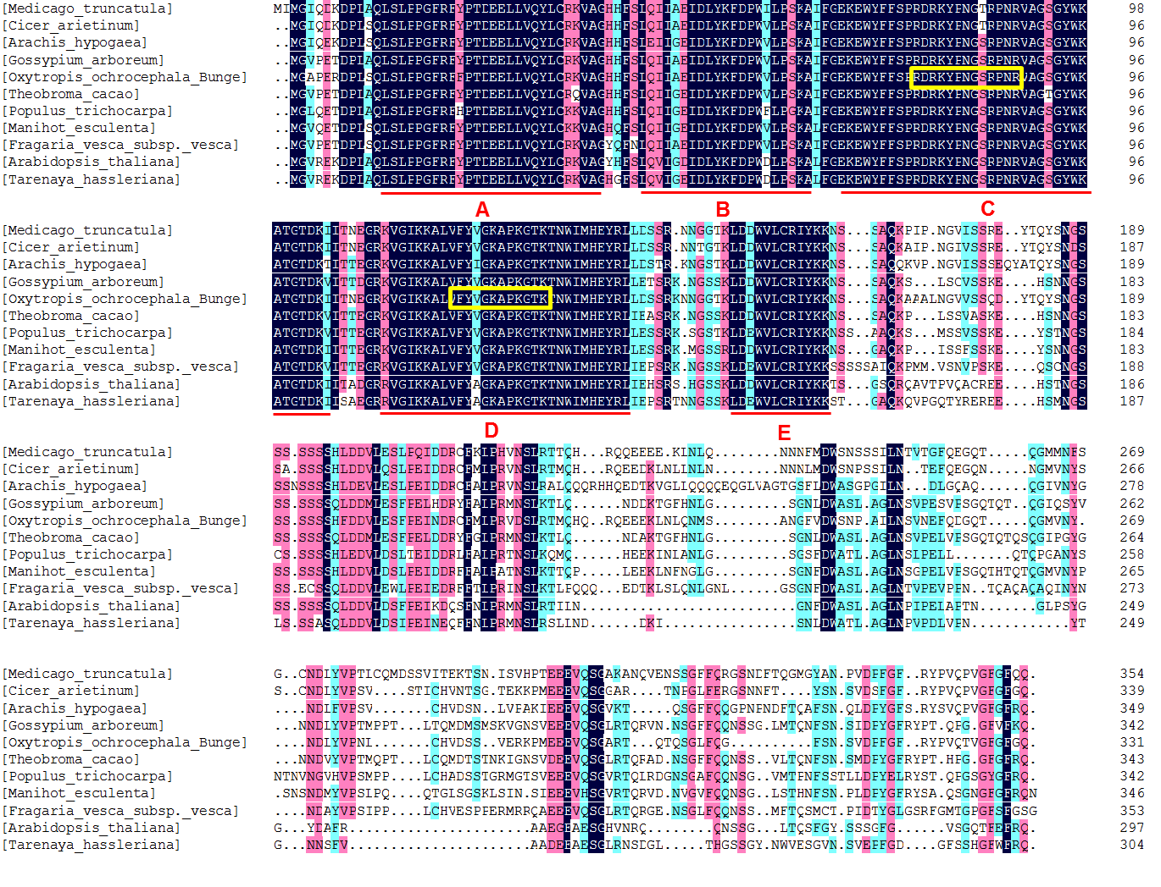
Supplementary Figure S1 | Multiple alignment of the amino acid sequences of OoNAC72 with NAC proteins from different species. A B C D and E represent the five subdomains of NAC domain; C and D subdomains framed in the yellow box indicates the nuclear localization signal.
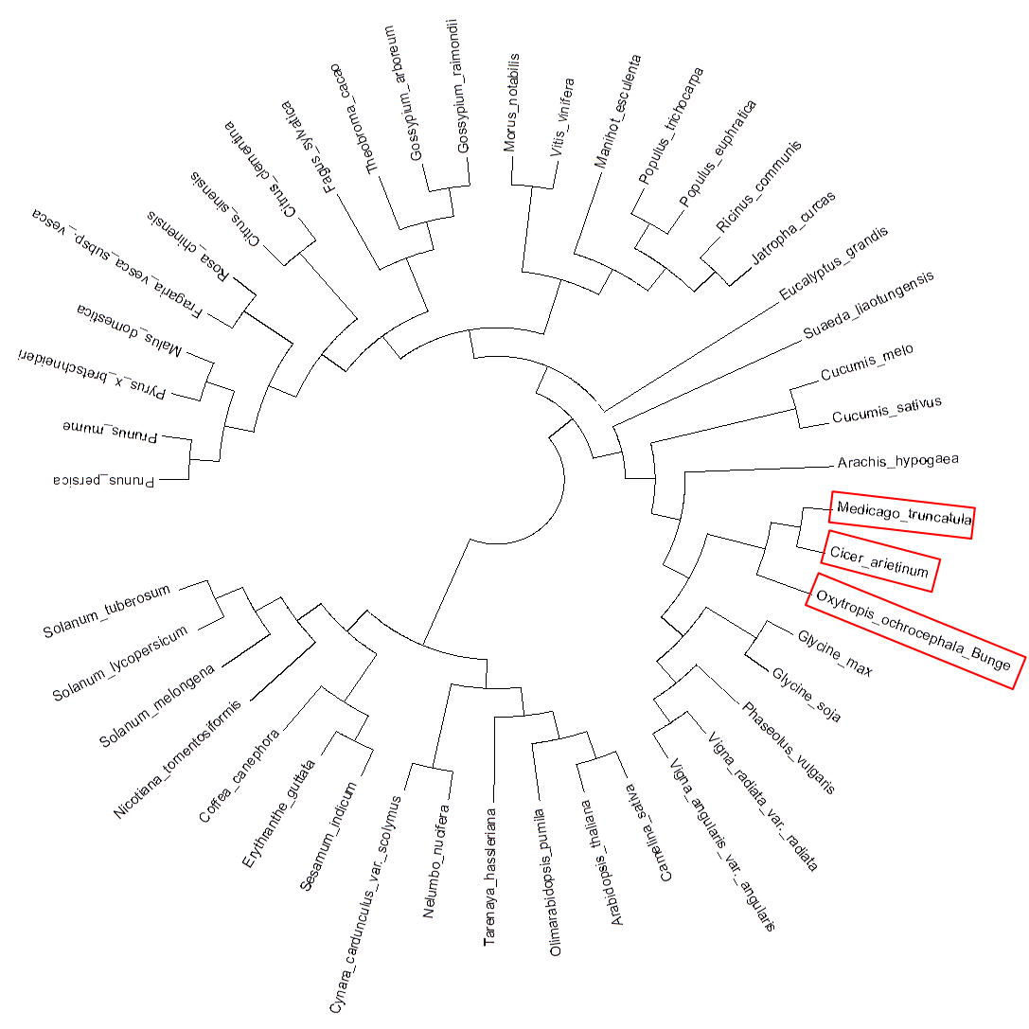
Supplementary Figure S2 | Phylogenetic analysis of the deduced amino acid sequences of OoNAC72 with other NAC domain proteins.

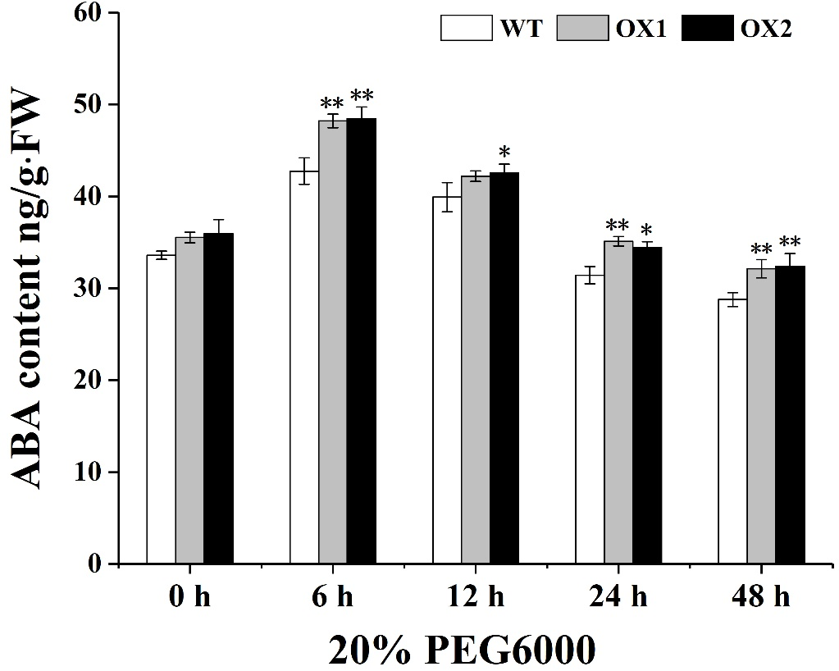
Supplementary Figure S3 | ABA content as determined by ELISA. Values are the mean ± SD (n = 3 experiments, * P < 0.05). FW, fresh weight.

