WORKFLOW

Plantation of mulberry

Mass culture of Silkworm strains

Larval Food utilization indices

Silk worm larva performance on different diets

Biochemical estimation of different strains of B. mori reared on different mulberry varieties

Statistical Analysis for host plant preference and economic parameters for finding the best suited host plants

Supplementary Table 1: Mulberry host plant varieties used in the study
MULBERRY VARIETIES (recommended for hilly regions)

Local (H1) - Locally available mulberry leaves
Jorhat (H2) - Origin not known, maintained at CSR & TI, CSB, Jorhat
BC2-59 (H3)- Developed at CSR & TI, CSB, Berhampore, by back crossing of hybrid of
Matigare Local x Kosen (Japanese variety) with Kosen twice.
TR10 (H4)- Triploid selection of Berhampore S-1 variety developed at CSR & TI,
Berhampore.

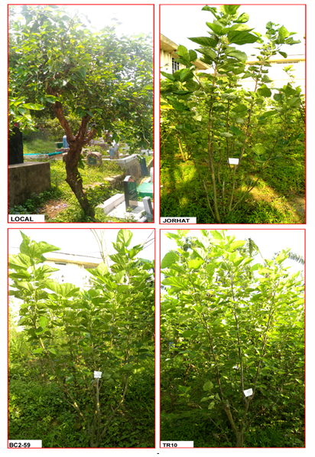
Supplementary Figure 1: Silkworm strains (recommended for hilly regions) used in the study

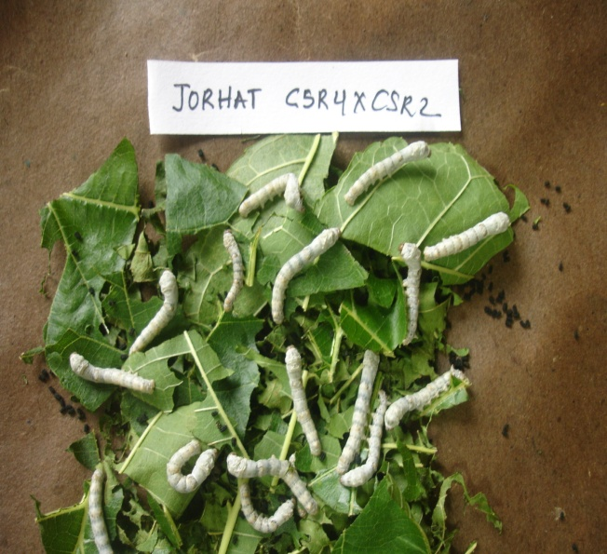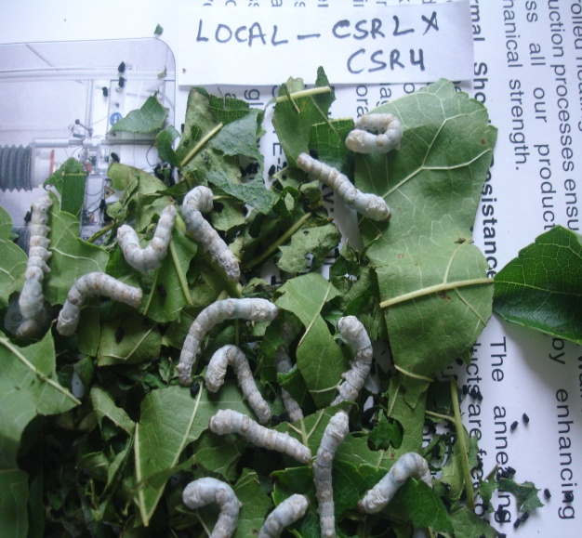
CSR4 X CSR2 CSR2 X CSR4

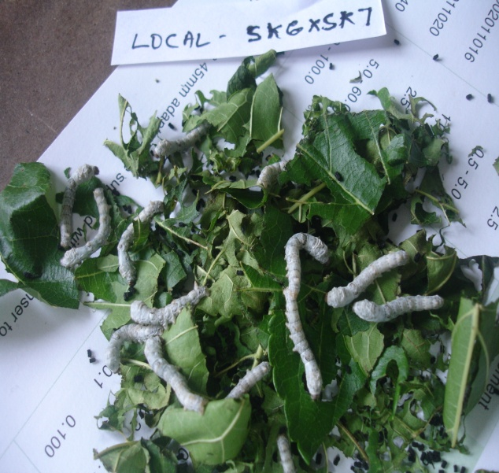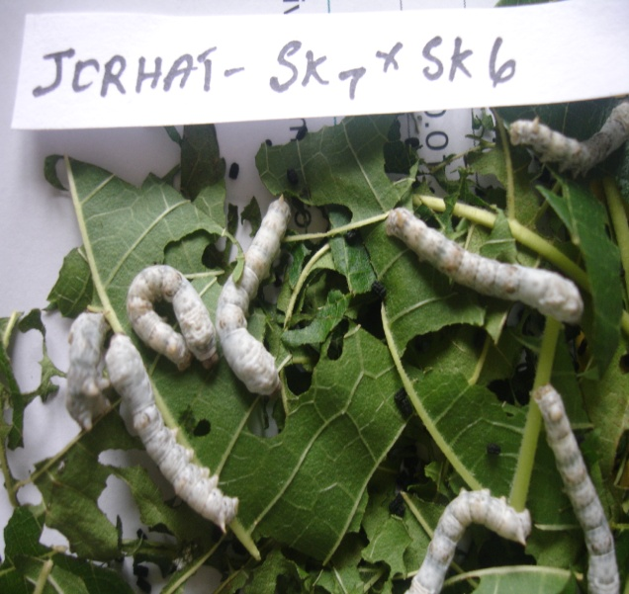
SK6 X SK7 SK7 X SK6
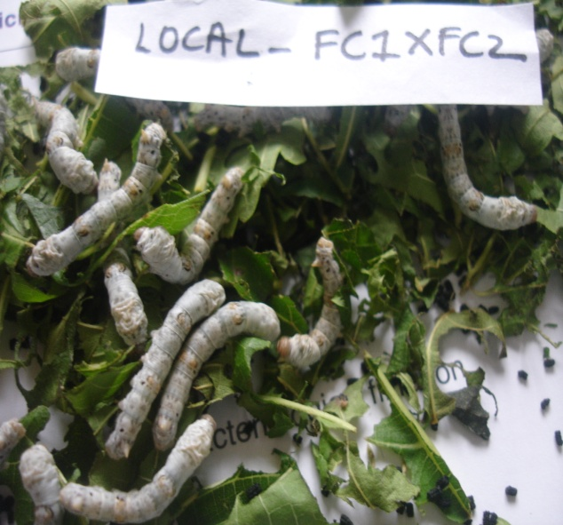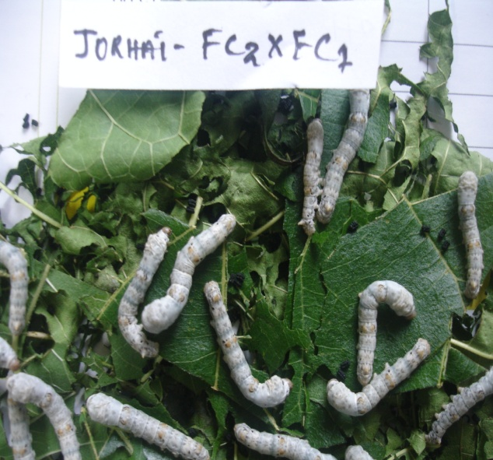
FC1 X FC2 FC2 X FC1

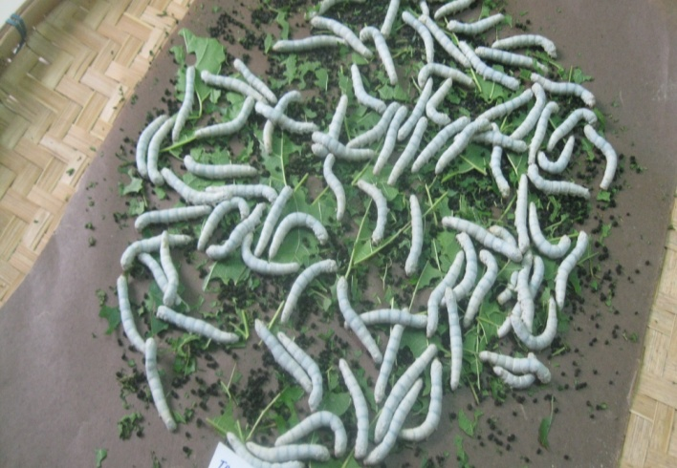
J112

