Supplementary Figures
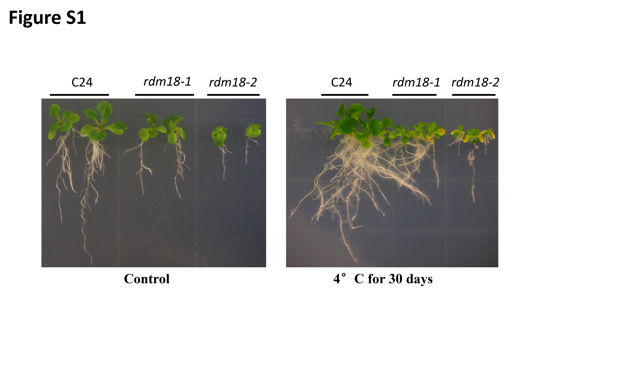
Supplementary Figure 1. rdm18-1 and rdm18-2 mutants are sensitive to chilling.
Phenotype of the rdm18-1 and rdm18-2 mutants at room temperature (left) and after chilling treatment (right). For chilling treatment, five-day-old seedlings grown on a MS medium were transferred to an incubator with 4°C for 30 days.

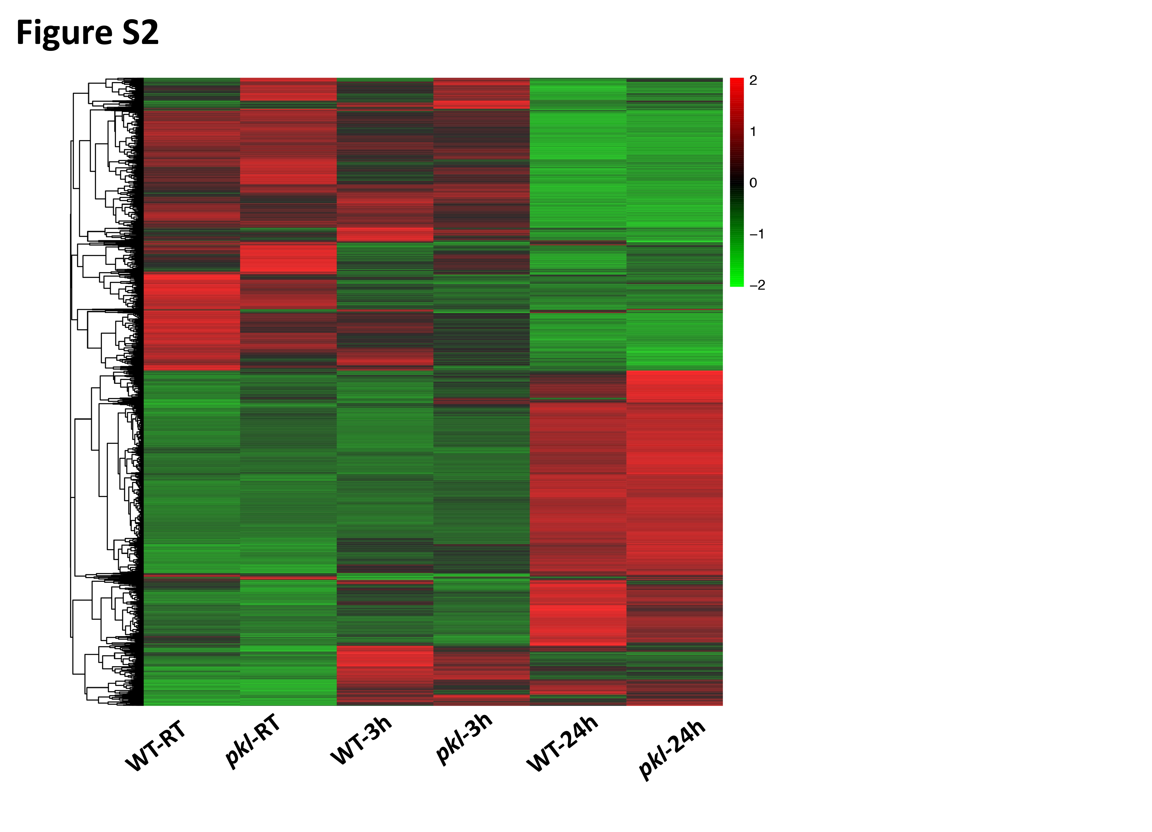

Supplementary Figure 2. Heat-map shows the genes that were up-regulated or down-regulated in the pkl mutant after being exposed to 4°C for 3 h and 24 h.

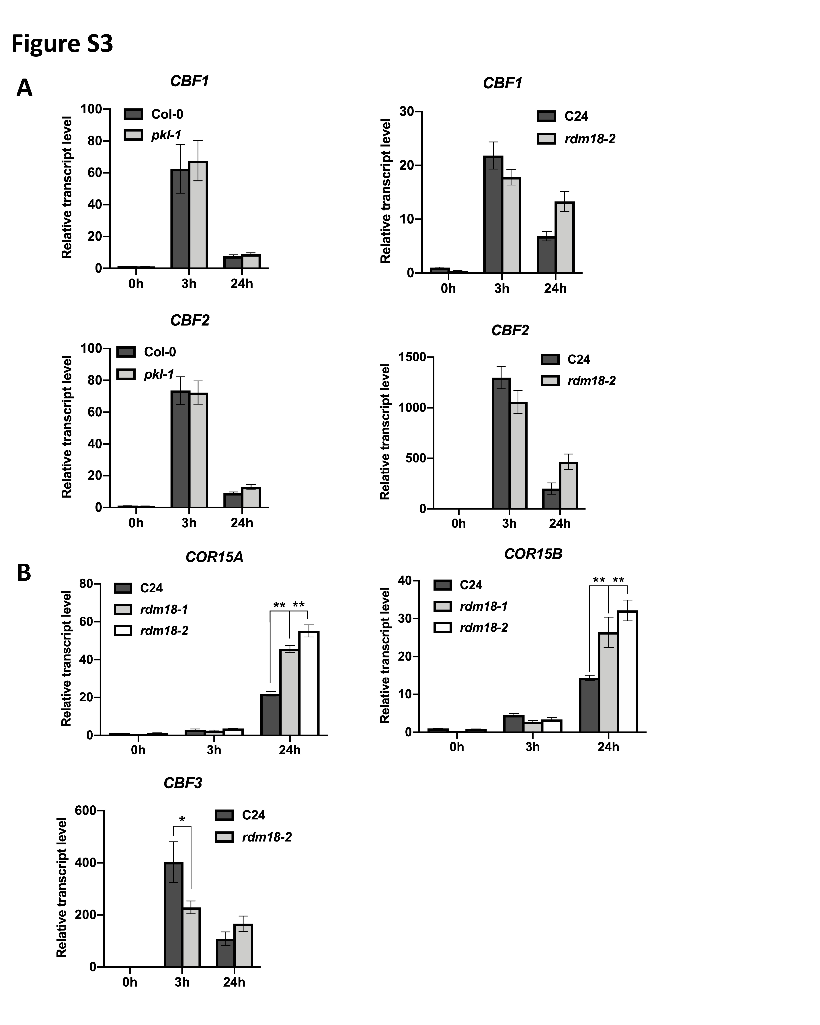
Supplementary Figure 3. Analysis of the expression of CBFs and CBF-regulated genes. (A) Transcript levels of CBF1 and CBF2 genes in the pkl-1 mutant (Col-0 background) and rdm18-2 (C24 background) mutant were detected by qRT-PCR. ACTIN2 was used as the internal control. (B) qRT-PCR analysis of the COR15A, COR15B, and CBF3 genes in the wild type (C24 ecotype), rdm18-1, and rdm18-2 after cold treatment (4°C) for 0, 3, and 24 h. ACTIN2 was served as the internal control. Error bars represent the SD of three biological replicates. Asterisks represent significant differences between the wild type and mutants (*p <0.05 and **p <0.01, two-tailed t-tests).

