Supplementary Material
Supplementary Figures and Tables
Supplementary Tables
Supplementary Table S1. Demographic characteristics of CyTOF datasets.
Groups  N  Age (years)  Sex (F/M)  WBC (x10⁹/ml) | HC  8  52.75 ± 7.91  2/6  6.54 ± 0.73 | CC  15  59.50 ± 7.62  6/9  7.95 ± 2.49 | CP
 |  |  | 8
 |  |  | 52.00 ± 9.91
 |  |  | 3/5
 |  |  | 6.28 ± 1.27
Note:
HC: healthy control;
CC: colon cancer patients;
CP: colonic polyp patients;
WBC: white blood cells;
Data is expressed as mean ± SD.

Supplementary Table S2. CyTOF antibody staining panel. The antibody panel was designed to obtain a comprehensive view of T cell subtype heterogeneity. For this purpose, the panel included markers that distinguish major T cell subtypes, e.g., CD4⁺ and CD8⁺ T cells. In addition, markers were included that allowed the identification of phenotypically distinct subsets within those immune cell subtypes, e.g., naïve (CD45RA⁺) and memory (CD45RO⁺) T cells.
Antigen | Mass Tag | Clone | Vendor | Cat#
CD45 | ⁸⁹Y | HI30 | Fluidigm | 3089003B
EpCAM/CD326 | ¹⁴¹Pr | 9C4 | Fluidigm | 3141006B
CD45RA | ¹⁴³Nd | HI100 | Fluidigm | 3143006B
CCR5/CD195 | ¹⁴⁴Nd | NP-6G4 | Fluidigm | 3144007A
CD4 | ¹⁴⁵Nd | RPA-T4 | Fluidigm | 3145001B
CD8a | ¹⁴⁶Nd | RPA-T8 | Fluidigm | 3146001B
PD-L1/CD274 | ¹⁴⁸Nd | 29E.2A3 | Fluidigm | 3148017B
CD45RO | ¹⁴⁹Sm | UCHL 1 | Fluidigm | 3149001B
CCR6/CD196 | ¹⁵¹Eu | G034E3 | Fluidigm | 353427
PD-1/CD279 | ¹⁵⁵Gd | EH12.2H7 | Fluidigm | 3155009B
CD161 | ¹⁶⁰Gd | HP-3G10 | BioLegend | 339902
CTLA_4/CD152 | ¹⁶¹Dy | 14D3 | Fluidigm | 3161004B
CCR4/CD194 | ¹⁶³Dy | L291H4 | BioLegend | 359402
LAG3/CD223 | ¹⁶⁵Ho | 874501 | Fluidigm | 3165028B
CCR7/CD197 | ¹⁶⁷Er | G043H7 | Fluidigm | 3167009A
CD127 | ¹⁶⁸Er | A019D5 | Fluidigm | 3168017B
CD25 | ¹⁶⁹Tm | 2A3 | Fluidigm | 3169003B
CD3 | ¹⁷⁰Er | SP34-2 | Fluidigm | 3170007B
CD57 | ¹⁷²Yb | HCD57 | Fluidigm | 3172009B
Intercalator | ¹⁹³Ir | -- | Fluidigm | 201192B
Cisplatin | ¹⁹⁵Pt | -- | Sigma-Aldrich | 479306

Supplementary Table S3. Demographic characteristics of flow cytometry datasets.
Groups  N  Age (years)  Sex (F/M) | HC  7  63.6 ± 3.30  4/3 | CC  7  61.87 ± 2.23  2/5
Note:
HC: healthy control;
CC: colon cancer patients;
Data are expressed as mean ± SD.

Supplementary Table S4. Imaging mass cytometry antibody staining panel. The antibody panel was designed to obtain the dysregulated signaling information of T cells subtypes.
Antigen | Mass Tag | Clone | Vendor | Cat#
EpCAM/CD326 | ¹⁴¹Pr | 9C4 | Fluidigm | 3141006B
CD19 | ¹⁴²Nd | HIB19 | Fluidigm | 3142001B
CD45RA | ¹⁴³Nd | HI100 | Fluidigm | 3143006B
CCR5/CD195 | ¹⁴⁴Nd | NP-6G4 | Fluidigm | 3144007A
CD4 | ¹⁴⁵Nd | RPA-T4 | Fluidigm | 3145001B
CD8a | ¹⁴⁶Nd | RPA-T8 | Fluidigm | 3146001B
CD11c | ¹⁴⁷Sm | 3.9 | Abcam | ab11029
PD-L1/CD274 | ¹⁴⁸Nd | 29E.2A3 | Fluidigm | 3148017B
CD45RO | ¹⁴⁹Sm | UCHL 1 | Fluidigm | 3149001B
pRb(Ser807/811) | ¹⁵⁰Nd | J112-906 | Fluidigm | 3150013A
CD14 | ¹⁵¹Eu | M5E2 | Fluidigm | 3151009B
pAkt(pS473) | ¹⁵²Sm | D9E | Fluidigm | 3152005A
pStat1(pY701) | ¹⁵³Eu | 4a | Fluidigm | 3153005A
CD56 | ¹⁵⁴Sm | RNL-1 | Abcam | ab9108
PD-1/CD279 | ¹⁵⁵Gd | EH12.2H7 | Fluidigm | 3155009B
pP38(180/182) | ¹⁵⁶Gd | D3F9 | Fluidigm | 3156002A
pStat3(Y705) | ¹⁵⁸Gd | 4/P-STAT3 | Fluidigm | 3158005A
pMAPKAPK2(Thr334) | ¹⁵⁹Tb | 27B7 | Fluidigm | 3159010A
CTLA_4/CD152 | ¹⁶¹Dy | 14D3 | Fluidigm | 3161004B
LAG3/CD223 | ¹⁶⁵Ho | 874501 | Fluidigm | 3165028B
CCR7/CD197 | ¹⁶⁷Er | G043H7 | Fluidigm | 3167009A
CD33 | ¹⁶⁶Er | WM53 | Abcam | ab30371
CD127 | ¹⁶⁸Er | A019D5 | Fluidigm | 3168017B
CD25 | ¹⁶⁹Tm | 2A3 | Fluidigm | 3169003B
CD3 | ¹⁷⁰Er | SP34-2 | Fluidigm | 3170007B
pErk1/2(202/204) | ¹⁷¹Yb | D13.14.4E | Fluidigm | 3171010A
HLA-DR | ¹⁷³Yb | L243 | Fluidigm | 3173005B
CD11b | ²⁰⁹Bi | ICRF44 | Fluidigm | 3209003B
CD45 | ⁸⁹Y | HI30 | Fluidigm | 3089003B
Intercalator | 193Ir | -- | Fluidigm | 201192B

Supplementary Table S5. Numbers of regions of interests (ROI) acquired by IMC for each sample. C, short for carcinoma tissue; P, short for para-cancerous tissue.
Sample ID | Number of ROIs
1317-C | 3
1317-P | 5
1466-C | 4
1466-P | 2
1468-C | 4
1468-P | 2

Supplementary Figures
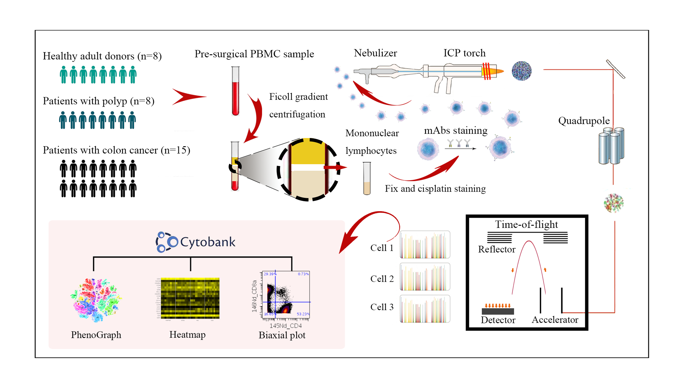
Supplementary Figure S1. Workflow of experimental design. Whole blood samples from 8 healthy volunteers as control, 8 patients with colonic polyps, and 15 patients with colon cancer were collected. Peripheral blood mononuclear cells were isolated and stained with a panel of 19 antibodies (Supplementary Table S2). Data was acquired using mass cytometry and analyzed as described in the Materials and Methods section.

Supplementary Figure S2. Gating hierarchy scheme. Typical biaxial gating hierarchy strategy was adopted to define classical T cell subpopulations. Ten markers were combined to define thirteen cell types. Pre-gating step involved removal of doublets, dead cells, and cell debris.

Supplementary Figure S3. PhenoGraph clustering analysis. (A) tSNE landscape was created to cross-validate the results in Figure 2. The map is colored according to sample groups. (B) tSNE maps with color representing expression of indicated markers on cells. (C) The same tSNE map presented in (A), labeled by PhenoGraph classification results. Color coding indicates cluster distribution. (D) Hierarchical clustering of expression pattern on the PhenoGraph identified clusters.

