SUPPLEMENTARY MATERIALS:
Table Supp-I: Serum and urine estimated population pharmacokinetic parameters, sampling importance resampling (SIR) and bootstrap confidence interval (CI) values of enalapril and enalaprilat from the reference f0ormulation.
Table Supp-II: Serum and urine estimated population pharmacokinetic parameters, sampling importance resampling (SIR) and bootstrap confidence interval (CI) values of enalapril and enalaprilat from the ODMT formulation
Fig Supp-1: Goodness of fit plots including the observed versus individual and population predicted and conditional weighted residuals (CWRES) versus population predicted (PRED) plots of enalapril and enalaprilat in serum and urine generated after the population pharmacokinetic modeling of reference formulation. The first and third row shows the predictive performance of the model for enalapril in serum and urine respectively. The second and fourth line shows the predictive performance of enalaprilat in serum and urine respectively.
Fig Supp-2: Goodness of fit plots including the observed versus individual and population predicted and conditional weighted residuals (CWRES) versus population predicted (PRED) plots of enalapril and enalaprilat in serum and urine generated after the population pharmacokinetic modeling of ODMT formulation. The first and third row shows the predictive performance of the model for enalapril in serum and urine respectively. The second and fourth row shows the predictive performance of enalaprilat in serum and urine respectively.

Parameters | Population Estimates (% RSE) | SIR 95th % CI | Bootstrap 95th % CI
 | FINAL (FULL) MODEL | FINAL MODEL | FINAL MODEL
Basic pharmacokinetic model parameters
KA (1/h) | 7.780 (37.0 %) | 5.640-11.90 | 5.541-12.10
VC (L) | 51.60 (6.00 %) | 46.31-57.06 | 45.00-55.40
F1 | 0.630 (5.00 %) | 0.574-0.681 | 0.562-0.667
MTT1 (hr) | 0.570 (10.00 %) | 0.492-0.681 | 0.475-0.643
KREN (1/h) | 0.312 (5.00 %) | 0.281-0.341 | 0.274-0.339
KM (1/h) | 0.683 (7.00 %) | 0.605-0.758 | 0.635-0.746
VM (L) | 44.70 (5.00 %) | 40.98-48.87 | 42.10-50.78
KQ1 (1/h) | 0.060 (6.0 %) | 0.054-0.065 | 0.053-0.068
KQ2 (1/h) | 0.057 (15.0 %) | 0.046-0.071 | 0.045-0.067
KME (1/h) | 0.192 (6.00 %) | 0.176-0.210 | 0.175-0.210
MTT2 (h) | 0.942 (13.0 %) | 0.745-1.144 | 0.741-1.025
Interindividual variability (IIV)
IIV_KA | 1.310 (53.0 %) | 0.796-1.604 | 0.799-1.522
IIV_VC | 0.069 (34.0 %) | 0.044-0.120 | 0.049-0.090
IIV_F1 | 0.057 (31.0 %) | 0.039-0.089 | 0.041-0.750
IIV_MTT1 | 0.203 (31.0 %) | 0.132-0.338 | 0.137-0.366
IIV_KREN | 0.056 (33.0 %) | 0.036-0.097 | 0.035-0.085
IIV_KM | 0.088 (32.0 %) | 0.056-0.141 | 0.050-0.134
IIV_VM | 0.048 (35.0 %) | 0.029-0.081 | 0.036-0.102
IIV_KME | 0.053 (33.0 %) | 0.033-0.088 | 0.035-0.086
IIV_ MTT2 | 0.330 (32.0 %) | 0.225-0.420 | 0.243-0.350
Residual unexplained variability (RUV)
Serum Enalapril
Proportional error (σ2) | 0.010 (12.0 %) | 0.007-0.011 | 0.006-0.014
Additive error (ug/l) | 0.189 (21.0 %) | 0.137-0.269 | 0.125-0.245
Serum Enalaprilat
Proportional error (σ2) | 0.021 (14.0 %) | 0.016-0.026 | 0.014-0.026
Additive error (ug/l) | 0.220 (22.0 %) | 0.159-0.310 | 0.147-0.316
Urine Enalapril
Proportional error (σ2) | 0.011 (14.0 %) | 0.009-0.014 | 0.007-0.016
Urine Enalaprilat
Proportional error (σ2) | 0.005 (16.0 %) | 0.004-0.006 | 0.003-0.009

Table Supp-I:

Table Supp-II:
Parameters | Population estimates  (% RES) | SIR 95th % CI | Bootstrap 95th % CI
 | FINAL (FULL) MODEL | FINAL MODEL | FINAL MODEL
Basic pharmacokinetic model parameters
KA (1/h) | 7.71 (26.0 %) | 5.623-11.59 | 5.329-12.22
VC (L) | 50.70 (5.00 %) | 46.87-55.05 | 47.00-55.59
F1 | 0.589 (4.00 %) | 0.556-0.624 | 0.553-0.627
MTT1 (hr) | 0.484 (7.00 %) | 0.438-0.551 | 0.417-0.553
KREN (1/h) | 0.298 (5.00 %) | 0.274-0.323 | 0.274-0.325
KM (1/h) | 0.693 (6.00 %) | 0.631-0.757 | 0.641-0.750
VM (L) | 47.60 (7.00 %) | 42.52-53.20 | 42.65-52.93
KQ1 (1/h) | 0.060 (5.00 %) | 0.056-0.066 | 0.054-0.066
KQ2 (1/h) | 0.051 (14.0 %) | 0.040-0.064 | 0.042-0.060
KME (1/h) | 0.175 (6.00 %) | 0.158-0.193 | 0.161-0.196
MTT2 (h) | 0.873 (11.0 %) | 0.732-1.043 | 0.731-1.015
Interindividual variability (IIV)
IIV_KA | 0.779 (50.0 %) | 0.460-1.616 | 0.215-1.462
IIV_VC | 0.047 (34.0 %) | 0.031-0.082 | 0.024-0.070
IIV_F1 | 0.025 (31.0 %) | 0.017–0.042 | 0.013-0.034
IIV_MTT1 | 0.269 (30.0 %) | 0.184-0.433 | 0.137-0.366
IIV_KREN | 0.056 (31.0 %) | 0.037-0.093 | 0.033-0.076
IIV_KM | 0.067 (31.0 %) | 0.045-0.111 | 0.037-0.090
IIV_VM | 0.087 (32.0 %) | 0.059-0.146 | 0.042-0.122
IIV_KME | 0.071(31.0 %) | 0.047-0.117 | 0.039-0.090
IIV_ MTT2 | 0.094 (31.0 %) | 0.065-0.156 | 0.043-0.122
Residual unexplained variability (RUV)
Serum Enalapril
Proportional error (σ2) | 0.010 (12.0 %) | 0.008-0.011 | 0.005-0.014
Additive error (ug/l) | 0.186 (23.0 %) | 0.133-0.266 | 0.116-0.425
Serum Enalaprilat
Proportional error (σ2) | 0.016 (13.0 %) | 0.013-0.019 | 0.010-0.024
Additive error (ug/l) | 0.220 (17.0 %) | 0.170-0.284 | 0.117-0.316
Urine Enalapril
Proportional error (σ2) | 0.026 (13.0 %) | 0.021-0.032 | 0.011-0.042
Urine Enalaprilat
Proportional error (σ2) | 0.005 (15.0 %) | 0.004-0.006 | 0.001-0.009

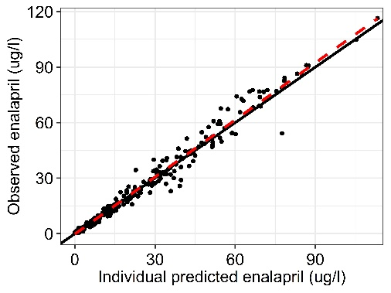
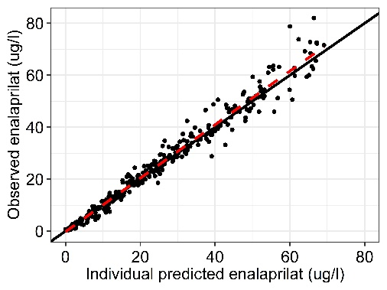
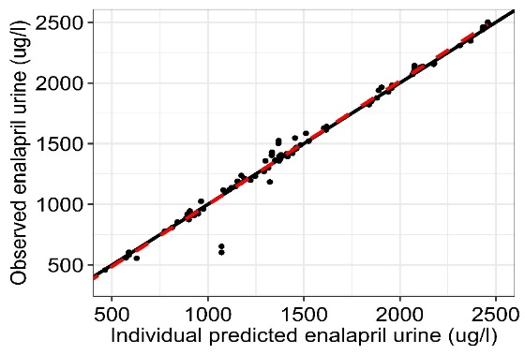
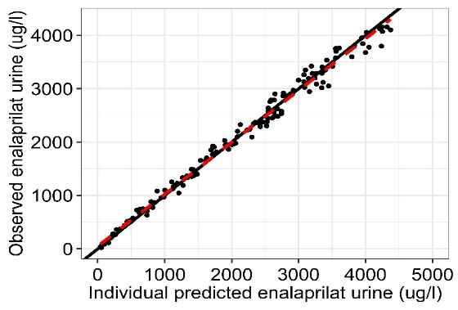
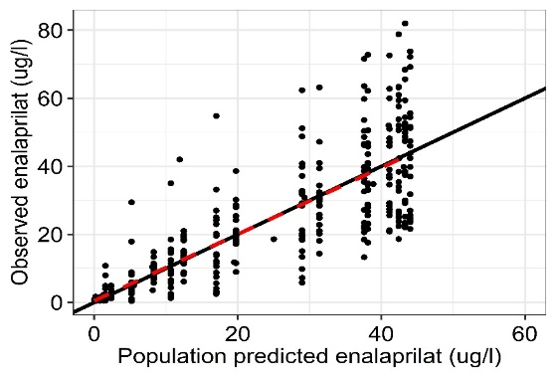
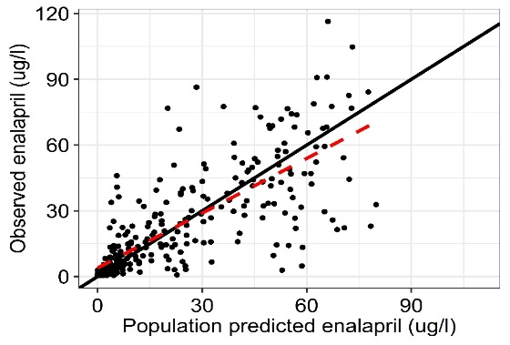
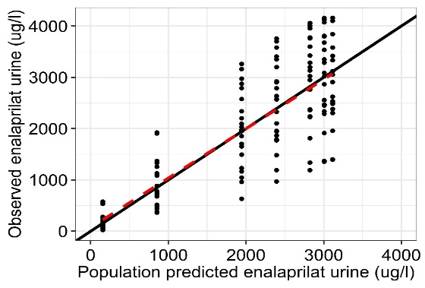
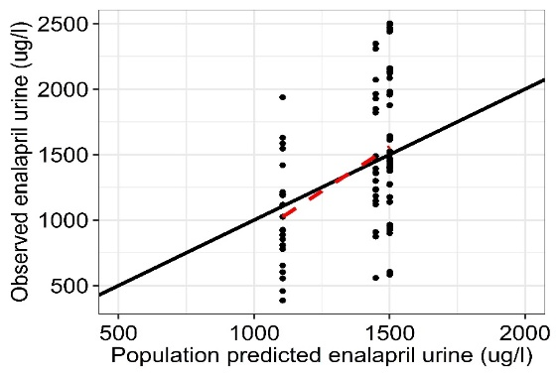

FIG Supp-1:

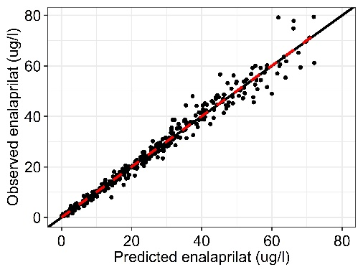
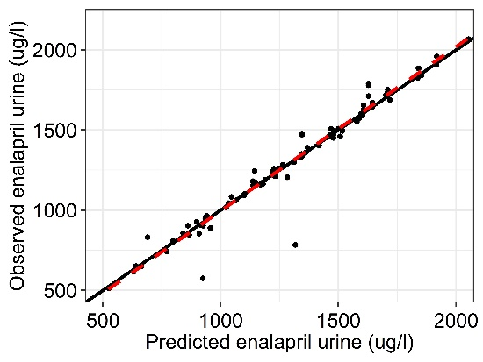
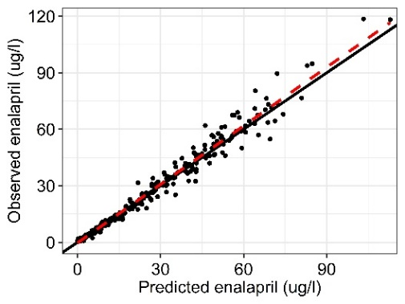
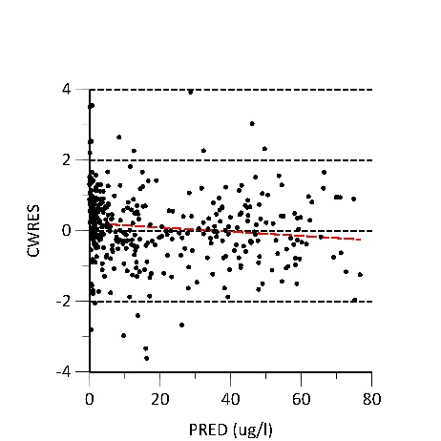
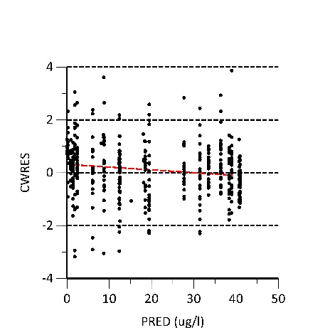
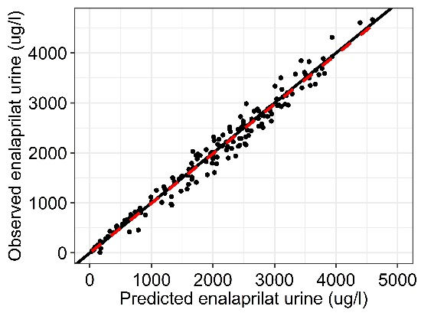
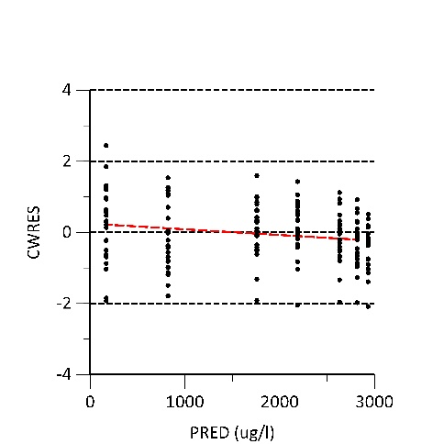
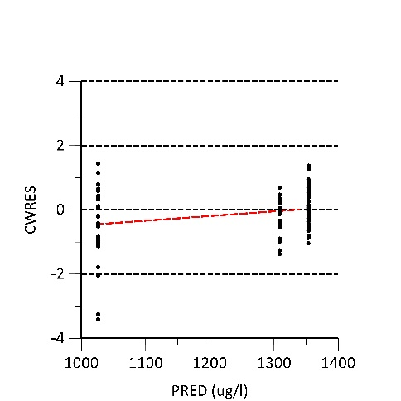
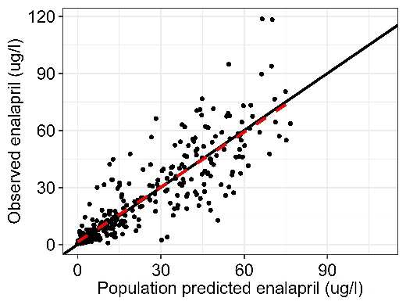
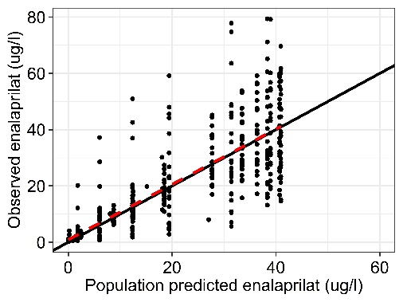
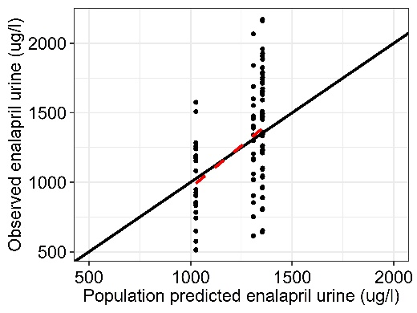
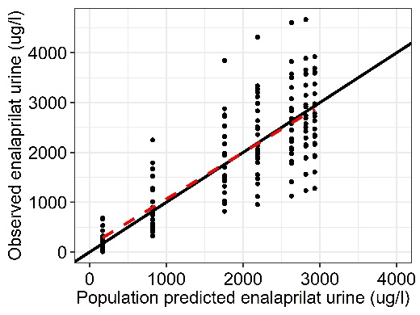

FIG Supp-2:

