Supplementary Material
Microbial diversity exploration of marine hosts at Serrana Bank, a coral atoll of the Seaflower Biosphere Reserve
Astrid Catalina Alvarez-Yela^{1*}, Jeanneth Mosquera-Rendón¹, Alejandra Noreña-P¹, Marco Cristancho², Diana López-Alvarez^{1,3*}
¹Centro de Bioinformática y Biología Computacional - BIOS, Manizales, Colombia
²Universidad de los Andes, Bogotá, Colombia
³Present address: Facultad de Ciencias Agropecuarias, Universidad Nacional de Colombia, Palmira, Colombia

* Correspondence:
Astrid Catalina Alvarez-Yela - catalina.alvarez@bios.co
Diana López-Alvarez dianalopez430@gmail.com
Keywords: seaflower, microbial diversity, marine hosts, amplicons, symbiotic interactions

Supplementary Figures and Tables

Supplementary Figures

A
B

Supplementary figure 1. Taxonomic distribution comparison of bacterial and archaeal communities found in marine hosts. a) Orders. b) Genera.

C
A
B

Supplementary figure 2. Taxonomic distribution comparison of eukaryotic communities found in marine hosts. a) Orders. b) Genera. c) Species.

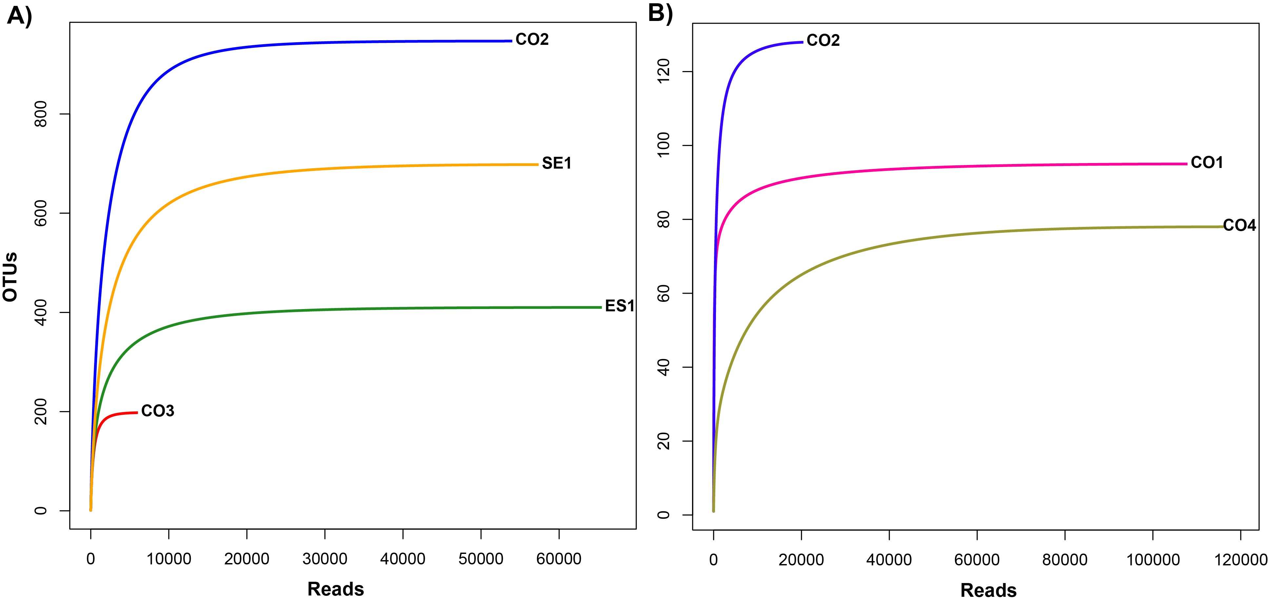
Supplementary figure 3. Rarefaction curves from microbial composition analysis of metagenomes at the Seaflower reserve. A) Bacterial and archaeal communities. B) Eukaryotic communities.

Supplementary Tables
Supplementary table 1. Metadata associated to the samples collected at the Seaflower Biosphere Reserve. Attached excel file (Table S1).
Supplementary table 2. Taxonomic assignment for bacterial communities associated to marine hosts at Serrana Bank (Kingdom to species). Attached excel file (Table S2).
Supplementary table 3. Taxonomic assignment for bacterial communities associated to marine hosts at Serrana Bank (Kingdom to species). Attached excel file (Table S3).

Figure legends
Figure 2. Relative abundances of bacterial microorganisms in marine host at the Seaflower Biosphere Reserve. A) Phylum. B) Class: Undefined are composed by reads of different phyla which are organized from highest to lowest abundance in the following way: AncK6, PAUC34f, Poribacteria, Gemmatimonadetes, Planctomycetes, WPS-2, GN02, Chloroflexi, NKB19, Acidobacteria, OD1. C) Order: Undefined are composed by reads of different phyla which are organized from highest to lowest abundance in the following way: Gemmatimonadetes, Chloroflexi, AncK6, PAUC34f, Proteobacteria, Acidobacteria, OD1, SBR1093, Poribacteria, Verrucomicrobia, GN02, Planctomycetes, Cyanobacteria, OP3, TM6, WS3, NKB19, Bacteroidetes, Chlorobi, WPS-2. D) Family: Undefined are composed by reads of different phyla which are organized from highest to lowest abundance in the following way: Cyanobacteria, Proteobacteria, Acidobacteria, Gemmatimonadetes, Chloroflexi, AncK6, PAUC34f, Actinobacteria, Firmicutes, Planctomycetes, Bacteroidetes, OD1, SBR1093, Verrucomicrobia, Poribacteria, GN02, Chlamydiae, WS3, OP3, Parvarchaeota, Tenericutes, TM6, Elusimicrobia, Fusobacteria, NKB19, Chlorobi, WPS-2, Euryarchaeota.

