Table 1: Quantification (cell L⁻¹) and identification of phytoplankton communities based on microscopic morphology.
 |  |  |  |  |  |  |  |  |  |  |  |  |  |  |  |  | Stations
Species |  |  |  |  | BOB-1 |  | BOB-2 |  | BOB-3 |  | BOB-4 |  | BOB-5 |  | BOB-6 |  | BOB-7 |  | BOB-8 |  | BOB-9 | BOB-10 | BOB-11 | BOB-12
Bacillariophyta
Asterolampra marylandica Ehrenberg |  |  |  |  | 2 |  | 2 |  | 0 |  | 0 |  | 0 |  | 0 |  | 0 |  | 0 |  | 0 | 0 | 0 | 0
Chaetoceros coarctatus |  |  |  |  | 0 |  | 0 |  | 0 |  | 0 |  | 26 |  | 0 |  | 0 |  | 0 |  | 0 | 20 | 0 | 0
Chaetoceros decipiens f.decipiens |  |  |  |  | 0 |  | 0 |  | 0 |  | 0 |  | 0 |  | 0 |  | 0 |  | 0 |  | 0 | 6 | 0 | 0
Chaetoceros curvisetus |  |  |  |  | 0 |  | 0 |  | 0 |  | 0 |  | 0 |  | 0 |  | 0 |  | 0 |  | 0 | 0 | 16 | 0
Coscinodiscus granii Grough |  |  |  |  | 0 |  | 0 |  | 0 |  | 0 |  | 2 |  | 0 |  | 0 |  | 2 |  | 0 | 0 | 2 | 0
Coscinodiscus radiatus Ehrenberg |  |  |  |  | 0 |  | 0 |  | 0 |  | 0 |  | 0 |  | 0 |  | 8 |  | 0 |  | 0 | 0 | 0 | 0
Coscinodiscus subtilis |  |  |  |  | 12 |  | 28 |  | 10 |  | 0 |  | 2 |  | 8 |  | 8 |  | 4 |  | 6 | 0 | 6 | 28
Coscinodiscus centralis |  |  |  |  | 0 |  | 0 |  | 0 |  | 2 |  | 2 |  | 0 |  | 0 |  | 0 |  | 0 | 0 | 0 | 0
Eunotogramma debile |  |  |  |  | 4 |  | 2 |  | 0 |  | 0 |  | 2 |  | 196 |  | 0 |  | 4 |  | 20 | 0 | 0 | 0
Fragilariopsis doliolus Medlin P.A.Sims |  |  |  |  | 0 |  | 0 |  | 0 |  | 20 |  | 0 |  | 0 |  | 0 |  | 0 |  | 0 | 0 | 0 | 0
Hemidiscus cuneiformis Wallich |  |  |  |  | 0 |  | 0 |  | 0 |  | 0 |  | 0 |  | 0 |  | 0 |  | 0 |  | 0 | 0 | 2 | 0
Hemiaulus sinensis Greville |  |  |  |  | 0 |  | 0 |  | 0 |  | 0 |  | 0 |  | 0 |  | 10 |  | 0 |  | 0 | 0 | 10 | 0
Navicula spp. |  |  |  |  | 0 |  | 0 |  | 0 |  | 2 |  | 4 |  | 0 |  | 0 |  | 2 |  | 0 | 0 | 0 | 0
Odontella sinensis |  |  |  |  | 0 |  | 0 |  | 2 |  | 0 |  | 0 |  | 0 |  | 0 |  | 0 |  | 0 | 0 | 0 | 0
Planktoniella foromsa |  |  |  |  | 0 |  | 0 |  | 0 |  | 0 |  | 0 |  | 0 |  | 4 |  | 0 |  | 0 | 0 | 0 | 0
Pleurosigma pelagicum |  |  |  |  | 0 |  | 0 |  | 0 |  | 0 |  | 0 |  | 2 |  | 0 |  | 0 |  | 0 | 0 | 0 | 0
Rhizosolenia robusta |  |  |  |  | 0 |  | 0 |  | 0 |  | 0 |  | 0 |  | 0 |  | 4 |  | 0 |  | 0 | 42 | 66 | 0
Rhizosolenia bergonii Perty |  |  |  |  | 0 |  | 0 |  | 20 |  | 0 |  | 0 |  | 0 |  | 0 |  | 0 |  | 0 | 18 | 12 | 0
Synedra spp. |  |  |  |  | 0 |  | 0 |  | 2 |  | 4 |  | 12 |  | 0 |  | 4 |  | 2 |  | 0 | 12 | 2 | 0
Thalassiothrix longissima Cleve et Grunow |  |  |  |  | 0 |  | 12 |  | 0 |  | 2 |  | 10 |  | 0 |  | 0 |  | 0 |  | 0 | 2 | 0 | 0
Thalassionema frauenfeldii (Grunow) Hallegraeff |  |  |  |  | 0 |  | 0 |  | 4 |  | 0 |  | 0 |  | 0 |  | 70 |  | 0 |  | 0 | 134 | 366 | 0
Thalassiosira nordenskioldii |  |  |  |  | 0 |  | 4 |  | 0 |  | 0 |  | 0 |  | 0 |  | 0 |  | 0 |  | 0 | 0 | 2 | 0
Bacillariophyta cells L⁻¹ |  |  |  |  | 1.8×10⁴ |  | 4.8×10⁴ |  | 3.8×10⁴ |  | 3×10⁴ |  | 6×10⁴ |  | 2.06×10⁵ |  | 1.08×10⁵ |  | 1.4×10⁴ |  | 2.6×10⁴ | 2.34×10⁵ | 4.84×10⁵ | 2.8×10⁴
Dinoflagellates
Amphisolenia bidentata |  |  |  |  | 0 |  | 0 |  | 0 |  | 0 |  | 2 |  | 0 |  | 0 |  | 0 |  | 2 | 0 | 0 | 0
Ceratium breve var.parallelum |  |  |  |  | 0 |  | 0 |  | 0 |  | 0 |  | 0 |  | 0 |  | 0 |  | 0 |  | 0 | 4 | 2 | 0
Ceratium breve var.breve |  |  |  |  | 0 |  | 0 |  | 0 |  | 0 |  | 0 |  | 0 |  | 0 |  | 0 |  | 0 | 0 | 2 | 0
Ceratium tripos var.pulcbellum |  |  |  |  | 0 |  | 0 |  | 0 |  | 0 |  | 0 |  | 0 |  | 0 |  | 0 |  | 4 | 0 | 0 | 0
Ceratium bumile |  |  |  |  | 0 |  | 0 |  | 0 |  | 0 |  | 0 |  | 0 |  | 0 |  | 0 |  | 0 | 0 | 0 | 2
Ceratium tripos var.atlanticum |  |  |  |  | 0 |  | 0 |  | 0 |  | 0 |  | 0 |  | 0 |  | 4 |  | 0 |  | 0 | 0 | 0 | 16
Ceratium borridum var.denticulatum |  |  |  |  | 0 |  | 0 |  | 0 |  | 0 |  | 2 |  | 0 |  | 6 |  | 0 |  | 0 | 0 | 0 | 0
Ceratium contrarium |  |  |  |  | 0 |  | 0 |  | 0 |  | 2 |  | 0 |  | 4 |  | 8 |  | 6 |  | 6 | 12 | 6 | 6
Ceratium candelabrum |  |  |  |  | 0 |  | 0 |  | 0 |  | 0 |  | 0 |  | 0 |  | 0 |  | 0 |  | 0 | 0 | 0 | 12
Ceratium deflexum |  |  |  |  | 0 |  | 0 |  | 0 |  | 0 |  | 0 |  | 0 |  | 4 |  | 0 |  | 0 | 0 | 2 | 2
Ceratium digitatum var.angusticornum |  |  |  |  | 0 |  | 0 |  | 0 |  | 0 |  | 0 |  | 2 |  | 0 |  | 0 |  | 0 | 0 | 0 | 0
Ceratium tripos var.indicum |  |  |  |  | 0 |  | 0 |  | 0 |  | 0 |  | 0 |  | 0 |  | 0 |  | 0 |  | 8 | 0 | 0 | 0
Ceratium azoricum |  |  |  |  | 0 |  | 0 |  | 0 |  | 0 |  | 0 |  | 0 |  | 0 |  | 0 |  | 0 | 0 | 2 | 0
Ceratium furca |  |  |  |  | 2 |  | 0 |  | 0 |  | 0 |  | 2 |  | 2 |  | 0 |  | 0 |  | 12 | 4 | 4 | 54
Ceratium candelabrum var.candelabrum |  |  |  |  | 0 |  | 0 |  | 0 |  | 0 |  | 0 |  | 0 |  | 0 |  | 0 |  | 4 | 0 | 0 | 0
Ceratium fusus var.seta |  |  |  |  | 0 |  | 0 |  | 2 |  | 2 |  | 2 |  | 4 |  | 6 |  | 0 |  | 10 | 4 | 4 | 4
Ceratium macroceros var.macroceros |  |  |  |  | 0 |  | 0 |  | 0 |  | 0 |  | 0 |  | 0 |  | 0 |  | 0 |  | 6 | 0 | 0 | 0
Ceratium massiliense var.massiliense |  |  |  |  | 2 |  | 0 |  | 0 |  | 0 |  | 0 |  | 0 |  | 0 |  | 0 |  | 0 | 0 | 0 | 0
Ceratium massiliense |  |  |  |  | 0 |  | 0 |  | 0 |  | 0 |  | 0 |  | 0 |  | 0 |  | 0 |  | 0 | 0 | 8 | 0
Ceratium tricboceros |  |  |  |  | 0 |  | 0 |  | 0 |  | 0 |  | 2 |  | 0 |  | 0 |  | 0 |  | 0 | 0 | 0 | 0
Ceratocorys horrida Stein 1 |  |  |  |  | 0 |  | 4 |  | 4 |  | 8 |  | 2 |  | 4 |  | 8 |  | 0 |  | 10 | 4 | 0 | 6
Dinophysis lativelata |  |  |  |  | 0 |  | 0 |  | 0 |  | 0 |  | 0 |  | 0 |  | 0 |  | 0 |  | 0 | 2 | 0 | 0
Dinophysis apicata |  |  |  |  | 0 |  | 0 |  | 0 |  | 0 |  | 0 |  | 0 |  | 0 |  | 0 |  | 2 | 0 | 0 | 0
Dinophysis laevis |  |  |  |  | 2 |  | 0 |  | 0 |  | 0 |  | 0 |  | 0 |  | 0 |  | 0 |  | 0 | 0 | 0 | 0
Dinophysis caudata |  |  |  |  | 0 |  | 0 |  | 0 |  | 0 |  | 0 |  | 0 |  | 0 |  | 0 |  | 0 | 0 | 2 | 0
Dinophysis doryphorum |  |  |  |  | 0 |  | 0 |  | 2 |  | 0 |  | 0 |  | 0 |  | 0 |  | 0 |  | 0 | 0 | 0 | 0
Dinophysis tailisuni |  |  |  |  | 0 |  | 0 |  | 0 |  | 0 |  | 0 |  | 0 |  | 0 |  | 2 |  | 0 | 0 | 0 | 0
Dinophysis acutoides |  |  |  |  | 0 |  | 0 |  | 0 |  | 0 |  | 0 |  | 2 |  | 0 |  | 0 |  | 0 | 0 | 0 | 0
Dissodinium elegans |  |  |  |  | 0 |  | 0 |  | 0 |  | 0 |  | 0 |  | 0 |  | 0 |  | 0 |  | 0 | 6 | 0 | 0
Gonyaulax polyedra |  |  |  |  | 0 |  | 0 |  | 0 |  | 0 |  | 0 |  | 0 |  | 2 |  | 0 |  | 0 | 0 | 0 | 0
Gonyaulax minuta |  |  |  |  | 2 |  | 0 |  | 2 |  | 0 |  | 0 |  | 0 |  | 0 |  | 0 |  | 0 | 0 | 0 | 0
Gonyaulax polygramma |  |  |  |  | 0 |  | 2 |  | 2 |  | 4 |  | 0 |  | 0 |  | 0 |  | 6 |  | 0 | 0 | 0 | 0
Gymnodinium splendens |  |  |  |  | 0 |  | 0 |  | 0 |  | 4 |  | 0 |  | 0 |  | 0 |  | 0 |  | 0 | 0 | 0 | 0
Gymnodinium vestifici |  |  |  |  | 0 |  | 0 |  | 0 |  | 0 |  | 0 |  | 0 |  | 0 |  | 0 |  | 0 | 0 | 8 | 0
Gymnodinium viridescens |  |  |  |  | 0 |  | 6 |  | 10 |  | 0 |  | 0 |  | 2 |  | 6 |  | 4 |  | 2 | 14 | 0 | 2
Histioneis cymbalaria |  |  |  |  | 0 |  | 0 |  | 0 |  | 0 |  | 0 |  | 0 |  | 2 |  | 0 |  | 0 | 0 | 0 | 0
Histioneis elongata |  |  |  |  | 0 |  | 0 |  | 0 |  | 0 |  | 0 |  | 0 |  | 0 |  | 2 |  | 0 | 0 | 0 | 0
Ornithocercus skogsbergii |  |  |  |  | 0 |  | 4 |  | 0 |  | 0 |  | 0 |  | 0 |  | 0 |  | 0 |  | 0 | 0 | 0 | 0
Ornithocercus magnificus Stein |  |  |  |  | 0 |  | 0 |  | 0 |  | 2 |  | 0 |  | 0 |  | 8 |  | 0 |  | 4 | 0 | 0 | 4
Ornithocercus thumii |  |  |  |  | 0 |  | 0 |  | 0 |  | 0 |  | 0 |  | 0 |  | 0 |  | 0 |  | 2 | 0 | 0 | 0
Ornithocercus steinii |  |  |  |  | 0 |  | 4 |  | 0 |  | 0 |  | 0 |  | 0 |  | 0 |  | 0 |  | 0 | 0 | 0 | 0
Oxytoxum scolopax |  |  |  |  | 0 |  | 2 |  | 0 |  | 0 |  | 6 |  | 0 |  | 0 |  | 0 |  | 0 | 0 | 0 | 0
Oxytoxum globosum |  |  |  |  | 0 |  | 0 |  | 0 |  | 0 |  | 0 |  | 0 |  | 0 |  | 2 |  | 0 | 0 | 0 | 0
Oxytoxum reticulatum |  |  |  |  | 0 |  | 0 |  | 0 |  | 0 |  | 6 |  | 0 |  | 0 |  | 0 |  | 0 | 0 | 0 | 0
Pyropbacus borologium |  |  |  |  | 0 |  | 2 |  | 0 |  | 0 |  | 0 |  | 0 |  | 0 |  | 0 |  | 2 | 0 | 0 | 0
Podolampas bipes var.bipes |  |  |  |  | 0 |  | 0 |  | 0 |  | 0 |  | 2 |  | 0 |  | 2 |  | 0 |  | 6 | 0 | 0 | 0
Prorocentrum compressum |  |  |  |  | 4 |  | 22 |  | 4 |  | 10 |  | 16 |  | 26 |  | 12 |  | 4 |  | 24 | 0 | 0 | 12
Prorocentrum dentatum Stein |  |  |  |  | 0 |  | 0 |  | 0 |  | 0 |  | 0 |  | 0 |  | 0 |  | 0 |  | 0 | 0 | 0 | 0
Prorocentrum gracile |  |  |  |  | 0 |  | 0 |  | 2 |  | 6 |  | 0 |  | 16 |  | 0 |  | 0 |  | 0 | 2 | 0 | 2
Prorocentrum leniculatum |  |  |  |  | 0 |  | 0 |  | 2 |  | 4 |  | 6 |  | 2 |  | 6 |  | 0 |  | 0 | 0 | 0 | 0
Prorocentrum micans Ehrenberg |  |  |  |  | 0 |  | 4 |  | 0 |  | 10 |  | 2 |  | 20 |  | 4 |  | 0 |  | 0 | 0 | 0 | 16
Protoperidinium biconicum |  |  |  |  | 0 |  | 0 |  | 0 |  | 0 |  | 0 |  | 0 |  | 0 |  | 0 |  | 0 | 2 | 0 | 0
Protoperidinium latissimum |  |  |  |  | 0 |  | 0 |  | 2 |  | 0 |  | 0 |  | 0 |  | 0 |  | 0 |  | 0 | 0 | 0 | 0
Protoperidinium curtipes |  |  |  |  | 0 |  | 2 |  | 0 |  | 0 |  | 0 |  | 0 |  | 0 |  | 0 |  | 0 | 0 | 0 | 0
Protoperidinium grande |  |  |  |  | 0 |  | 0 |  | 0 |  | 0 |  | 0 |  | 0 |  | 0 |  | 0 |  | 0 | 0 | 2 | 0
Protoperidinium inclinatum |  |  |  |  | 0 |  | 0 |  | 0 |  | 8 |  | 0 |  | 0 |  | 0 |  | 0 |  | 0 | 0 | 0 | 0
Heteraulacus polyedricus |  |  |  |  | 2 |  | 0 |  | 0 |  | 0 |  | 0 |  | 0 |  | 0 |  | 4 |  | 0 | 0 | 0 | 0
Protoperidinium tubum |  |  |  |  | 0 |  | 0 |  | 0 |  | 6 |  | 0 |  | 0 |  | 8 |  | 0 |  | 0 | 2 | 0 | 0
Protoperidinium acbromaticum |  |  |  |  | 0 |  | 0 |  | 0 |  | 0 |  | 0 |  | 0 |  | 0 |  | 0 |  | 0 | 0 | 0 | 2
Protoperidinium longicollum |  |  |  |  | 0 |  | 0 |  | 0 |  | 0 |  | 0 |  | 0 |  | 0 |  | 0 |  | 2 | 0 | 0 | 0
Protoperidinium subinerme |  |  |  |  | 2 |  | 2 |  | 0 |  | 4 |  | 0 |  | 0 |  | 2 |  | 0 |  | 2 | 0 | 0 | 2
Protoperidinium biconicum |  |  |  |  | 0 |  | 0 |  | 0 |  | 2 |  | 0 |  | 0 |  | 0 |  | 0 |  | 0 | 0 | 0 | 0
Protoperidinium subpyriforme |  |  |  |  | 2 |  | 2 |  | 0 |  | 0 |  | 0 |  | 0 |  | 0 |  | 0 |  | 0 | 2 | 0 | 0
Protoperidinium sourniai |  |  |  |  | 0 |  | 0 |  | 0 |  | 0 |  | 0 |  | 2 |  | 0 |  | 0 |  | 0 | 0 | 0 | 0
Pyrocystis fusiformis |  |  |  |  | 0 |  | 0 |  | 0 |  | 2 |  | 0 |  | 0 |  | 0 |  | 0 |  | 0 | 0 | 0 | 0
Pyrocystis robusta |  |  |  |  | 0 |  | 0 |  | 2 |  | 12 |  | 8 |  | 0 |  | 2 |  | 0 |  | 2 | 0 | 0 | 0
Pyrocystis noctiluca |  |  |  |  | 0 |  | 2 |  | 0 |  | 2 |  | 0 |  | 2 |  | 0 |  | 0 |  | 0 | 0 | 0 | 0
Dissodinium gerbaultii |  |  |  |  | 0 |  | 0 |  | 4 |  | 0 |  | 0 |  | 0 |  | 0 |  | 0 |  | 0 | 0 | 0 | 0
Pyropbacus vancampoae |  |  |  |  | 0 |  | 0 |  | 0 |  | 0 |  | 0 |  | 0 |  | 0 |  | 0 |  | 0 | 0 | 2 | 0
Scrippsiella trochoidea (Stein) Loeblich |  |  |  |  | 0 |  | 0 |  | 0 |  | 0 |  | 0 |  | 0 |  | 0 |  | 2 |  | 0 | 0 | 0 | 0
Heteraulacus polyedricus |  |  |  |  |  |  |  |  |  |  |  |  |  |  |  |  | 4
Dinoflagellates cells L⁻¹ |  |  |  |  | 1.8×10⁴ |  | 5.8×10⁴ |  | 3.8×10⁴ |  | 8.8×10⁴ |  | 5.8×10⁴ |  | 8.8×10⁴ |  | 9.4×10⁴ |  | 3.2×10⁴ |  | 1.1×10⁵ | 5.8×10⁴ | 4.4×10⁴ | 1.42×10⁵
Chrysophyta
Dictyocha fibula |  |  |  |  | 0 |  | 0 |  | 0 |  | 16 |  | 0 |  | 0 |  | 8 |  | 8 |  | 0 | 0 | 0 | 8
Chrysophyta cells L⁻¹ |  |  |  |  | 0 |  | 0 |  | 0 |  | 1.6×10⁴ |  | 0 |  | 0 |  | 8×10³ |  | 8×10³ |  | 0 | 0 | 0 | 8×10³
Cyanophyta
Trichodesmium thiebaultii Gomont |  |  |  |  | 0 |  | 0 |  | 0 |  | 0 |  | 140 |  | 0 |  | 0 |  | 0 |  | 5060 | 0 | 2000 | 0
Richelia intracellularis |  |  |  |  | 0 |  | 0 |  | 120 |  | 0 |  | 40 |  | 96 |  | 0 |  | 0 |  | 0 | 0 | 0 | 0
Cyanobacteria cells L⁻¹ |  |  |  |  | 0 |  | 0 |  | 1.2×10⁵ |  | 0 |  | 1.8×10⁵ |  | 9.6×10⁴ |  | 0 |  | 0 |  | 5.6×10⁶ | 0 | 2×10⁶ | 0

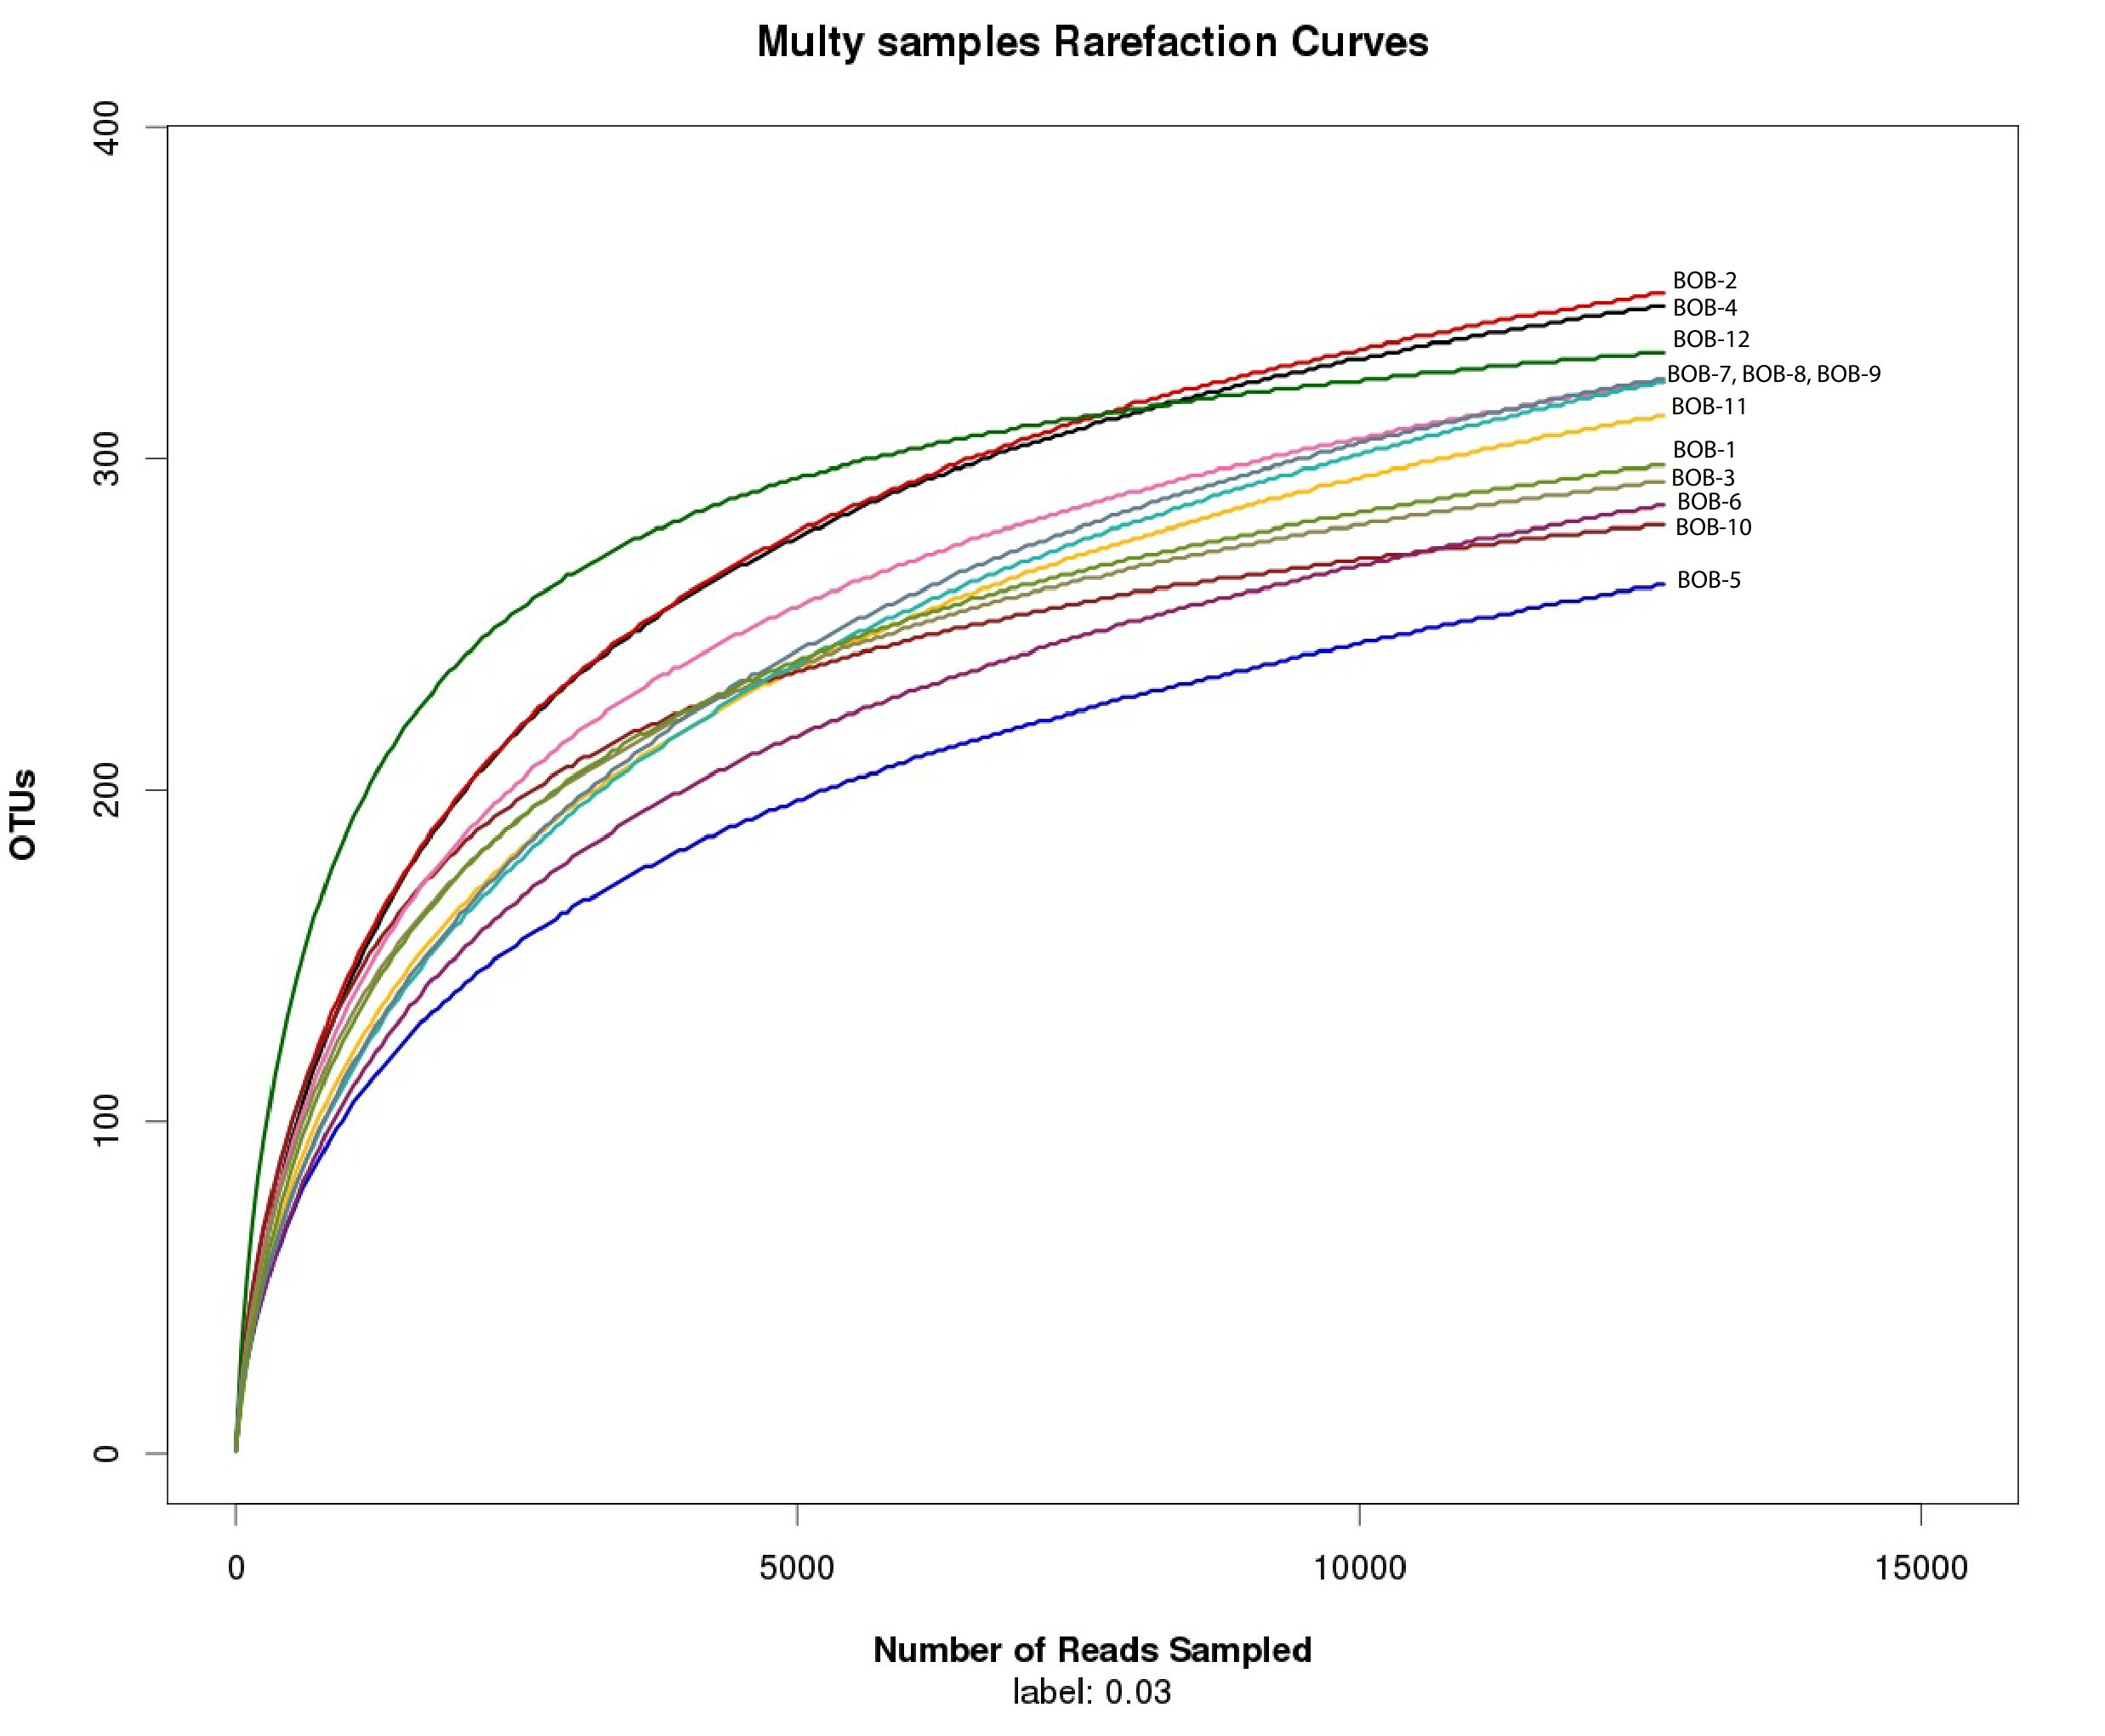

Figure 1. Rarefaction curves comparing the number of reads to the number of phylotypes (OTUs) found in the BOB samples

