Supplementary Material

Supplementary Table

Supplementary Table 1. Summary of the self-docking, cross-docking and enrichment experiments. The self- and cross-docking results are shown as the average RMSDs over 1,030 SB2012 targets (self-docking) and 603 Astex non-native targets (cross-docking). The enrichment results are shown as the average Adjusted LogAUC over the 38 targets of the DUD38 subset of DUD-E.
δ_{VDW} | Electrostatic Model | Self-Docking | Cross-Docking | Enrichment
 |  | RMSD (Å) |  | logAUC
0.0 | PB | 1.129 | 3.951 | 4.91
0.5 | PB | 1.079 | 3.900 | 4.99
2.0 | PB | 1.185 | 3.712 | 5.36
0.0 | Coulomb | 1.215 | 4.477 | 4.50
0.5 | Coulomb | 1.287 | 4.653 | 5.01
2.0 | Coulomb | 5.643 | 7.603 | 1.80

Supplementary Figures

Supplementary Figure 1. Enrichment plots with adjusted logAUC (area under the curve) of known ligands against decoys for the 38 targets of DUDE38 database and for different docking condition.

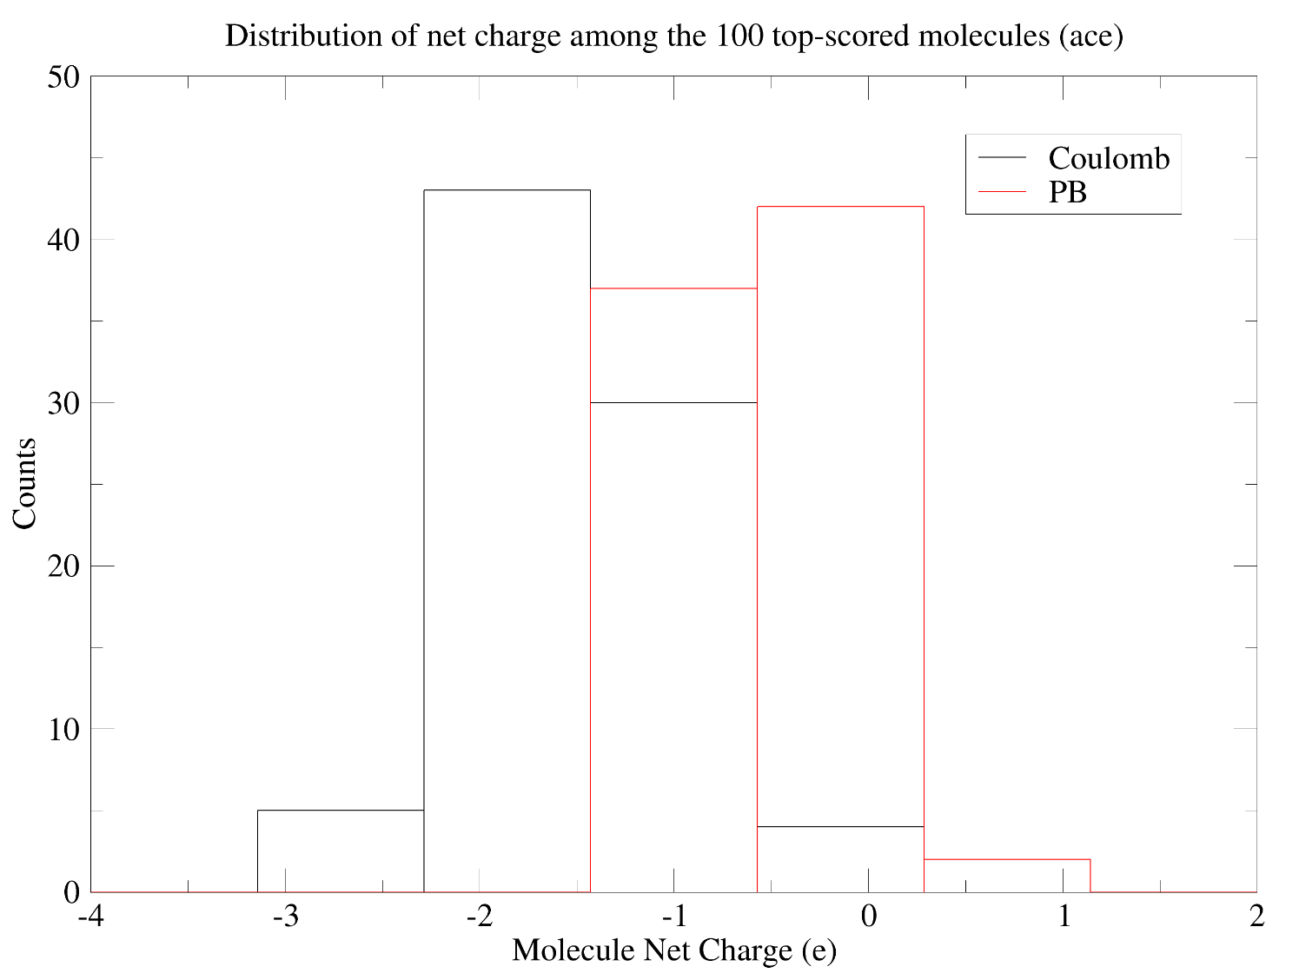
Supplementary Figure 2. Distribution of the net charge for the 100 top-scored molecules in docking calculations of the DUD38 target ace. The calculations were done without soft-core potential, i.e., with smoothing parameter δ_{VDW} set to 0 Å.

