Supplementary Material

R script for Neutral model analysis
## NEUTRAL MODEL, adapted from Burns et al. ISME J. 2015

# The following script is for MLE fitting in one reactor. Fitting was performed for each reactor.

# Dependence
library(minpack.lm)
library(Hmisc)
library(stats4)

# Import following parameters
# pool: A community table for all SRTs with samples as rows and taxa as columns. All samples must be rarefied to the same depth.
# spp: A community table for one specific SRT with samples as rows and taxa as columns.

# Calculate the number of individuals per community
N <- mean(apply(pool, 1, sum))

# Calculate the average relative abundance of each taxon across communities
p.m <- apply(pool, 2, mean)
p.m <- p.m[p.m != 0]
p <- p.m/N

# Calculate the occurrence frequency of each taxon at the specific SRT
spp.bi <- 1*(spp>0)
freq <- apply(spp.bi, 2, mean)
freq <- freq[freq != 0]

# Combine
C <- merge(p, freq, by=0)
C <- C[order(C[,2]),]
C <- as.data.frame(C)
C.0 <- C[!(apply(C, 1, function(y) any(y == 0))),] # Removes rows with any zero (absent in either source pool or local communities)
p <- C.0[,2]
freq <- C.0[,3]
names(p) <- C.0[,1]
names(freq) <- C.0[,1]

# Calculate the limit of detection
d = 1/N

# Fit model parameter m (or Nm) using Non-linear least squares (NLS)
m.fit <- nlsLM(freq ~ pbeta(d, N*m*p, N*m*(1-p), lower.tail=FALSE), start=list(m=0.1))
m.ci <- confint(m.fit, 'm', level=0.95)
m[n,i] <- coef(m.fit)

# Calculate goodness-of-fit (R-squared and Root Mean Squared Error)
freq.pred <- pbeta(d, N*coef(m.fit)*p, N*coef(m.fit)*(1-p), lower.tail=FALSE)
Rsqr[n,i] <- 1 - (sum((freq - freq.pred)^2))/(sum((freq - mean(freq))^2))
RMSE <- sqrt(sum((freq-freq.pred)^2)/(length(freq)-1))
pred.ci <- binconf(freq.pred*nrow(spp), nrow(spp), alpha=0.05, method="wilson", return.df=TRUE)

## NEUTRAL MODEL, Zhou et al. PNAS 2013

# Dependence
library(dplyr)
library(dendextend)
library(vegan)

# Import the OTU tables of the three reactors (otu1, otu2, otu3), row is sample, column is taxon

# Calculate the richness of each sample
rich1 = apply(1*(otu1>0), 1, sum)
rich2 = apply(1*(otu2>0), 1, sum)
rich3 = apply(1*(otu3>0), 1, sum)

# Calculate the expected and actual Jaccard's between Reactor 1&2. The process is repeated for Reactor 2&3 and Reactor 3&1.
J.exp <- vector()
J.obs <- vector()
null <- data.frame()
expect <- data.frame()

for(n in 1:96) # 96 samples
{
sample1 <- otu1[n,] # assign sample to be tested
sample2 <- otu2[n,]
J <- vector()
for(m in 1:999) # repeat random drawing
{
p1 <- sample1[1,sample(ncol(sample1), rich1[n], replace=FALSE)] # subsampling of Reactor 1 based on the richness of sample n
p2 <- sample2[1,sample(ncol(sample2), rich2[n], replace=FALSE)]
C <- bind_rows(p1, p2) # bind two subsamples
C[is.na(C)] <- 0
J[m] <- jaccard(C[1,], C[2,]) # expected Jaccard's similarity
null <- bind_rows(null, p1) # collect the subsample of Reactor 1 at each time point
}
J.exp[n] <- mean(J) # mean expected Jaccard's similarity
J.obs[n] <- jaccard(sample1, sample2) # actuall Jaccard's similarity
null[is.na(null)] <- 0
expect <- bind_rows(expect, round(apply(null,2,mean),0)) # construct the null community of reactor 1
}

# Calculate %stochasity between Reactor 1&2
SS = 1 - (J.obs - J.exp)/J.obs

# PERMDISP between the actual and null community of Reactor 1
all <- bind_rows(otu1, expect)
dis <- vegdist(all, method = "jaccard", na.rm = T)
groups <- factor(c(rep(1,nrow(all)/2), rep(2,nrow(all)/2)), labels = c("actual", "null"))
mod <- betadisper(dis, groups)
permutest(mod, pairwise = TRUE)

Supplementary Table 1. Pairwise Spearman correlation of the 31 shared core OTUs in the triplicate reactors. Unsynchronized OTUs with Spearman’s rho <0 and p-value >0.05 are highlighted.
 | Reactor 1 & 2 |  | Reactor 2 & 3 |  | Reactor 3 & 1
 | rho | p | rho | p | rho | p
Synchronized
OTU124 | 0.625 | 0 | 0.293 | 0.015 | 0.391 | 0.001
OTU51 | 0.486 | 0 | 0.655 | 0 | 0.406 | 0.003
OTU5 | 0.258 | 0.032 | 0.599 | 0 | 0.443 | 0
OTU1012 | 0.632 | 0 | 0.463 | 0 | 0.466 | 0
OTU1073 | 0.646 | 0 | 0.669 | 0 | 0.509 | 0
OTU1807 | 0.622 | 0 | 0.746 | 0 | 0.541 | 0
OTU636 | 0.777 | 0 | 0.705 | 0 | 0.652 | 0
OTU990 | 0.935 | 0 | 0.786 | 0 | 0.737 | 0
OTU1583 | 0.643 | 0 | 0.578 | 0.001 | 0.739 | 0
OTU1397 | 0.732 | 0 | 0.355 | 0.015 | 0.757 | 0
OTU2116 | 0.832 | 0 | 0.895 | 0 | 0.783 | 0
OTU69 | 0.649 | 0 | 0.435 | 0 | 0.803 | 0
OTU560 | 0.656 | 0 | 0.694 | 0 | 0.815 | 0
OTU1674 | 0.737 | 0 | 0.850 | 0 | 0.840 | 0
OTU1856 | 0.845 | 0 | 0.731 | 0 | 0.843 | 0
OTU2001 | 0.760 | 0 | 0.644 | 0 | 0.889 | 0
OTU1729 | 0.864 | 0 | 0.801 | 0 | 0.898 | 0
Unsynchronized
OTU1389 | -0.217 | 0.249 | 0.606 | 0.001 | 0.048 | 0.765
OTU902 | 0.679 | 0 | 0.114 | 0.476 | 0.08 | 0.602
OTU695 | 0.529 | 0 | 0.106 | 0.505 | 0.087 | 0.583
OTU637 | 0.491 | 0.003 | 0.381 | 0.001 | 0.108 | 0.536
OTU2142 | 0.678 | 0 | -0.325 | 0.005 | 0.167 | 0.166
OTU1964 | 0.320 | 0.009 | 0.043 | 0.761 | 0.236 | 0.1
OTU1150 | 0.520 | 0 | -0.15 | 0.305 | 0.227 | 0.075
OTU1647 | 0.094 | 0.511 | 0.191 | 0.158 | -0.324 | 0.022
OTU2217 | 0.154 | 0.209 | 0.044 | 0.732 | 0.325 | 0.009
OTU258 | -0.264 | 0.235 | -0.663 | 0.003 | -0.652 | 0.001
OTU40 | 0.748 | 0 | 0.405 | 0.120 | 0.713 | 0.001
OTU462 | 0.449 | 0.001 | 0.174 | 0.269 | 0.606 | 0
OTU63 | 0.693 | 0 | 0.059 | 0.625 | 0.673 | 0
OTU1719 | 0.513 | 0.002 | -0.174 | 0.278 | 0.736 | 0

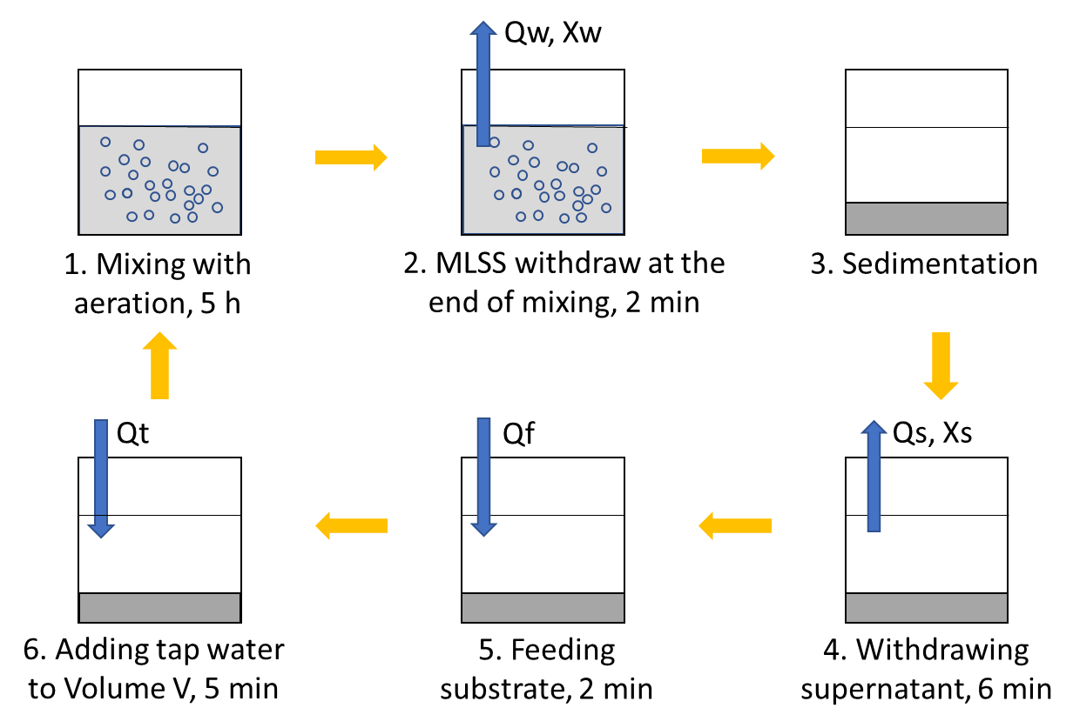

Supplementary Figure S1. Schematics of experimental setup.

Supplementary Figure S2. Rarefaction curves of the communities at different SRTs in (A) Reactors 1, (B) Reactors 2 and (C) Reactors 3.

Supplementary Figure S3. Alpha-diversity indices of the communities at different SRTs in the three reactors. Asterisk indicates significant difference among the reactors (ANOVA, p < 0.05).

Supplementary Figure S4. Hierarchical clustering (based on the Kendall’s τ similarity metric of the major OTUs at 15-d SRT) and the relative abundance of the dominant phyla at the start-up phase in (A) Reactors 1, (B) Reactors 2 and (C) Reactors 3.

Supplementary Figure S5. UPGMA dendrogram built based on unweighted UniFrac distance matrix and the sample on day 0 as the root.

Supplementary Figure S6. Relative abundance of the unshared core OTUs in the three reactors.

