Supplementary Material
Bycatch of loggerhead turtle (Caretta caretta) in the Italian Adriatic pelagic pair trawl fishery
Jacopo Pulcinella^{1*}, Sara Bonanomi^{1*}, Alessandro Colombelli¹, Caterina Maria Fortuna², Fabrizio Moro¹, Antonello Sala¹
1 Italian National Research Council (CNR), Institute of Marine Biological Resources and Biotechnologies (IRBIM), Largo Fiera della Pesca 1, 60125 Ancona, Italy
2 Italian National Institute for Environmental Protection and Research (ISPRA), via Vitaliano Brancati 60, 00144 Rome, Italy
* These authors contributed equally to this work.
Correspondence and requests for materials should be addressed to: jacopo.pulcinella@irbim.cnr.it
This document includes:
Supplementary Figure 1
Supplementary Figure 2
Supplementary Figure 3
Supplementary Figure 4
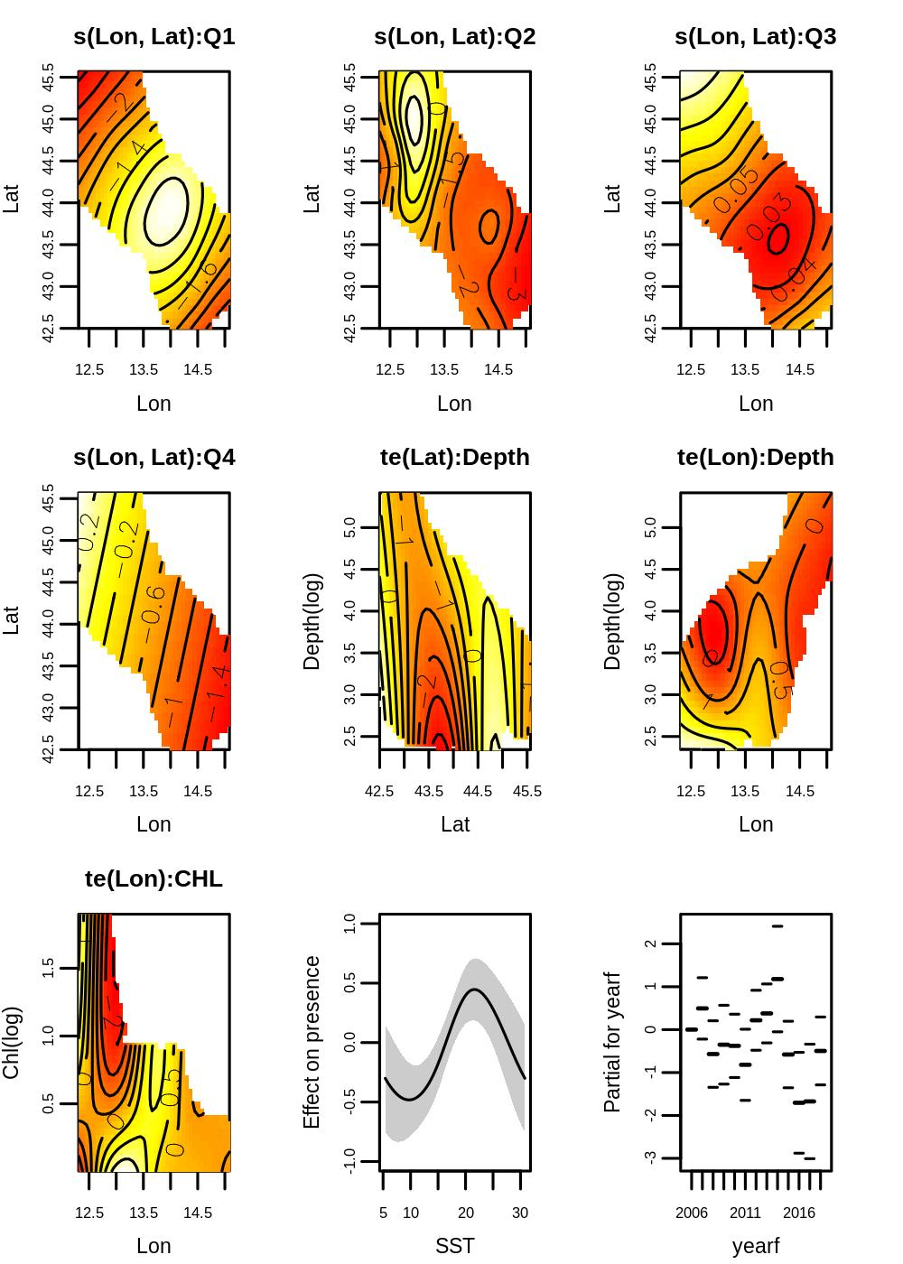
Supplementary Figure 1. Generalized additive model-derived effects of covariates used to model the presence/absence of loggerhead turtles in the northern central Adriatic Sea during 2006–2018. In the bivariate predictor map, longitude-latitude interaction by quarter, the solid line is the estimate of the smooth function. In the univariate predictor plots, the solid line is the estimate of the smooth function, and the grey area indicates 95% confidence intervals. The effect of parametric predictor is reported as boxplot, solid lines indicate the median value and dashed the 75% quantile.
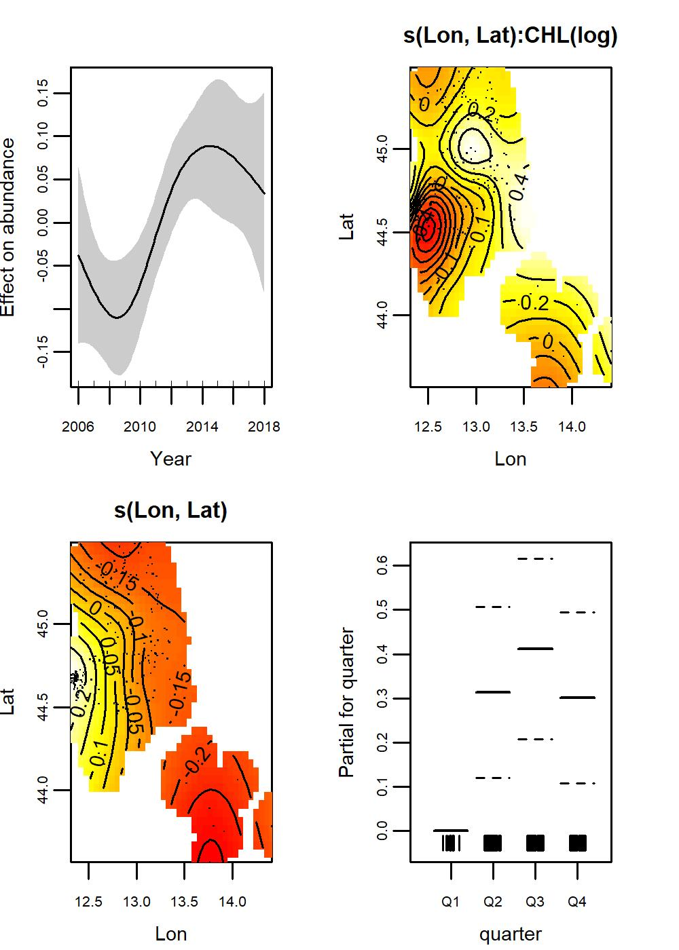
Supplementary Figure 2. Generalized additive model-derived effects of covariates used to model the abundance of loggerhead turtles in the northern central Adriatic Sea during 2006–2018. In the bivariate predictor map, longitude-latitude interaction by quarter, the solid line is the estimate of the smooth function, and the black dots indicate haul locations with positive catch. In the univariate predictor plot, the solid line is the estimate of the smooth function, the grey area indicates 95% confidence interval. The effect of parametric predictor is reported as boxplot, solid lines indicate the median value and dashed the 75% quantile.

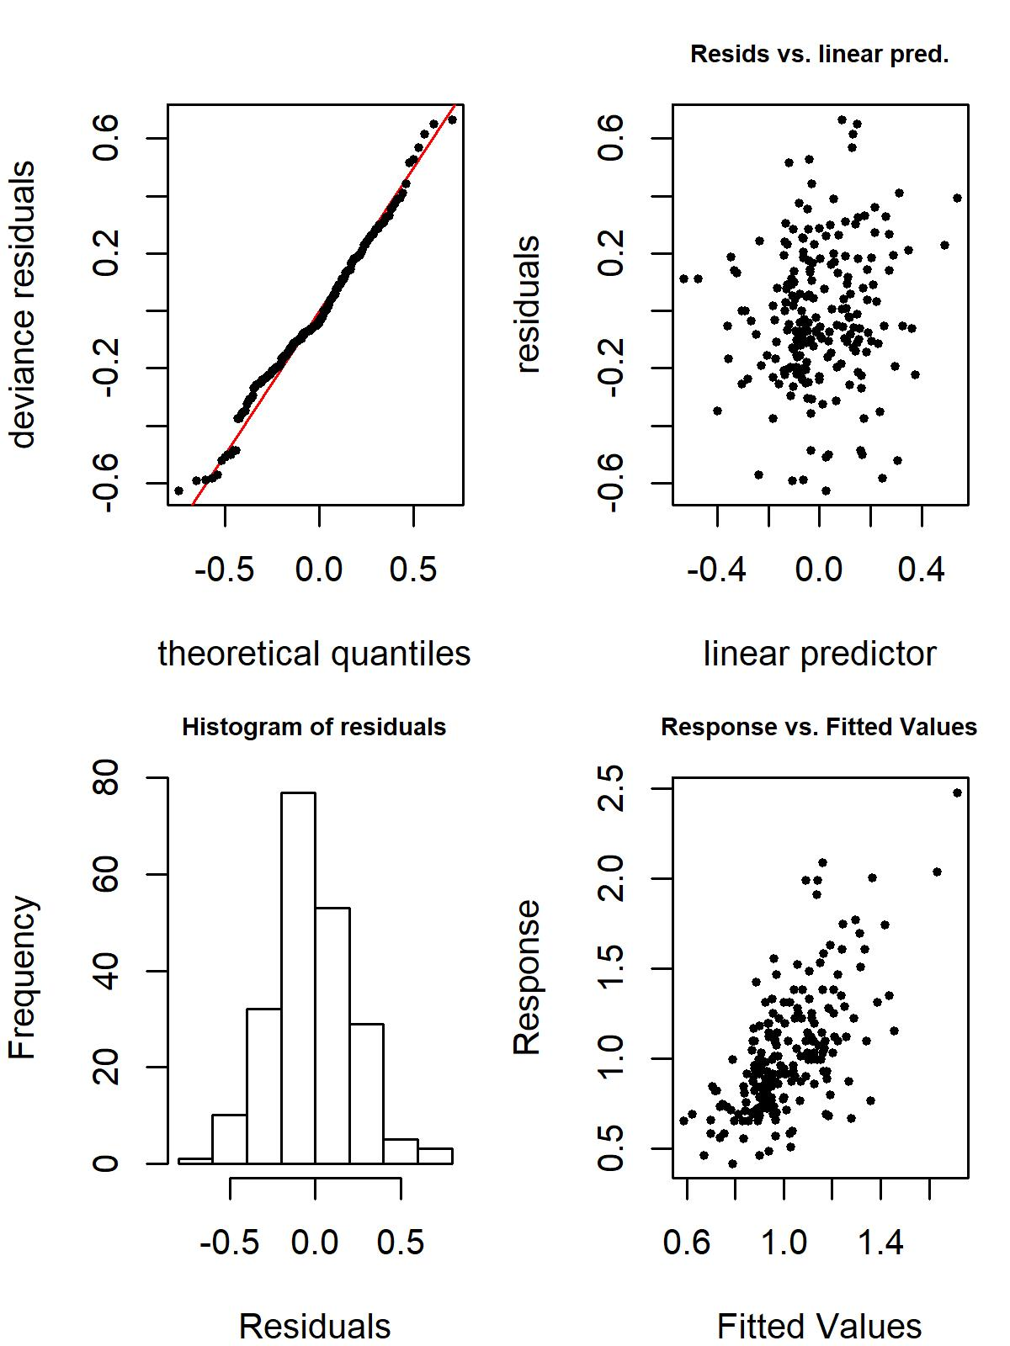
Supplementary Figure 3. Residual plots of abundance model of loggerhead turtles in the northern central Adriatic Sea during 2006–2018.
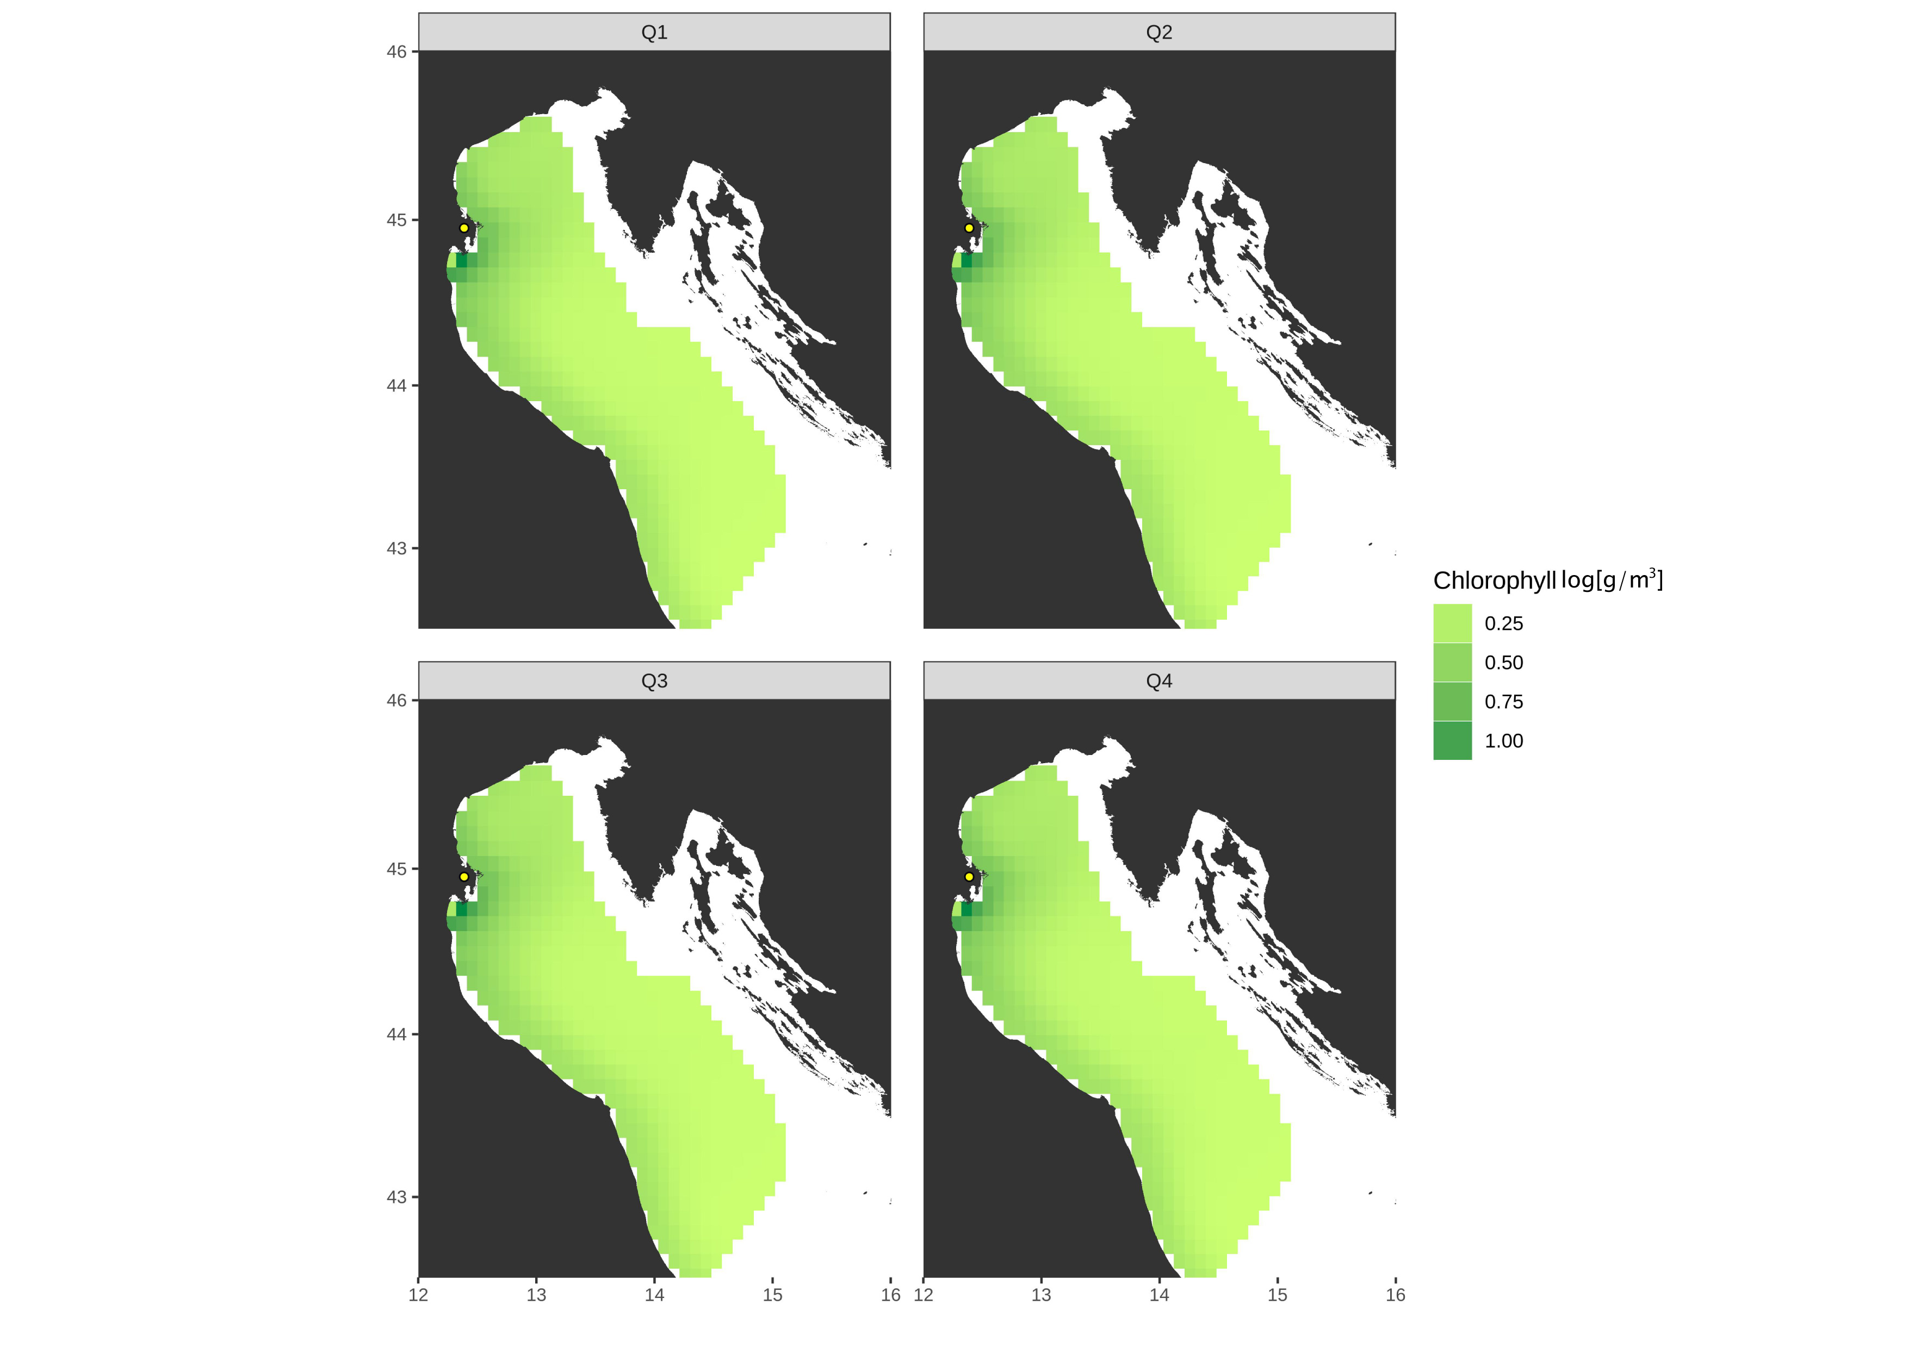Supplementary Figure 4. Distribution of Chlorophyll concentrations expressed in log[g/m³] in the northern central Adriatic Sea at quarterly base.

