Supplementary Material
Metabolic inactivity and re-awakening of a nitrate reduction dependent iron(II)-oxidizing bacterium Bacillus ferrooxidans
Guo-Wei Zhou^{1,2}, Xiao-Ru Yang^{1,}*, Regin Rønn³, Jian-Qiang Su¹, Li Cui¹, Bang-Xiao Zheng⁴, and Yong-Guan Zhu^{1,2,5}
¹Key Lab of Urban Environment and Health, Institute of Urban Environment, Chinese Academy of Sciences, Xiamen, China
²State Key Lab of Urban and Regional Ecology, Research Center for Eco-Environmental Sciences, Chinese Academy of Sciences, Beijing, China
³Department of Biology, University of Copenhagen, Copenhagen Ø, Denmark
⁴Falculty of Biological and Environmental Sciences, University of Helsinki, Lahti, Finland,
⁵College of Advanced Agricultural Sciences, University of Chinese Academy of Sciences, Beijing, China.

* Corresponding Author
Phone: (+86) 592 6190997; Fax: (+86) 592 6190977;
E-mail: xryang@iue.ac.cn

Number of figures: 6.
Number of tables: 4.

- Supplementary materials and methods
PMA incubation experiments.
In order to investigate the role of PMA in distinguishing the dead cells from living cells, five experimental treatments were set, including Bacillus ferrooxidans PMA addition, B. ferrooxidans no PMA addition, B. ferrooxidans (cell fragment) PMA addition, Enterobacter sp. (TCD1-1) PMA addition, and TCD1-1 no PMA addition (TCD1-1 was a strain isolated from a paddy soil in our lab and belonged to the genus Enterobacter).
For B. ferrooxidans PMA addition and TCD1-1 PMA addition, before PMA incubation, 650 μl (B. ferrooxidans; OD = 0.950) and 700 μl (TCD1-1; OD = 0.723) of cell suspension cultivated overnight (30 °C, R2A culture) were incubated with PMA (final concentration of PMA was 30 µmol L⁻¹ in the mixture), respectively. Then, the following operation was consistent with the method describe previously.
B. ferrooxidans no PMA addition and TCD1-1 no PMA addition represented the treatments without PMA incubation. 650 μl (B. ferrooxidans; OD = 0.950) and 700 μl (TCD1-1; OD = 0.723) of cell suspension were collected by centrifuging (14000 g, 10 min), respectively.
For B. ferrooxidans (cell fragment) PMA addition, 650 μl (B. ferrooxidans; OD = 1.350) of cell was fragmented using homogenous cruder (6.0 m s⁻¹, 40 s; FastPrep®-24, MP, America), and the cell suspension was incubated with PMA (final concentration of PMA was 30 µmol L⁻¹ in the mixture) as described above.

Measurement of ¹³CO₂ assimilation in cells
Strain B. ferrooxidans was cultivated according to the method described before with replacing NaH¹²CO₃ with NaH¹³CO₃ (¹³C 99%, Cambridge Isotope Laboratories) during the incubation. After 120-h incubation, cells of strain B. ferrooxidans in NaH¹²CO₃ and NaH¹³CO₃ added FeOB media were harvested (8000 g, 10 min), washed three times with anoxic distilled water, then air-dried cells were used for Raman spectroscopy and freeze-dried samples were used for measurement of ¹³CO₂ assimilation by GC-isotope ratio mass spectrometry (Thermo Finnigan Delta V Advantage, Bremen, Germany) (Conrad et al. 2000; Zhou et al. 2017).

Measurement of N₂O, N₂, NO₂⁻, NH₄⁺ and SOD activity
Headspace N₂O and N₂ were determined by gas chromatography with a robotized incubation system (Agilent 7890, Santa Clara, CA, US) (Molstad et al. 2007). A aliquot of 1 mL liquid sample was collected for analysis of NO₂⁻ and NH₄⁺ in the anaerobic box. After filtrated through 0.22 μm filter, the concentrations were detected by chromatography (Dionex ICS-3000 system, Diones, Sunnyvale, CA, USA) (Zhou et al. 2019). Cells were collected from R2A and FeOM after 12 hours of cultivation at 30 °C in the anaerobic, and SOD activity were analyzed using the xanthine–xanthine oxidase-nitroblue tetrazolium method (Miyatake and Iwabuchi 2005).
- Supplementary Figures and Tables
  - Supplementary Figures
Figure S1. Images of B. ferrooxidans (YT-3) cultured on the Fe(II)-oxidizing and R2A plates at 30 °C in the anaerobic box. The “Abiotic FeO plate” represented the Fe(II)-oxidizing agar plate and was used as a control setup on which no cells were inoculated.
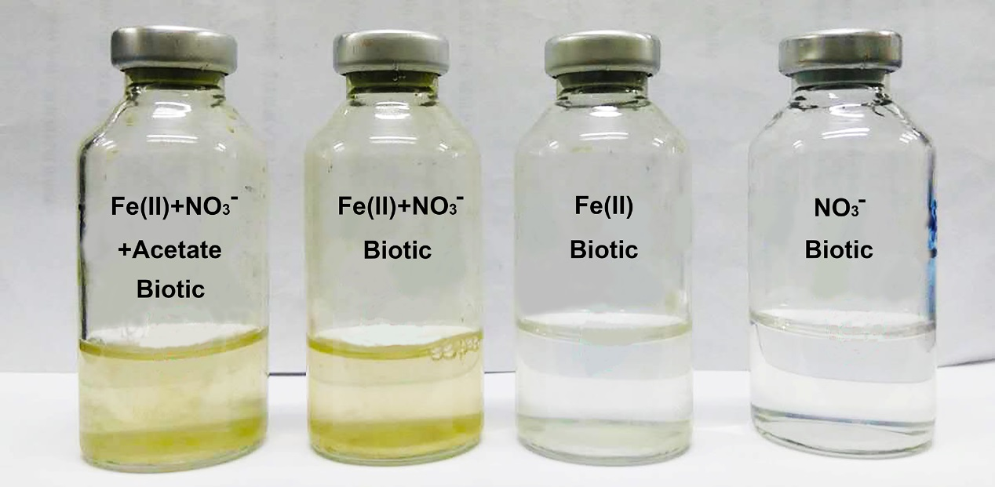

Figure S2. Images of B. ferrooxidans cultured in the different medium at 30 °C in the anaerobic box. Fe(II) + NO₃⁻ + Acetate represented the medium contained ferrous iron, nitrate and acetate. Fe(II) + NO₃⁻ represented the medium contained ferrous iron and nitrate. Fe(II) represented the medium contained ferrous iron. NO₃⁻ represented the medium contained NaNO₃.
Figure S3. Images of B. ferrooxidans cultured in the Fe(II)-oxidizing medium inoculated with different densities of cells at 30 °C in the anaerobic box.
Figure S4. Kinetics of ferrous iron (A), nitrate reduction (B) and acetate (C) in the incubation of different medium. Fe(II) + NO₃⁻ + Acetate represented the medium contained ferrous iron, nitrate and acetate. Fe(II) + NO₃⁻ represented the medium contained ferrous iron and nitrate. The error bars represent standard deviations of three replications.

Figure S5. Raman spectra of B. ferrooxidans cells cultured in FeOB media added with NaH¹²CO₃ (12C) and NaH¹³CO₃ (13C). 745, 1130, 1318 and 1587 cm⁻¹ were characteristic bands of cytochrome c. The shade of light blue represented the characteristic bands of phenylalanine. Shift of band from 1004 cm⁻¹ to 972 cm⁻¹ was observed in these two setups.
Figure S6. Gene copy numbers of bacterial 16S rRNA in six setups (B. ferrooxidans PMA addition, B. ferrooxidans no PMA addition, B. ferrooxidans (cell fragment) PMA addition, TCD1-1 PMA addition and TCD1-1 no PMA addition).

- Supplementary Tables
Table S1. Primers and qPCR processes used in this study.
Genes | Primers  (sequences 5’-3’) |  | qPCR processes | References | length
narG | NarG1960f | TAYGTSGGSCARGARAA | 5 min at 95°C, followed by 40 cycles of 30 s at 95°C, 40 s at 58°C and 40 s at 72°C. | (Zhang et al. 2014) | 420 bp
 | NarG2650r | TTYTCRTACCABGTAGC
nasA | nasA964  nasA1735 | CARCCNAAYGCNATGGG  ATNGTRTGCCAYTGRTC | 5 min at 95°C, followed by 40 cycles of 30 s at 95°C, 40 s at 60°C and 35 s at 72°C. | (Allen et al. 2001) | 756 bp
nosZ | nosZ-F  nosZ-1622R | CGYTGTTCMTCGACAGCCAG  CGSACCTTSTTGCCSTYGCG | 5 min at 95°C, followed by 40 cycles of 15 s at 95°C, 15 s at 60°C and 34 s at 72°C. | (Kandeler et al. 2006) | 435 bp
Table S2. Concentrations of N₂O and N₂ produced from setups in the FeOM after 120-hour incubation.
Setups | N₂O (mmol L⁻¹) | N₂ (mmol L⁻¹)
Control (Sterile) | ND | ND
B. ferrooxidans (1×) | 0.14 ± 0.021 | 0.12 ± 0.052
ND: not detected.

Table S3. Values of ¹³C/total carbon in cells of strain B. ferroxidans cultivated in FeOB media added with NaH¹²CO₃ and NaH¹³CO₃.
Setups | Value
Cells in NaH¹²CO₃-added medium | 0.0107 ± 0.0000100
Cells in NaH¹³CO₃-added medium | 0.0134 ± 0.0000770*
* indicate significant difference between the treatments at P < 0.05 using independent samples t-test.

Table S4. SOD activity of cells in two setups.
Setups | SOD activity (U mg⁻¹ protein)
Cells from R2A | 13.22 ± 1.68
Cells from ANDFO | 38.75 ± 5.45*

*indicate significant difference between the treatments at P < 0.05 using independent samples t-test.

- Supplementary References
Allen, A. E., Booth, M. G., Frischer, M. E., Verity, P. G., Zehr, J. P., and Zani, S. (2001). Diversity and detection of nitrate assimilation genes in marine bacteria. Appl. Environ. Microbiol. 67, 5343-5348. doi: 10.1128/AEM.67.11.5343-5348.2001.
Conrad, R., Klose, M., and Claus, P. (2000). Phosphate inhibits acetotrophic methanogenesis on rice roots. Appl. Environ. Microbiol. 66, 828-831. doi: 10.1128/AEM.66.2.828-831.2000.
Kandeler, E., Deiglmayr, K., Tscherko, D., Bru, D., and Philippot, L. (2006). Abundance of narG, nirS, nirK, and nosZ genes of denitrifying bacteria during primary successions of a glacier foreland. Appl. Environ. Microbiol. 72, 5957-5962. doi: 10.1128/AEM.00439-06.
Miyatake, F., and Iwabuchi, K. (2005). Effect of high compost temperature on enzymatic activity and species diversity of culturable bacteria in cattle manure compost. Bioresour. Technol. 96, 1821-1825. doi: 10.1016/j.biortech.2005.01.005.
Molstad, L., Dorsch, P., and Bakken, L. R. (2007). Robotized incubation system for monitoring gases (O₂, NO, N₂O and N₂) in denitrifying cultures. J. Microbiol. Meth. 71, 202-211. doi: DOI: 10.1016/j.mimet.2007.08.011.
Zhang, H., Wang, H., Yang, K., Sun, Y., Tian, J., and Lv, B. (2014). Nitrate removal by a novel autotrophic denitrifier (Microbacterium sp.) using Fe(II) as electron donor. Ann. Microbiol. 65, 1069-1078. doi: 10.1007/s13213-014-0952-6.
Zhou, G. W., Yang, X. R., Marshall, C. W., Li, H., Zheng, B. X., Yan, Y., et al. (2017). Biochar addition increases the rates of dissimilatory iron reduction and methanogenesis in ferrihydrite enrichments. Front. Microbiol. 8, 589. doi: 10.3389/fmicb.2017.00589.
Zhou, G. W., Yang, X. R., Sun, A. Q., Li, H., Lassen, S. B., Zheng, B. X., et al. (2019). Mobile Incubator for Iron(III) Reduction in the Gut of the Soil-Feeding Earthworm Pheretima guillelmi and Interaction with Denitrification. Environ. Sci. Technol. Lett. doi: 10.1021/acs.est.8b06187.

