Nitrogen addition increases the sensitivity of photosynthesis to drought and re-watering differentially in C₃ versus C₄ grass species
Shangzhi Zhong¹, Yueqiao Xu¹, Bo Meng¹ Michael E. Loik², Jian-Ying Ma^{3,*} and Wei Sun^{1,*}
¹ Key Laboratory of Vegetation Ecology, Ministry of Education, Institute of Grassland Science, Northeast Normal University, Changchun, Jilin Province, P. R. China 130024
² Environmental Studies Department, University of California, Santa Cruz, CA 95064, USA
³ Key Laboratory of Biogeography and Bioresources in Arid Land, Xinjiang Institute of Ecology and Geography, Chinese Academy of Sciences, Urumqi, P. R. China, 830011

*Corresponding author
Jian-Ying Ma
Xinjiang Institute of Ecology and Geography, Chinese Academy of Sciences
Urumqi, 830011, China
Tel.: +86 991 7885425
E-mail address: jyma@ms.xjb.ac.cn
Wei Sun
Key Laboratory for Vegetation Ecology, Ministry of Education
Institute of Grassland Science, Northeast Normal University
Changchun, Jilin Province, P. R. China 130024
Tel.: +86 431 8509 8187

E-mail address: sunwei@nenu.edu.cn

Supplementary Figure 1. Timeline figure indicates the dates and age of plants after germinating under different treatment periods of the whole experiment.
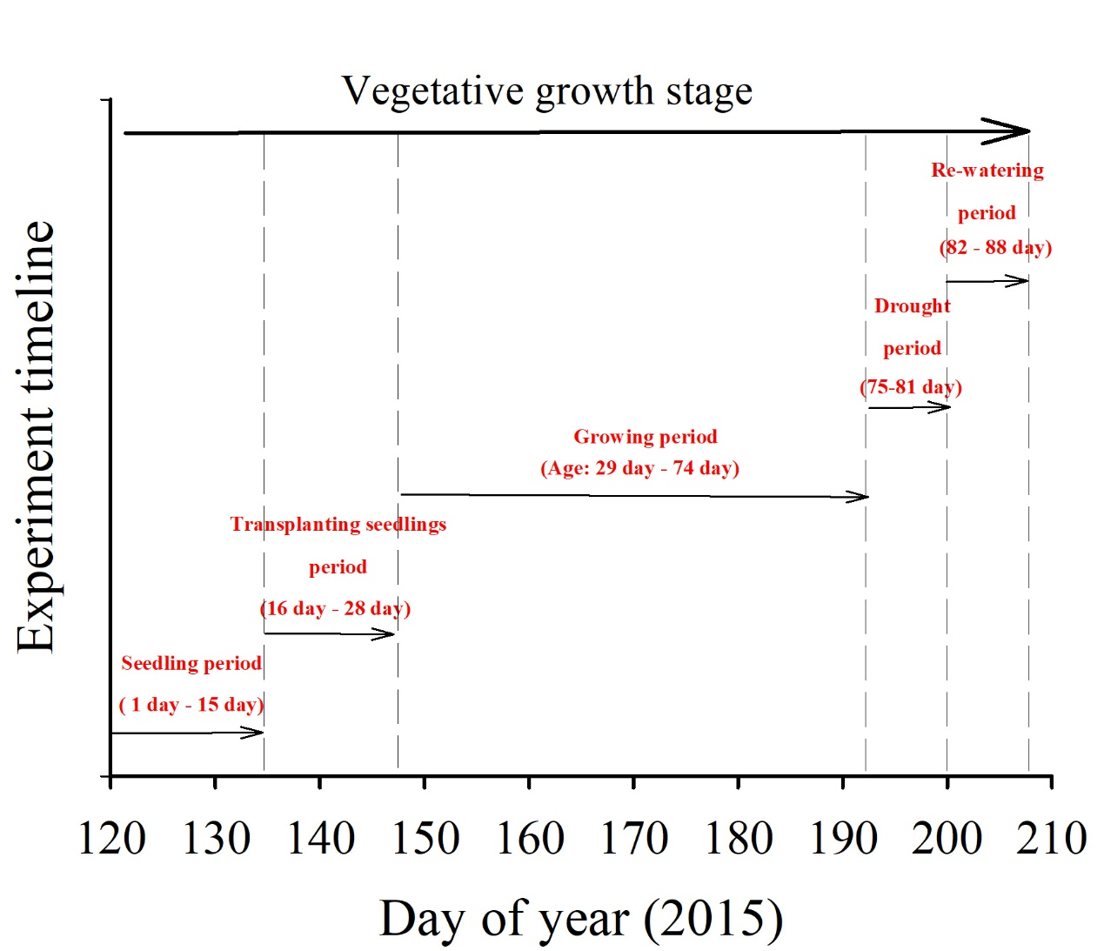
Supplementary Figure 2. Meteorological data: (a) diurnal mean air temperature, (b) diurnal photosynthetic photon flux density, (c) diurnal mean air relative humidity and (d) diurnal mean air water vapor pressure on the days 1, 3, 5, 7 and 14 of the drought/re-watering treatment.
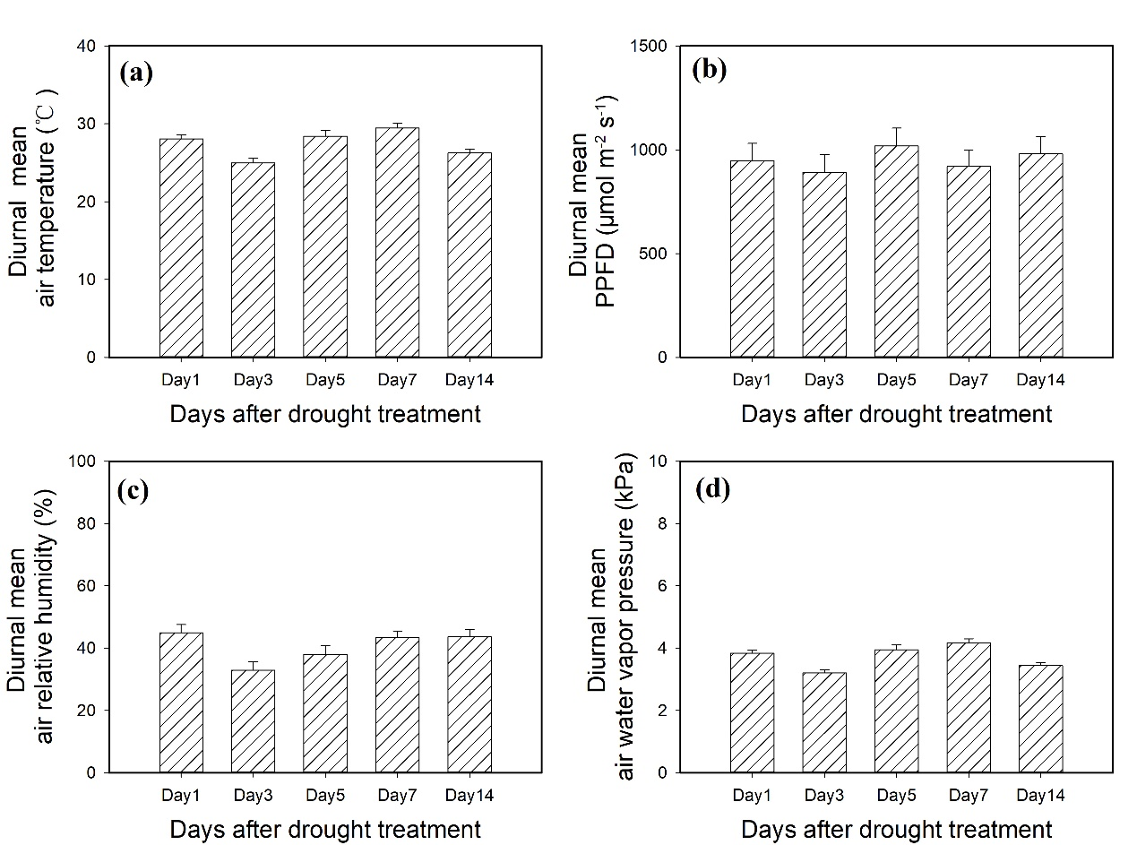

Supplementary Figure 3. Leaf nitrogen content in Chloris virgata (annual C₄), Hemarthria altissima (perennial C₄) and Leymus chinensis (perennial C₃) grown in the unfertilized (N0) and fertilized (N10) conditions. “*” represents significant differences between the N treatments (P < 0.05). Data are reported as the arithmetic mean ± 1 standard error (n=6).
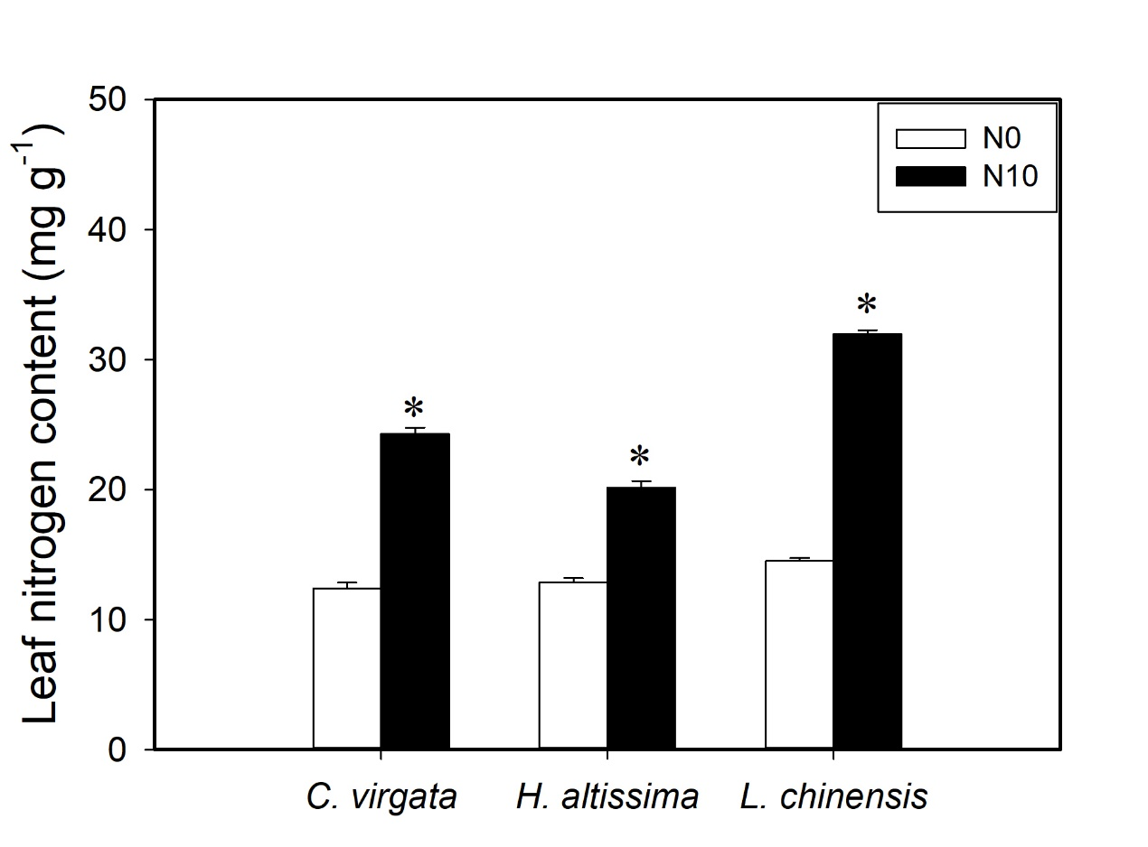

Supplementary Figure 4. (a) Plant height and (b) total biomass in Chloris virgata (annual C₄), Hemarthria altissima (perennial C₄) and Leymus chinensis (perennial C₃) grown in the unfertilized (N0) and fertilized (N10) conditions. “*” represents significant differences between the N treatments (P < 0.05). Data are reported as the arithmetic mean ± 1 standard error (n=6).
