Supplementary Material

Supplementary Figure 1.
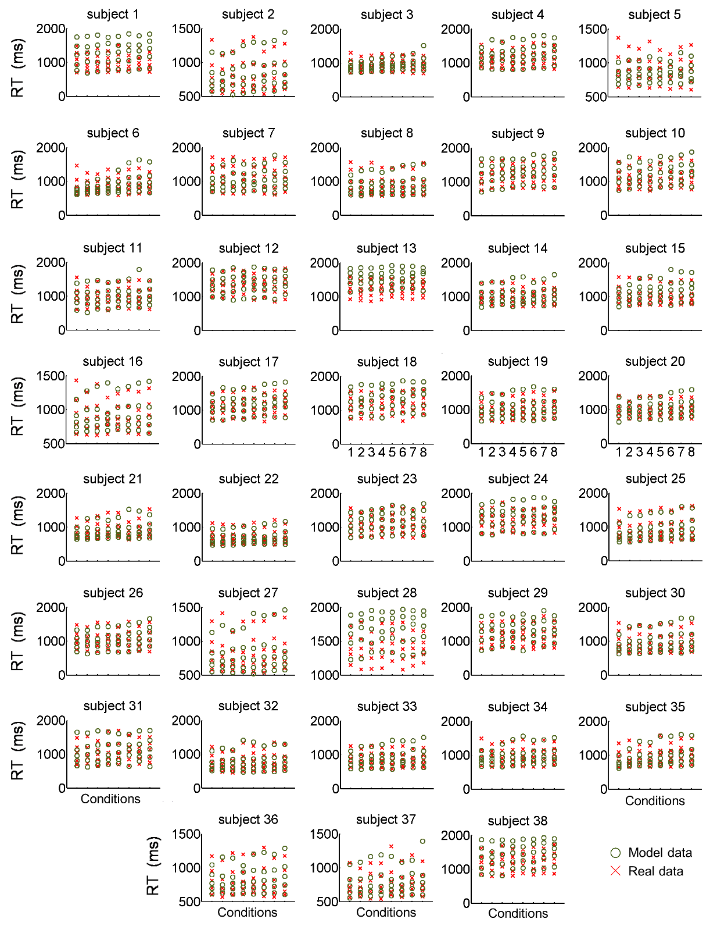

Single subject quantile probability plots. Quantile reaction times (RTs) for the .1, .3, .5, .7, and .9 quantiles (stacked vertically) are plotted for each experimental condition and for each subject. Predicted RTs (model data) are represented by the green circles, and collected RTs (real data) are the red crosses. RTs are expressed in milliseconds (ms).

Supplementary Table 1.

Statistics
Factor
 | logRTc |  |  |  | d’
BEN | F_{1,32 =} 2.09 |  | p = .158 |  | F_{1,32 =} 1.69 | p = .203
PAY | F_{1,32 =} 0.67 |  | p = .418 |  | F_{1,32 =} 2.61 | p = .116
DIF | F_{2,64 =} 34.7 |  | p < .000001 |  | F_{2,64 =} 25.1 | p < .000001
BEN * PAY | F_{2,64 =} 0.66 |  | p = .423 |  | F_{2,64 =} 0.09 | p = .766
BEN * DIF | F_{2,64 =} 0.03 |  | p = .971 |  | F_{2,64 =} 0.95 | p = .392
PAY * DIF | F_{2,64 =} 7.26 |  | p = .0014 |  | F_{2,64 =} 4.54 | p = .014
BEN * PAY * DIF | F_{2,64 =} 4.01 |  | p = .023 |  | F_{2,64 =} 1.99 | p = .144
When the other is anonymous, the main effect of beneficiary is not significant on reaction times and on sensitivity (d’). There were three difficulty levels (13%, 15%, and 17% of dot coherence) in this version. Otherwise, factors were identical. The analysis was performed on logarithmically transformed reaction times from correct trials (logRTc) on 33 participants. BEN: Beneficiary; PAY: Payoff; DIF: Difficulty.

Supplementary Table 2.

Statistics
Factor
 | logRTc |  | d’
 | F_{1,37} | p | F_{1,37} | p
Gender | 1.10 | .302 | .075 | .785
BEN * Gender | 2.26 | .141 | .378 | .543
PAY * Gender | 1.23 | .274 | .235 | .631
DIF * Gender | 1.14 | .294 | .253 | .618
BEN * PAY * Gender | 0.00 | .992 | .636 | .430
BEN * DIF * Gender | 0.16 | .689 | .515 | .478
PAY * DIF * Gender | 1.24 | .273 | 1.35 | .253
BEN * PAY * DIF * Gender | 1.75 | .194 | .261 | .612
There was no effect of gender on reaction times (RT) or on sensitivity (d’), and in interaction with any of our three factors (BEN: Beneficiary; PAY: Payoff; DIF: Difficulty). The analysis was performed on logarithmically transformed reaction times from correct trials (logRTc).

Supplementary Table 3.

 | Condition
 | Self |  |  |  | Other
 | Low |  | High |  | Low |  | High
 | Easy | Difficult | Easy | Difficult | Easy | Difficult | Easy | Difficult
v | .049 | .061 | .233 | > .5 | .232 | .001 | .001 | .017
a | .284 | > .5 | .035 | .405 | .368 | .001 | > .5 | .005
Ter | .003 | .193 | .007 | .084 | .289 | .004 | .088 | .003
Log(v) | .273 | > .5 | > .5 | .301 | > .5 | .210 | .459 | .004
Log(a) | > .5 | .298 | > .5 | .195 | .063 | .485 | .052 | .151
Log(Ter) | .140 | > .5 | > .5 | .001 | > .5 | .389 | > .5 | .194
Log transformation effectively normalized parameter distributions. P values of the (Lilliefors) normality tests performed on the DDM estimated parameters and their logarithmic transformation. v: drift rate; a: boundary; Ter: non-decision time. Log(): logarithmic transformation.

