Culicidae of the Dutch caribbean
Sam Boerlijst
25 juli 2018

Load libraries and attach dataset
library(car)
## Warning: package 'car' was built under R version 3.4.4
## Loading required package: carData
## Warning: package 'carData' was built under R version 3.4.4
library(formatR)
## Warning: package 'formatR' was built under R version 3.4.3
library(ggplot2)
## Warning: package 'ggplot2' was built under R version 3.4.4
library(plotly)
## Warning: package 'plotly' was built under R version 3.4.4
##
## Attaching package: 'plotly'
## The following object is masked from 'package:ggplot2':
##
## last_plot
## The following object is masked from 'package:stats':
##
## filter
## The following object is masked from 'package:graphics':
##
## layout
library(readr)
## Warning: package 'readr' was built under R version 3.4.4

change species to factors
library(readr)
dataset1 <- read_delim("C:/Users/sboer/Desktop/18022 heranalyse/blast and concat/dataset.csv",
",", escape_double = FALSE, col_types = cols(Aedes = col_factor(levels = c("1",
"0")), Aedes_aegypti = col_factor(levels = c("1",
"0")), Aedes_busckii = col_factor(levels = c("1",
"0")), Chironomus = col_skip(), Chironomus_calligraphus = col_skip(),
Culex = col_factor(levels = c("1",
"0")), Culex_bahamensis = col_factor(levels = c("1",
"0")), Culex_bisulcatus = col_factor(levels = c("1",
"0")), Culex_pipiens_molestus = col_factor(levels = c("1",
"0")), Culex_quinquefasciatus = col_factor(levels = c("1",
"0")), Culex_renatoi = col_factor(levels = c("1",
"0")), Culicoides = col_factor(levels = c("1",
"0")), Toxorhinchites = col_factor(levels = c("1",
"0")),volume = col_number(), subsamples = col_integer(),
method = col_factor(levels = c("morphological",
"unoise", "vsearch")), waterbody = col_factor(levels = c("well",
"pond", "pool", "lake", "ditch", "plant container", "rockpool",
"cistern", "artificial container", "treehole", "sink")), ioncode = col_factor(levels = c("201", "202", "203", "204", "205", "206", "207", "208", "209", "210", "211", "212", "213", "214", "215", "216", "217", "218", "219", "220", "221", "222", "223", "224", "225", "226", "227", "228", "229", "230", "231", "232", "233", "234", "235", "236", "237", "238", "239", "240", "241", "242", "243", "244", "245", "246", "247", "248", "249", "250", "251", "252", "253", "254", "255", "256", "257", "258", "259", "260", "261", "262", "263", "264", "265", "266", "267", "268", "269", "270", "271", "272", "273", "274", "275", "276", "277", "278"))), na = "NA",
trim_ws = TRUE)
summary(dataset1)
## ioncode method waterbody
## 201 : 3 morphological:78 plant container :51
## 202 : 3 unoise :78 pond :45
## 203 : 3 vsearch :78 artificial container:36
## 204 : 3 treehole :27
## 205 : 3 ditch :24
## 206 : 3 (Other) :48
## (Other):216 NA's : 3
## volume subsamples Aedes_aegypti Aedes_busckii
## Min. : 0.0 Min. : 1.00 1: 13 1: 5
## 1st Qu.: 40.0 1st Qu.: 1.00 0:221 0:229
## Median :100.0 Median : 1.00
## Mean :103.1 Mean : 3.78
## 3rd Qu.:177.5 3rd Qu.: 6.00
## Max. :220.0 Max. :20.00
## NA's :30 NA's :57
## Culex_bahamensis Culex_bisulcatus Culex_pipiens_molestus
## 1: 7 1: 6 1: 1
## 0:227 0:228 0:233
##
##
##
##
##
## Culex_quinquefasciatus Culex_renatoi Toxorhinchites Culicoides Aedes
## 1: 49 1: 8 1: 2 1: 5 1: 3
## 0:185 0:226 0:232 0:229 0:231
##
##
##
##
##
## Culex
## 1: 36
## 0:198
##
##
##
##
##

attach(dataset1)
table(method,Aedes_aegypti)
## Aedes_aegypti
## method 1 0
## morphological 2 76
## unoise 4 74
## vsearch 7 71
table(method, Aedes_busckii)
## Aedes_busckii
## method 1 0
## morphological 1 77
## unoise 2 76
## vsearch 2 76
table(method, Culex_bahamensis)
## Culex_bahamensis
## method 1 0
## morphological 1 77
## unoise 3 75
## vsearch 3 75
table(method, Culex_bisulcatus)
## Culex_bisulcatus
## method 1 0
## morphological 5 73
## unoise 0 78
## vsearch 1 77
table(method, Culex_pipiens_molestus)
## Culex_pipiens_molestus
## method 1 0
## morphological 0 78
## unoise 0 78
## vsearch 1 77
table(method, Culex_quinquefasciatus)
## Culex_quinquefasciatus
## method 1 0
## morphological 3 75
## unoise 23 55
## vsearch 23 55
table(method, Culex_renatoi)
## Culex_renatoi
## method 1 0
## morphological 0 78
## unoise 4 74
## vsearch 4 74
table(method, Aedes)
## Aedes
## method 1 0
## morphological 3 75
## unoise 0 78
## vsearch 0 78
table(method, Culex)
## Culex
## method 1 0
## morphological 9 69
## unoise 14 64
## vsearch 13 65
table(method, Culicoides)
## Culicoides
## method 1 0
## morphological 0 78
## unoise 3 75
## vsearch 2 76
table(method, Toxorhinchites)
## Toxorhinchites
## method 1 0
## morphological 0 78
## unoise 1 77
## vsearch 1 77
#overal more detections with eDNA

Detection probabilities
chi.table.aegypt <- xtabs(~method+Aedes_aegypti, data=dataset1)
chi.test.aegypt <- chisq.test(chi.table.aegypt, correct=FALSE)
## Warning in chisq.test(chi.table.aegypt, correct = FALSE): Chi-squared
## approximation may be incorrect
print(chi.table.aegypt)
## Aedes_aegypti
## method 1 0
## morphological 2 76
## unoise 4 74
## vsearch 7 71
print(chi.test.aegypt)
##
## Pearson's Chi-squared test
##
## data: chi.table.aegypt
## X-squared = 3.095, df = 2, p-value = 0.2128
chi.table.busckii <- xtabs(~method+Aedes_busckii, data=dataset1)
chi.test.busckii <- chisq.test(chi.table.busckii, correct=FALSE)
## Warning in chisq.test(chi.table.busckii, correct = FALSE): Chi-squared
## approximation may be incorrect
print(chi.table.busckii)
## Aedes_busckii
## method 1 0
## morphological 1 77
## unoise 2 76
## vsearch 2 76
print(chi.test.busckii)
##
## Pearson's Chi-squared test
##
## data: chi.table.busckii
## X-squared = 0.40873, df = 2, p-value = 0.8152
chi.table.bahamensis <- xtabs(~method+Culex_bahamensis, data=dataset1)
chi.test.bahamensis <- chisq.test(chi.table.bahamensis, correct=FALSE)
## Warning in chisq.test(chi.table.bahamensis, correct = FALSE): Chi-squared
## approximation may be incorrect
print(chi.table.bahamensis)
## Culex_bahamensis
## method 1 0
## morphological 1 77
## unoise 3 75
## vsearch 3 75
print(chi.test.bahamensis)
##
## Pearson's Chi-squared test
##
## data: chi.table.bahamensis
## X-squared = 1.1781, df = 2, p-value = 0.5549
chi.table.bisulcatus <- xtabs(~method+Culex_bisulcatus, data=dataset1)
chi.test.bisulcatus <- chisq.test(chi.table.bisulcatus, correct=FALSE)
## Warning in chisq.test(chi.table.bisulcatus, correct = FALSE): Chi-squared
## approximation may be incorrect
print(chi.table.bisulcatus)
## Culex_bisulcatus
## method 1 0
## morphological 5 73
## unoise 0 78
## vsearch 1 77
print(chi.test.bisulcatus)
##
## Pearson's Chi-squared test
##
## data: chi.table.bisulcatus
## X-squared = 7.1842, df = 2, p-value = 0.02754
chi.table.pipiens_molestus <- xtabs(~method+Culex_pipiens_molestus, data=dataset1)
chi.test.pipiens_molestus <- chisq.test(chi.table.pipiens_molestus, correct=FALSE)
## Warning in chisq.test(chi.table.pipiens_molestus, correct = FALSE): Chi-
## squared approximation may be incorrect
print(chi.table.pipiens_molestus)
## Culex_pipiens_molestus
## method 1 0
## morphological 0 78
## unoise 0 78
## vsearch 1 77
print(chi.test.pipiens_molestus)
##
## Pearson's Chi-squared test
##
## data: chi.table.pipiens_molestus
## X-squared = 2.0086, df = 2, p-value = 0.3663
chi.table.quinquefasciatus <- xtabs(~method+Culex_quinquefasciatus, data=dataset1)
chi.test.quinquefasciatus <- chisq.test(chi.table.quinquefasciatus, correct=FALSE)
print(chi.table.quinquefasciatus)
## Culex_quinquefasciatus
## method 1 0
## morphological 3 75
## unoise 23 55
## vsearch 23 55
print(chi.test.quinquefasciatus)
##
## Pearson's Chi-squared test
##
## data: chi.table.quinquefasciatus
## X-squared = 20.651, df = 2, p-value = 3.279e-05
chi.table.renatoi <- xtabs(~method+Culex_renatoi, data=dataset1)
chi.test.renatoi <- chisq.test(chi.table.renatoi, correct=FALSE)
## Warning in chisq.test(chi.table.renatoi, correct = FALSE): Chi-squared
## approximation may be incorrect
print(chi.table.renatoi)
## Culex_renatoi
## method 1 0
## morphological 0 78
## unoise 4 74
## vsearch 4 74
print(chi.test.renatoi)
##
## Pearson's Chi-squared test
##
## data: chi.table.renatoi
## X-squared = 4.1416, df = 2, p-value = 0.1261
chi.table.Toxorhinchites <- xtabs(~method+Toxorhinchites, data=dataset1)
chi.test.Toxorhinchites <- chisq.test(chi.table.Toxorhinchites, correct=FALSE)
## Warning in chisq.test(chi.table.Toxorhinchites, correct = FALSE): Chi-
## squared approximation may be incorrect
print(chi.table.Toxorhinchites)
## Toxorhinchites
## method 1 0
## morphological 0 78
## unoise 1 77
## vsearch 1 77
print(chi.test.Toxorhinchites)
##
## Pearson's Chi-squared test
##
## data: chi.table.Toxorhinchites
## X-squared = 1.0086, df = 2, p-value = 0.6039
chi.table.Culicoides <- xtabs(~method+Culicoides, data=dataset1)
chi.test.Culicoides <- chisq.test(chi.table.Culicoides, correct=FALSE)
## Warning in chisq.test(chi.table.Culicoides, correct = FALSE): Chi-squared
## approximation may be incorrect
print(chi.table.Culicoides)
## Culicoides
## method 1 0
## morphological 0 78
## unoise 3 75
## vsearch 2 76
print(chi.test.Culicoides)
##
## Pearson's Chi-squared test
##
## data: chi.table.Culicoides
## X-squared = 2.8611, df = 2, p-value = 0.2392
chi.table.Aedes <- xtabs(~method+Aedes, data=dataset1)
chi.test.Aedes <- chisq.test(chi.table.Aedes, correct=FALSE)
## Warning in chisq.test(chi.table.Aedes, correct = FALSE): Chi-squared
## approximation may be incorrect
print(chi.table.Aedes)
## Aedes
## method 1 0
## morphological 3 75
## unoise 0 78
## vsearch 0 78
print(chi.test.Aedes)
##
## Pearson's Chi-squared test
##
## data: chi.table.Aedes
## X-squared = 6.0779, df = 2, p-value = 0.04788
chi.table.Culex <- xtabs(~method+Culex, data=dataset1)
chi.test.Culex <- chisq.test(chi.table.Culex, correct=FALSE)
print(chi.table.Culex)
## Culex
## method 1 0
## morphological 9 69
## unoise 14 64
## vsearch 13 65
print(chi.test.Culex)
##
## Pearson's Chi-squared test
##
## data: chi.table.Culex
## X-squared = 1.3788, df = 2, p-value = 0.5019

bisulcates and quinquefasciatus differ significantly in detection over the different methods.

With bisulcatus being better detectable my morphology and quinquefasciatus by eDNA.

The lower detection of bisulcatus for eDNA may be caused by a shortage of public sequences, since in all samples where it was not detected, Culex DNA with an insufficient hit for species level identification was detected.

A logit will be used since it’s binary data containing rare events, which would normally bias the coefficients

simple glm’s
glmaegypti<- glm(Aedes_aegypti~method, data=dataset1, family=binomial(link="logit"))
glmbusckii<- glm(Aedes_busckii~method, data=dataset1, family=binomial(link="logit"))
glmbahamensis<- glm(Culex_bahamensis~method, data=dataset1, family=binomial(link="logit"))
glmbisulcatius<- glm(Culex_bisulcatus~method, data=dataset1, family=binomial(link="logit"))
glmpipiens<- glm(Culex_pipiens_molestus~method, data=dataset1, family=binomial(link="logit"))
glmquinq<- glm(Culex_quinquefasciatus~method, data=dataset1, family=binomial(link="logit"))
glmrenatoi<- glm(Culex_renatoi~method, data=dataset1, family=binomial(link="logit"))
glmaedes<- glm(Aedes~method, data=dataset1, family=binomial(link="logit"))
glmculex<- glm(Culex~method, data=dataset1, family=binomial(link="logit"))
glmculicoides<- glm(Culicoides~method, data=dataset1, family=binomial(link="logit"))
glmtoxorhinchites<- glm(Toxorhinchites~method, data=dataset1, family=binomial(link="logit"))
summary(glmaegypti)
##
## Call:
## glm(formula = Aedes_aegypti ~ method, family = binomial(link = "logit"),
## data = dataset1)
##
## Deviance Residuals:
## Min 1Q Median 3Q Max
## -2.7069 0.2279 0.3245 0.4337 0.4337
##
## Coefficients:
## Estimate Std. Error z value Pr(>|z|)
## (Intercept) 3.6376 0.7163 5.078 3.81e-07 ***
## methodunoise -0.7198 0.8813 -0.817 0.414
## methodvsearch -1.3208 0.8186 -1.614 0.107
## ---
## Signif. codes: 0 '***' 0.001 '**' 0.01 '*' 0.05 '.' 0.1 ' ' 1
##
## (Dispersion parameter for binomial family taken to be 1)
##
## Null deviance: 100.41 on 233 degrees of freedom
## Residual deviance: 97.26 on 231 degrees of freedom
## AIC: 103.26
##
## Number of Fisher Scoring iterations: 6
summary(glmbusckii)
##
## Call:
## glm(formula = Aedes_busckii ~ method, family = binomial(link = "logit"),
## data = dataset1)
##
## Deviance Residuals:
## Min 1Q Median 3Q Max
## -2.9518 0.1606 0.2279 0.2279 0.2279
##
## Coefficients:
## Estimate Std. Error z value Pr(>|z|)
## (Intercept) 4.3438 1.0065 4.316 1.59e-05 ***
## methodunoise -0.7062 1.2354 -0.572 0.568
## methodvsearch -0.7062 1.2354 -0.572 0.568
## ---
## Signif. codes: 0 '***' 0.001 '**' 0.01 '*' 0.05 '.' 0.1 ' ' 1
##
## (Dispersion parameter for binomial family taken to be 1)
##
## Null deviance: 48.351 on 233 degrees of freedom
## Residual deviance: 47.906 on 231 degrees of freedom
## AIC: 53.906
##
## Number of Fisher Scoring iterations: 7
summary(glmbahamensis)
##
## Call:
## glm(formula = Culex_bahamensis ~ method, family = binomial(link = "logit"),
## data = dataset1)
##
## Deviance Residuals:
## Min 1Q Median 3Q Max
## -2.9518 0.1606 0.2801 0.2801 0.2801
##
## Coefficients:
## Estimate Std. Error z value Pr(>|z|)
## (Intercept) 4.344 1.006 4.316 1.59e-05 ***
## methodunoise -1.125 1.166 -0.965 0.335
## methodvsearch -1.125 1.166 -0.965 0.335
## ---
## Signif. codes: 0 '***' 0.001 '**' 0.01 '*' 0.05 '.' 0.1 ' ' 1
##
## (Dispersion parameter for binomial family taken to be 1)
##
## Null deviance: 62.920 on 233 degrees of freedom
## Residual deviance: 61.564 on 231 degrees of freedom
## AIC: 67.564
##
## Number of Fisher Scoring iterations: 7
summary(glmbisulcatius)
##
## Call:
## glm(formula = Culex_bisulcatus ~ method, family = binomial(link = "logit"),
## data = dataset1)
##
## Deviance Residuals:
## Min 1Q Median 3Q Max
## -2.95185 0.00005 0.16064 0.36400 0.36400
##
## Coefficients:
## Estimate Std. Error z value Pr(>|z|)
## (Intercept) 2.6810 0.4623 5.800 6.65e-09 ***
## methodunoise 17.8850 2007.5691 0.009 0.993
## methodvsearch 1.6628 1.1076 1.501 0.133
## ---
## Signif. codes: 0 '***' 0.001 '**' 0.01 '*' 0.05 '.' 0.1 ' ' 1
##
## (Dispersion parameter for binomial family taken to be 1)
##
## Null deviance: 55.808 on 233 degrees of freedom
## Residual deviance: 47.846 on 231 degrees of freedom
## AIC: 53.846
##
## Number of Fisher Scoring iterations: 19
summary(glmpipiens)
##
## Call:
## glm(formula = Culex_pipiens_molestus ~ method, family = binomial(link = "logit"),
## data = dataset1)
##
## Deviance Residuals:
## Min 1Q Median 3Q Max
## -2.95185 0.00002 0.00002 0.16064 0.16064
##
## Coefficients:
## Estimate Std. Error z value Pr(>|z|)
## (Intercept) 2.257e+01 5.457e+03 0.004 0.997
## methodunoise -1.142e-08 7.718e+03 0.000 1.000
## methodvsearch -1.822e+01 5.457e+03 -0.003 0.997
##
## (Dispersion parameter for binomial family taken to be 1)
##
## Null deviance: 12.906 on 233 degrees of freedom
## Residual deviance: 10.701 on 231 degrees of freedom
## AIC: 16.701
##
## Number of Fisher Scoring iterations: 21
summary(glmquinq)
##
## Call:
## glm(formula = Culex_quinquefasciatus ~ method, family = binomial(link = "logit"),
## data = dataset1)
##
## Deviance Residuals:
## Min 1Q Median 3Q Max
## -2.5527 0.2801 0.2801 0.8359 0.8359
##
## Coefficients:
## Estimate Std. Error z value Pr(>|z|)
## (Intercept) 3.2189 0.5886 5.469 4.53e-08 ***
## methodunoise -2.3470 0.6388 -3.674 0.000239 ***
## methodvsearch -2.3470 0.6388 -3.674 0.000239 ***
## ---
## Signif. codes: 0 '***' 0.001 '**' 0.01 '*' 0.05 '.' 0.1 ' ' 1
##
## (Dispersion parameter for binomial family taken to be 1)
##
## Null deviance: 240.16 on 233 degrees of freedom
## Residual deviance: 214.65 on 231 degrees of freedom
## AIC: 220.65
##
## Number of Fisher Scoring iterations: 5
summary(glmrenatoi)
##
## Call:
## glm(formula = Culex_renatoi ~ method, family = binomial(link = "logit"),
## data = dataset1)
##
## Deviance Residuals:
## Min 1Q Median 3Q Max
## -2.43738 0.00005 0.32448 0.32448 0.32448
##
## Coefficients:
## Estimate Std. Error z value Pr(>|z|)
## (Intercept) 20.57 2007.57 0.010 0.992
## methodunoise -17.65 2007.57 -0.009 0.993
## methodvsearch -17.65 2007.57 -0.009 0.993
##
## (Dispersion parameter for binomial family taken to be 1)
##
## Null deviance: 69.737 on 233 degrees of freedom
## Residual deviance: 63.109 on 231 degrees of freedom
## AIC: 69.109
##
## Number of Fisher Scoring iterations: 19
summary(glmaedes)
##
## Call:
## glm(formula = Aedes ~ method, family = binomial(link = "logit"),
## data = dataset1)
##
## Deviance Residuals:
## Min 1Q Median 3Q Max
## -2.55268 0.00003 0.00003 0.28007 0.28007
##
## Coefficients:
## Estimate Std. Error z value Pr(>|z|)
## (Intercept) 3.2189 0.5888 5.467 4.58e-08 ***
## methodunoise 18.3472 3309.9218 0.006 0.996
## methodvsearch 18.3472 3309.9219 0.006 0.996
## ---
## Signif. codes: 0 '***' 0.001 '**' 0.01 '*' 0.05 '.' 0.1 ' ' 1
##
## (Dispersion parameter for binomial family taken to be 1)
##
## Null deviance: 32.102 on 233 degrees of freedom
## Residual deviance: 25.432 on 231 degrees of freedom
## AIC: 31.432
##
## Number of Fisher Scoring iterations: 20
summary(glmculex)
##
## Call:
## glm(formula = Culex ~ method, family = binomial(link = "logit"),
## data = dataset1)
##
## Deviance Residuals:
## Min 1Q Median 3Q Max
## -2.0782 0.4952 0.6039 0.6290 0.6290
##
## Coefficients:
## Estimate Std. Error z value Pr(>|z|)
## (Intercept) 2.0369 0.3544 5.747 9.06e-09 ***
## methodunoise -0.5171 0.4611 -1.121 0.262
## methodvsearch -0.4274 0.4668 -0.916 0.360
## ---
## Signif. codes: 0 '***' 0.001 '**' 0.01 '*' 0.05 '.' 0.1 ' ' 1
##
## (Dispersion parameter for binomial family taken to be 1)
##
## Null deviance: 200.92 on 233 degrees of freedom
## Residual deviance: 199.49 on 231 degrees of freedom
## AIC: 205.49
##
## Number of Fisher Scoring iterations: 4
summary(glmculicoides)
##
## Call:
## glm(formula = Culicoides ~ method, family = binomial(link = "logit"),
## data = dataset1)
##
## Deviance Residuals:
## Min 1Q Median 3Q Max
## -2.70687 0.00005 0.22793 0.28007 0.28007
##
## Coefficients:
## Estimate Std. Error z value Pr(>|z|)
## (Intercept) 20.57 2007.57 0.010 0.992
## methodunoise -17.35 2007.57 -0.009 0.993
## methodvsearch -16.93 2007.57 -0.008 0.993
##
## (Dispersion parameter for binomial family taken to be 1)
##
## Null deviance: 48.351 on 233 degrees of freedom
## Residual deviance: 44.034 on 231 degrees of freedom
## AIC: 50.034
##
## Number of Fisher Scoring iterations: 19
summary(glmtoxorhinchites)
##
## Call:
## glm(formula = Toxorhinchites ~ method, family = binomial(link = "logit"),
## data = dataset1)
##
## Deviance Residuals:
## Min 1Q Median 3Q Max
## -2.95185 0.00003 0.16064 0.16064 0.16064
##
## Coefficients:
## Estimate Std. Error z value Pr(>|z|)
## (Intercept) 21.57 3309.92 0.007 0.995
## methodunoise -17.22 3309.92 -0.005 0.996
## methodvsearch -17.22 3309.92 -0.005 0.996
##
## (Dispersion parameter for binomial family taken to be 1)
##
## Null deviance: 23.032 on 233 degrees of freedom
## Residual deviance: 21.401 on 231 degrees of freedom
## AIC: 27.401
##
## Number of Fisher Scoring iterations: 20

the species for which a difference in larval and eDNA sampling was found comprise Aedes_aegypti,Aedes_busckii,Culex_bahamensis,Culex_quinquefasciatus,Aedes and Culex.

But, for Cx quinquefasciatus, the residuals are higher than the amount of Df, so that tests can only be seen as indication, since the model underestimates the dispersal. The model for Culex aproaches the amount of Df and should be interppreted with caution

possibly there are interactions between the species

{r} ##glmtotal<- glm(method~Aedes_aegypti+Aedes_busckii+Culex_bahamensis+Culex_bisulcatus+Culex_pipiens_molestus+Culex_quinquefasciatus+Culex_renatoi+Toxorhinchites+Culicoides+Aedes+Culex, data=dataset1, family=binomial(link="logit")) ##glmselect<- glm(method~Aedes_aegypti+Aedes_busckii+Culex_bahamensis+Culex_quinquefasciatus+Aedes+Culex, data=dataset1, #family=binomial(link="logit")) ##summary(glmtotal) ##summary(glmselect) ##

the reduces model has a higher AIC and thus fits worse; culex quinquefasciatus seems to be the cause of the measured differences, which naturally correlates with Culex. Possible interaction seen when compared with univariate analysis. Possibly there is interaction with the waterbody type
glmaegypti1<- glm(Aedes_aegypti~waterbody, data=dataset1, family=binomial(link="logit"))
glmbusckii1<- glm(Aedes_busckii~waterbody, data=dataset1, family=binomial(link="logit"))
glmbahamensis1<- glm(Culex_bahamensis~waterbody, data=dataset1, family=binomial(link="logit"))
glmbisulcatius1<- glm(Culex_bisulcatus~waterbody, data=dataset1, family=binomial(link="logit"))
glmpipiens1<- glm(Culex_pipiens_molestus~waterbody, data=dataset1, family=binomial(link="logit"))
glmquinq1<- glm(Culex_quinquefasciatus~waterbody, data=dataset1, family=binomial(link="logit"))
glmrenatoi1<- glm(Culex_renatoi~waterbody, data=dataset1, family=binomial(link="logit"))
glmaedes1<- glm(Aedes~waterbody, data=dataset1, family=binomial(link="logit"))
glmculex1<- glm(Culex~waterbody, data=dataset1, family=binomial(link="logit"))
glmculicoides1<- glm(Culicoides~waterbody, data=dataset1, family=binomial(link="logit"))
glmtoxorhinchites1<- glm(Toxorhinchites~waterbody, data=dataset1, family=binomial(link="logit"))
summary(glmaegypti1)
##
## Call:
## glm(formula = Aedes_aegypti ~ waterbody, family = binomial(link = "logit"),
## data = dataset1)
##
## Deviance Residuals:
## Min 1Q Median 3Q Max
## -2.52113 0.00005 0.00005 0.30154 0.90052
##
## Coefficients:
## Estimate Std. Error z value Pr(>|z|)
## (Intercept) 2.057e+01 5.118e+03 0.004 0.997
## waterbodypond -1.750e+01 5.118e+03 -0.003 0.997
## waterbodylake -1.564e-08 1.144e+04 0.000 1.000
## waterbodyditch -1.565e-08 6.269e+03 0.000 1.000
## waterbodyplant container -1.266e-08 5.689e+03 0.000 1.000
## waterbodyrockpool -1.599e-08 1.144e+04 0.000 1.000
## waterbodycistern -1.743e+01 5.118e+03 -0.003 0.997
## waterbodyartificial container -1.931e+01 5.118e+03 -0.004 0.997
## waterbodytreehole -1.601e-08 6.151e+03 0.000 1.000
## waterbodysink -1.987e+01 5.118e+03 -0.004 0.997
##
## (Dispersion parameter for binomial family taken to be 1)
##
## Null deviance: 100.068 on 230 degrees of freedom
## Residual deviance: 70.455 on 221 degrees of freedom
## (3 observations deleted due to missingness)
## AIC: 90.455
##
## Number of Fisher Scoring iterations: 19
summary(glmbusckii1)
##
## Call:
## glm(formula = Aedes_busckii ~ waterbody, family = binomial(link = "logit"),
## data = dataset1)
##
## Deviance Residuals:
## Min 1Q Median 3Q Max
## -2.38043 0.00003 0.00003 0.34821 0.39233
##
## Coefficients:
## Estimate Std. Error z value Pr(>|z|)
## (Intercept) 2.157e+01 8.439e+03 0.003 0.998
## waterbodypond -3.274e-08 9.497e+03 0.000 1.000
## waterbodylake 4.733e-09 1.887e+04 0.000 1.000
## waterbodyditch -3.292e-08 1.034e+04 0.000 1.000
## waterbodyplant container -1.879e+01 8.439e+03 -0.002 0.998
## waterbodyrockpool -2.602e-08 1.887e+04 0.000 1.000
## waterbodycistern -2.598e-08 1.034e+04 0.000 1.000
## waterbodyartificial container 4.717e-09 9.744e+03 0.000 1.000
## waterbodytreehole -1.904e+01 8.439e+03 -0.002 0.998
## waterbodysink -3.212e-08 1.462e+04 0.000 1.000
##
## (Dispersion parameter for binomial family taken to be 1)
##
## Null deviance: 48.221 on 230 degrees of freedom
## Residual deviance: 37.078 on 221 degrees of freedom
## (3 observations deleted due to missingness)
## AIC: 57.078
##
## Number of Fisher Scoring iterations: 20
summary(glmbahamensis1)
##
## Call:
## glm(formula = Culex_bahamensis ~ waterbody, family = binomial(link = "logit"),
## data = dataset1)
##
## Deviance Residuals:
## Min 1Q Median 3Q Max
## -1.89302 0.00001 0.00001 0.00001 0.60386
##
## Coefficients:
## Estimate Std. Error z value Pr(>|z|)
## (Intercept) 1.6094 0.7746 2.078 0.0377 *
## waterbodypond 21.9566 11845.4985 0.002 0.9985
## waterbodylake 21.9566 45877.4185 0.000 0.9996
## waterbodyditch 21.9566 16220.1124 0.001 0.9989
## waterbodyplant container 21.9566 11126.9053 0.002 0.9984
## waterbodyrockpool -25.1755 45877.4100 -0.001 0.9996
## waterbodycistern 21.9566 16220.1122 0.001 0.9989
## waterbodyartificial container 21.9566 13243.6699 0.002 0.9987
## waterbodytreehole 21.9566 15292.4730 0.001 0.9989
## waterbodysink 21.9566 32440.2337 0.001 0.9995
## ---
## Signif. codes: 0 '***' 0.001 '**' 0.01 '*' 0.05 '.' 0.1 ' ' 1
##
## (Dispersion parameter for binomial family taken to be 1)
##
## Null deviance: 48.221 on 230 degrees of freedom
## Residual deviance: 10.813 on 221 degrees of freedom
## (3 observations deleted due to missingness)
## AIC: 30.813
##
## Number of Fisher Scoring iterations: 22
summary(glmbisulcatius1)
##
## Call:
## glm(formula = Culex_bisulcatus ~ waterbody, family = binomial(link = "logit"),
## data = dataset1)
##
## Deviance Residuals:
## Min 1Q Median 3Q Max
## -2.56743 0.00003 0.00003 0.27474 0.45428
##
## Coefficients:
## Estimate Std. Error z value Pr(>|z|)
## (Intercept) 2.157e+01 8.439e+03 0.003 0.998
## waterbodypond 3.169e-08 9.497e+03 0.000 1.000
## waterbodylake 3.187e-08 1.887e+04 0.000 1.000
## waterbodyditch 3.179e-08 1.034e+04 0.000 1.000
## waterbodyplant container -1.935e+01 8.439e+03 -0.002 0.998
## waterbodyrockpool 3.160e-08 1.887e+04 0.000 1.000
## waterbodycistern 3.169e-08 1.034e+04 0.000 1.000
## waterbodyartificial container 2.545e-08 9.744e+03 0.000 1.000
## waterbodytreehole -1.831e+01 8.439e+03 -0.002 0.998
## waterbodysink 3.167e-08 1.462e+04 0.000 1.000
##
## (Dispersion parameter for binomial family taken to be 1)
##
## Null deviance: 55.651 on 230 degrees of freedom
## Residual deviance: 41.271 on 221 degrees of freedom
## (3 observations deleted due to missingness)
## AIC: 61.271
##
## Number of Fisher Scoring iterations: 20
summary(glmpipiens1)
##
## Call:
## glm(formula = Culex_pipiens_molestus ~ waterbody, family = binomial(link = "logit"),
## data = dataset1)
##
## Deviance Residuals:
## Min 1Q Median 3Q Max
## -2.22931 0.00001 0.00001 0.00001 0.41716
##
## Coefficients:
## Estimate Std. Error z value Pr(>|z|)
## (Intercept) 2.398 1.044 2.296 0.0217 *
## waterbodypond 21.168 11845.495 0.002 0.9986
## waterbodylake 21.168 45877.419 0.000 0.9996
## waterbodyditch 21.168 16220.112 0.001 0.9990
## waterbodyplant container 21.168 11126.905 0.002 0.9985
## waterbodyrockpool 21.168 45877.418 0.000 0.9996
## waterbodycistern 21.168 16220.117 0.001 0.9990
## waterbodyartificial container 21.168 13243.670 0.002 0.9987
## waterbodytreehole 21.168 15292.473 0.001 0.9989
## waterbodysink 21.168 32440.234 0.001 0.9995
## ---
## Signif. codes: 0 '***' 0.001 '**' 0.01 '*' 0.05 '.' 0.1 ' ' 1
##
## (Dispersion parameter for binomial family taken to be 1)
##
## Null deviance: 12.8805 on 230 degrees of freedom
## Residual deviance: 6.8841 on 221 degrees of freedom
## (3 observations deleted due to missingness)
## AIC: 26.884
##
## Number of Fisher Scoring iterations: 22
summary(glmquinq1)
##
## Call:
## glm(formula = Culex_quinquefasciatus ~ waterbody, family = binomial(link = "logit"),
## data = dataset1)
##
## Deviance Residuals:
## Min 1Q Median 3Q Max
## -2.06885 0.00013 0.50033 0.60386 1.17741
##
## Coefficients:
## Estimate Std. Error z value Pr(>|z|)
## (Intercept) 1.862e-15 5.774e-01 0.000 1.00000
## waterbodypond 1.872e+00 7.250e-01 2.582 0.00983 **
## waterbodylake 1.857e+01 3.766e+03 0.005 0.99607
## waterbodyditch 1.857e+01 1.331e+03 0.014 0.98887
## waterbodyplant container 2.015e+00 7.226e-01 2.788 0.00530 **
## waterbodyrockpool 1.857e+01 3.766e+03 0.005 0.99607
## waterbodycistern 1.609e+00 7.958e-01 2.022 0.04314 *
## waterbodyartificial container 1.112e-01 6.669e-01 0.167 0.86755
## waterbodytreehole 8.650e-01 7.148e-01 1.210 0.22624
## waterbodysink 1.857e+01 2.663e+03 0.007 0.99444
## ---
## Signif. codes: 0 '***' 0.001 '**' 0.01 '*' 0.05 '.' 0.1 ' ' 1
##
## (Dispersion parameter for binomial family taken to be 1)
##
## Null deviance: 233.39 on 230 degrees of freedom
## Residual deviance: 193.16 on 221 degrees of freedom
## (3 observations deleted due to missingness)
## AIC: 213.16
##
## Number of Fisher Scoring iterations: 17
summary(glmrenatoi1)
##
## Call:
## glm(formula = Culex_renatoi ~ waterbody, family = binomial(link = "logit"),
## data = dataset1)
##
## Deviance Residuals:
## Min 1Q Median 3Q Max
## -2.09629 0.00003 0.00003 0.00003 0.90052
##
## Coefficients:
## Estimate Std. Error z value Pr(>|z|)
## (Intercept) 6.931e-01 6.124e-01 1.132 0.258
## waterbodypond 2.087e+01 4.358e+03 0.005 0.996
## waterbodylake 2.087e+01 1.688e+04 0.001 0.999
## waterbodyditch 2.087e+01 5.967e+03 0.003 0.997
## waterbodyplant container 2.087e+01 4.093e+03 0.005 0.996
## waterbodyrockpool 2.087e+01 1.688e+04 0.001 0.999
## waterbodycistern 2.087e+01 5.967e+03 0.003 0.997
## waterbodyartificial container 1.386e+00 8.101e-01 1.711 0.087 .
## waterbodytreehole 2.087e+01 5.626e+03 0.004 0.997
## waterbodysink 2.087e+01 1.193e+04 0.002 0.999
## ---
## Signif. codes: 0 '***' 0.001 '**' 0.01 '*' 0.05 '.' 0.1 ' ' 1
##
## (Dispersion parameter for binomial family taken to be 1)
##
## Null deviance: 69.527 on 230 degrees of freedom
## Residual deviance: 40.392 on 221 degrees of freedom
## (3 observations deleted due to missingness)
## AIC: 60.392
##
## Number of Fisher Scoring iterations: 20
summary(glmaedes1)
##
## Call:
## glm(formula = Aedes ~ waterbody, family = binomial(link = "logit"),
## data = dataset1)
##
## Deviance Residuals:
## Min 1Q Median 3Q Max
## -2.80422 0.00003 0.00003 0.19901 0.33811
##
## Coefficients:
## Estimate Std. Error z value Pr(>|z|)
## (Intercept) 2.157e+01 8.439e+03 0.003 0.998
## waterbodypond -3.651e-08 9.497e+03 0.000 1.000
## waterbodylake -3.650e-08 1.887e+04 0.000 1.000
## waterbodyditch -5.771e-09 1.034e+04 0.000 1.000
## waterbodyplant container -1.765e+01 8.439e+03 -0.002 0.998
## waterbodyrockpool -3.630e-08 1.887e+04 0.000 1.000
## waterbodycistern -3.680e-08 1.034e+04 0.000 1.000
## waterbodyartificial container -1.873e+01 8.439e+03 -0.002 0.998
## waterbodytreehole -5.738e-09 1.014e+04 0.000 1.000
## waterbodysink -5.766e-09 1.462e+04 0.000 1.000
##
## (Dispersion parameter for binomial family taken to be 1)
##
## Null deviance: 32.024 on 230 degrees of freedom
## Residual deviance: 25.292 on 221 degrees of freedom
## (3 observations deleted due to missingness)
## AIC: 45.292
##
## Number of Fisher Scoring iterations: 20
summary(glmculex1)
##
## Call:
## glm(formula = Culex ~ waterbody, family = binomial(link = "logit"),
## data = dataset1)
##
## Deviance Residuals:
## Min 1Q Median 3Q Max
## -2.22931 0.00008 0.41716 0.60386 0.99784
##
## Coefficients:
## Estimate Std. Error z value Pr(>|z|)
## (Intercept) 1.609e+00 7.746e-01 2.078 0.0377 *
## waterbodypond 1.796e+01 1.603e+03 0.011 0.9911
## waterbodylake 1.796e+01 6.209e+03 0.003 0.9977
## waterbodyditch 1.796e+01 2.195e+03 0.008 0.9935
## waterbodyplant container -1.171e+00 8.260e-01 -1.418 0.1562
## waterbodyrockpool -9.163e-01 1.449e+00 -0.632 0.5272
## waterbodycistern 7.885e-01 1.070e+00 0.737 0.4613
## waterbodyartificial container 2.550e-15 8.944e-01 0.000 1.0000
## waterbodytreehole 4.700e-01 9.874e-01 0.476 0.6341
## waterbodysink 1.796e+01 4.390e+03 0.004 0.9967
## ---
## Signif. codes: 0 '***' 0.001 '**' 0.01 '*' 0.05 '.' 0.1 ' ' 1
##
## (Dispersion parameter for binomial family taken to be 1)
##
## Null deviance: 193.02 on 230 degrees of freedom
## Residual deviance: 147.99 on 221 degrees of freedom
## (3 observations deleted due to missingness)
## AIC: 167.99
##
## Number of Fisher Scoring iterations: 18
summary(glmculicoides1)
##
## Call:
## glm(formula = Culicoides ~ waterbody, family = binomial(link = "logit"),
## data = dataset1)
##
## Deviance Residuals:
## Min 1Q Median 3Q Max
## -2.75923 0.00003 0.00003 0.21200 0.40417
##
## Coefficients:
## Estimate Std. Error z value Pr(>|z|)
## (Intercept) 2.157e+01 8.439e+03 0.003 0.998
## waterbodypond -1.778e+01 8.439e+03 -0.002 0.998
## waterbodylake 5.832e-09 1.887e+04 0.000 1.000
## waterbodyditch 3.708e-08 1.034e+04 0.000 1.000
## waterbodyplant container -1.910e+01 8.439e+03 -0.002 0.998
## waterbodyrockpool -1.329e-10 1.887e+04 0.000 1.000
## waterbodycistern 1.370e-10 1.034e+04 0.000 1.000
## waterbodyartificial container 2.560e-13 9.744e+03 0.000 1.000
## waterbodytreehole 5.895e-09 1.014e+04 0.000 1.000
## waterbodysink -2.041e-10 1.462e+04 0.000 1.000
##
## (Dispersion parameter for binomial family taken to be 1)
##
## Null deviance: 48.221 on 230 degrees of freedom
## Residual deviance: 37.633 on 221 degrees of freedom
## (3 observations deleted due to missingness)
## AIC: 57.633
##
## Number of Fisher Scoring iterations: 20
summary(glmtoxorhinchites1)
##
## Call:
## glm(formula = Toxorhinchites ~ waterbody, family = binomial(link = "logit"),
## data = dataset1)
##
## Deviance Residuals:
## Min 1Q Median 3Q Max
## -2.54507 0.00002 0.00002 0.00002 0.28286
##
## Coefficients:
## Estimate Std. Error z value Pr(>|z|)
## (Intercept) 2.257e+01 1.391e+04 0.002 0.999
## waterbodypond -1.376e-08 1.566e+04 0.000 1.000
## waterbodylake -1.302e-08 3.111e+04 0.000 1.000
## waterbodyditch -1.348e-08 1.704e+04 0.000 1.000
## waterbodyplant container -1.937e+01 1.391e+04 -0.001 0.999
## waterbodyrockpool 6.120e-08 3.111e+04 0.000 1.000
## waterbodycistern 6.115e-08 1.704e+04 0.000 1.000
## waterbodyartificial container 6.118e-08 1.607e+04 0.000 1.000
## waterbodytreehole 6.118e-08 1.672e+04 0.000 1.000
## waterbodysink 6.101e-08 2.410e+04 0.000 1.000
##
## (Dispersion parameter for binomial family taken to be 1)
##
## Null deviance: 22.980 on 230 degrees of freedom
## Residual deviance: 16.875 on 221 degrees of freedom
## (3 observations deleted due to missingness)
## AIC: 36.875
##
## Number of Fisher Scoring iterations: 21

Observed differences in waterbody type exist for the species Cx. bahamensis, Cx. pipiens, Cx. quinquefasciatus and Cx. renatoi (naturally clustering with Culex). The differences are seen between the intercept and the rest (well) for all species. Additional effects are seen between pond, plant container and cistern for Cx. quinquefasciatus and plant container for Cx. renatoi. However, the high AIC and residuals for Cx. quinquefasciatus and Culex approach the amount of Df, indicating a highly dispersed model. Still, all aforementioned effects are significant.
glmaegypti4<- glm(Aedes_aegypti~volume, data=dataset1, family=binomial(link="logit"))
glmbusckii4<- glm(Aedes_busckii~volume, data=dataset1, family=binomial(link="logit"))
glmbahamensis4<- glm(Culex_bahamensis~volume, data=dataset1, family=binomial(link="logit"))
glmbisulcatius4<- glm(Culex_bisulcatus~volume, data=dataset1, family=binomial(link="logit"))
glmpipiens4<- glm(Culex_pipiens_molestus~volume, data=dataset1, family=binomial(link="logit"))
glmquinq4<- glm(Culex_quinquefasciatus~volume, data=dataset1, family=binomial(link="logit"))
glmrenatoi4<- glm(Culex_renatoi~volume, data=dataset1, family=binomial(link="logit"))
glmaedes4<- glm(Aedes~volume, data=dataset1, family=binomial(link="logit"))
glmculex4<- glm(Culex~volume, data=dataset1, family=binomial(link="logit"))
glmculicoides4<- glm(Culicoides~volume, data=dataset1, family=binomial(link="logit"))
glmtoxorhinchites4<- glm(Toxorhinchites~volume, data=dataset1, family=binomial(link="logit"))
summary(glmaegypti4)
##
## Call:
## glm(formula = Aedes_aegypti ~ volume, family = binomial(link = "logit"),
## data = dataset1)
##
## Deviance Residuals:
## Min 1Q Median 3Q Max
## -2.3595 0.3572 0.3630 0.3666 0.3689
##
## Coefficients:
## Estimate Std. Error z value Pr(>|z|)
## (Intercept) 2.6532511 0.4999585 5.307 1.11e-07 ***
## volume 0.0003328 0.0040300 0.083 0.934
## ---
## Signif. codes: 0 '***' 0.001 '**' 0.01 '*' 0.05 '.' 0.1 ' ' 1
##
## (Dispersion parameter for binomial family taken to be 1)
##
## Null deviance: 96.736 on 203 degrees of freedom
## Residual deviance: 96.729 on 202 degrees of freedom
## (30 observations deleted due to missingness)
## AIC: 100.73
##
## Number of Fisher Scoring iterations: 5
summary(glmbusckii4)
##
## Call:
## glm(formula = Aedes_busckii ~ volume, family = binomial(link = "logit"),
## data = dataset1)
##
## Deviance Residuals:
## Min 1Q Median 3Q Max
## -2.71395 0.08547 0.18059 0.27412 0.37751
##
## Coefficients:
## Estimate Std. Error z value Pr(>|z|)
## (Intercept) 2.605604 0.627139 4.155 3.26e-05 ***
## volume 0.015024 0.009135 1.645 0.1
## ---
## Signif. codes: 0 '***' 0.001 '**' 0.01 '*' 0.05 '.' 0.1 ' ' 1
##
## (Dispersion parameter for binomial family taken to be 1)
##
## Null deviance: 46.963 on 203 degrees of freedom
## Residual deviance: 43.189 on 202 degrees of freedom
## (30 observations deleted due to missingness)
## AIC: 47.189
##
## Number of Fisher Scoring iterations: 7
summary(glmbahamensis4)
##
## Call:
## glm(formula = Culex_bahamensis ~ volume, family = binomial(link = "logit"),
## data = dataset1)
##
## Deviance Residuals:
## Min 1Q Median 3Q Max
## -2.6672 0.1807 0.2406 0.3208 0.3930
##
## Coefficients:
## Estimate Std. Error z value Pr(>|z|)
## (Intercept) 4.366163 0.907738 4.810 1.51e-06 ***
## volume -0.008382 0.005803 -1.444 0.149
## ---
## Signif. codes: 0 '***' 0.001 '**' 0.01 '*' 0.05 '.' 0.1 ' ' 1
##
## (Dispersion parameter for binomial family taken to be 1)
##
## Null deviance: 60.968 on 203 degrees of freedom
## Residual deviance: 58.692 on 202 degrees of freedom
## (30 observations deleted due to missingness)
## AIC: 62.692
##
## Number of Fisher Scoring iterations: 6
summary(glmbisulcatius4)
##
## Call:
## glm(formula = Culex_bisulcatus ~ volume, family = binomial(link = "logit"),
## data = dataset1)
##
## Deviance Residuals:
## Min 1Q Median 3Q Max
## -2.8205 0.2109 0.2381 0.2741 0.3030
##
## Coefficients:
## Estimate Std. Error z value Pr(>|z|)
## (Intercept) 3.958654 0.829758 4.771 1.83e-06 ***
## volume -0.004092 0.005856 -0.699 0.485
## ---
## Signif. codes: 0 '***' 0.001 '**' 0.01 '*' 0.05 '.' 0.1 ' ' 1
##
## (Dispersion parameter for binomial family taken to be 1)
##
## Null deviance: 54.138 on 203 degrees of freedom
## Residual deviance: 53.643 on 202 degrees of freedom
## (30 observations deleted due to missingness)
## AIC: 57.643
##
## Number of Fisher Scoring iterations: 6
summary(glmpipiens4)
##
## Call:
## glm(formula = Culex_pipiens_molestus ~ volume, family = binomial(link = "logit"),
## data = dataset1)
##
## Deviance Residuals:
## Min 1Q Median 3Q Max
## -3.2610 0.0962 0.0992 0.1010 0.1023
##
## Coefficients:
## Estimate Std. Error z value Pr(>|z|)
## (Intercept) 5.2502873 1.7323785 3.031 0.00244 **
## volume 0.0006195 0.0141265 0.044 0.96502
## ---
## Signif. codes: 0 '***' 0.001 '**' 0.01 '*' 0.05 '.' 0.1 ' ' 1
##
## (Dispersion parameter for binomial family taken to be 1)
##
## Null deviance: 12.631 on 203 degrees of freedom
## Residual deviance: 12.629 on 202 degrees of freedom
## (30 observations deleted due to missingness)
## AIC: 16.629
##
## Number of Fisher Scoring iterations: 8
summary(glmquinq4)
##
## Call:
## glm(formula = Culex_quinquefasciatus ~ volume, family = binomial(link = "logit"),
## data = dataset1)
##
## Deviance Residuals:
## Min 1Q Median 3Q Max
## -1.9485 0.5409 0.6313 0.7939 0.9298
##
## Coefficients:
## Estimate Std. Error z value Pr(>|z|)
## (Intercept) 0.614733 0.271675 2.263 0.0237 *
## volume 0.005607 0.002429 2.308 0.0210 *
## ---
## Signif. codes: 0 '***' 0.001 '**' 0.01 '*' 0.05 '.' 0.1 ' ' 1
##
## (Dispersion parameter for binomial family taken to be 1)
##
## Null deviance: 224.93 on 203 degrees of freedom
## Residual deviance: 219.34 on 202 degrees of freedom
## (30 observations deleted due to missingness)
## AIC: 223.34
##
## Number of Fisher Scoring iterations: 4
summary(glmrenatoi4)
##
## Call:
## glm(formula = Culex_renatoi ~ volume, family = binomial(link = "logit"),
## data = dataset1)
##
## Deviance Residuals:
## Min 1Q Median 3Q Max
## -2.5702 0.2018 0.2737 0.3282 0.3700
##
## Coefficients:
## Estimate Std. Error z value Pr(>|z|)
## (Intercept) 2.647307 0.555147 4.769 1.85e-06 ***
## volume 0.006182 0.005538 1.116 0.264
## ---
## Signif. codes: 0 '***' 0.001 '**' 0.01 '*' 0.05 '.' 0.1 ' ' 1
##
## (Dispersion parameter for binomial family taken to be 1)
##
## Null deviance: 67.501 on 203 degrees of freedom
## Residual deviance: 66.152 on 202 degrees of freedom
## (30 observations deleted due to missingness)
## AIC: 70.152
##
## Number of Fisher Scoring iterations: 6
summary(glmaedes4)
##
## Call:
## glm(formula = Aedes ~ volume, family = binomial(link = "logit"),
## data = dataset1)
##
## Deviance Residuals:
## Min 1Q Median 3Q Max
## -2.9397 0.1557 0.1718 0.1823 0.1896
##
## Coefficients:
## Estimate Std. Error z value Pr(>|z|)
## (Intercept) 4.009560 0.970118 4.133 3.58e-05 ***
## volume 0.001986 0.008305 0.239 0.811
## ---
## Signif. codes: 0 '***' 0.001 '**' 0.01 '*' 0.05 '.' 0.1 ' ' 1
##
## (Dispersion parameter for binomial family taken to be 1)
##
## Null deviance: 31.273 on 203 degrees of freedom
## Residual deviance: 31.215 on 202 degrees of freedom
## (30 observations deleted due to missingness)
## AIC: 35.215
##
## Number of Fisher Scoring iterations: 7
summary(glmculex4)
##
## Call:
## glm(formula = Culex ~ volume, family = binomial(link = "logit"),
## data = dataset1)
##
## Deviance Residuals:
## Min 1Q Median 3Q Max
## -2.0568 0.5104 0.5343 0.5629 0.5852
##
## Coefficients:
## Estimate Std. Error z value Pr(>|z|)
## (Intercept) 1.986573 0.369492 5.377 7.59e-08 ***
## volume -0.001403 0.002847 -0.493 0.622
## ---
## Signif. codes: 0 '***' 0.001 '**' 0.01 '*' 0.05 '.' 0.1 ' ' 1
##
## (Dispersion parameter for binomial family taken to be 1)
##
## Null deviance: 163.18 on 203 degrees of freedom
## Residual deviance: 162.94 on 202 degrees of freedom
## (30 observations deleted due to missingness)
## AIC: 166.94
##
## Number of Fisher Scoring iterations: 4
summary(glmculicoides4)
##
## Call:
## glm(formula = Culicoides ~ volume, family = binomial(link = "logit"),
## data = dataset1)
##
## Deviance Residuals:
## Min 1Q Median 3Q Max
## -2.57560 0.05003 0.10958 0.27181 0.51072
##
## Coefficients:
## Estimate Std. Error z value Pr(>|z|)
## (Intercept) 7.72994 2.54120 3.042 0.00235 **
## volume -0.02618 0.01335 -1.960 0.04998 *
## ---
## Signif. codes: 0 '***' 0.001 '**' 0.01 '*' 0.05 '.' 0.1 ' ' 1
##
## (Dispersion parameter for binomial family taken to be 1)
##
## Null deviance: 46.963 on 203 degrees of freedom
## Residual deviance: 38.450 on 202 degrees of freedom
## (30 observations deleted due to missingness)
## AIC: 42.45
##
## Number of Fisher Scoring iterations: 8
summary(glmtoxorhinchites4)
##
## Call:
## glm(formula = Toxorhinchites ~ volume, family = binomial(link = "logit"),
## data = dataset1)
##
## Deviance Residuals:
## Min 1Q Median 3Q Max
## -2.60241 0.00493 0.02196 0.12518 0.42555
##
## Coefficients:
## Estimate Std. Error z value Pr(>|z|)
## (Intercept) 13.30765 10.17640 1.308 0.191
## volume -0.04978 0.05081 -0.980 0.327
##
## (Dispersion parameter for binomial family taken to be 1)
##
## Null deviance: 22.480 on 203 degrees of freedom
## Residual deviance: 17.488 on 202 degrees of freedom
## (30 observations deleted due to missingness)
## AIC: 21.488
##
## Number of Fisher Scoring iterations: 11

volume overal seems to be of influence and will be therefore used as parameter in the multinomial approach
glmaegypti5<- glm(Aedes_aegypti~subsamples, data=dataset1, family=binomial(link="logit"))
glmbusckii5<- glm(Aedes_busckii~subsamples, data=dataset1, family=binomial(link="logit"))
glmbahamensis5<- glm(Culex_bahamensis~subsamples, data=dataset1, family=binomial(link="logit"))
glmbisulcatius5<- glm(Culex_bisulcatus~subsamples, data=dataset1, family=binomial(link="logit"))
glmpipiens5<- glm(Culex_pipiens_molestus~subsamples, data=dataset1, family=binomial(link="logit"))
## Warning: glm.fit: algorithm did not converge
glmquinq5<- glm(Culex_quinquefasciatus~subsamples, data=dataset1, family=binomial(link="logit"))
glmrenatoi5<- glm(Culex_renatoi~subsamples, data=dataset1, family=binomial(link="logit"))
## Warning: glm.fit: fitted probabilities numerically 0 or 1 occurred
glmaedes5<- glm(Aedes~subsamples, data=dataset1, family=binomial(link="logit"))
glmculex5<- glm(Culex~subsamples, data=dataset1, family=binomial(link="logit"))
glmculicoides5<- glm(Culicoides~subsamples, data=dataset1, family=binomial(link="logit"))
glmtoxorhinchites5<- glm(Toxorhinchites~subsamples, data=dataset1, family=binomial(link="logit"))
summary(glmaegypti5)
##
## Call:
## glm(formula = Aedes_aegypti ~ subsamples, family = binomial(link = "logit"),
## data = dataset1)
##
## Deviance Residuals:
## Min 1Q Median 3Q Max
## -2.5177 0.2559 0.3833 0.4096 0.4096
##
## Coefficients:
## Estimate Std. Error z value Pr(>|z|)
## (Intercept) 2.2982 0.4200 5.472 4.45e-08 ***
## subsamples 0.1380 0.1162 1.188 0.235
## ---
## Signif. codes: 0 '***' 0.001 '**' 0.01 '*' 0.05 '.' 0.1 ' ' 1
##
## (Dispersion parameter for binomial family taken to be 1)
##
## Null deviance: 82.423 on 176 degrees of freedom
## Residual deviance: 80.555 on 175 degrees of freedom
## (57 observations deleted due to missingness)
## AIC: 84.555
##
## Number of Fisher Scoring iterations: 6
summary(glmbusckii5)
##
## Call:
## glm(formula = Aedes_busckii ~ subsamples, family = binomial(link = "logit"),
## data = dataset1)
##
## Deviance Residuals:
## Min 1Q Median 3Q Max
## -2.7977 0.2009 0.2009 0.2554 0.4933
##
## Coefficients:
## Estimate Std. Error z value Pr(>|z|)
## (Intercept) 3.99069 0.67028 5.954 2.62e-09 ***
## subsamples -0.09728 0.08669 -1.122 0.262
## ---
## Signif. codes: 0 '***' 0.001 '**' 0.01 '*' 0.05 '.' 0.1 ' ' 1
##
## (Dispersion parameter for binomial family taken to be 1)
##
## Null deviance: 45.525 on 176 degrees of freedom
## Residual deviance: 44.452 on 175 degrees of freedom
## (57 observations deleted due to missingness)
## AIC: 48.452
##
## Number of Fisher Scoring iterations: 6
summary(glmbahamensis5)
##
## Call:
## glm(formula = Culex_bahamensis ~ subsamples, family = binomial(link = "logit"),
## data = dataset1)
##
## Deviance Residuals:
## Min 1Q Median 3Q Max
## -2.8480 0.1611 0.1984 0.1984 0.1984
##
## Coefficients:
## Estimate Std. Error z value Pr(>|z|)
## (Intercept) 3.85852 0.78736 4.901 9.56e-07 ***
## subsamples 0.05989 0.17601 0.340 0.734
## ---
## Signif. codes: 0 '***' 0.001 '**' 0.01 '*' 0.05 '.' 0.1 ' ' 1
##
## (Dispersion parameter for binomial family taken to be 1)
##
## Null deviance: 30.414 on 176 degrees of freedom
## Residual deviance: 30.283 on 175 degrees of freedom
## (57 observations deleted due to missingness)
## AIC: 34.283
##
## Number of Fisher Scoring iterations: 7
summary(glmbisulcatius5)
##
## Call:
## glm(formula = Culex_bisulcatus ~ subsamples, family = binomial(link = "logit"),
## data = dataset1)
##
## Deviance Residuals:
## Min 1Q Median 3Q Max
## -2.7484 0.2152 0.2152 0.2525 0.3928
##
## Coefficients:
## Estimate Std. Error z value Pr(>|z|)
## (Intercept) 3.81838 0.65013 5.873 4.27e-09 ***
## subsamples -0.06477 0.09410 -0.688 0.491
## ---
## Signif. codes: 0 '***' 0.001 '**' 0.01 '*' 0.05 '.' 0.1 ' ' 1
##
## (Dispersion parameter for binomial family taken to be 1)
##
## Null deviance: 45.525 on 176 degrees of freedom
## Residual deviance: 45.104 on 175 degrees of freedom
## (57 observations deleted due to missingness)
## AIC: 49.104
##
## Number of Fisher Scoring iterations: 6
summary(glmpipiens5)
##
## Call:
## glm(formula = Culex_pipiens_molestus ~ subsamples, family = binomial(link = "logit"),
## data = dataset1)
##
## Deviance Residuals:
## Min 1Q Median 3Q Max
## -2.409e-06 -2.409e-06 -2.409e-06 -2.409e-06 -2.409e-06
##
## Coefficients:
## Estimate Std. Error z value Pr(>|z|)
## (Intercept) -2.657e+01 3.690e+04 -0.001 0.999
## subsamples -3.424e-15 6.720e+03 0.000 1.000
##
## (Dispersion parameter for binomial family taken to be 1)
##
## Null deviance: 0.0000e+00 on 176 degrees of freedom
## Residual deviance: 1.0269e-09 on 175 degrees of freedom
## (57 observations deleted due to missingness)
## AIC: 4
##
## Number of Fisher Scoring iterations: 25
summary(glmquinq5)
##
## Call:
## glm(formula = Culex_quinquefasciatus ~ subsamples, family = binomial(link = "logit"),
## data = dataset1)
##
## Deviance Residuals:
## Min 1Q Median 3Q Max
## -2.1276 0.3236 0.6687 0.8590 0.8590
##
## Coefficients:
## Estimate Std. Error z value Pr(>|z|)
## (Intercept) 0.61451 0.24839 2.474 0.01336 *
## subsamples 0.19238 0.06936 2.774 0.00554 **
## ---
## Signif. codes: 0 '***' 0.001 '**' 0.01 '*' 0.05 '.' 0.1 ' ' 1
##
## (Dispersion parameter for binomial family taken to be 1)
##
## Null deviance: 191.60 on 176 degrees of freedom
## Residual deviance: 180.93 on 175 degrees of freedom
## (57 observations deleted due to missingness)
## AIC: 184.93
##
## Number of Fisher Scoring iterations: 5
summary(glmrenatoi5)
##
## Call:
## glm(formula = Culex_renatoi ~ subsamples, family = binomial(link = "logit"),
## data = dataset1)
##
## Deviance Residuals:
## Min 1Q Median 3Q Max
## -2.3548 0.0000 0.3593 0.3593 0.3593
##
## Coefficients:
## Estimate Std. Error z value Pr(>|z|)
## (Intercept) -12.74 2170.93 -0.006 0.995
## subsamples 15.45 2170.93 0.007 0.994
##
## (Dispersion parameter for binomial family taken to be 1)
##
## Null deviance: 52.407 on 176 degrees of freedom
## Residual deviance: 44.888 on 175 degrees of freedom
## (57 observations deleted due to missingness)
## AIC: 48.888
##
## Number of Fisher Scoring iterations: 22
summary(glmaedes5)
##
## Call:
## glm(formula = Aedes ~ subsamples, family = binomial(link = "logit"),
## data = dataset1)
##
## Deviance Residuals:
## Min 1Q Median 3Q Max
## -2.9473 0.1617 0.1617 0.1961 0.3345
##
## Coefficients:
## Estimate Std. Error z value Pr(>|z|)
## (Intercept) 4.40797 0.84390 5.223 1.76e-07 ***
## subsamples -0.07763 0.11545 -0.672 0.501
## ---
## Signif. codes: 0 '***' 0.001 '**' 0.01 '*' 0.05 '.' 0.1 ' ' 1
##
## (Dispersion parameter for binomial family taken to be 1)
##
## Null deviance: 30.414 on 176 degrees of freedom
## Residual deviance: 30.024 on 175 degrees of freedom
## (57 observations deleted due to missingness)
## AIC: 34.024
##
## Number of Fisher Scoring iterations: 7
summary(glmculex5)
##
## Call:
## glm(formula = Culex ~ subsamples, family = binomial(link = "logit"),
## data = dataset1)
##
## Deviance Residuals:
## Min 1Q Median 3Q Max
## -2.0753 0.4968 0.4968 0.5050 0.5370
##
## Coefficients:
## Estimate Std. Error z value Pr(>|z|)
## (Intercept) 2.038895 0.321462 6.343 2.26e-10 ***
## subsamples -0.008756 0.057124 -0.153 0.878
## ---
## Signif. codes: 0 '***' 0.001 '**' 0.01 '*' 0.05 '.' 0.1 ' ' 1
##
## (Dispersion parameter for binomial family taken to be 1)
##
## Null deviance: 128.93 on 176 degrees of freedom
## Residual deviance: 128.91 on 175 degrees of freedom
## (57 observations deleted due to missingness)
## AIC: 132.91
##
## Number of Fisher Scoring iterations: 4
summary(glmculicoides5)
##
## Call:
## glm(formula = Culicoides ~ subsamples, family = binomial(link = "logit"),
## data = dataset1)
##
## Deviance Residuals:
## Min 1Q Median 3Q Max
## -2.8754 0.1545 0.1545 0.2252 0.6254
##
## Coefficients:
## Estimate Std. Error z value Pr(>|z|)
## (Intercept) 4.5742 0.8047 5.684 1.32e-08 ***
## subsamples -0.1521 0.0864 -1.760 0.0784 .
## ---
## Signif. codes: 0 '***' 0.001 '**' 0.01 '*' 0.05 '.' 0.1 ' ' 1
##
## (Dispersion parameter for binomial family taken to be 1)
##
## Null deviance: 38.228 on 176 degrees of freedom
## Residual deviance: 35.674 on 175 degrees of freedom
## (57 observations deleted due to missingness)
## AIC: 39.674
##
## Number of Fisher Scoring iterations: 7
summary(glmtoxorhinchites5)
##
## Call:
## glm(formula = Toxorhinchites ~ subsamples, family = binomial(link = "logit"),
## data = dataset1)
##
## Deviance Residuals:
## Min 1Q Median 3Q Max
## -2.9870 0.1394 0.1617 0.1617 0.1617
##
## Coefficients:
## Estimate Std. Error z value Pr(>|z|)
## (Intercept) 4.27084 0.96128 4.443 8.88e-06 ***
## subsamples 0.05959 0.21507 0.277 0.782
## ---
## Signif. codes: 0 '***' 0.001 '**' 0.01 '*' 0.05 '.' 0.1 ' ' 1
##
## (Dispersion parameter for binomial family taken to be 1)
##
## Null deviance: 21.909 on 176 degrees of freedom
## Residual deviance: 21.822 on 175 degrees of freedom
## (57 observations deleted due to missingness)
## AIC: 25.822
##
## Number of Fisher Scoring iterations: 7

the amount of subsamples overal seems to affect detection and will therefore be included in the multinomial approach
glmaegypti2<- glm(Aedes_aegypti~waterbody+method, data=dataset1, family=binomial(link="logit"))
glmaegypti2.1<- glm(Aedes_aegypti~waterbody*method, data=dataset1, family=binomial(link="logit"))
glmaegypti2.2<- glm(Aedes_aegypti~waterbody*method+volume+subsamples, data=dataset1, family=binomial(link="logit"))
glmaegypti2.3<- glm(Aedes_aegypti~waterbody+method+volume+subsamples, data=dataset1, family=binomial(link="logit"))
glmbusckii2<- glm(Aedes_busckii~waterbody+method, data=dataset1, family=binomial(link="logit"))
glmbusckii2.1<- glm(Aedes_busckii~waterbody*method, data=dataset1, family=binomial(link="logit"))
glmbusckii2.2<- glm(Aedes_busckii~waterbody*method+volume+subsamples, data=dataset1, family=binomial(link="logit"))
glmbusckii2.3<- glm(Aedes_busckii~waterbody+method+volume+subsamples, data=dataset1, family=binomial(link="logit"))
glmbahamensis2<- glm(Culex_bahamensis~waterbody+method, data=dataset1, family=binomial(link="logit"))
## Warning: glm.fit: fitted probabilities numerically 0 or 1 occurred
glmbahamensis2.1<- glm(Culex_bahamensis~waterbody*method, data=dataset1, family=binomial(link="logit"))
glmbahamensis2.2<- glm(Culex_bahamensis~waterbody*method+volume+subsamples, data=dataset1, family=binomial(link="logit"))
## Warning: glm.fit: algorithm did not converge
glmbahamensis2.3<- glm(Culex_bahamensis~waterbody+method+volume+subsamples, data=dataset1, family=binomial(link="logit"))
## Warning: glm.fit: algorithm did not converge
glmbisulcatius2<- glm(Culex_bisulcatus~waterbody+method, data=dataset1, family=binomial(link="logit"))
## Warning: glm.fit: fitted probabilities numerically 0 or 1 occurred
glmbisulcatius2.1<- glm(Culex_bisulcatus~waterbody*method, data=dataset1, family=binomial(link="logit"))
glmbisulcatius2.2<- glm(Culex_bisulcatus~waterbody*method+volume+subsamples, data=dataset1, family=binomial(link="logit"))
glmbisulcatius2.3<- glm(Culex_bisulcatus~waterbody+method+volume+subsamples, data=dataset1, family=binomial(link="logit"))
## Warning: glm.fit: fitted probabilities numerically 0 or 1 occurred
glmpipiens2<- glm(Culex_pipiens_molestus~waterbody+method, data=dataset1, family=binomial(link="logit"))
## Warning: glm.fit: fitted probabilities numerically 0 or 1 occurred
glmpipiens2.1<- glm(Culex_pipiens_molestus~waterbody*method, data=dataset1, family=binomial(link="logit"))
glmpipiens2.2<- glm(Culex_pipiens_molestus~waterbody*method+volume+subsamples, data=dataset1, family=binomial(link="logit"))
## Warning: glm.fit: algorithm did not converge
glmpipiens2.3<- glm(Culex_pipiens_molestus~waterbody+method+volume+subsamples, data=dataset1, family=binomial(link="logit"))
## Warning: glm.fit: algorithm did not converge
glmquinq2<- glm(Culex_quinquefasciatus~waterbody+method, data=dataset1, family=binomial(link="logit"))
glmquinq2.1<- glm(Culex_quinquefasciatus~waterbody*method, data=dataset1, family=binomial(link="logit"))
glmquinq2.2<- glm(Culex_quinquefasciatus~waterbody*method+volume+subsamples, data=dataset1, family=binomial(link="logit"))
glmquinq2.3<- glm(Culex_quinquefasciatus~waterbody+method+volume+subsamples, data=dataset1, family=binomial(link="logit"))
glmrenatoi2<- glm(Culex_renatoi~waterbody+method, data=dataset1, family=binomial(link="logit"))
## Warning: glm.fit: fitted probabilities numerically 0 or 1 occurred
glmrenatoi2.1<- glm(Culex_renatoi~waterbody*method, data=dataset1, family=binomial(link="logit"))
glmrenatoi2.2<- glm(Culex_renatoi~waterbody*method+volume+subsamples, data=dataset1, family=binomial(link="logit"))
## Warning: glm.fit: fitted probabilities numerically 0 or 1 occurred
glmrenatoi2.3<- glm(Culex_renatoi~waterbody+method+volume+subsamples, data=dataset1, family=binomial(link="logit"))
## Warning: glm.fit: fitted probabilities numerically 0 or 1 occurred
glmaedes2<- glm(Aedes~waterbody+method, data=dataset1, family=binomial(link="logit"))
## Warning: glm.fit: fitted probabilities numerically 0 or 1 occurred
glmaedes2.1<- glm(Aedes~waterbody*method, data=dataset1, family=binomial(link="logit"))
glmaedes2.2<- glm(Aedes~waterbody*method+volume+subsamples, data=dataset1, family=binomial(link="logit"))
glmaedes2.3<- glm(Aedes~waterbody+method+volume+subsamples, data=dataset1, family=binomial(link="logit"))
## Warning: glm.fit: fitted probabilities numerically 0 or 1 occurred
glmculex2<- glm(Culex~waterbody+method, data=dataset1, family=binomial(link="logit"))
glmculex2.1<- glm(Culex~waterbody*method, data=dataset1, family=binomial(link="logit"))
glmculex2.2<- glm(Culex~waterbody*method+volume+subsamples, data=dataset1, family=binomial(link="logit"))
glmculex2.3<- glm(Culex~waterbody+method+volume+subsamples, data=dataset1, family=binomial(link="logit"))
glmculicoides2<- glm(Culicoides~waterbody+method, data=dataset1, family=binomial(link="logit"))
## Warning: glm.fit: fitted probabilities numerically 0 or 1 occurred
glmculicoides2.1<- glm(Culicoides~waterbody*method, data=dataset1, family=binomial(link="logit"))
glmculicoides2.2<- glm(Culicoides~waterbody*method+volume+subsamples, data=dataset1, family=binomial(link="logit"))
## Warning: glm.fit: fitted probabilities numerically 0 or 1 occurred
glmculicoides2.3<- glm(Culicoides~waterbody+method+volume+subsamples, data=dataset1, family=binomial(link="logit"))
## Warning: glm.fit: fitted probabilities numerically 0 or 1 occurred
glmtoxorhinchites2<- glm(Toxorhinchites~waterbody+method, data=dataset1, family=binomial(link="logit"))
## Warning: glm.fit: fitted probabilities numerically 0 or 1 occurred
glmtoxorhinchites2.1<- glm(Toxorhinchites~waterbody*method, data=dataset1, family=binomial(link="logit"))
glmtoxorhinchites2.2<- glm(Toxorhinchites~waterbody*method+volume+subsamples, data=dataset1, family=binomial(link="logit"))
## Warning: glm.fit: algorithm did not converge
## Warning: glm.fit: fitted probabilities numerically 0 or 1 occurred
glmtoxorhinchites2.3<- glm(Toxorhinchites~waterbody+method+volume+subsamples, data=dataset1, family=binomial(link="logit"))
## Warning: glm.fit: algorithm did not converge
## Warning: glm.fit: fitted probabilities numerically 0 or 1 occurred
AIC(glmaegypti2)
## [1] 90.73642
AIC(glmaegypti2.1)
## [1] 123.1726
AIC(glmaegypti2.2)
## [1] 99.08818
AIC(glmaegypti2.3)
## [1] 65.74084
AIC(glmbusckii2)
## [1] 60.61348
AIC(glmbusckii2.1)
## [1] 95.3772
AIC(glmbusckii2.2)
## [1] 95.23828
AIC(glmbusckii2.3)
## [1] 60.4591
AIC(glmbahamensis2)
## [1] 32.99736
AIC(glmbahamensis2.1)
## [1] 68.99736
AIC(glmbahamensis2.2)
## [1] 64
AIC(glmbahamensis2.3)
## [1] 28
AIC(glmbisulcatius2)
## [1] 56.80046
AIC(glmbisulcatius2.1)
## [1] 92.43561
AIC(glmbisulcatius2.2)
## [1] 81.28963
AIC(glmbisulcatius2.3)
## [1] 45.52811
AIC(glmpipiens2)
## [1] 28.49868
AIC(glmpipiens2.1)
## [1] 64.49868
AIC(glmpipiens2.2)
## [1] 64
AIC(glmpipiens2.3)
## [1] 28
AIC(glmquinq2)
## [1] 189.2581
AIC(glmquinq2.1)
## [1] 219.5321
AIC(glmquinq2.2)
## [1] 184.2995
AIC(glmquinq2.3)
## [1] 152.6144
AIC(glmrenatoi2)
## [1] 56.71729
AIC(glmrenatoi2.1)
## [1] 92.71729
AIC(glmrenatoi2.2)
## [1] 86.266
AIC(glmrenatoi2.3)
## [1] 50.266
AIC(glmaedes2)
## [1] 42.41988
AIC(glmaedes2.1)
## [1] 78.41988
AIC(glmaedes2.2)
## [1] 79.21627
AIC(glmaedes2.3)
## [1] 43.21627
AIC(glmculex2)
## [1] 170.88
AIC(glmculex2.1)
## [1] 196.651
AIC(glmculex2.2)
## [1] 153.9491
AIC(glmculex2.3)
## [1] 124.5981
AIC(glmculicoides2)
## [1] 57.17522
AIC(glmculicoides2.1)
## [1] 91.97822
AIC(glmculicoides2.2)
## [1] 71.95189
AIC(glmculicoides2.3)
## [1] 35.95189
AIC(glmtoxorhinchites2)
## [1] 39.21283
AIC(glmtoxorhinchites2.1)
## [1] 75.21283
AIC(glmtoxorhinchites2.2)
## [1] 64
AIC(glmtoxorhinchites2.3)
## [1] 28

optimal models: All models without interaction fitted better than the ones with interaction; the models including volume and subsample count fitted best, apart for Aedes, where the reduced model fits the data best.
Still, apart from the best fitted model, the reduced model for the species with low abundance will be used (all species apart from quinq) since the low abundance may introduce overfitting by the volume and subsample counts
summary(glmaegypti2)
##
## Call:
## glm(formula = Aedes_aegypti ~ waterbody + method, family = binomial(link = "logit"),
## data = dataset1)
##
## Deviance Residuals:
## Min 1Q Median 3Q Max
## -2.55312 0.00005 0.00007 0.27991 1.17890
##
## Coefficients:
## Estimate Std. Error z value Pr(>|z|)
## (Intercept) 2.150e+01 5.004e+03 0.004 0.9966
## waterbodypond -1.747e+01 5.004e+03 -0.003 0.9972
## waterbodylake 1.247e-09 1.119e+04 0.000 1.0000
## waterbodyditch 1.303e-09 6.128e+03 0.000 1.0000
## waterbodyplant container 1.127e-09 5.561e+03 0.000 1.0000
## waterbodyrockpool 1.117e-09 1.119e+04 0.000 1.0000
## waterbodycistern -1.740e+01 5.004e+03 -0.003 0.9972
## waterbodyartificial container -1.935e+01 5.004e+03 -0.004 0.9969
## waterbodytreehole 1.182e-09 6.014e+03 0.000 1.0000
## waterbodysink -1.995e+01 5.004e+03 -0.004 0.9968
## methodunoise -8.070e-01 9.301e-01 -0.868 0.3856
## methodvsearch -1.549e+00 8.773e-01 -1.766 0.0775 .
## ---
## Signif. codes: 0 '***' 0.001 '**' 0.01 '*' 0.05 '.' 0.1 ' ' 1
##
## (Dispersion parameter for binomial family taken to be 1)
##
## Null deviance: 100.068 on 230 degrees of freedom
## Residual deviance: 66.736 on 219 degrees of freedom
## (3 observations deleted due to missingness)
## AIC: 90.736
##
## Number of Fisher Scoring iterations: 19
summary(glmaegypti2.3)
##
## Call:
## glm(formula = Aedes_aegypti ~ waterbody + method + volume + subsamples,
## family = binomial(link = "logit"), data = dataset1)
##
## Deviance Residuals:
## Min 1Q Median 3Q Max
## -2.77928 0.00001 0.00002 0.00008 1.57760
##
## Coefficients:
## Estimate Std. Error z value Pr(>|z|)
## (Intercept) 2.163e+01 9.445e+03 0.002 0.9982
## waterbodypond 3.362e+00 1.044e+04 0.000 0.9997
## waterbodylake 1.822e+00 1.889e+04 0.000 0.9999
## waterbodyditch 1.912e+00 1.165e+04 0.000 0.9999
## waterbodyplant container 5.675e+00 1.006e+04 0.001 0.9996
## waterbodyrockpool -5.615e-01 1.889e+04 0.000 1.0000
## waterbodycistern -1.840e+01 9.445e+03 -0.002 0.9984
## waterbodyartificial container -2.033e+01 9.445e+03 -0.002 0.9983
## waterbodytreehole 1.097e+00 1.088e+04 0.000 0.9999
## waterbodysink -2.119e+01 9.445e+03 -0.002 0.9982
## methodunoise -5.962e-01 1.105e+00 -0.539 0.5896
## methodvsearch -1.895e+00 1.076e+00 -1.761 0.0782 .
## volume 1.480e-02 7.679e-03 1.927 0.0539 .
## subsamples -4.593e-01 2.461e-01 -1.866 0.0620 .
## ---
## Signif. codes: 0 '***' 0.001 '**' 0.01 '*' 0.05 '.' 0.1 ' ' 1
##
## (Dispersion parameter for binomial family taken to be 1)
##
## Null deviance: 82.423 on 176 degrees of freedom
## Residual deviance: 37.741 on 163 degrees of freedom
## (57 observations deleted due to missingness)
## AIC: 65.741
##
## Number of Fisher Scoring iterations: 20
summary(glmbusckii2)
##
## Call:
## glm(formula = Aedes_busckii ~ waterbody + method, family = binomial(link = "logit"),
## data = dataset1)
##
## Deviance Residuals:
## Min 1Q Median 3Q Max
## -2.58735 0.00003 0.00003 0.26764 0.43122
##
## Coefficients:
## Estimate Std. Error z value Pr(>|z|)
## (Intercept) 2.210e+01 8.388e+03 0.003 0.998
## waterbodypond -9.115e-09 9.441e+03 0.000 1.000
## waterbodylake -9.066e-09 1.876e+04 0.000 1.000
## waterbodyditch 5.192e-10 1.027e+04 0.000 1.000
## waterbodyplant container -1.879e+01 8.388e+03 -0.002 0.998
## waterbodyrockpool 5.064e-10 1.876e+04 0.000 1.000
## waterbodycistern 6.388e-10 1.027e+04 0.000 1.000
## waterbodyartificial container 5.108e-10 9.686e+03 0.000 1.000
## waterbodytreehole -1.904e+01 8.388e+03 -0.002 0.998
## waterbodysink -8.970e-09 1.453e+04 0.000 1.000
## methodunoise -7.345e-01 1.258e+00 -0.584 0.559
## methodvsearch -7.345e-01 1.258e+00 -0.584 0.559
##
## (Dispersion parameter for binomial family taken to be 1)
##
## Null deviance: 48.221 on 230 degrees of freedom
## Residual deviance: 36.613 on 219 degrees of freedom
## (3 observations deleted due to missingness)
## AIC: 60.613
##
## Number of Fisher Scoring iterations: 20
summary(glmbusckii2.3)
##
## Call:
## glm(formula = Aedes_busckii ~ waterbody + method + volume + subsamples,
## family = binomial(link = "logit"), data = dataset1)
##
## Deviance Residuals:
## Min 1Q Median 3Q Max
## -2.40355 0.00002 0.00003 0.28512 0.83280
##
## Coefficients:
## Estimate Std. Error z value Pr(>|z|)
## (Intercept) 2.108e+01 9.681e+03 0.002 0.998
## waterbodypond 8.187e-01 1.086e+04 0.000 1.000
## waterbodylake 7.399e-01 1.936e+04 0.000 1.000
## waterbodyditch 4.293e-02 1.214e+04 0.000 1.000
## waterbodyplant container -1.801e+01 9.681e+03 -0.002 0.999
## waterbodyrockpool -9.115e-01 1.936e+04 0.000 1.000
## waterbodycistern -6.262e-01 1.181e+04 0.000 1.000
## waterbodyartificial container 2.883e-01 1.111e+04 0.000 1.000
## waterbodytreehole -1.817e+01 9.681e+03 -0.002 0.999
## waterbodysink 3.120e-02 1.499e+04 0.000 1.000
## methodunoise -7.688e-01 1.286e+00 -0.598 0.550
## methodvsearch -7.688e-01 1.286e+00 -0.598 0.550
## volume 1.171e-02 1.326e-02 0.883 0.377
## subsamples -1.295e-01 1.027e-01 -1.262 0.207
##
## (Dispersion parameter for binomial family taken to be 1)
##
## Null deviance: 45.525 on 176 degrees of freedom
## Residual deviance: 32.459 on 163 degrees of freedom
## (57 observations deleted due to missingness)
## AIC: 60.459
##
## Number of Fisher Scoring iterations: 20
summary(glmbahamensis2)
##
## Call:
## glm(formula = Culex_bahamensis ~ waterbody + method, family = binomial(link = "logit"),
## data = dataset1)
##
## Deviance Residuals:
## Min 1Q Median 3Q Max
## -1.66511 0.00000 0.00001 0.00001 0.75853
##
## Coefficients:
## Estimate Std. Error z value Pr(>|z|)
## (Intercept) 20.14 7152.76 0.003 0.998
## waterbodypond 21.95 11188.44 0.002 0.998
## waterbodylake 21.95 43332.64 0.001 1.000
## waterbodyditch 21.95 15320.40 0.001 0.999
## waterbodyplant container 21.95 10509.71 0.002 0.998
## waterbodyrockpool -42.34 40916.10 -0.001 0.999
## waterbodycistern 21.95 15320.40 0.001 0.999
## waterbodyartificial container 21.95 12509.05 0.002 0.999
## waterbodytreehole 21.95 14444.21 0.002 0.999
## waterbodysink 21.95 30640.80 0.001 0.999
## methodunoise -19.04 7152.76 -0.003 0.998
## methodvsearch -19.04 7152.76 -0.003 0.998
##
## (Dispersion parameter for binomial family taken to be 1)
##
## Null deviance: 48.2208 on 230 degrees of freedom
## Residual deviance: 8.9974 on 219 degrees of freedom
## (3 observations deleted due to missingness)
## AIC: 32.997
##
## Number of Fisher Scoring iterations: 22
summary(glmbahamensis2.3)
##
## Call:
## glm(formula = Culex_bahamensis ~ waterbody + method + volume +
## subsamples, family = binomial(link = "logit"), data = dataset1)
##
## Deviance Residuals:
## Min 1Q Median 3Q Max
## -2.409e-06 2.409e-06 2.409e-06 2.409e-06 2.409e-06
##
## Coefficients:
## Estimate Std. Error z value Pr(>|z|)
## (Intercept) 2.657e+01 1.336e+05 0 1
## waterbodypond -4.816e-06 1.411e+05 0 1
## waterbodylake -4.816e-06 2.395e+05 0 1
## waterbodyditch -4.818e-06 1.553e+05 0 1
## waterbodyplant container -4.419e-06 1.393e+05 0 1
## waterbodyrockpool -5.313e+01 2.423e+05 0 1
## waterbodycistern -1.270e-08 1.516e+05 0 1
## waterbodyartificial container -1.270e-08 1.372e+05 0 1
## waterbodytreehole -1.270e-08 1.412e+05 0 1
## waterbodysink -1.270e-08 1.880e+05 0 1
## methodunoise 1.126e-09 6.557e+04 0 1
## methodvsearch -3.225e-07 6.557e+04 0 1
## volume -9.126e-26 4.940e+02 0 1
## subsamples -8.842e-25 8.272e+03 0 1
##
## (Dispersion parameter for binomial family taken to be 1)
##
## Null deviance: 3.0414e+01 on 176 degrees of freedom
## Residual deviance: 1.0269e-09 on 163 degrees of freedom
## (57 observations deleted due to missingness)
## AIC: 28
##
## Number of Fisher Scoring iterations: 25
summary(glmbisulcatius2)
##
## Call:
## glm(formula = Culex_bisulcatus ~ waterbody + method, family = binomial(link = "logit"),
## data = dataset1)
##
## Deviance Residuals:
## Min 1Q Median 3Q Max
## -2.44789 0.00001 0.00002 0.00004 0.74819
##
## Coefficients:
## Estimate Std. Error z value Pr(>|z|)
## (Intercept) 2.144e+01 1.272e+04 0.002 0.999
## waterbodypond -1.050e-08 1.432e+04 0.000 1.000
## waterbodylake -9.318e-09 2.844e+04 0.000 1.000
## waterbodyditch -9.411e-09 1.558e+04 0.000 1.000
## waterbodyplant container -2.031e+01 1.272e+04 -0.002 0.999
## waterbodyrockpool -1.028e-08 2.844e+04 0.000 1.000
## waterbodycistern -9.284e-09 1.558e+04 0.000 1.000
## waterbodyartificial container -9.955e-09 1.469e+04 0.000 1.000
## waterbodytreehole -1.918e+01 1.272e+04 -0.002 0.999
## waterbodysink -9.143e-09 2.203e+04 0.000 1.000
## methodunoise 1.978e+01 4.729e+03 0.004 0.997
## methodvsearch 1.815e+00 1.143e+00 1.588 0.112
##
## (Dispersion parameter for binomial family taken to be 1)
##
## Null deviance: 55.651 on 230 degrees of freedom
## Residual deviance: 32.800 on 219 degrees of freedom
## (3 observations deleted due to missingness)
## AIC: 56.8
##
## Number of Fisher Scoring iterations: 21
summary(glmbisulcatius2.3)
##
## Call:
## glm(formula = Culex_bisulcatus ~ waterbody + method + volume +
## subsamples, family = binomial(link = "logit"), data = dataset1)
##
## Deviance Residuals:
## Min 1Q Median 3Q Max
## -1.81660 0.00000 0.00001 0.00006 1.98101
##
## Coefficients:
## Estimate Std. Error z value Pr(>|z|)
## (Intercept) 2.422e+01 1.443e+04 0.002 0.9987
## waterbodypond 1.261e+00 1.594e+04 0.000 0.9999
## waterbodylake -9.999e-01 2.885e+04 0.000 1.0000
## waterbodyditch 1.882e+00 1.803e+04 0.000 0.9999
## waterbodyplant container -2.034e+01 1.443e+04 -0.001 0.9989
## waterbodyrockpool 2.844e+00 2.885e+04 0.000 0.9999
## waterbodycistern 2.718e+00 1.754e+04 0.000 0.9999
## waterbodyartificial container 1.337e+00 1.622e+04 0.000 0.9999
## waterbodytreehole -2.078e+01 1.443e+04 -0.001 0.9989
## waterbodysink 2.034e+00 2.148e+04 0.000 0.9999
## methodunoise 2.075e+01 4.796e+03 0.004 0.9965
## methodvsearch 2.461e+00 1.592e+00 1.546 0.1221
## volume -2.926e-02 1.239e-02 -2.362 0.0182 *
## subsamples 4.072e-02 1.429e-01 0.285 0.7757
## ---
## Signif. codes: 0 '***' 0.001 '**' 0.01 '*' 0.05 '.' 0.1 ' ' 1
##
## (Dispersion parameter for binomial family taken to be 1)
##
## Null deviance: 45.525 on 176 degrees of freedom
## Residual deviance: 17.528 on 163 degrees of freedom
## (57 observations deleted due to missingness)
## AIC: 45.528
##
## Number of Fisher Scoring iterations: 21
summary(glmpipiens2)
##
## Call:
## glm(formula = Culex_pipiens_molestus ~ waterbody + method, family = binomial(link = "logit"),
## data = dataset1)
##
## Deviance Residuals:
## Min 1Q Median 3Q Max
## -1.66511 0.00000 0.00000 0.00001 0.75853
##
## Coefficients:
## Estimate Std. Error z value Pr(>|z|)
## (Intercept) 2.115e+01 1.189e+04 0.002 0.999
## waterbodypond 2.211e+01 1.713e+04 0.001 0.999
## waterbodylake 2.211e+01 6.635e+04 0.000 1.000
## waterbodyditch 2.211e+01 2.346e+04 0.001 0.999
## waterbodyplant container 2.211e+01 1.609e+04 0.001 0.999
## waterbodyrockpool 2.211e+01 6.635e+04 0.000 1.000
## waterbodycistern 2.211e+01 2.346e+04 0.001 0.999
## waterbodyartificial container 2.211e+01 1.915e+04 0.001 0.999
## waterbodytreehole 2.211e+01 2.212e+04 0.001 0.999
## waterbodysink 2.211e+01 4.692e+04 0.000 1.000
## methodunoise -1.087e-09 1.682e+04 0.000 1.000
## methodvsearch -2.005e+01 1.189e+04 -0.002 0.999
##
## (Dispersion parameter for binomial family taken to be 1)
##
## Null deviance: 12.8805 on 230 degrees of freedom
## Residual deviance: 4.4987 on 219 degrees of freedom
## (3 observations deleted due to missingness)
## AIC: 28.499
##
## Number of Fisher Scoring iterations: 23
summary(glmpipiens2.3)
##
## Call:
## glm(formula = Culex_pipiens_molestus ~ waterbody + method + volume +
## subsamples, family = binomial(link = "logit"), data = dataset1)
##
## Deviance Residuals:
## Min 1Q Median 3Q Max
## -2.409e-06 -2.409e-06 -2.409e-06 -2.409e-06 -2.409e-06
##
## Coefficients:
## Estimate Std. Error z value Pr(>|z|)
## (Intercept) -2.657e+01 1.336e+05 0 1
## waterbodypond 5.853e-14 1.411e+05 0 1
## waterbodylake 5.853e-14 2.395e+05 0 1
## waterbodyditch 5.853e-14 1.553e+05 0 1
## waterbodyplant container 5.853e-14 1.393e+05 0 1
## waterbodyrockpool 5.853e-14 2.423e+05 0 1
## waterbodycistern 5.853e-14 1.516e+05 0 1
## waterbodyartificial container 5.853e-14 1.372e+05 0 1
## waterbodytreehole 5.853e-14 1.412e+05 0 1
## waterbodysink 5.853e-14 1.880e+05 0 1
## methodunoise 1.261e-14 6.557e+04 0 1
## methodvsearch 1.261e-14 6.557e+04 0 1
## volume -5.719e-30 4.940e+02 0 1
## subsamples 2.718e-29 8.272e+03 0 1
##
## (Dispersion parameter for binomial family taken to be 1)
##
## Null deviance: 0.0000e+00 on 176 degrees of freedom
## Residual deviance: 1.0269e-09 on 163 degrees of freedom
## (57 observations deleted due to missingness)
## AIC: 28
##
## Number of Fisher Scoring iterations: 25
summary(glmquinq2.3)
##
## Call:
## glm(formula = Culex_quinquefasciatus ~ waterbody + method + volume +
## subsamples, family = binomial(link = "logit"), data = dataset1)
##
## Deviance Residuals:
## Min 1Q Median 3Q Max
## -2.40626 0.00004 0.21332 0.65822 1.71768
##
## Coefficients:
## Estimate Std. Error z value Pr(>|z|)
## (Intercept) 1.011e+00 1.045e+00 0.967 0.333462
## waterbodypond 1.957e+00 1.052e+00 1.860 0.062899 .
## waterbodylake 1.879e+01 3.482e+03 0.005 0.995695
## waterbodyditch 1.766e+01 1.545e+03 0.011 0.990877
## waterbodyplant container 1.940e+00 1.014e+00 1.914 0.055607 .
## waterbodyrockpool 1.718e+01 3.482e+03 0.005 0.996064
## waterbodycistern 9.857e-02 1.065e+00 0.093 0.926276
## waterbodyartificial container -7.174e-01 9.227e-01 -0.778 0.436849
## waterbodytreehole 1.704e+00 9.779e-01 1.742 0.081484 .
## waterbodysink 1.855e+01 2.328e+03 0.008 0.993641
## methodunoise -2.820e+00 7.596e-01 -3.713 0.000205 ***
## methodvsearch -2.820e+00 7.596e-01 -3.713 0.000205 ***
## volume 1.269e-02 4.893e-03 2.593 0.009505 **
## subsamples 4.228e-02 7.890e-02 0.536 0.592054
## ---
## Signif. codes: 0 '***' 0.001 '**' 0.01 '*' 0.05 '.' 0.1 ' ' 1
##
## (Dispersion parameter for binomial family taken to be 1)
##
## Null deviance: 191.60 on 176 degrees of freedom
## Residual deviance: 124.61 on 163 degrees of freedom
## (57 observations deleted due to missingness)
## AIC: 152.61
##
## Number of Fisher Scoring iterations: 17
summary(glmrenatoi2)
##
## Call:
## glm(formula = Culex_renatoi ~ waterbody + method, family = binomial(link = "logit"),
## data = dataset1)
##
## Deviance Residuals:
## Min 1Q Median 3Q Max
## -1.89302 0.00000 0.00002 0.00002 1.17741
##
## Coefficients:
## Estimate Std. Error z value Pr(>|z|)
## (Intercept) 19.6819 4504.3249 0.004 0.997
## waterbodypond 22.0307 6732.9328 0.003 0.997
## waterbodylake 22.0307 26076.5356 0.001 0.999
## waterbodyditch 22.0307 9219.4477 0.002 0.998
## waterbodyplant container 22.0307 6324.4889 0.003 0.997
## waterbodyrockpool 22.0307 26076.5364 0.001 0.999
## waterbodycistern 22.0307 9219.4477 0.002 0.998
## waterbodyartificial container 1.6094 0.8944 1.799 0.072 .
## waterbodytreehole 22.0307 8692.1786 0.003 0.998
## waterbodysink 22.0307 18438.8953 0.001 0.999
## methodunoise -19.6819 4504.3250 -0.004 0.997
## methodvsearch -19.6819 4504.3250 -0.004 0.997
## ---
## Signif. codes: 0 '***' 0.001 '**' 0.01 '*' 0.05 '.' 0.1 ' ' 1
##
## (Dispersion parameter for binomial family taken to be 1)
##
## Null deviance: 69.527 on 230 degrees of freedom
## Residual deviance: 32.717 on 219 degrees of freedom
## (3 observations deleted due to missingness)
## AIC: 56.717
##
## Number of Fisher Scoring iterations: 21
summary(glmrenatoi2.3)
##
## Call:
## glm(formula = Culex_renatoi ~ waterbody + method + volume + subsamples,
## family = binomial(link = "logit"), data = dataset1)
##
## Deviance Residuals:
## Min 1Q Median 3Q Max
## -1.48230 0.00000 0.00000 0.00001 1.23478
##
## Coefficients:
## Estimate Std. Error z value Pr(>|z|)
## (Intercept) 6.001e+00 1.365e+04 0.000 1.000
## waterbodypond 2.240e+01 1.701e+04 0.001 0.999
## waterbodylake -1.979e+01 7.156e+04 0.000 1.000
## waterbodyditch 4.857e+00 2.364e+04 0.000 1.000
## waterbodyplant container 2.355e+01 1.757e+04 0.001 0.999
## waterbodyrockpool -7.477e+00 7.125e+04 0.000 1.000
## waterbodycistern 2.163e+01 2.592e+04 0.001 0.999
## waterbodyartificial container 7.201e-01 1.228e+00 0.586 0.558
## waterbodytreehole 2.462e+01 2.335e+04 0.001 0.999
## waterbodysink 2.352e+01 4.676e+04 0.001 1.000
## methodunoise -2.158e+01 1.332e+04 -0.002 0.999
## methodvsearch -2.158e+01 1.332e+04 -0.002 0.999
## volume 1.719e-02 1.419e-02 1.211 0.226
## subsamples 1.455e+01 2.964e+03 0.005 0.996
##
## (Dispersion parameter for binomial family taken to be 1)
##
## Null deviance: 52.407 on 176 degrees of freedom
## Residual deviance: 22.266 on 163 degrees of freedom
## (57 observations deleted due to missingness)
## AIC: 50.266
##
## Number of Fisher Scoring iterations: 23
summary(glmaedes2)
##
## Call:
## glm(formula = Aedes ~ waterbody + method, family = binomial(link = "logit"),
## data = dataset1)
##
## Deviance Residuals:
## Min 1Q Median 3Q Max
## -2.38043 0.00000 0.00001 0.00002 0.60386
##
## Coefficients:
## Estimate Std. Error z value Pr(>|z|)
## (Intercept) 2.220e+01 2.003e+04 0.001 0.999
## waterbodypond -4.535e-10 2.254e+04 0.000 1.000
## waterbodylake -5.060e-09 4.478e+04 0.000 1.000
## waterbodyditch -7.845e-10 2.453e+04 0.000 1.000
## waterbodyplant container -1.942e+01 2.003e+04 -0.001 0.999
## waterbodyrockpool -5.424e-09 4.478e+04 0.000 1.000
## waterbodycistern -1.860e-09 2.453e+04 0.000 1.000
## waterbodyartificial container -2.059e+01 2.003e+04 -0.001 0.999
## waterbodytreehole -1.023e-09 2.407e+04 0.000 1.000
## waterbodysink -5.530e-10 3.469e+04 0.000 1.000
## methodunoise 2.020e+01 7.935e+03 0.003 0.998
## methodvsearch 2.020e+01 7.935e+03 0.003 0.998
##
## (Dispersion parameter for binomial family taken to be 1)
##
## Null deviance: 32.024 on 230 degrees of freedom
## Residual deviance: 18.420 on 219 degrees of freedom
## (3 observations deleted due to missingness)
## AIC: 42.42
##
## Number of Fisher Scoring iterations: 22
summary(glmculex2.3)
##
## Call:
## glm(formula = Culex ~ waterbody + method + volume + subsamples,
## family = binomial(link = "logit"), data = dataset1)
##
## Deviance Residuals:
## Min 1Q Median 3Q Max
## -2.14590 0.00007 0.29416 0.53075 1.30503
##
## Coefficients:
## Estimate Std. Error z value Pr(>|z|)
## (Intercept) 2.051e+01 3.578e+03 0.006 0.99543
## waterbodypond 2.665e-01 4.000e+03 0.000 0.99995
## waterbodylake -3.492e-01 7.155e+03 0.000 0.99996
## waterbodyditch 6.841e-01 4.508e+03 0.000 0.99988
## waterbodyplant container -1.855e+01 3.578e+03 -0.005 0.99586
## waterbodyrockpool -1.775e+01 3.578e+03 -0.005 0.99604
## waterbodycistern -1.645e+01 3.578e+03 -0.005 0.99633
## waterbodyartificial container -1.817e+01 3.578e+03 -0.005 0.99595
## waterbodytreehole -1.821e+01 3.578e+03 -0.005 0.99594
## waterbodysink 4.883e-01 5.479e+03 0.000 0.99993
## methodunoise 1.884e-01 6.147e-01 0.307 0.75921
## methodvsearch 3.971e-01 6.341e-01 0.626 0.53110
## volume -1.130e-02 4.359e-03 -2.593 0.00951 **
## subsamples 3.381e-03 6.751e-02 0.050 0.96006
## ---
## Signif. codes: 0 '***' 0.001 '**' 0.01 '*' 0.05 '.' 0.1 ' ' 1
##
## (Dispersion parameter for binomial family taken to be 1)
##
## Null deviance: 128.932 on 176 degrees of freedom
## Residual deviance: 96.598 on 163 degrees of freedom
## (57 observations deleted due to missingness)
## AIC: 124.6
##
## Number of Fisher Scoring iterations: 18
summary(glmculicoides2)
##
## Call:
## glm(formula = Culicoides ~ waterbody + method, family = binomial(link = "logit"),
## data = dataset1)
##
## Deviance Residuals:
## Min 1Q Median 3Q Max
## -2.53257 0.00002 0.00003 0.23037 0.55082
##
## Coefficients:
## Estimate Std. Error z value Pr(>|z|)
## (Intercept) 4.103e+01 1.394e+04 0.003 0.998
## waterbodypond -1.867e+01 1.308e+04 -0.001 0.999
## waterbodylake -2.997e-09 2.925e+04 0.000 1.000
## waterbodyditch 2.838e-09 1.602e+04 0.000 1.000
## waterbodyplant container -2.003e+01 1.308e+04 -0.002 0.999
## waterbodyrockpool -3.596e-09 2.925e+04 0.000 1.000
## waterbodycistern 3.033e-09 1.602e+04 0.000 1.000
## waterbodyartificial container 2.869e-09 1.510e+04 0.000 1.000
## waterbodytreehole 3.147e-09 1.572e+04 0.000 1.000
## waterbodysink 2.782e-09 2.266e+04 0.000 1.000
## methodunoise -1.919e+01 4.816e+03 -0.004 0.997
## methodvsearch -1.874e+01 4.816e+03 -0.004 0.997
##
## (Dispersion parameter for binomial family taken to be 1)
##
## Null deviance: 48.221 on 230 degrees of freedom
## Residual deviance: 33.175 on 219 degrees of freedom
## (3 observations deleted due to missingness)
## AIC: 57.175
##
## Number of Fisher Scoring iterations: 21
summary(glmculicoides2.3)
##
## Call:
## glm(formula = Culicoides ~ waterbody + method + volume + subsamples,
## family = binomial(link = "logit"), data = dataset1)
##
## Deviance Residuals:
## Min 1Q Median 3Q Max
## -1.21809 0.00000 0.00000 0.00001 1.42621
##
## Coefficients:
## Estimate Std. Error z value Pr(>|z|)
## (Intercept) 58.6185 25804.4316 0.002 0.998
## waterbodypond 18.0250 26996.7907 0.001 0.999
## waterbodylake -2.2536 49647.7751 0.000 1.000
## waterbodyditch 13.2317 30401.3671 0.000 1.000
## waterbodyplant container -7.4638 24823.8909 0.000 1.000
## waterbodyrockpool 15.4719 49647.7767 0.000 1.000
## waterbodycistern 19.4084 28548.7399 0.001 0.999
## waterbodyartificial container 12.6087 27411.7538 0.000 1.000
## waterbodytreehole -2.6359 27327.2640 0.000 1.000
## waterbodysink 13.1910 36443.9890 0.000 1.000
## methodunoise -20.7791 7045.7915 -0.003 0.998
## methodvsearch -20.7791 7045.7915 -0.003 0.998
## volume -0.1415 0.1153 -1.227 0.220
## subsamples -0.6633 0.6064 -1.094 0.274
##
## (Dispersion parameter for binomial family taken to be 1)
##
## Null deviance: 38.2278 on 176 degrees of freedom
## Residual deviance: 7.9519 on 163 degrees of freedom
## (57 observations deleted due to missingness)
## AIC: 35.952
##
## Number of Fisher Scoring iterations: 22
summary(glmtoxorhinchites2)
##
## Call:
## glm(formula = Toxorhinchites ~ waterbody + method, family = binomial(link = "logit"),
## data = dataset1)
##
## Deviance Residuals:
## Min 1Q Median 3Q Max
## -2.38043 0.00000 0.00001 0.00001 0.34821
##
## Coefficients:
## Estimate Std. Error z value Pr(>|z|)
## (Intercept) 4.199e+01 2.300e+04 0.002 0.999
## waterbodypond -9.027e-10 2.442e+04 0.000 1.000
## waterbodylake -5.318e-09 4.851e+04 0.000 1.000
## waterbodyditch -5.706e-09 2.657e+04 0.000 1.000
## waterbodyplant container -2.028e+01 2.170e+04 -0.001 0.999
## waterbodyrockpool 1.618e-10 4.851e+04 0.000 1.000
## waterbodycistern -9.039e-10 2.657e+04 0.000 1.000
## waterbodyartificial container 1.623e-10 2.505e+04 0.000 1.000
## waterbodytreehole 4.078e-10 2.608e+04 0.000 1.000
## waterbodysink -1.794e-09 3.758e+04 0.000 1.000
## methodunoise -1.895e+01 7.649e+03 -0.002 0.998
## methodvsearch -1.895e+01 7.649e+03 -0.002 0.998
##
## (Dispersion parameter for binomial family taken to be 1)
##
## Null deviance: 22.980 on 230 degrees of freedom
## Residual deviance: 15.213 on 219 degrees of freedom
## (3 observations deleted due to missingness)
## AIC: 39.213
##
## Number of Fisher Scoring iterations: 22
summary(glmtoxorhinchites2.3)
##
## Call:
## glm(formula = Toxorhinchites ~ waterbody + method + volume +
## subsamples, family = binomial(link = "logit"), data = dataset1)
##
## Deviance Residuals:
## Min 1Q Median 3Q Max
## -8.543e-05 2.100e-08 2.100e-08 2.100e-08 8.524e-05
##
## Coefficients:
## Estimate Std. Error z value Pr(>|z|)
## (Intercept) 119.165 116767.829 0.001 0.999
## waterbodypond 51.143 117042.170 0.000 1.000
## waterbodylake -143.947 225990.112 -0.001 0.999
## waterbodyditch 50.120 129651.172 0.000 1.000
## waterbodyplant container -31.986 112653.603 0.000 1.000
## waterbodyrockpool 13.478 223584.582 0.000 1.000
## waterbodycistern 89.537 128743.682 0.001 0.999
## waterbodyartificial container 88.194 122011.833 0.001 0.999
## waterbodytreehole -2.792 121352.599 0.000 1.000
## waterbodysink 90.256 165919.783 0.001 1.000
## methodunoise -40.789 27719.744 -0.001 0.999
## methodvsearch -40.789 27719.744 -0.001 0.999
## volume -0.912 245.891 -0.004 0.997
## subsamples 38.862 10051.943 0.004 0.997
##
## (Dispersion parameter for binomial family taken to be 1)
##
## Null deviance: 2.1909e+01 on 176 degrees of freedom
## Residual deviance: 3.4164e-08 on 163 degrees of freedom
## (57 observations deleted due to missingness)
## AIC: 28
##
## Number of Fisher Scoring iterations: 25

bisulcatus negatively affected by volume; was to be expected since we only found it in small waterbodies (treeholes and bromeliads)

the model for quinq underestimates how dispersed the samples are (resid>Df) and thus this model will not be analysed

renatoi is posetively affected by plant containers, which is to be expected since its larvae are known to inhabit bromeliads

Culex is slightly negatively affected by the volume, which is a likely effect of the quinq samples that were excluded
plot(fitted(glmaegypti2))
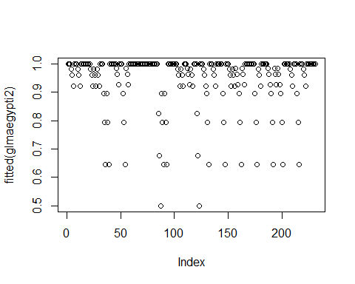
plot(fitted(glmaegypti2.3))
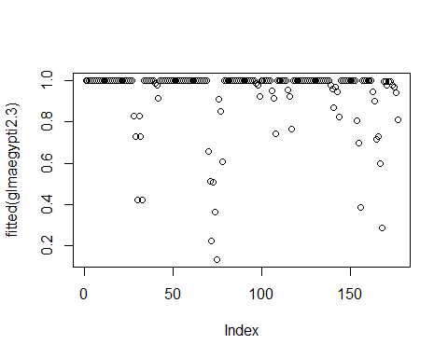
plot(fitted(glmbusckii2))
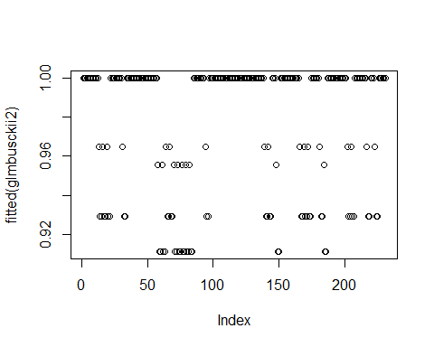
plot(fitted(glmbusckii2.3))
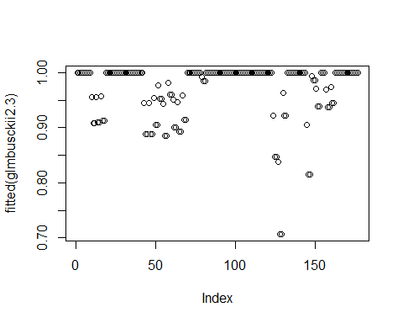
plot(fitted(glmbahamensis2))
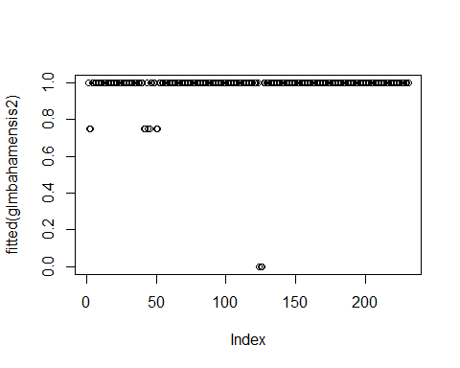
plot(fitted(glmbahamensis2.3))
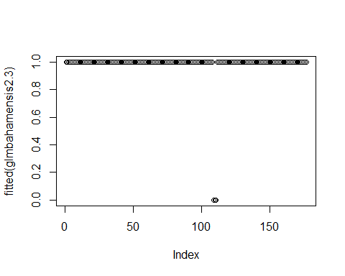
plot(fitted(glmbisulcatius2))
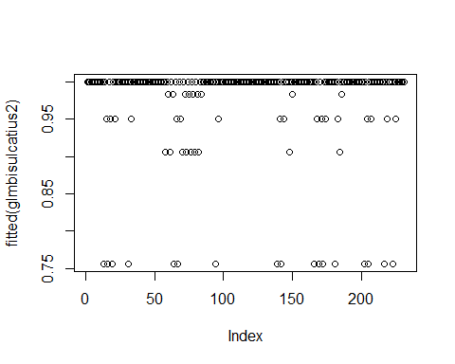
plot(fitted(glmbisulcatius2.3))
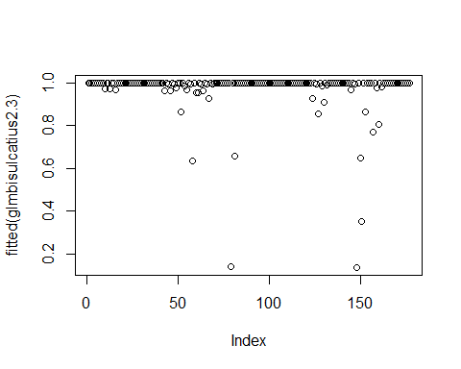
plot(fitted(glmpipiens2))
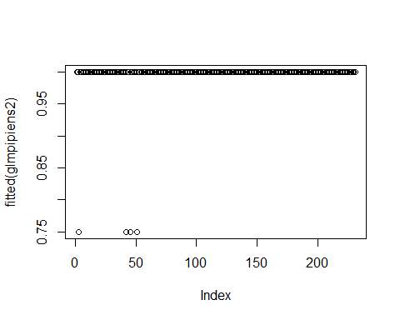
plot(fitted(glmpipiens2.3))
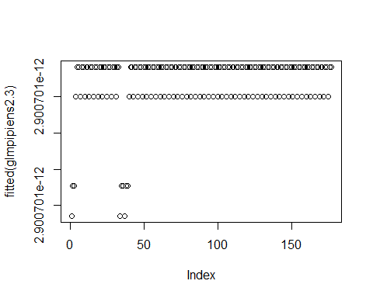
plot(fitted(glmquinq2))
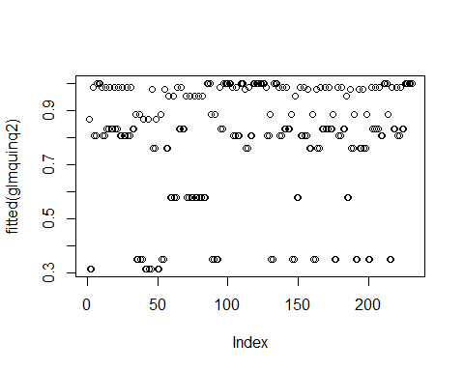
plot(fitted(glmquinq2.3))
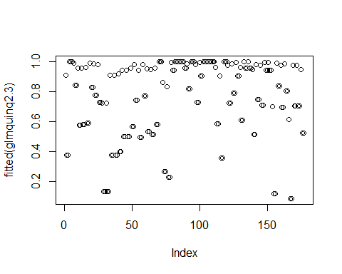
plot(fitted(glmrenatoi2))
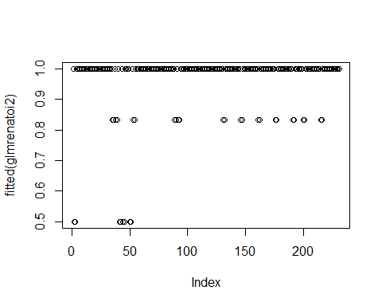
plot(fitted(glmrenatoi2.3))
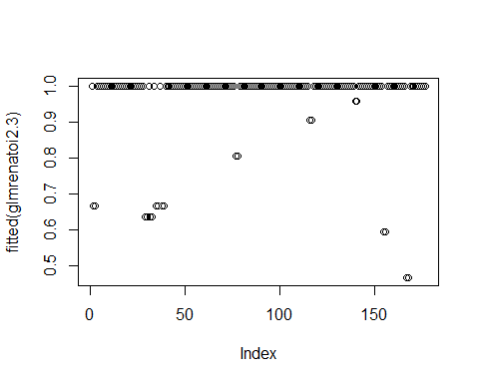
plot(fitted(glmaedes2))
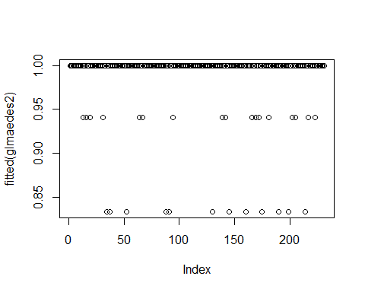
plot(fitted(glmaedes2.3))
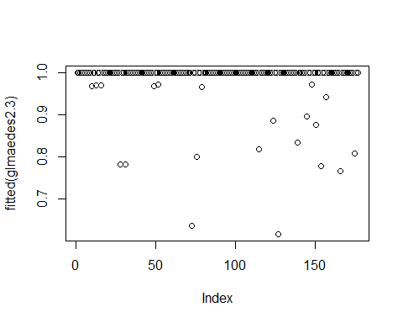
plot(fitted(glmculex2))
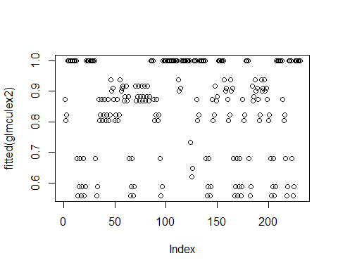
plot(fitted(glmculex2.3))
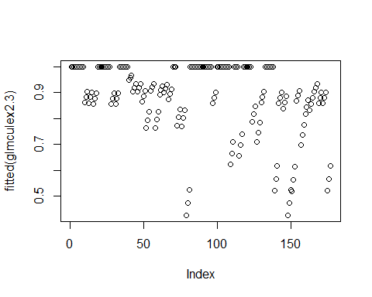
plot(fitted(glmculicoides2))
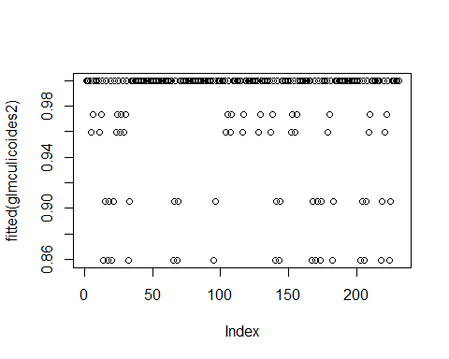
plot(fitted(glmculicoides2.3))
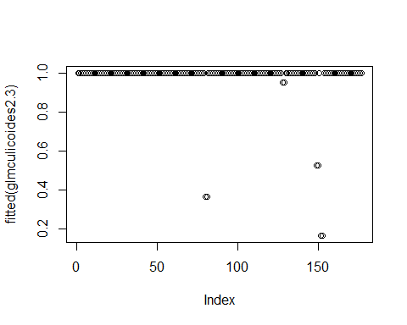
plot(fitted(glmtoxorhinchites2))
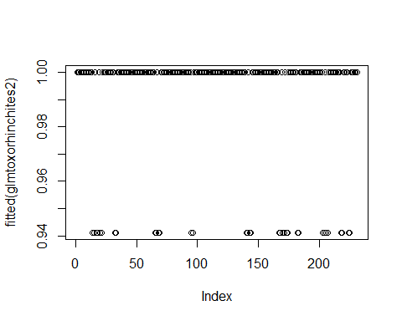
plot(fitted(glmtoxorhinchites2.3))
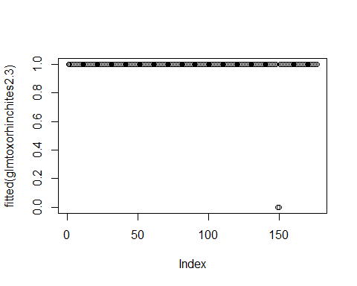 #overview of the residuals grom the glm’s. Again it is visible that there is a large spread in the samples from Cx. quinquefasciatus, which is carried over to Culex.

