The Antarctic Peninsula under a 1.5°C global warming scenario

The Antarctic Peninsula under a 1.5°C global warming scenario

A working paper submitted by the United Kingdom

Summary

- The UN Paris Agreement seeks to limit global warming to well below 2°C above pre-industrial levels, prompting an assessment of how to achieve a 1.5°C target^{1,2}. This paper synthesises scientific information on how the 1.5°C scenario will impact the Antarctic Peninsula; noting it has already experienced rapid change in atmospheric climate, ocean and ice conditions, and human activities. Antarctic Treaty Parties are invited to consider the implications of these predictions for the governance of human activities in the Antarctic Peninsula over the coming decades.

- Headlines:
  - Antarctic Peninsula warming in the late 20th Century was greater than anywhere in the Southern Hemisphere, with clear cryospheric and biological impacts;
  - Temperatures will increase by 1-2°C in winter and 0.5-1.0°C in summer, with up to 130 days per year above 0°C, leading to increased rain, melting and surface run-off;
  - Ocean turbulence will increase and deliver heat to the sea surface and coast;
  - Sea-ice extent will be highly variable west of the Antarctic Peninsula;
  - Retreat of marine glacier margins will accelerate, increasing iceberg production;
  - Meltwater production will increase on ice shelves, but will likely not lead to collapses;
  - Southward shifts in marine life distribution have been observed and will continue;
  - Ice-free land will expand providing habitats for native and non-native plants; each is each likely to benefit from warming;
  - The threat to native biodiversity by non-native species far outweighs the impacts of warming under the 1.5°C scenario.

Antarctic Peninsula overview

- This paper covers the Antarctic Peninsula region from the South Shetlands in the north to the southern extent of George VI Sound and the northern extent of the Ronne Ice Shelf, as well as its surrounding ocean and continental shelf. The Peninsula is divided down its lengthy mountainous spine by very strong West to East gradients in atmospheric and ocean circulation, which makes for distinct characteristics in oceanography, glaciology and biology either side of it. The Peninsula is also affected by North-South changes from the fringe of the sub-Antarctic to the deep continent.

- As a consequence of measurements over the last 100 years, we know more about change in the Antarctic Peninsula than elsewhere on the continent. Although there is a strong signal of atmospheric warming, this is also an area of high natural variability. Annual near-surface temperatures increased by over 2.5°C in the latter 20th Century and, at least in the northern Antarctic Peninsula, have stabilised in the last 20 years with inter-annual variations of ~1.5°C. Summer melting occurs, allowing ~3% to be snow-free (the continental average is ~2%).

- Ice shelves around the Antarctic Peninsula have retreated and break-up events have occurred. The break-up of Larsen A (1995) and Larsen B (2007) ice shelves caused acceleration in land-ice flow. The glaciers of the Antarctic Peninsula contribute around 0.09 mm per year to global sea-level rise³, ~3% of the global value^{4,5}, influenced by heat provided by the ocean^{5, 6, 7}. Sea ice conditions are often heavy to the east of the Antarctic Peninsula and light to the west but, again, there is large degree of year-to-year variability. Marine life has been affected by humans (sealing, whaling and fishing), especially up until the 1960s, and responses to climate must be interpreted in that context. A clear signal of global warming is the exposure of terrestrial surfaces that have been colonised by vegetation.

How will the Antarctic Peninsula respond to the 1.5°C scenario?

Climate and weather

- Antarctic Peninsula temperatures will increase by more than the global average in the 1.5°C scenario². Such a warming has already been exceeded in the northern Peninsula⁸, despite the recent pause in rising temperatures⁹. Regional temperatures could increase beyond current levels by 1-2°C in winter and 0.5-1.0°C in summer¹⁰. A 1°C warming will result in a 50-150% increase in days per year above 0°C, from 25-80 each year in the Northern Antarctic Peninsula to 35-130. While there has been a 10-20% increase in precipitation, and more extreme precipitation events¹¹, there is unlikely to be much further increase beyond current levels¹⁰. The greatest change in circulation affecting the Peninsula is a weakening of the circumpolar summer westerlies in response to ozone recovery. Increased levels of surface water run-off (from rain and snow/glacial melt) and/or melting of any thin layers of sediment, may alter the geotechnical properties of ice free land considerably, albeit for limited periods of the year.

Ocean Conditions

- Because of ocean circulation, the west of the Peninsula is influenced by warm Circumpolar Deep Water (CDW), in contrast to the east of the Peninsula where waters are much colder¹². The Southern Ocean is warming¹³, but we have no clear evidence that the Polar Front is moving as a result of this¹⁴. However, the CDW is both warming and becoming more shallow ¹⁵, and the amount of turbulence in the Southern Ocean is increasing¹⁶. We expect these trends to continue.

Sea Ice

- The two sides of the Antarctic Peninsula have very different sea ice conditions. The ice edge is generally at a higher latitude on the Peninsula’s west, compared with the east. In summer, virtually the whole Bellingshausen Sea is sea ice free, but on the east in the Weddell Sea, the sea ice typically extends to the northern end of the Antarctic Peninsula, and is much thicker so even the highest classification ice-breaking ships have great navigational difficulty. Since satellite records began ~30 years ago, there has been a modest increase in sea ice extent, the interannual variability has increased¹⁷ and there has been large regional change. To the west, sea ice extent has decreased ~6-10% per decade with the greatest changes in autumn and summer¹⁸. The length of the sea ice season on the west of the Peninsula had reduced by ~4 days¹⁹. We expect increased sea ice variability on the west of the Peninsula, compared with the east, as the climate warms.

Land Ice

- Antarctic Peninsula glaciers are steep and fast flowing, and respond rapidly to climatic change⁴. Thinning and recession of glaciers and ice caps is expected to accelerate, driven by increased upwelling of warm CDW. Because the loss of marine-terminating glaciers is greater than land-terminating glaciers, it is possible that glaciers will retreat to their land margins and subsequently experience less thinning. In southern Palmer Land, significant glacier retreat could happen as glaciers here are grounded deeply below sea level¹⁴. That said, under the 1.5°C scenario, glaciers on land will experience more melting than at present^{14,20}, causing surface run-off.

Ice Shelves

- It is likely that Antarctic Peninsula ice shelves will continue to thin, primarily due to increased surface melting^{21,22}. If meltwater ponds, it could cause ice-shelf flexure and fracture; a process implicated in the collapse of Larsen B²³. However, surface rivers may mitigate against ice-shelf instability by transporting meltwater into the ocean²⁴. Ice shelves will also thin in response to sub-shelf melting by warm ocean water²⁵. While ice-shelf thinning increases the likelihood of iceberg calving, the largest ice shelves (e.g., Larsen C and George VI) have sufficient surface area to avoid catastrophic failure.

Marine Ecosystems

- The response of marine biota to climate change is complicated by effects of marine resource extraction. Sequential over-exploitation of seals, whales and some species of fish over the last two centuries has severely perturbed the food web, making it hard to unravel its effect from that of climate²⁶. Marine life response to the 1.5°C scenario will be diverse, with likely changes in behaviour, physiology, geographic- or depth- distribution, plus evolutionary adaptation. An observed southward shift in the distribution of biota down the peninsula is likely to continue²⁷.

Terrestrial Ecosystems

- Terrestrial biology is limited to ice-free areas, of which only a fraction is currently visibly colonised. The seasonally-exposed terrestrial area of the Peninsula is expected to expand. This will provide new habitats for colonisation by both native and likely, non-native organisms. It will also lead to the coalescing of some areas that are currently isolated, and a loss of genetic diversity. Native plants are well adapted to the variable conditions of the Antarctic Peninsula^{28,29} and are likely to benefit from modest warming³⁰. A wide range of non-native species could survive in parts of the Antarctic Peninsula. Thus, the threat of non-native species to native biodiversity far outweighs the impacts of climate change under the 1.5°C scenario. In light of these pressures, environmental protection of the Antarctic Peninsula must remain resolute.

Recommendations
The United Kingdom recommends that the Committee for Environmental Protection (CEP) and the Antarctic Treaty Consultative Meeting (ATCM):

- Considers the predictions of what a 1.5°C global-average temperature rise above pre-industrial levels means for the Antarctic Peninsula region, based on current scientific understandings; and

- Discusses the implications of the predicted changes for the work of the CEP and ATCM.

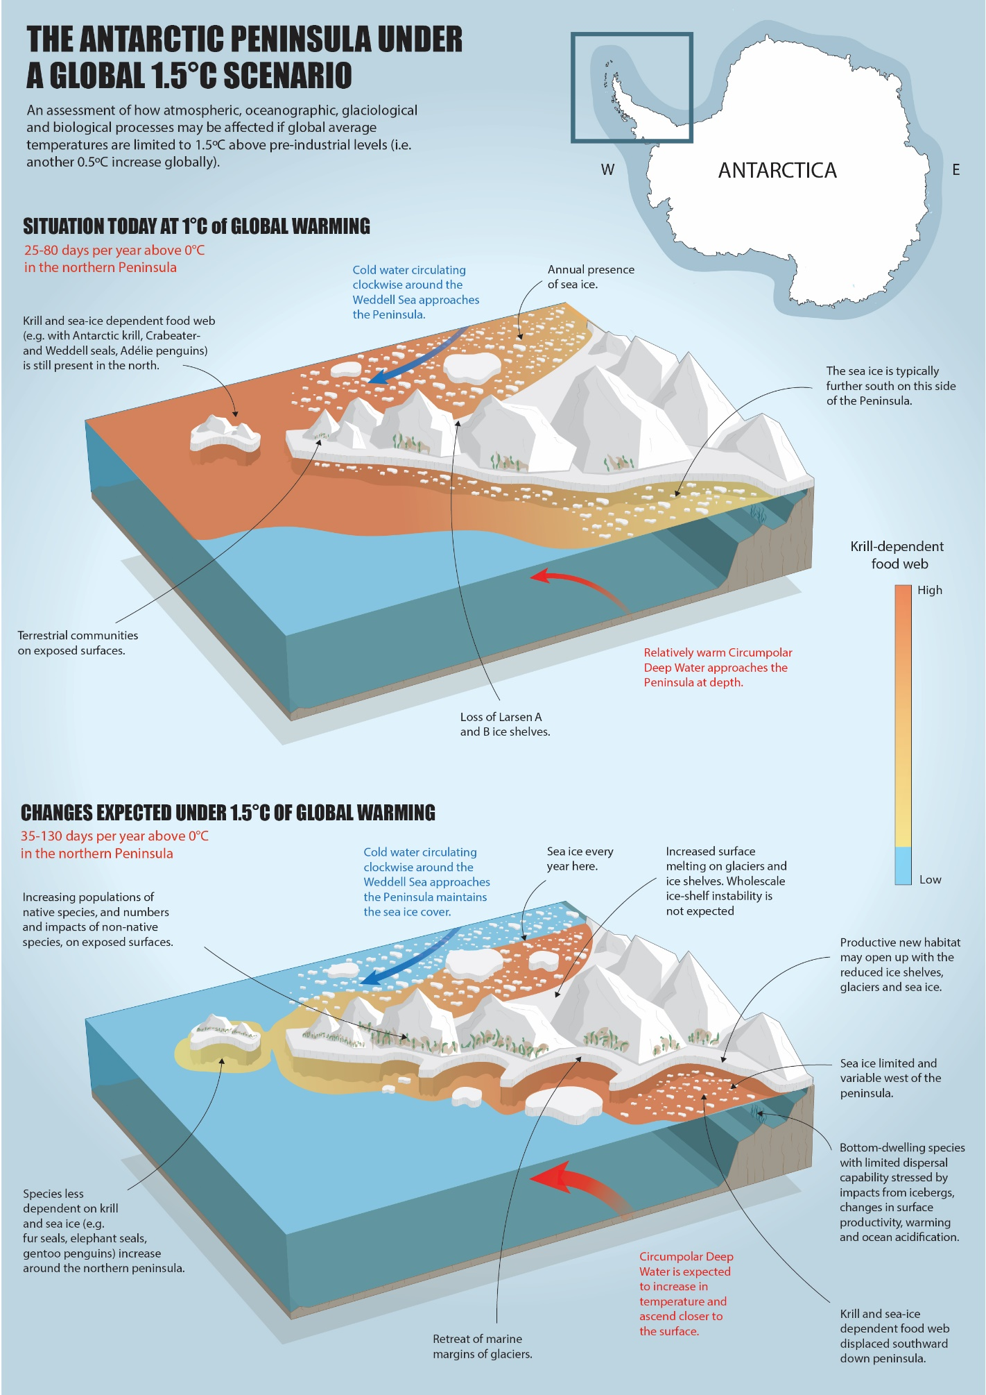

References (Not translated)

[1] https://unfccc.int/sites/default/files/english_paris_agreement.pdf
[2] IPCC, 2018: Summary for Policymakers. In: Global Warming of 1.5°C. An IPCC Special Report on the impacts of global warming of 1.5°C above pre-industrial levels and related global greenhouse gas emission pathways, in the context of strengthening the global response to the threat of climate change, sustainable development, and efforts to eradicate poverty [Masson-Delmotte et al. (eds.)]. World Meteorological Organization, Geneva, Switzerland, 32 pp.
[3] Shepherd, A., Ivins, E., Rignot, E., Smith, B., Van Den Broeke, M., Velicogna, I., Whitehouse, P., Briggs, K., Joughin, I., Krinner, G., 2018. Mass balance of the Antarctic Ice Sheet from 1992 to 2017. Nature 558, 219-222.
[4] Cook, A.J., Vaughan, D.G., Luckman, A.J., Murray, T., 2014. A new Antarctic Peninsula glacier basin inventory and observed area changes since the 1940s. Antarctic Science 26, 614-624.
[5] Wouters, B., Martin-Español, A., Helm, V., Flament, T., van Wessem, J.M., Ligtenberg, S.R.M., van den Broeke, M.R., Bamber, J.L., 2015. Dynamic thinning of glaciers on the Southern Antarctic Peninsula. Science 348, 899-903.
[6] Cook, A.J., Holland, P.R., Meredith, M.P., Murray, T., Luckman, A., Vaughan, D.G., 2016. Ocean forcing of glacier retreat in the western Antarctic Peninsula. Science 353, 283-286.
[7] Rignot, E., Mouginot, J., Scheuchl, B., van den Broeke, M., van Wessem, M.J., Morlighem, M., 2019. Four decades of Antarctic Ice Sheet mass balance from 1979–2017. Proceedings of the National Academy of Sciences 116, 1095-1103.
[8] Turner, J., S. R. Colwell, G. J. Marshall, T. A. Lachlan-Cope, A. M. Carleton, P. D. Jones, V; Lagun, P. A. Reid, and S. Iagovkina, 2005: Antarctic climate change during the last 50 years. Int. J. Climatol., 25, 279-294.
[9] Turner, J., H. Lu, I. White, J. C. King, T. Phillips, J. S. Hosking, T. J. Bracegirdle, G. J. Marshall, R. Mulvaney, and P. Deb, 2016: Absence of 21st century warming on Antarctic Peninsula consistent with natural variability. Nature, 535, 411-415, doi:10.1038/nature18645.
[10] Li, C., C. Michel, L. Seland Graff, I. Bethke, G. Zappa, T. J. Bracegirdle, E. Fischer, B. J. Harvey, T. Iversen, M. P. King, H. Krishnan, L. Lierhammer, D. Mitchell, J. Scinocca, H. Shiogama, D. A. Stone, and J. J. Wettstein, 2018: Midlatitude atmospheric circulation responses under 1.5 and 2.0 °C warming and implications for regional impacts. Earth. Syst. Dynam., 9, 359-382, doi:10.5195/esd-9-359-2018.
[11] Thomas, E. R., G. J. Marshall, and J. R. McConnell, 2008: A doubling in snow accumulation in the western Antarctic Peninsula since 1850. Geophys. Res. Lett., 35, L01706, doi: 10.1029/2007GL032529.
[12] Meredith, M. P., & Brandon, M. A. (2017). Oceanography and sea ice in the Southern Ocean. In D. N. Thomas (Ed.), Sea Ice (3rd ed) (pp. 216–238). Chichester: John Wiley & Sons.
[13] Llovel, W., & Terray, L. (2016). Observed southern upper-ocean warming over 2005–2014 and associated mechanisms. Environmental Research Letters: 11(12), 124023.
[14] Gille, S. T. (2014). Meridional displacement of the Antarctic Circumpolar Current. Philosophical Transactions. Series A, Mathematical, Physical, and Engineering Sciences, 372(2019), 20130273.
[15] Schmidtko, S., Heywood, K. J., Thompson, A. F., & Aoki, S. (2014). Multidecadal warming of Antarctic waters. Science, 346(6214). https://doi.org/10.1126/science.1256117
[16] Hogg, A. M., Meredith, M. P., Chambers, D. P., Abrahamsen, E. P., Hughes, C. W., & Morrison, A. K. (2015). Recent trends in the Southern Ocean eddy field. Journal of Geophysical Research, C: Oceans. https://doi.org/10.1002/2014JC010470
[17] Turner, J., & Comiso, J. (2017). Solve Antarctica’s sea-ice puzzle. Nature, 547(7663), 275–277.
[18] Turner, J., Hosking, J. S., Bracegirdle, T. J., Marshall, G. J., & Phillips, T. (2015). Recent changes in Antarctic Sea Ice. Philosophical Transactions of the Royal Society A: Mathematical, Physical and Engineering Sciences, 373(2045).
[19] Massom, R. A., Scambos, T. A., Bennetts, L. G., Reid, P., Squire, V. A., & Stammerjohn, S. E. (2018). Antarctic ice shelf disintegration triggered by sea ice loss and ocean swell. Nature, 558(7710), 383–389.
[20] Luckman, A., Elvidge, A., Jansen, D., Kulessa, B., Kuipers Munneke, P., King, J., Barrand, N.E., 2014. Surface melt and ponding on Larsen C Ice Shelf and the impact of föhn winds. Antarctic Science 26, 625-635.
[21] Trusel, L.D., et al., Divergent trajectories of Antarctic surface melt under two twenty-first-century climate scenarios.Nature Geoscience, 8, 927-932.
[22] Lenaerts, J.T.M., et al., Meltwater produced by wind–albedo interaction stored in an East Antarctic ice shelf.Nature Climate Change, 7, 58-62.
[23] Banwell, A.F., D.R. MacAyeal, and O.V. Sergienko, Breakup of the Larsen B Ice Shelf triggered by chain reaction drainage of supraglacial lakes.Geophysical Research Letters, 2013. 40(22): p. 5872-5876.
[24] Bell, R. E. et al. Antarctic ice shelf potentially stabilized by export of meltwater in surface river. Nature 544, 344–348 (2017).
[25] Bentley, M.J., Hodgson, D.A., Sugden, D.E., Roberts, S.J., Smith, J.A., Leng, M.J., Bryant, C. 2005. Early Holocene retreat of the George VI Ice Shelf, Antarctic Peninsula. Geology , 33 (3), 173-176. doi: 10.1130/G21203.1
[26] Trivelpiece WZ, Hinke JT, Miller AK, Reiss CS, Trivelpiece SG, Watters GM (2011) Variability in krill biomass links harvesting and climate warming to penguin population changes in Antarctica. Proc Natl Acad Sci 108: 7625-7628 doi: 10.1073/pnas.1016560108
[28] Peck, L.S., Convey, P. & Barnes, D.K.A. 2006. Environmental constraints on life histories in Antarctic ecosystems: tempos, timings and predictability. Biological Reviews 81, 75-109.
[29] Pertierra, L.R., Aragón, P., Shaw, J.D., Bergstrom, D.M., Terauds, A. & Olalla-Tárraga, M.Á. 2017. Global thermal niche models of two European grasses show high invasion risks in Antarctica. Global Change Biology, 23, 2863–2873, 10.1111/gcb.13596.
[30] Convey, P. 2011. Antarctic terrestrial biodiversity in a changing world. Polar Biology 34, 1629-1641.

