Supporting Information

Alkylative Ring-Opening of Bicyclic Aziridinium Ion and Its Application for Alkaloid Synthesis
Nagendra Nath Yadav,ª Young-Gun Lee,^{b} Nikhil Srivastava^{b} and Hyun-Joon Ha^{b},*

ªDepartment of Chemistry, North Eastern Regional Institute of Science and Technology, Nirjuli, Arunachal Pradesh-791109, India
^{b}Department of Chemistry, Hankuk University of Foreign Studies, Yongin, Kyunggi-Do 17035, Korea

E-mail: hjha@hufs.ac.kr

Table of Contents

¹H and ¹³C NMR spectra of 2 S2
¹H and ¹³C NMR spectra of 3a S3
¹H and ¹³C NMR spectra of 3b S4
¹H and ¹³C NMR spectra of 3c S5
¹H and ¹³C NMR spectra of 3d S6
¹H and ¹³C NMR spectra of 3e S7
¹H and ¹³C NMR spectra of 3f S8
¹H and ¹³C NMR spectra of 3g S9
¹H and ¹³C NMR spectra of 3h S10
¹H and ¹³C NMR spectra of 3i S11
¹H and ¹³C NMR spectra of 3j S12
¹H and ¹³C NMR spectra of 3k S13
¹H and ¹³C NMR spectra of 3l S14
¹H and ¹³C NMR spectra of 5 S15
¹H and ¹³C NMR spectra of 10 S16
¹H and ¹³C NMR spectra of 11 S17
¹H and ¹³C NMR spectra of 13 S18
¹H and ¹³C NMR spectra of 14 S19

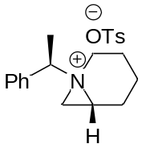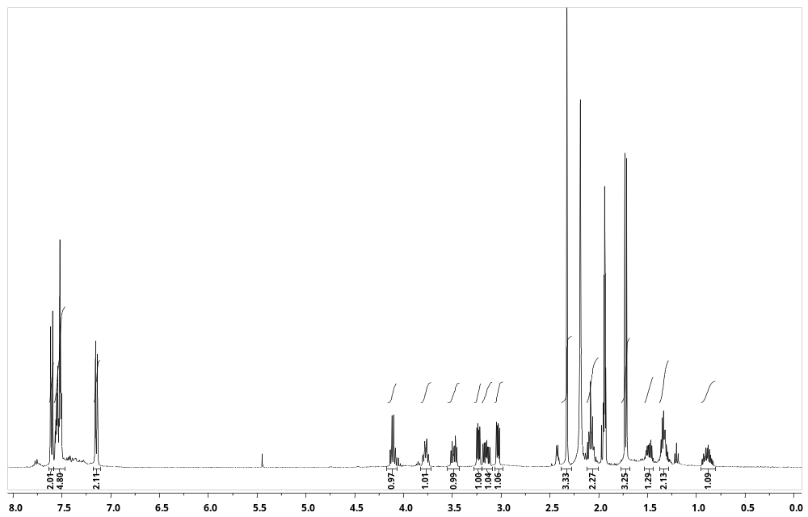

¹H NMR of Compound 2 (400 MHz, CD₃CN)

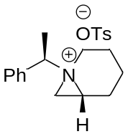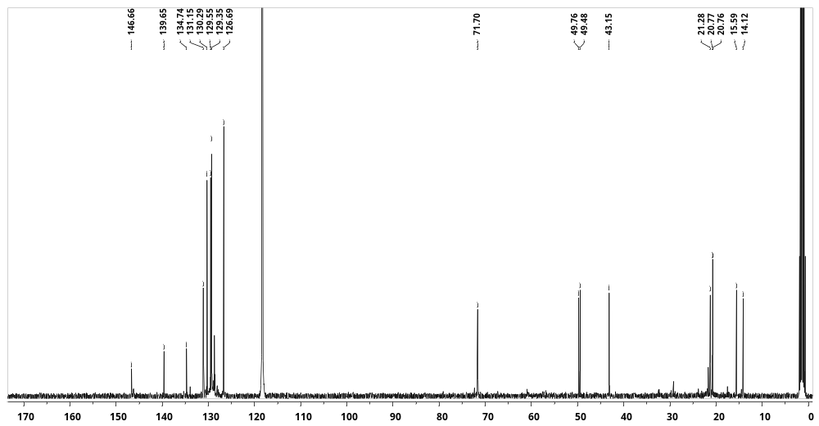

¹³C NMR of Compound 2 (101 MHz, CD₃CN)
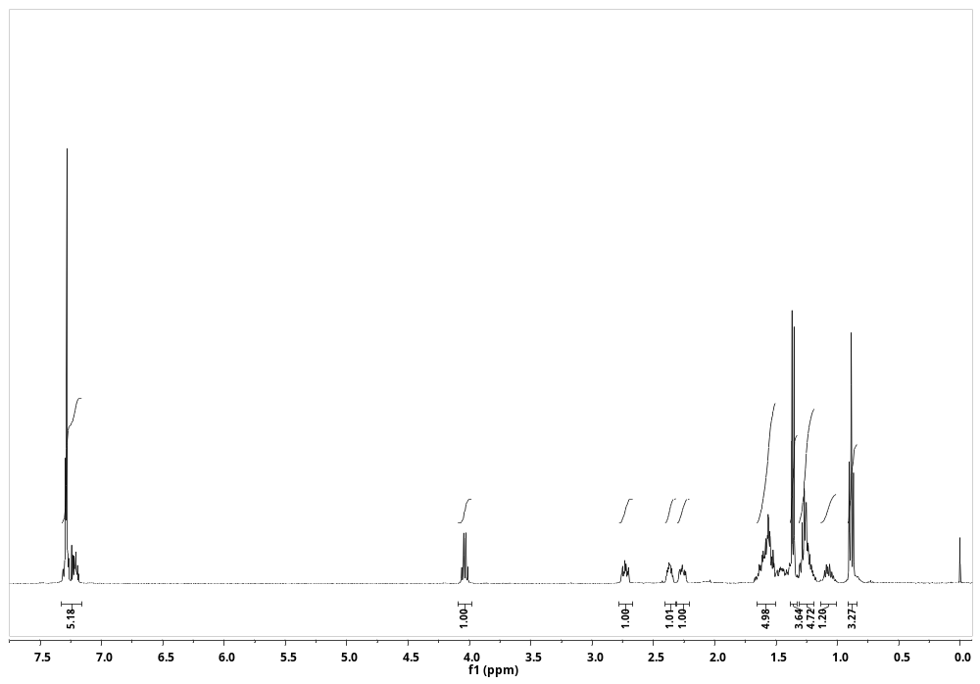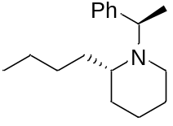
¹H NMR Spectra of compound 3a (400 MHz, CDCl₃)
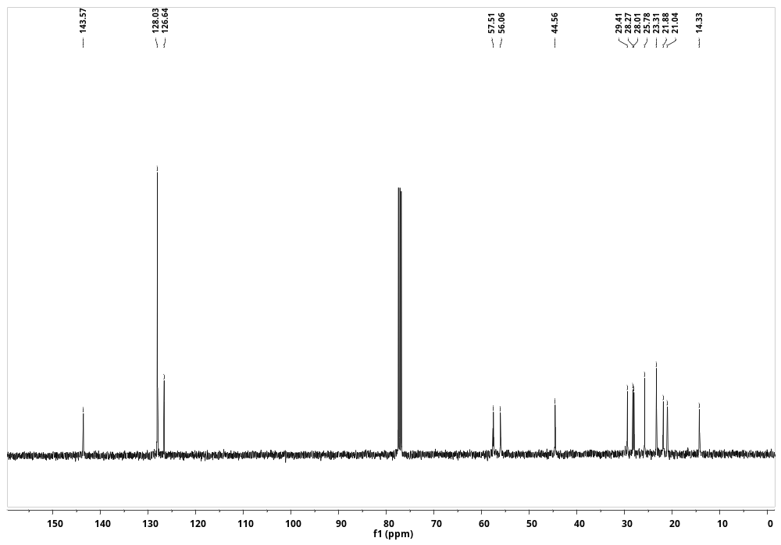
¹³C NMR Spectra of compound 3a (101 MHz, CDCl₃)
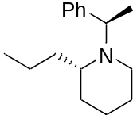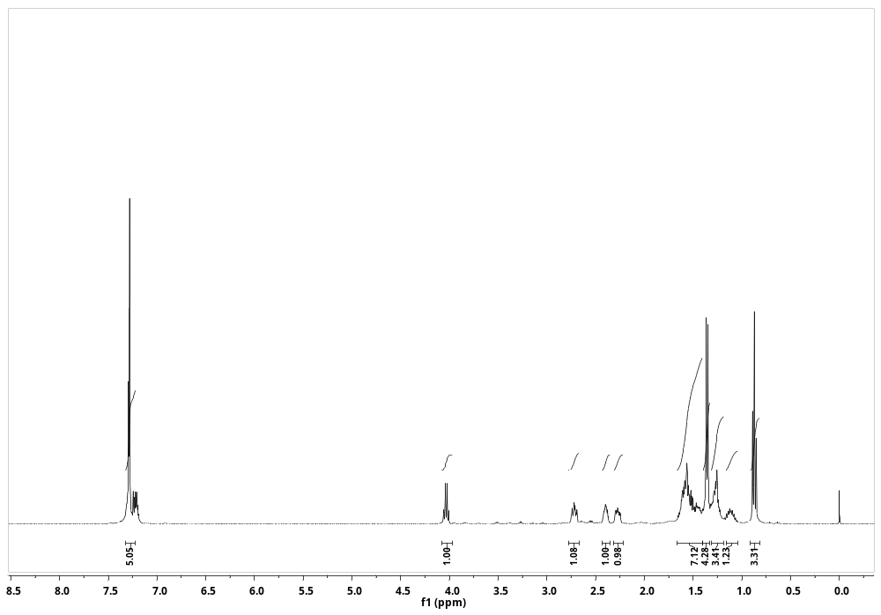
¹H NMR Spectra of compound 3b (400 MHz, CDCl₃)
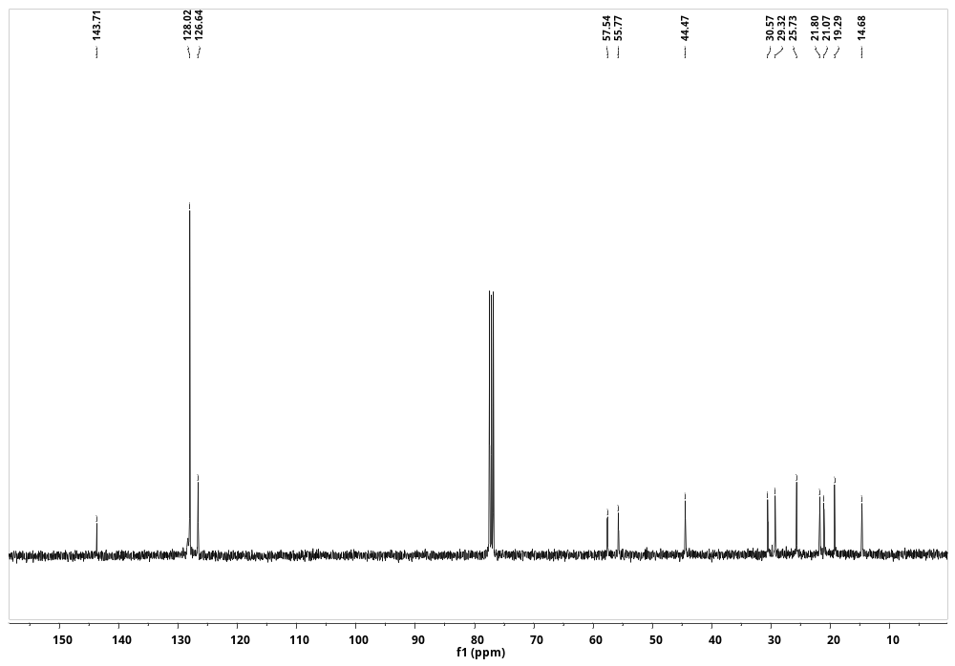
¹³C NMR Spectra of compound 3b (101 MHz, CDCl₃)
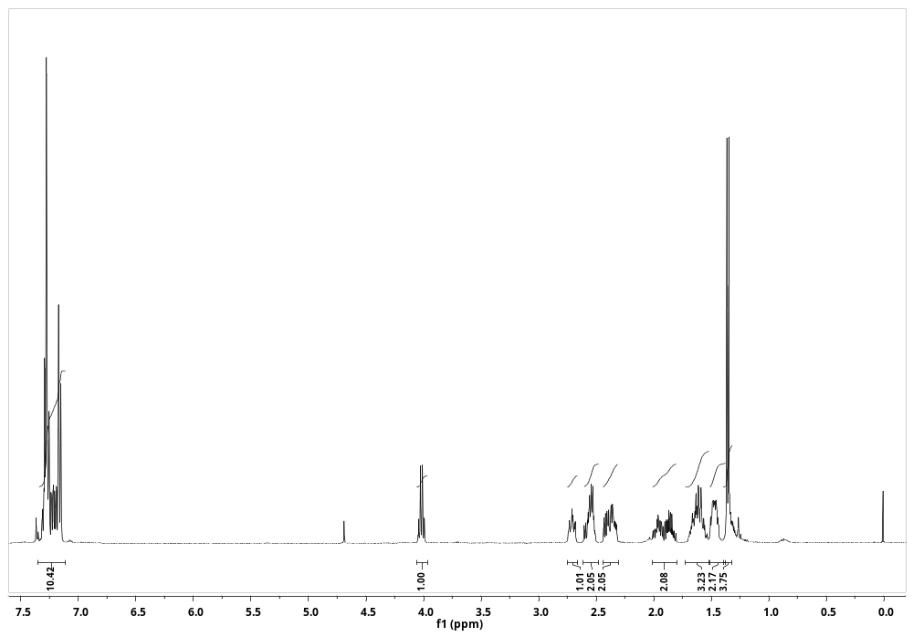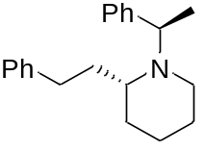
¹H NMR Spectra of compound 3c (400 MHz, CDCl₃)
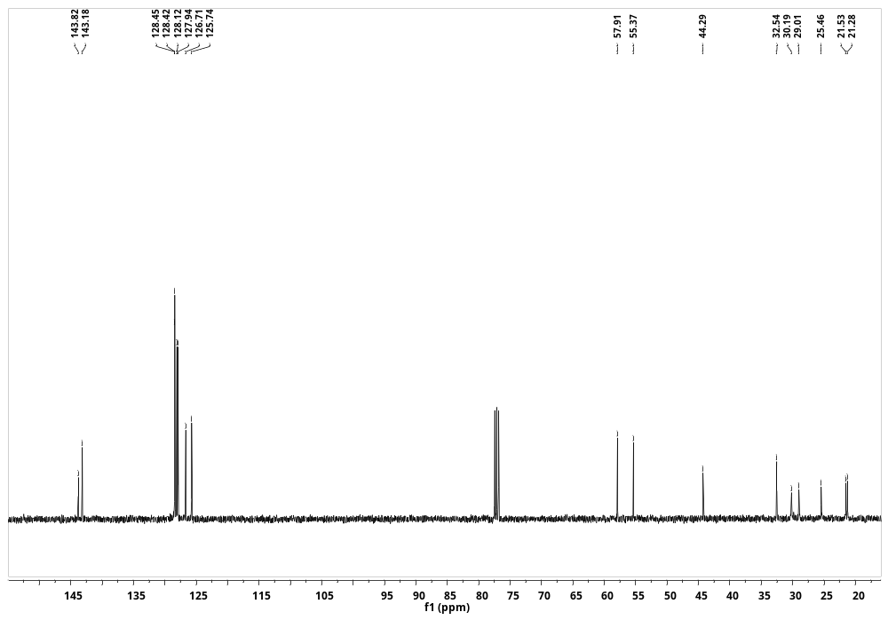
¹³C NMR Spectra of compound 3c (101 MHz, CDCl₃)
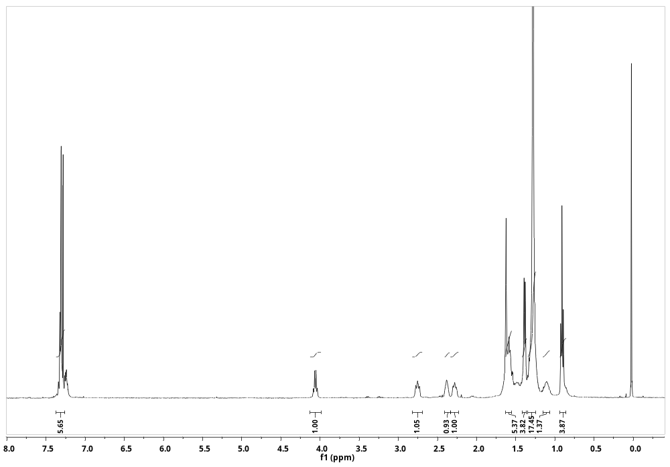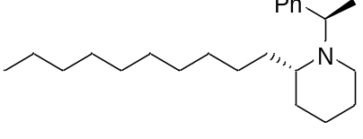
¹H NMR Spectra of compound 3d (400 MHz, CDCl₃)
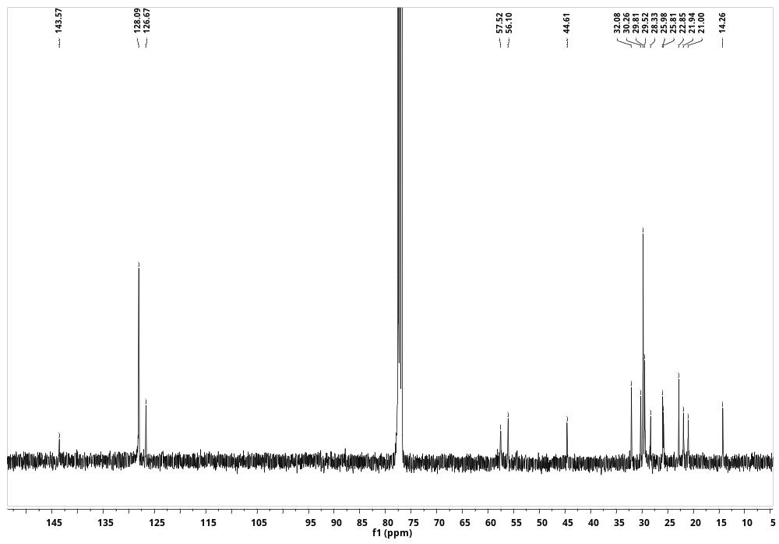
¹³C NMR Spectra of compound 3d (101 MHz, CDCl₃)
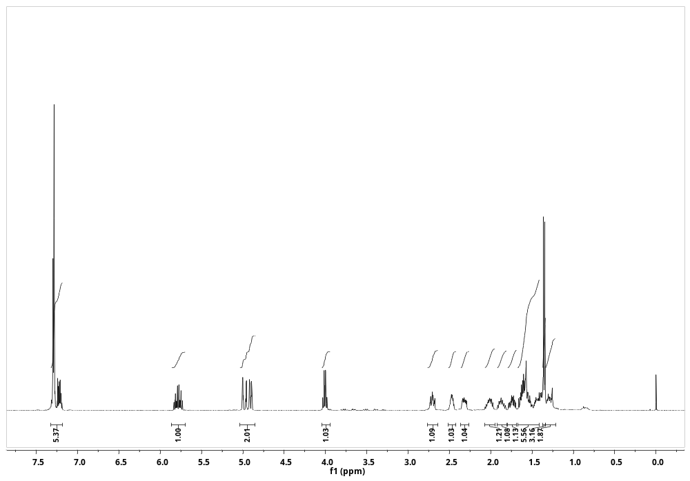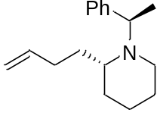
¹H NMR Spectra of compound 3e (400 MHz, CDCl₃)
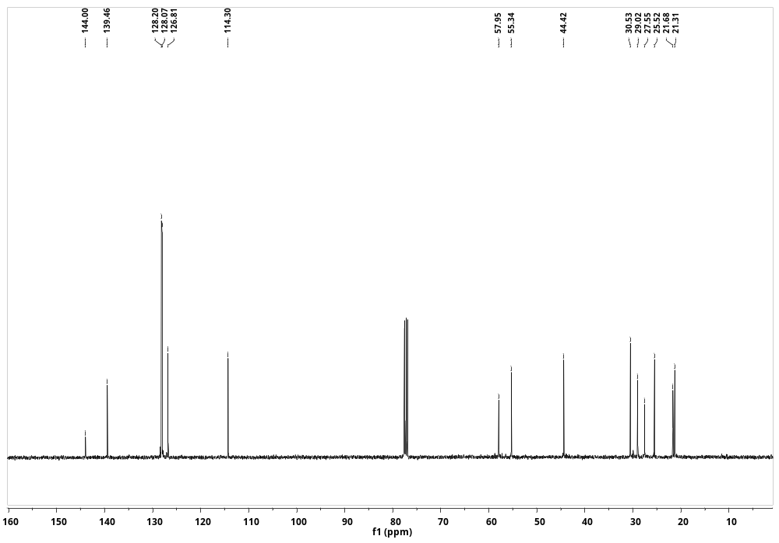
¹³C NMR Spectra of compound 3e (101 MHz, CDCl₃)
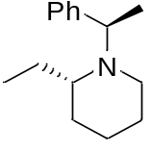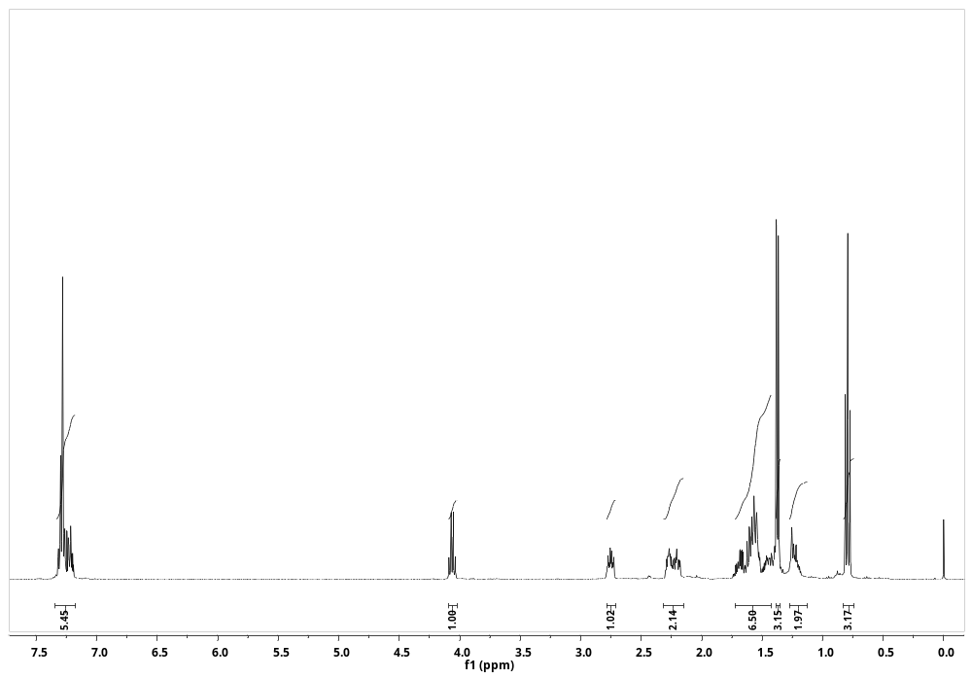
¹H NMR Spectra of compound 3f (400 MHz, CDCl₃)
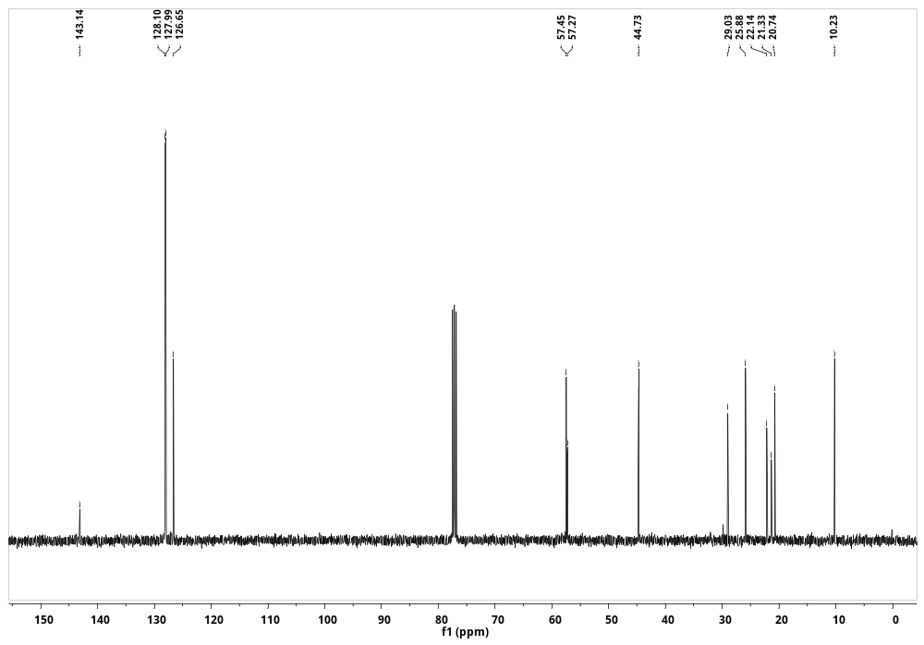
¹³C NMR Spectra of compound 3f (101 MHz, CDCl₃)
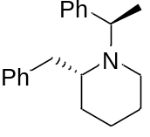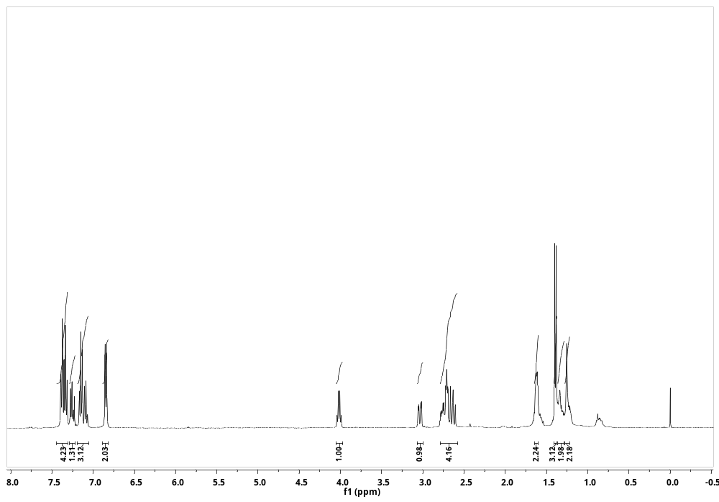
¹H NMR Spectra of compound 3g (400 MHz, CDCl₃)
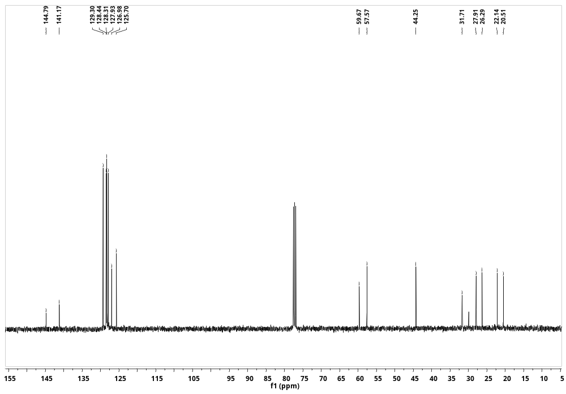
¹³C NMR Spectra of compound 3g (101 MHz, CDCl₃)
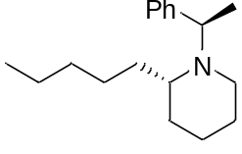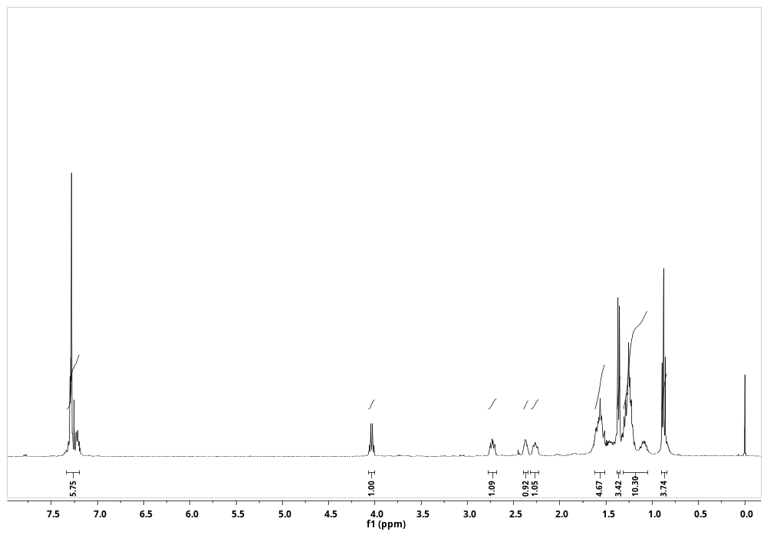
¹H NMR Spectra of compound 3h (400 MHz, CDCl₃)
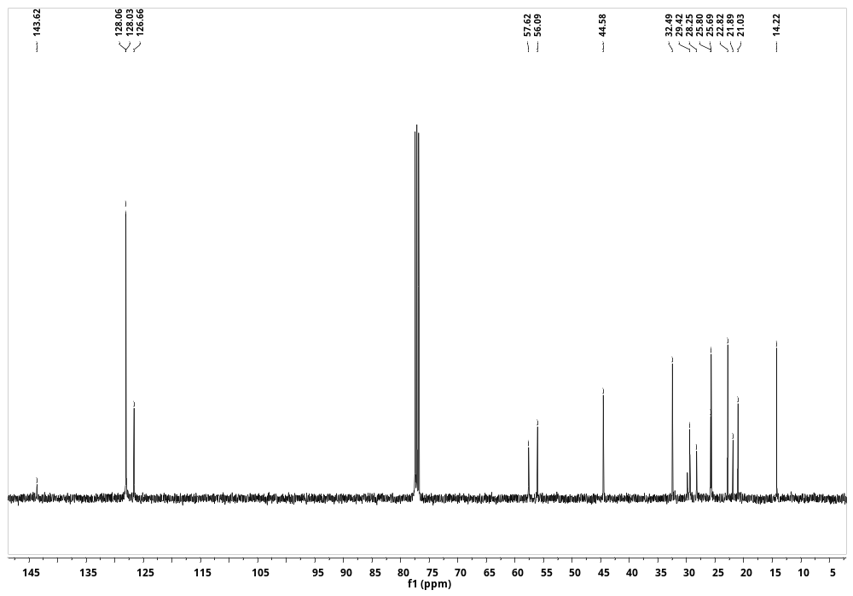
¹³C NMR Spectra of compound 3h (101 MHz, CDCl₃)
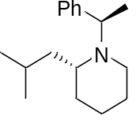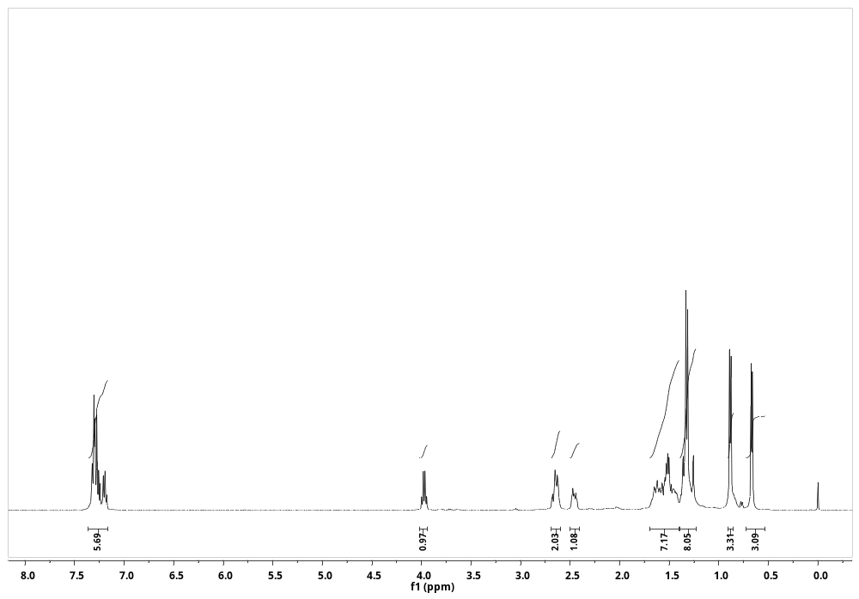
¹H NMR Spectra of compound 3i (400 MHz, CDCl₃)
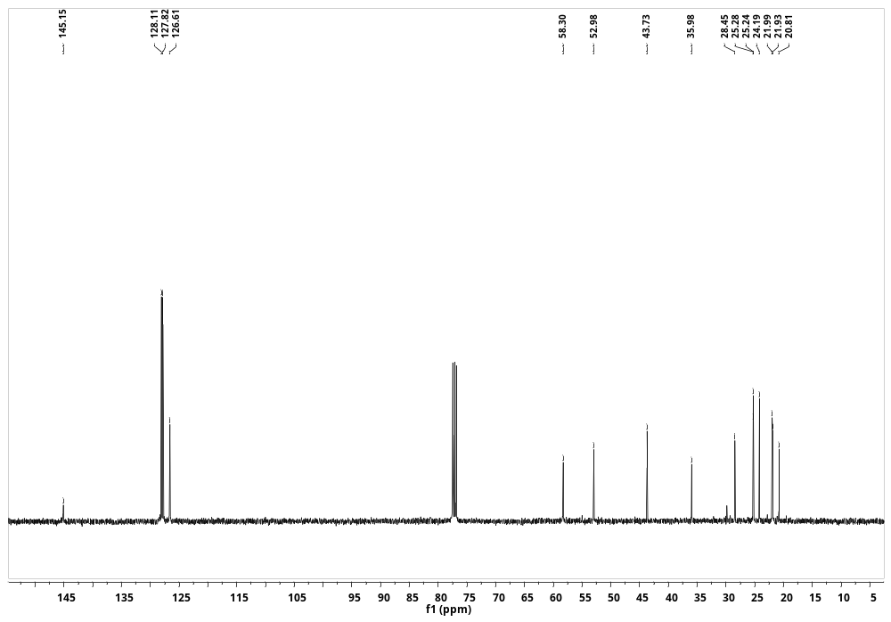
¹³C NMR Spectra of compound 3i (101 MHz, CDCl₃)
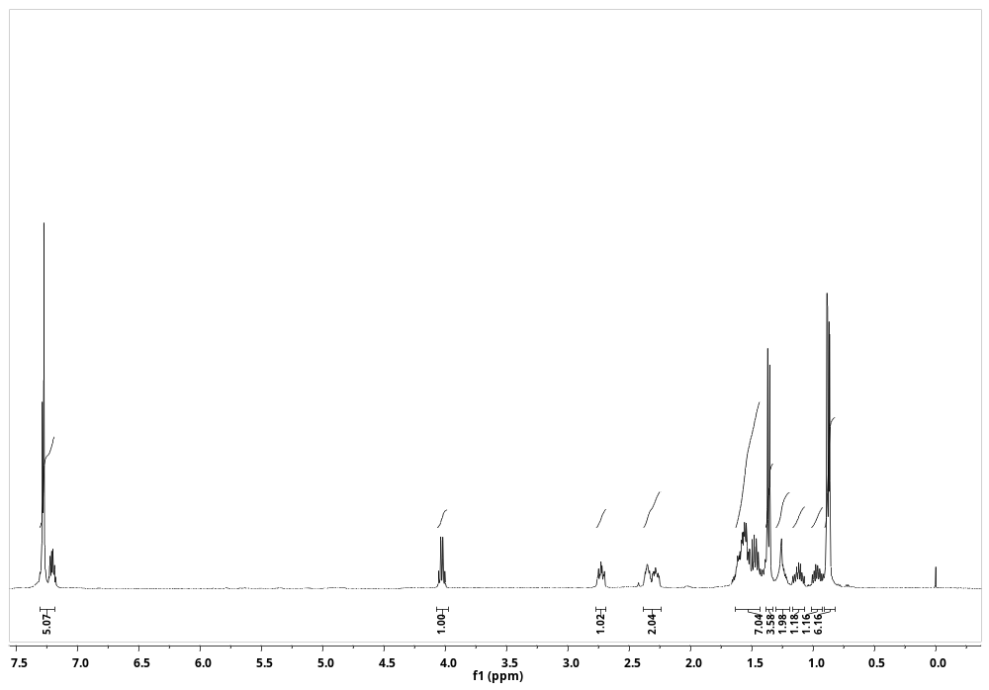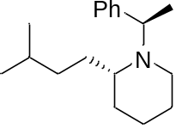
¹H NMR Spectra of compound 3j (400 MHz, CDCl₃)
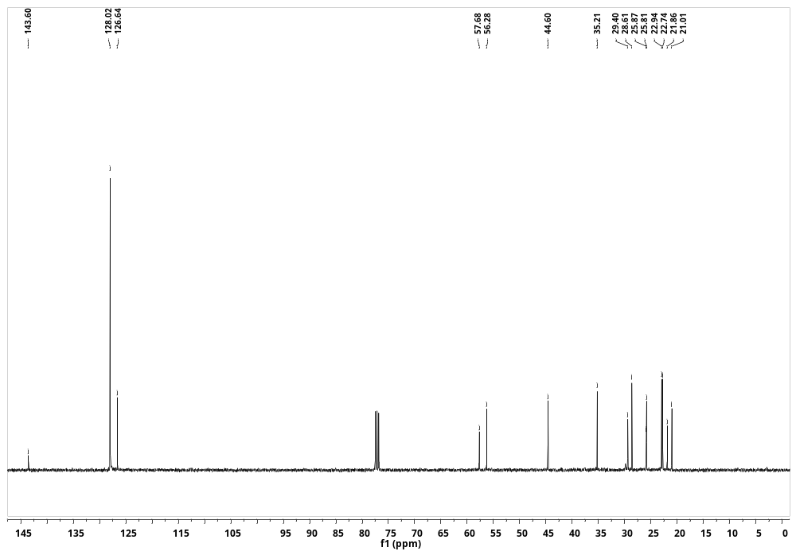
¹³C NMR Spectra of compound 3j (101 MHz, CDCl₃)
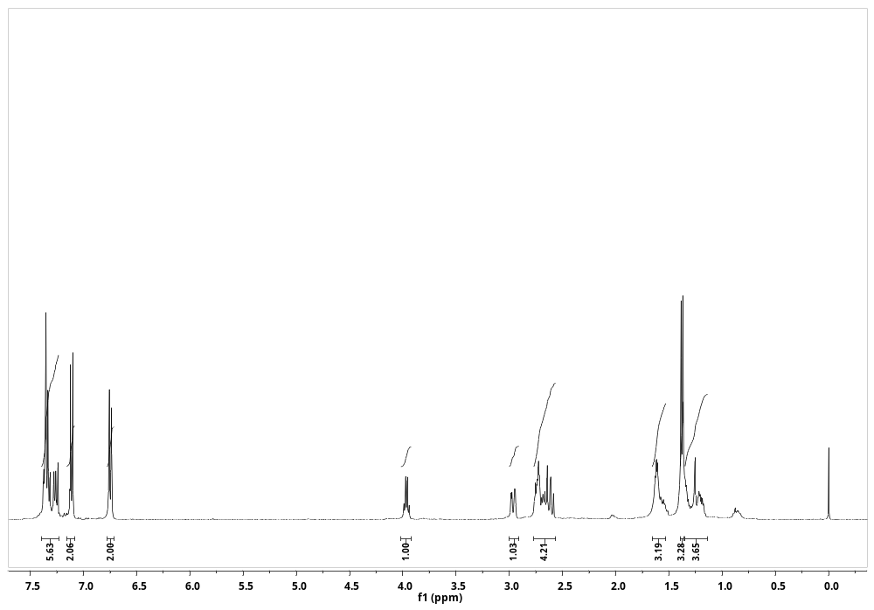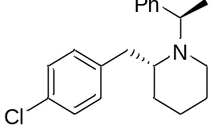
¹H NMR Spectra of compound 3k (400 MHz, CDCl₃)
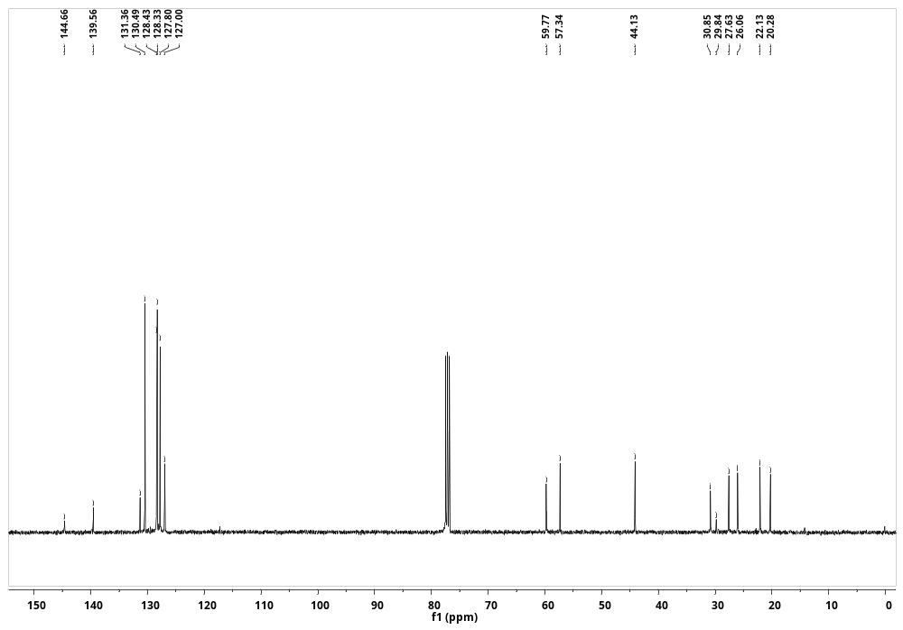
¹³C NMR Spectra of compound 3k (101 MHz, CDCl₃)
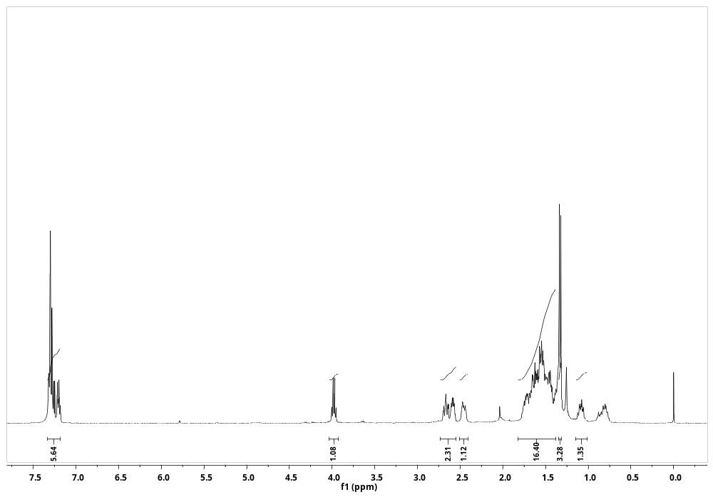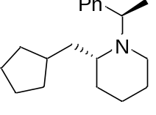
¹H NMR Spectra of compound 3l (400 MHz, CDCl₃)
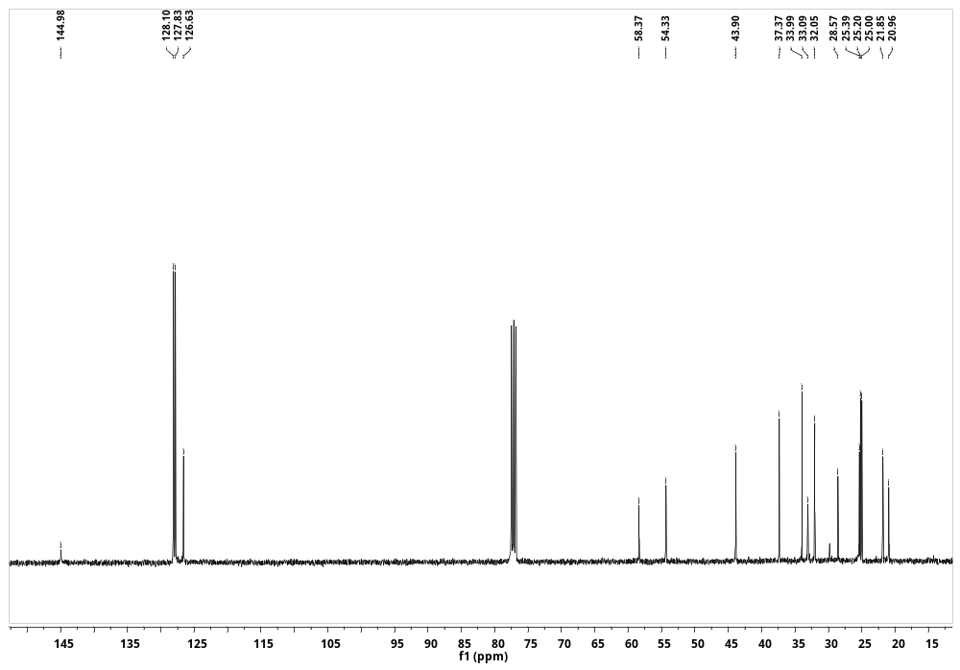
¹³C NMR Spectra of compound 3l (101 MHz, CDCl₃)
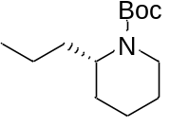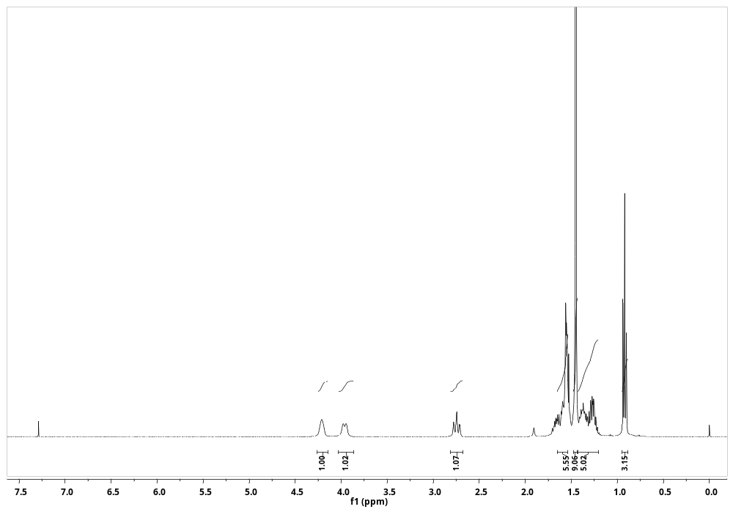
¹H NMR Spectra of compound 5 (400 MHz, CDCl₃)
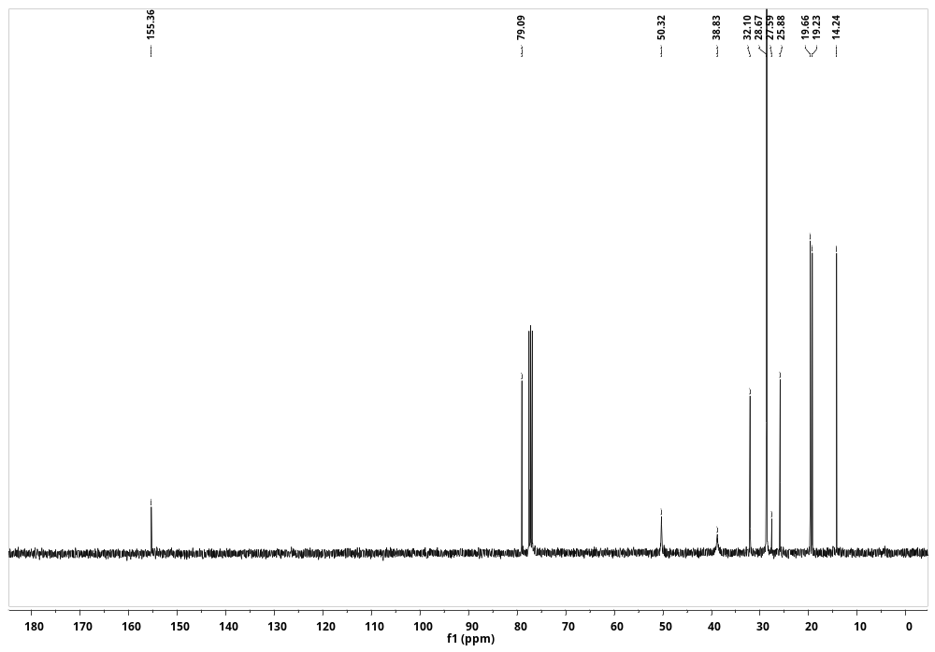
¹³C NMR Spectra of compound 5 (101 MHz, CDCl₃)
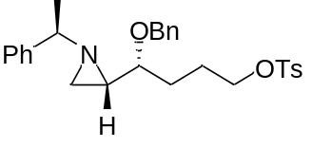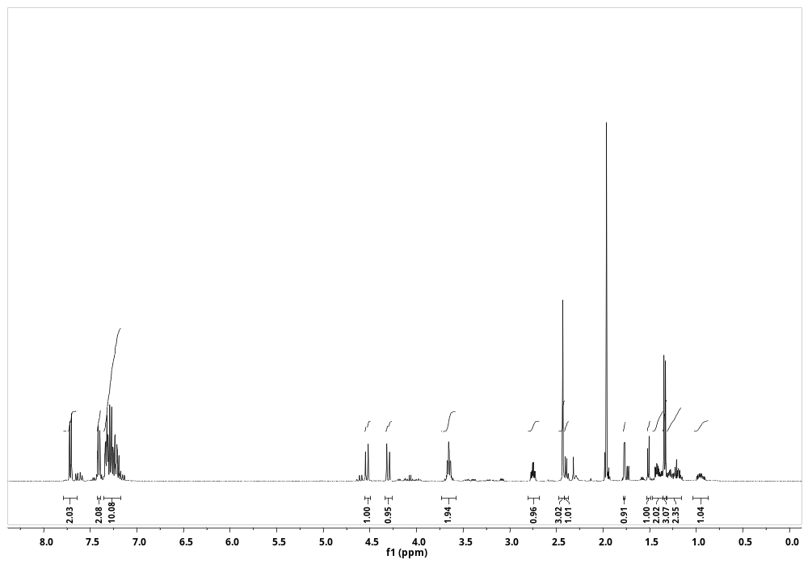
¹H NMR Spectra of compound 10 (400 MHz, CD₃CN)
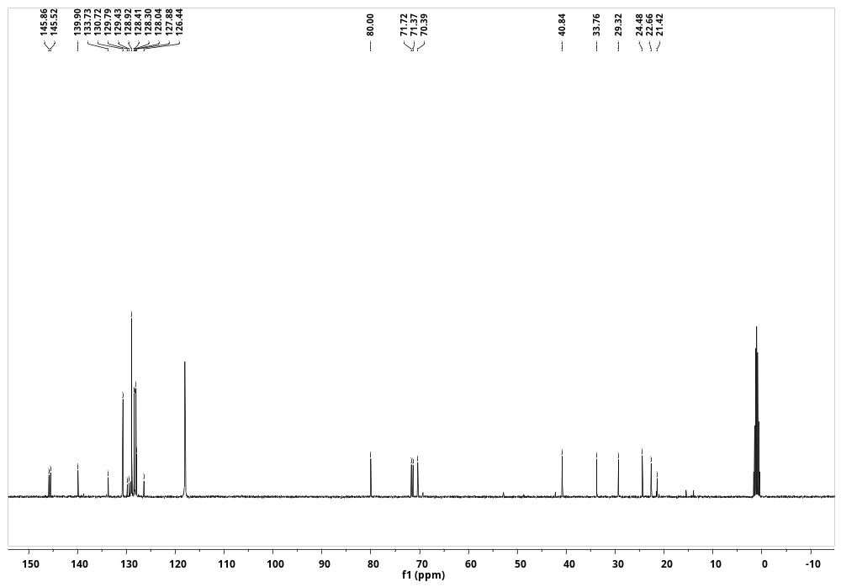
¹³C NMR Spectra of compound 10 (101 MHz, CD₃CN)
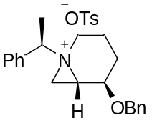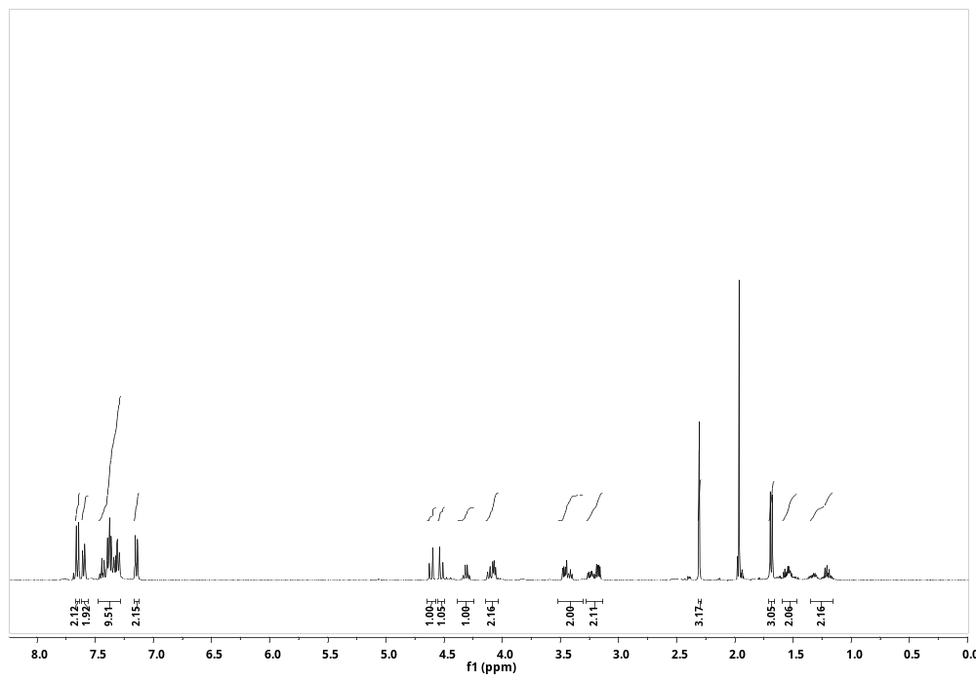
¹H NMR Spectra of compound 11 (400 MHz, CD₃CN)
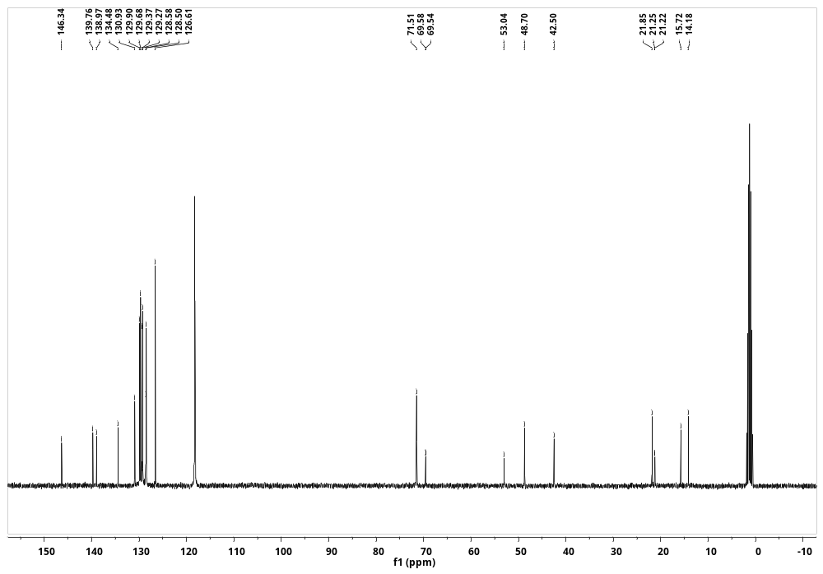
¹³C NMR Spectra of compound 11 (101 MHz, CD₃CN)
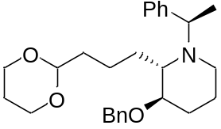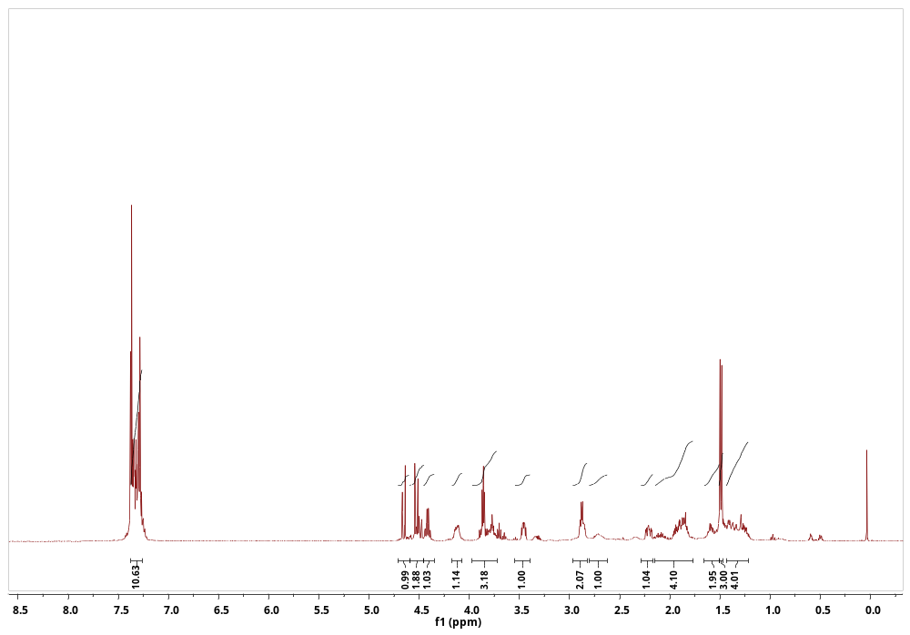
¹H NMR Spectra of compound 13 (400 MHz, CDCl₃)
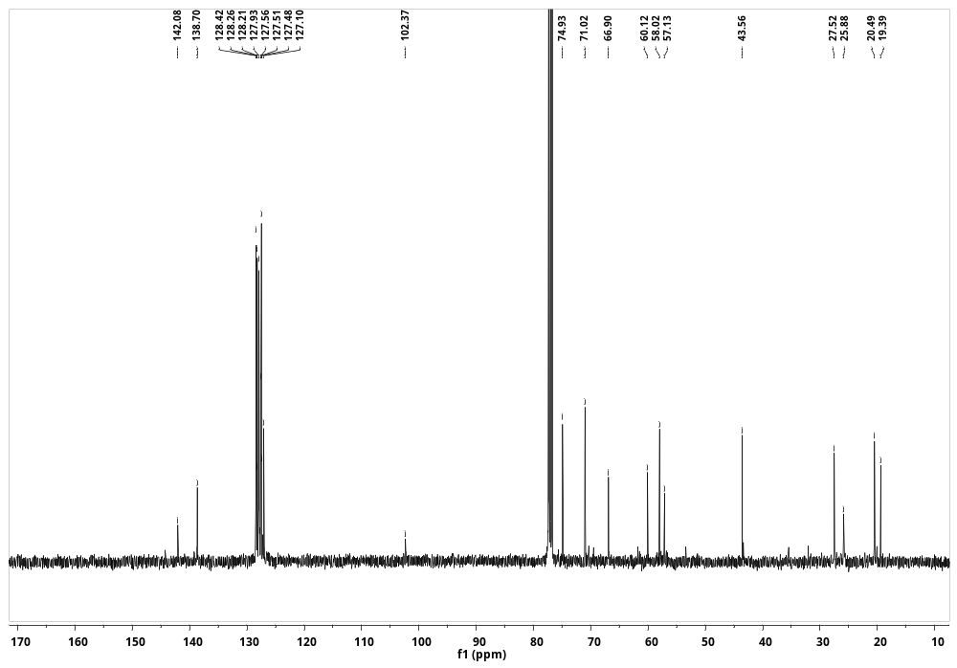
¹³C NMR Spectra of compound 13 (101 MHz, CDCl₃)
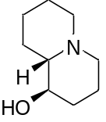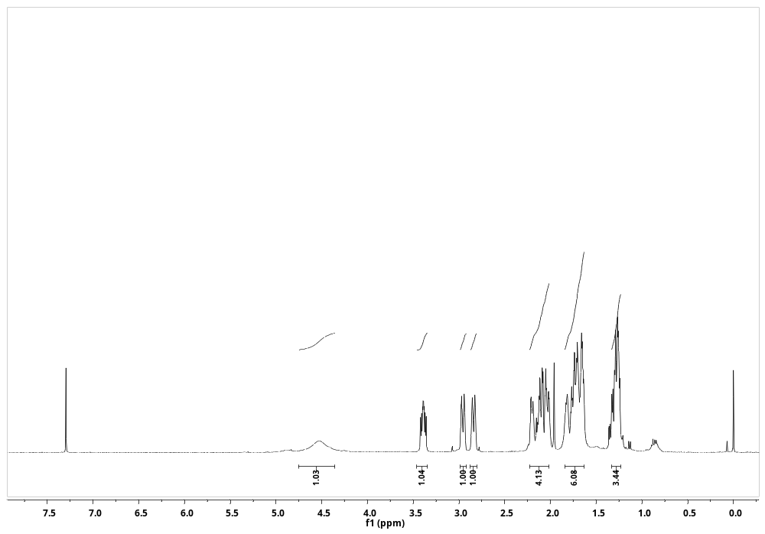
¹H NMR Spectra of compound 14 (400 MHz, CDCl₃)
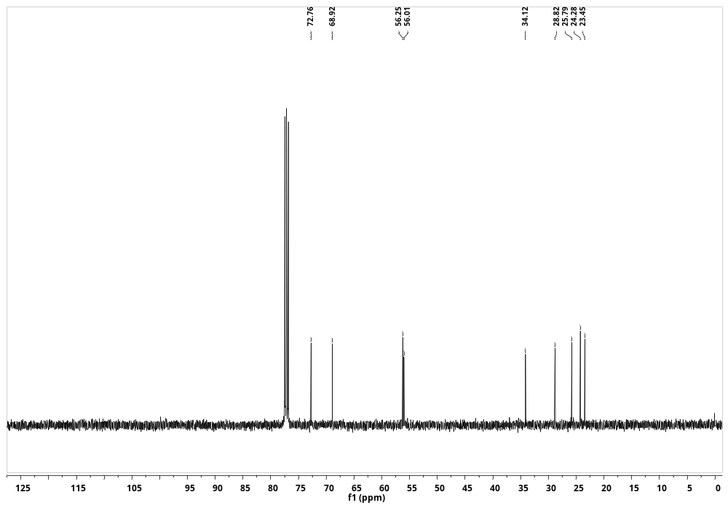
¹³C NMR Spectra of compound 14 (101 MHz, CDCl₃)

