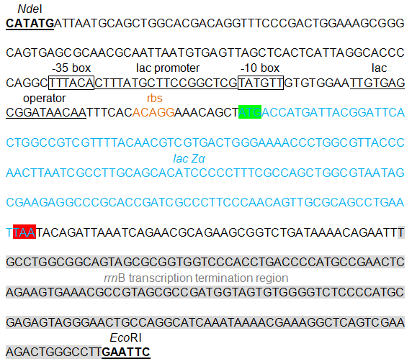
The cloning/expression region of pPlac-lacZα. lacZα is transcribed under the control of lac promoter.

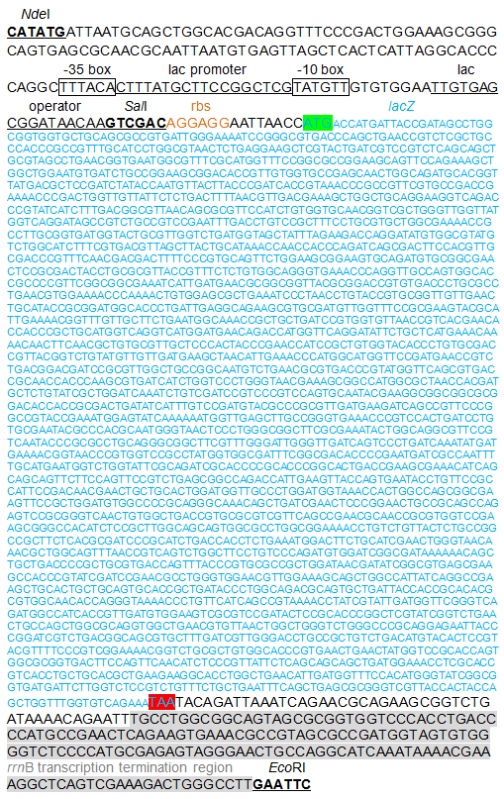
The cloning/expression region of pPlac-lacZ. lacZ is transcribed under the control of lac promoter.

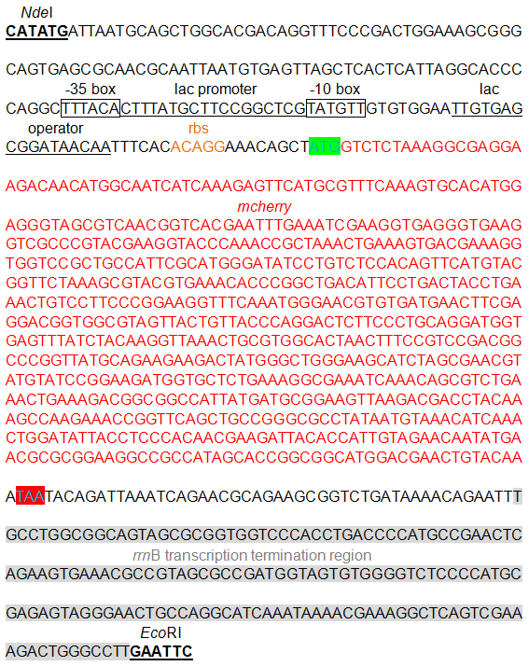
The cloning/expression region of pPlac-RFP. mCherry is transcribed under the control of lac promoter.

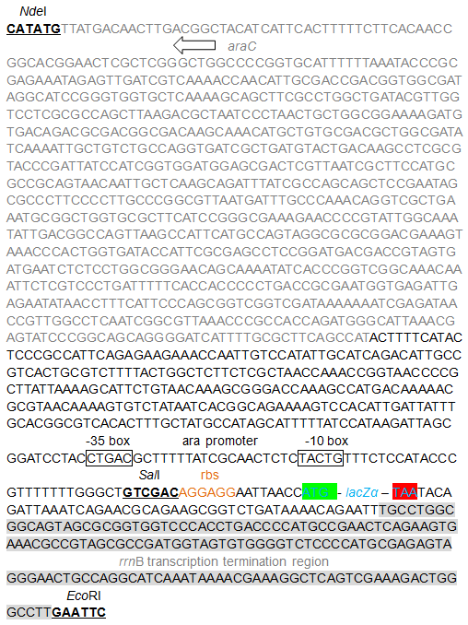
The cloning/expression region of pPara-lacZα. lacZα is transcribed under the control of ara promoter.

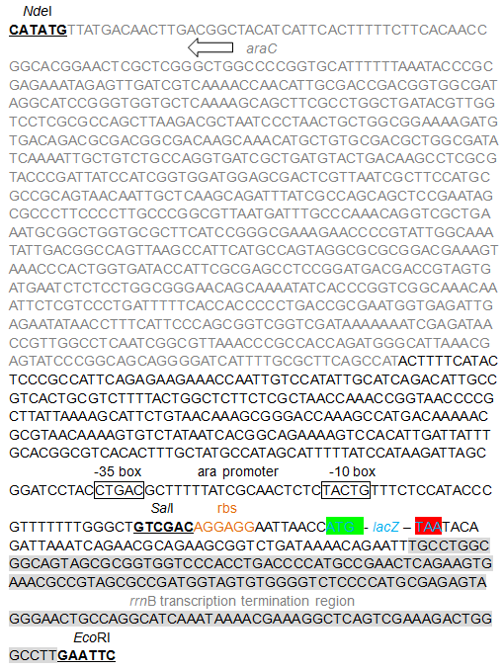
The cloning/expression region of pPara-lacZ. lacZ is transcribed under the control of ara promoter.

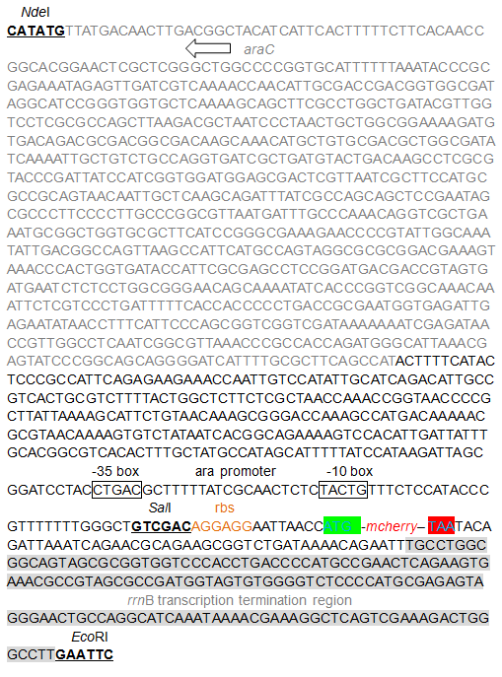
The cloning/expression region of pPara-RFP. mCherry is transcribed under the control of ara promoter.
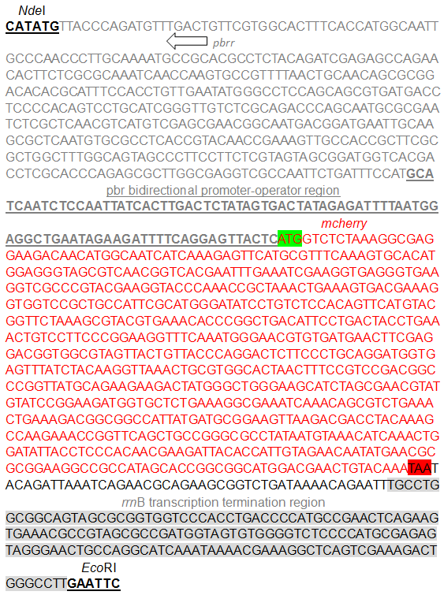
The cloning/expression region of pPpbr-RFP. The cassette including the pbrR gene and the divergent pbr promoter was inserted in front of mCherry.
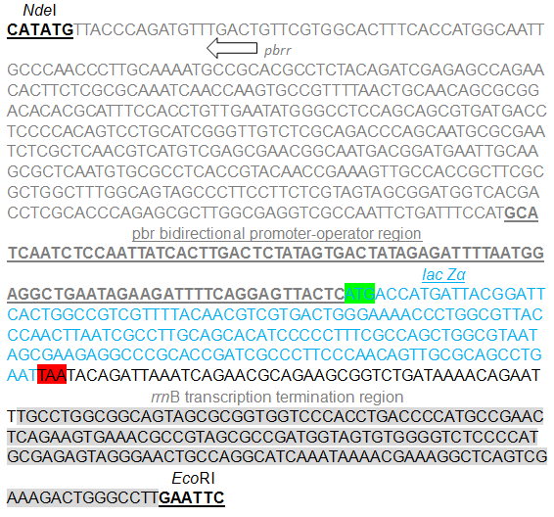
The cloning/expression region of pPpbr-lacZα. The cassette including the pbrR gene and the divergent pbr promoter was inserted in front of lacZα.

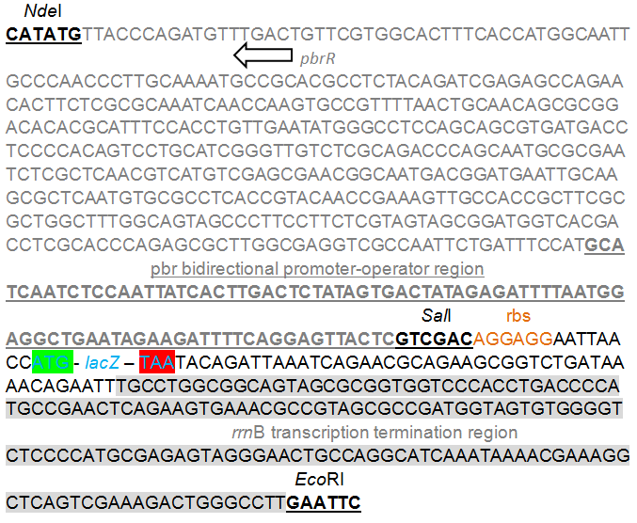
The cloning/expression region of pPpbr-lacZ. The cassette including the pbrR gene and the divergent pbr promoter was inserted in front of lacZ.

Figure S1. The cloning/expression region of recombinant plasmids used in this study. DNA sequence and annotation data were all marked.

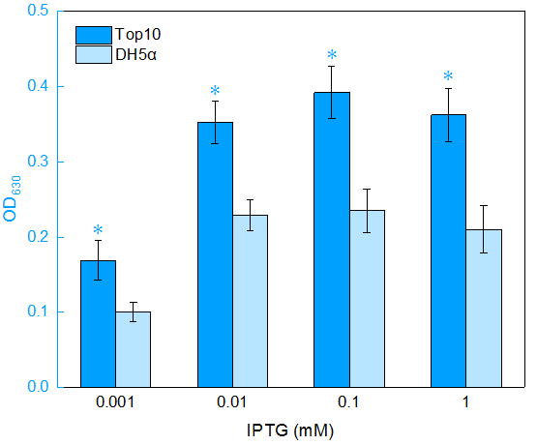
Figure S2. Assay of the lac promoter activities in different hosts based on a lacZα reporter system.
Overnight cultures were diluted in fresh 1% glucose-containing LB media. At the logarithmic growth phase, E. coli strains harboring pPlac-lacZα were exposed to different concentrations of IPTG. After a 4 h incubation at 37ºC, the β-galactosidase activities were assayed. The optical density at 630 nm was normalized by dividing the OD₆₃₀ of the β-galactosidase activity determination system by the OD₆₀₀ value of the induced culture. The data are representative of three independent experiments, and expressed as mean ± SEM. *A significant difference (t test, P<0.05) between E. coli Top10 and DH5α hosts.

