Supplementary Table 1

Specificity | Clone | Manufacturer
CD3 | 17A2 | BD
CD4 | GK1.5 | BD
CD8 | 53-6.7 | BD
CD45 | 30-F11 | BD
CD25 | PC16 | BD
CD19 | 1D3 | BD
Tbet | 3C8 | eBioscience
GATA3 | TWAJ | eBioscience
FoxP3 | FJK-16s | eBioscience
RoRgt | B2D | eBioscience
CD11c | N418 | Biolegend
CD11b | M1/70 | Biolegend
Ly6C | HK1.4 | Biolegend
Ly6G | RB6-8C5 | Biolegend
CD69 | H1.2F3 | eBioscience
IL-10 | JES5-16E3 | Biolegend
IL-17 | TC11-18H10.1 | Biolegend

Supplementary Table 1 List of antibodies used.

Supplementary Table 2

Activity index (0-24)
Endocapillary proliferation (0-3)
Leukocyte infiltration (0-3)
Subendothelial hyaline deposits (0-3)
Fibrinoid necrosis / karyorrhexis (0-3) x 2
Cellular crescents (0-3) x 2
Interstitial inflammation (0-3)

Chronicity index (0-12)
Glomerular sclerosis (0-3)
Fibrous crescents (0-3)
Tubular atrophy (0-3)
Interstitial fibrosis (0-3)

0: Absent
1: Less than 25% of glomeruli or cortical tubules/intersitium affected
2: 25-50% of glomeruli or cortical tubules/intersitium affected
3: More than 50% of glomeruli or cortical tubules/intersitium affected

Supplementary Table 2 The activity and chronicity indices used are the NIH activity and chronicity indices (modified Austin index) which are based on Austin et al. Diffuse proliferative lupus nephritis: Identification of specific pathologic features affecting renal outcome. Kidney International 1984; 25: 689-695.

Supplementary Table 3

Groups | EP | Glomerulo-sclerosis | AI | CI
DKO | 2.96 (1.08) | 0.04 (0.04) | 0.48 (0.11) | 0.08 (0.07)
B6.lpr | 0.16 (0.1) | 0 | 0.08 (0.04) | 0
P value | 0.013 | 0.377 | 0.002 | 0.215

Abbreviations: EP = Endocapillary proliferation; AI = activity index; CI = chronicity index; DKO = double knock out

Supplementary Table 3 The presence of endocapillary proliferation and glomerulosclerosis, and activity index and chronicity index in 48 DKO and 38 B6.lpr mice.

Supplementary Table 4

Splenocytes subset | B6.lpr | DKO | B6 WT | P value
CD3⁺ (from CD45⁺ population) | 9.2±1.3 | 13.0±3.0 | 7.2±0.8 | 0.289
CD4⁺ (from CD3⁺ population) | 76.3±3.9 | 72.2±7.4 | 85.5±1.4 | 0.401
CD8⁺ (from CD3⁺ population) | 6.9±2.4 | 10.4±3.8 | 2.5±1.6 | 0.321
CD19⁺ (from CD45⁺ population) | 33.3±4.8 | 27.1±4.2 | 42.7±10.3 | 0.154
CD3⁺CD4⁻CD8⁻ (DNTC, from CD3⁺ population) | 8.30±1.5 | 9.7±4.8 | 6.8±0.8 | 0.875
CD3⁺CD69⁺ (from CD3⁺ population) | 14.6±2.2†* | 8.0±1.3† | 5.4±0.6* | 0.030
CD4⁺CD69⁺ (from CD4⁺ population) | 21.1±5.3 | 16.7±3.5 | 16.2±1.9 | 0.687
CD8⁺CD69⁺ (from CD8⁺ population) | 38.2±15.4‡ | 3.2±1.3‡ | 0.8±0.8 | 0.015
CD19⁺CD69⁺ (from CD19⁺ population) | 3.0±1.1 | 2.3±0.6 | 1.1±0.1 | 0.398
CD69⁺DNTC (from DNTC population) | 16.6±6.9 | 8.5±4.0 | 2.7±1.9 | 0.266
Granulocytes (CD11b⁺Ly6G^{high}Ly6C⁺)** | 32.5±7.0 | 40.0±3.0 | 32.3±5.5 | 0.485
Monocytes (CD11b⁺Ly6C^{high}Ly6G⁻)** | 6.6±1.2 | 10.1±1.1 | 7.1±1.4 | 0.107
CD11b⁺CD11c⁺ (cDCs)** | 10.4±3.0 | 8.50±1.9 | 5.5±0.7 | 0.441
Abbreviations: DKO = double knock-out mice; WT = wild type; DNTC = double negative T cells; cDC -= conventional dendritic cells
† Post-hoc comparison (Tukey HSD) between B6.lpr and DKO groups, p=0.033
* Post-hoc comparison (Tukey HSD) between B6.lpr and B6 WT groups, p=0.015
‡ Post-hoc comparison (Tukey HSD) between B6.lpr and DKO groups, p=0.045
** Splenic granulocytes, monocytes and cDCs were gated from the CD45⁺ population

Supplementary Table 4 Frequencies of different splenocyte subsets.

Supplementary Table 5

T-cell subset | B6.lpr | DKO | B6 WT | P-value
CD3⁺CD4⁺CD25⁺FoxP3⁺ (Treg) | 4.8±1.0 | 5.5±0.9 | 7.8±0.8 | 0.209
CD3⁺CD4⁺Tbet⁺  (Th1) | 66.4±8.8 | 41.9±8.0 | 47.8±4.6 | 0.116
CD3⁺CD4⁺GATA3⁺ (Th2) | 13.9±7.9 | 9.9±3.6 | 25.5±8.1 | 0.337
CD3⁺CD4⁺RORγt⁺ (Th17) | 15.5±3.9* | 36.5±6.1* | 22.2±3.8 | 0.032
CD3⁺CD4⁺RORγt⁺Tbet⁺ (Th1/Th17) | 7.0±1.1 | 14.5±2.8 | 9.5±1.9 | 0.439
Abbreviations: DKO = double knock out; WT = wild type
* Post-hoc comparison (Tukey HSD) between B6.lpr and DKO groups, p=0.028

Supplementary Table 5 Frequencies of different subsets of the Th population. Splenocytes were stained for lineage specific transcription factors along with CD3, CD4 and analysed via flow cytometry.

Supplementary Table 6

Cytokine | B6.lpr  (n=18) | DKO  (n=17) | B6 WT  (n=3) | P-value
IFN-γ | 617.4±599.6 | 74.0±54.7 | 3.1±0.8 | 0.457
TNF | 59.7±39.3* | 19.6±9.1* | 4.4±0 | 0.033
IL-2 | 9.2±5.3 | 1.8±0 | 1.8±0 | 0.172
IL-6 | 72.8±55.0 | 10.6±5.5 | 1.2±0 | 0.485
IL-4 | 20.9±17.8 | 1.8±0.4 | 1.3±0 | 0.652
IL-5 | 12.4±7.1 | 6.2±1.1 | 4.1±0 | 0.529
IL-13 | 5.5±0.7 | 4.4±0.3 | 4.7±0 | 0.116
IL-9 | 23.8±8.1 | 7.4±0.6 | 6.4±0 | 0.477
IL-10 | 128.4±39.3† | 31.7±21.6† | 2.0±0 | 0.017
IL-17A | 10.1±8.3 | 1.9±0.1 | 1.7±0 | 0.916
IL-17F | 4.7±0.8 | 3.9±0 | 3.9±0 | 0.319
IL-21 | 46.2±28.2 | 7.7±1.0 | 9.2±2.6 | 0.375
IL-22 | 3.2±0.7 | 2.8±0.3 | 2.4±0 | 0.916
Footnotes: Mann-Whitney U test: *TNF: B6.lpr vs. DKO, p=0.116; †IL-10: B6.lpr vs. DKO, p=0.036

Supplementary Table 6 Serum cytokine levels in the DKO, B6.lpr and B6 WT mice.
Serum from the mice was analyzed for cytokine levels using the LEGENDplexTM platform and the cytokine levels, extrapolated from a standard curve were, compared across the 3 mouse groups. All measurements were performed in a single multiplex assay.

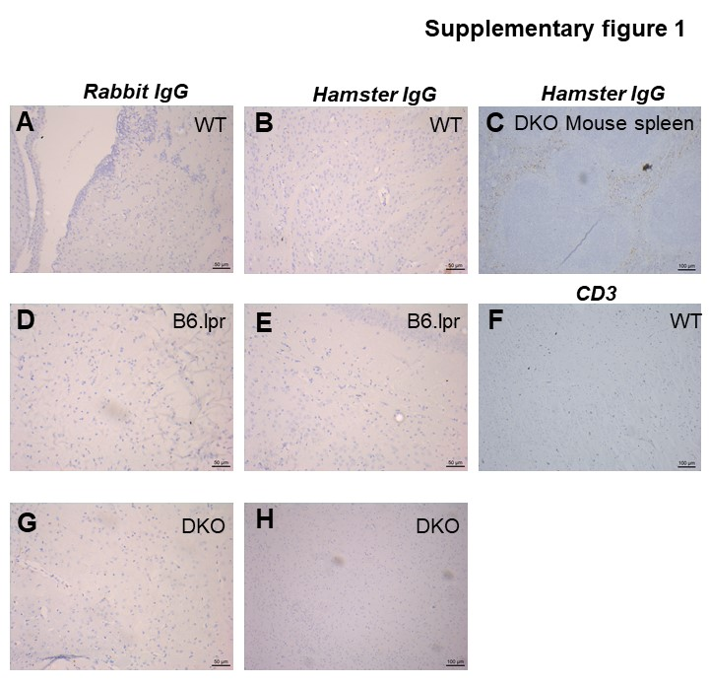

Supplementary Figure 1 Immunohistochemistry of mouse brain. (A, D, G) Staining of mouse brain tissue sections with rabbit IgG. (B, E, H) Staining of brain tissue sections with hamster IgG. (C) Mouse spleen stained with hamster IgG. (F) Brain tissue section of WT mice stained with hamster anti-mouse CD3 antibody.

