Supplementary Figure 1

Supplementary Figure 1. Proliferation of CD4⁺ T cells (evaluated on CFSE-stained CD4⁺T cells) in cells from inguinal lymph nodes from immunized mice.

Supplementary Figure 2
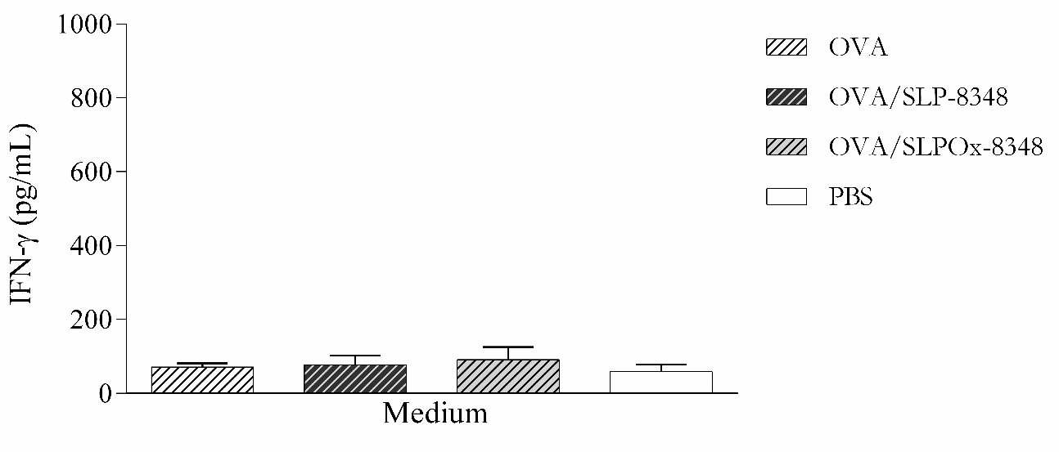

Supplementary Figure 2. IFN-γ levels in supernatants of cells from inguinal lymph nodes obtained from BALB/c mice subcutaneously injected with one dose (10 µg/mouse) of SLP-8348 + OVA, oxidized SLP-8348 (SLPOx-8348) + OVA, PBS + OVA (OVA), or PBS (PBS) in absence of in vitro antigenic stimulation.

Supplementary Figure 3

Supplementary Figure 3. CLR-hFc fusion proteins interaction with SLPOx-8348 and SLPB-8348.

