Supplementary Material

Supplementary Figures
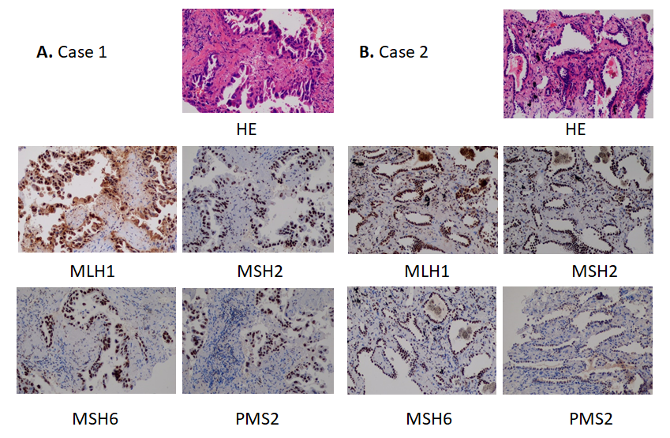
Figure S1. HE and IHC staining of MLH1, MSH2, MSH6 and PMS2 of lung cancer tissues from case 1 (A), and case 2 (B) (200x magnification).

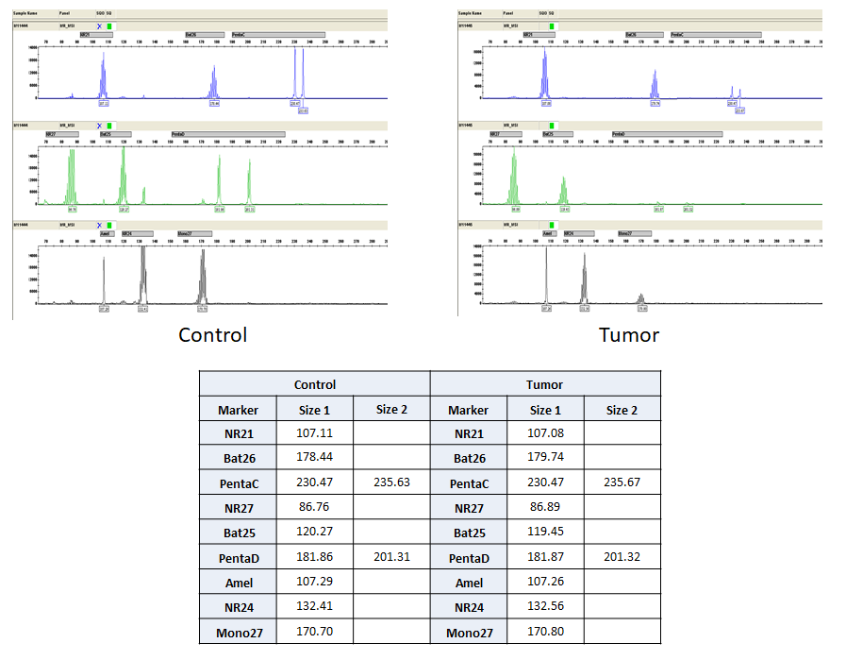
Figure S2. Microsatellite instability (MSI) profiles of control and tumor samples (Upper panel). No shifts of microsatellite repeat lengths were noticed indicating the MSS statue. Microsatellite repeat lengths are listed in the table (Lower panel).

