Supplementary Information

Chemical transfers occurring through Oenococcus oeni biofilm in different enological conditions
- Christian Coelho^{1, *}, Régis D. Gougeon¹, Luc Perekelkine², Hervé Alexandre³, Jean Guzzo³, Stéphanie Weidmann³
¹UMR A 02.102 PAM Laboratoire PCAV AgroSup Dijon, Université de Bourgogne, Institut Universitaire de la Vigne et du Vin Jules Guyot, rue Claude Ladrey, BP 27877, 21078 Dijon Cedex, France
²SAAT Sayens, Maison régionale de l'innovation, 64a Rue Sully, 21000 Dijon
³UMR A 02.102 PAM Laboratoire VAlMiS AgroSup Dijon, Université de Bourgogne, Institut Universitaire de la Vigne et du Vin Jules Guyot, rue Claude Ladrey, BP 27877, 21078 Dijon Cedex, France.

Table S.I.1 : Oenological parameters followed during fermentation for the three oenological conditions. Among the parameters, TA and VA represent respectively total acidity in g/L in H₂SO₄ and volatile acidity in g/L in CH₃COOH . Glu/Fru represents the ratio of glucose/fructose.

A) Condition 1 :

PAD1 :

Time / days | 10 | 11 | 14 | 18 | 21 | 24 | 28 | 34 | 41
Malic acid g/L | 2,16 | 2,05 | 1,96 | 1,69 | 1,63 | 1,63 | 1,46 | 1,08 | 0,63
O.o UFC/mL | 6,44E+05 | 6,67E+04 | 5,40E+05 | 9,67E+05 | 9,67E+05 | 6,00E+05 | 1,20E+06 | 1,73E+06 | -
Ethanol % | 12,4 | 12,92 | 12,44 | 13 | 13 | 13,0 | 12,98 | 12,88 | 12,94
TA g/L | 4,8 | 4,82 | 4,8 | 4,81 | 4,78 | 4,74 | 4,66 | 4,61 | 4,61
Glu/Fru | 0,0 | 0,0 | 0,2 | 0,0 | 0,0 | 0,0 | 0,0 | 0,0 | 0,0
pH | 3,23 | 3,20 | 3,21 | 3,25 | 3,24 | 3,24 | 3,26 | 3,28 | 3,32
VA g/L | 0,31 | 0,43 | 0,43 | 0,46 | 0,45 | 0,44 | 0,46 | 0,46 | 0,51

BF1 :

Time / days | 10 | 11 | 14 | 18 | 21 | 24 | 28 | 34 | 41
Malic acid g/L | 1,87 | 2,13 | 1,97 | 2,46 | 1,90 | 1,85 | 2,00 | 1,92 | 1,46
O.o UFC/mL | 4,67E+05 | 3,33E+03 | 7,33E+03 | 5,33E+03 | 3,33E+03 | 4,33E+03 | 5,67E+03 | 3,67E+04 | -
Ethanol % | 12,58 | 12,88 | 12,87 | 12,96 | 12,97 | 12,91 | 12,81 | 12,17 | 12,76
TA g/L | 4,8 | 4,8 | 4,8 | 4,8 | 4,9 | 4,9 | 4,9 | 4,9 | 4,9
Ac.malique | 2,1 | 2,1 | 2,1 | 2,1 | 2,2 | 2,2 | 2,2 | 2,0 | 2,0
Glu/Fru | 0,0 | 0,0 | 0,0 | 0,0 | 0,0 | 0,0 | 0,0 | 0,0 | 0,0
pH | 3,20 | 3,24 | 3,23 | 3,25 | 3,25 | 3,25 | 3,27 | 3,33 | 3,30
VA g/L | 0,41 | 0,44 | 0,44 | 0,46 | 0,44 | 0,45 | 0,45 | 0,39 | 0,49

B) Condition 2 :

PAD2 :

Time /days | 10 | 14 | 17 | 21 | 26 | 31 | 34 | 40 | 52 | 56 | 60 | 63 | 69 | 76
Malic Acid g/L | 2,15 | 1,98 | 1,98 | 2,26 | 1,93 | 1,92 | 2,01 | 1,80 | 1,79 | 1,12 | 1,04 | 1,06 | 0,32 | 0,01
O.o UFC/mL | 2,00E+06 | 1,00E+00 | 1,00E+00 | 1,00E+00 | 1,33E+05 | 1,37E+04 | 9,33E+03 | 1,90E+04 | 9,33E+04 | 3,33E+05 | 6,67E+05 | 1,33E+06 | 4,67E+05 | -
Ethanol % | 12,9 | 12,93 | 12,9 | 12,9 | 12,92 | 12,92 | 12,78 | 12,88 | 12,96 | 12,93 | 12,83 | 12,96 | 12,7 | 12,75
TA g/L | 5,2 | 4,97 | 4,99 | 4,99 | 5,06 | 5,00 | 4,97 | 4,95 | 4,88 | 4,8 | 4,75 | 4,2 | 4,51 | 4,4
Ac.malique | 1,9 | 2,1 | 2,1 | 2,1 | 2,2 | 2,1 | 2,2 | 2 | 1,8 | 1,4 | 1,3 | 1,3 | 0,6 | 0,5
Glu/Fru | 0,4 | 0,0 | 0,0 | 0,0 | 0,0 | 0,0 | 0,0 | 0,0 | 0,0 | 0,0 | 0,0 | 0,0 | 0,0 | 0,0
pH | 3,13 | 3,23 | 3,21 | 3,22 | 3,22 | 3,24 | 3,26 | 3,25 | 3,26 | 3,28 | 3,28 | 3,26 | 3,29 | 3,32
VA g/L | 0,41 | 0,44 | 0,43 | 0,45 | 0,47 | 0,44 | 0,46 | 0,47 | 0,46 | 0,49 | 0,49 | 0,46 | 0,43 | 0,51

BF2 :

Time /days | 10 | 14 | 17 | 21 | 24 | 26 | 31 | 34 | 38 | 40 | 44 | 48
Malic Acid g/L | 2,15 | 2,02 | 1,84 | 1,60 | 1,67 | 1,58 | 1,17 | 0,64 | 0,39 | 0,11 | 0,00 | 0,02
O.o UFC/mL |  | 2,10E+05 | 2,73E+05 | 3,83E+05 | 4,67E+05 | 4,00E+05 | 4,93E+05 | 1,93E+06 | 3,30E+06 | 1,63E+05 | 7,00E+05 | 2,07E+04
Ethanol % | 12,87 | 13,07 | 12,66 | 12,89 | 12,97 | 12,86 | 12,81 | 12,99 | 12,84 | 12,87 | 12,99 | 12,72
TA g/L | 5,2 | 5,1 | 5,1 | 5,0 | 4,9 | 4,9 | 4,7 | 4,6 | 4,4 | 4,3 | 4,4 | 4,4
Ac.malique | 1,9 | 1,9 | 2,0 | 1,8 | 1,7 | 1,6 | 1,3 | 1,0 | 0,5 | 0,2 | 0,2 | 0,4
Glu/Fru | 0,4 | 0,0 | 0,0 | 0,0 | 0,0 | 0,0 | 0,0 | 0,0 | 0,0 | 0,0 | 0,0 | 0,0
pH | 3,13 | 3,17 | 3,16 | 3,17 | 3,22 | 3,22 | 3,25 | 3,24 | 3,25 | 3,29 | 3,30 | 3,32
VA g/L | 0,41 | 0,40 | 0,44 | 0,43 | 0,44 | 0,43 | 0,43 | 0,47 | 0,44 | 0,45 | 0,46 | 0,50

C) Condition 3 :

PAD 3 :

Time /days | 1 | 2 | 6 | 10 | 31 | 36 | 38 | 41 | 50 | 62 | 66 | 70 | 73 | 79
Malic Acid g/L | 3,13 | 2,95 | 2,15 | 2,37 | 2,34 | 2,32 | 2,01 | 2,02 | 1,83 | 1,24 | 0,55 | 0,25 | 0,16 | 0,09
O.o UFC/mL | 1,33E+06 | 1,90E+06 | 1,67E+04 | 1,00E+00 | 1,00E+00 | 7,00E+04 | 2,03E+04 | 2,00E+03 | 2,63E+03 | 1,27E+05 | 3,67E+05 | 4,67E+05 | 8,67E+05 | 2,50E+05
Ethanol % | 0,1 | 0,8 | 12,0 | 12,63 | 12,75 | 12,73 | 12,55 | 12,71 | 12,47 | 12,73 | 12,71 | 12,75 | 12,72 | 12,75
TA g/L | 4,7 | 4,9 | 5,4 | 5,16 | 4,9 | 4,96 | 4,84 | 4,86 | 4,76 | 4,42 | 4,39 | 4,31 | 4,25 | 4,23
Ac.malique | 3,7 | 3,5 | 2,7 | 1,9 | 2,0 | 2,1 | 2,0 | 1,9 | 1,8 | 1 | 0,5 | 0,3 | 0,2 | 0,3
Glu/Fru | 205,0 | 183,5 | 5,3 | 0,6 | 0,0 | 0,0 | 0,0 | 0,0 | 0,0 | 0,0 | 0,0 | 0,0 | 0,0 | 0,0
pH | 3,20 | 3,24 | 3,10 | 3,09 | 3,09 | 3,13 | 3,10 | 3,12 | 3,12 | 3,17 | 3,18 | 3,18 | 3,19 | 3,21
VA g/L | 0,24 | 0,24 | 0,23 | 0,32 | 0,33 | 0,39 | 0,34 | 0,35 | 0,35 | 0,36 | 0,37 | 0,37 | 0,36 | 0,35

BF3 :
Time /days | 1 | 2 | 6 | 8 | 10 | 14 | 17 | 20 | 27 | 31 | 36 | 41 | 44 | 48
Malic Acid g/L | 3,08 | 2,98 | 2,03 | 1,86 | 2,02 | 1,89 | 1,91 | 1,51 | 1,46 | 1,32 | 0,75 | 0,33 | 0,21 | 0,12
O.o UFC/mL | 1,60E+06 | 2,00E+05 | 2,00E+04 | 5,33E+04 | 3,67E+04 | 2,77E+04 | 2,07E+04 | 2,23E+04 | 2,67E+04 | 2,87E+04 | 9,00E+04 | 2,80E+05 | 2,03E+05 | 1,83E+05
Ethanol % | 0,1 | 0,5 | 10,8 | 12,0 | 12,4 | 12,7 | 12,7 | 12,5 | 11,8 | 12,7 | 12,7 | 12,7 | 12,7 | 12,7
TA g/L | 4,7 | 5,0 | 5,1 | 5,1 | 4,9 | 4,9 | 4,8 | 4,8 | 4,9 | 4,7 | 4,5 | 4,3 | 4,3 | 4,2
Ac.malique | 3,7 | 3,6 | 2,3 | 2,4 | 1,8 | 1,6 | 1,6 | 1,6 | 1,9 | 1,2 | 0,8 | 0,3 | 0,2 | 0,1
Glu/Fru | 205,0 | 191,4 | 26,7 | 6,1 | 1,3 | 0,0 | 0,0 | 0,0 | 0,0 | 0,0 | 0,0 | 0,0 | 0,0 | 0,0
pH | 3,20 | 3,21 | 3,11 | 3,11 | 3,14 | 3,11 | 3,09 | 3,14 | 3,12 | 3,22 | 3,22 | 3,20 | 3,20 | 3,21
VA g/L | 0,24 | 0,25 | 0,22 | 0,19 | 0,30 | 0,36 | 0,34 | 0,34 | 0,34 | 0,45 | 0,47 | 0,38 | 0,36 | 0,38

Table S.I.2 : Time required to AF and MLF to achieve based on the following criteria : Glu/Fru below 2 g.L⁻¹ and L-malic acid concentration below 0.2 g.L⁻¹ in the three BF/PAD conditions.

Conditions | Time to achieve AF /day | Time to achieve MLF /day | Total Fermentation time (AF+MLF) / day
PAD 1 | 10 | 63 | 73
BF 1 | 10 | 43 | 53
PAD 2 | 10 | 76 | 86
BF 2 | 10 | 31 | 41
PAD 3 | 10 | 73 | 73
BF 3 | 10 | 48 | 48

Figure S.I.1 : Excitation (A) and Emission (B) spectra of the four PARAFAC components obtained by a split-half analysis with four independent splits and validated for excitation spectra (C) and emission spectra (D)

A)  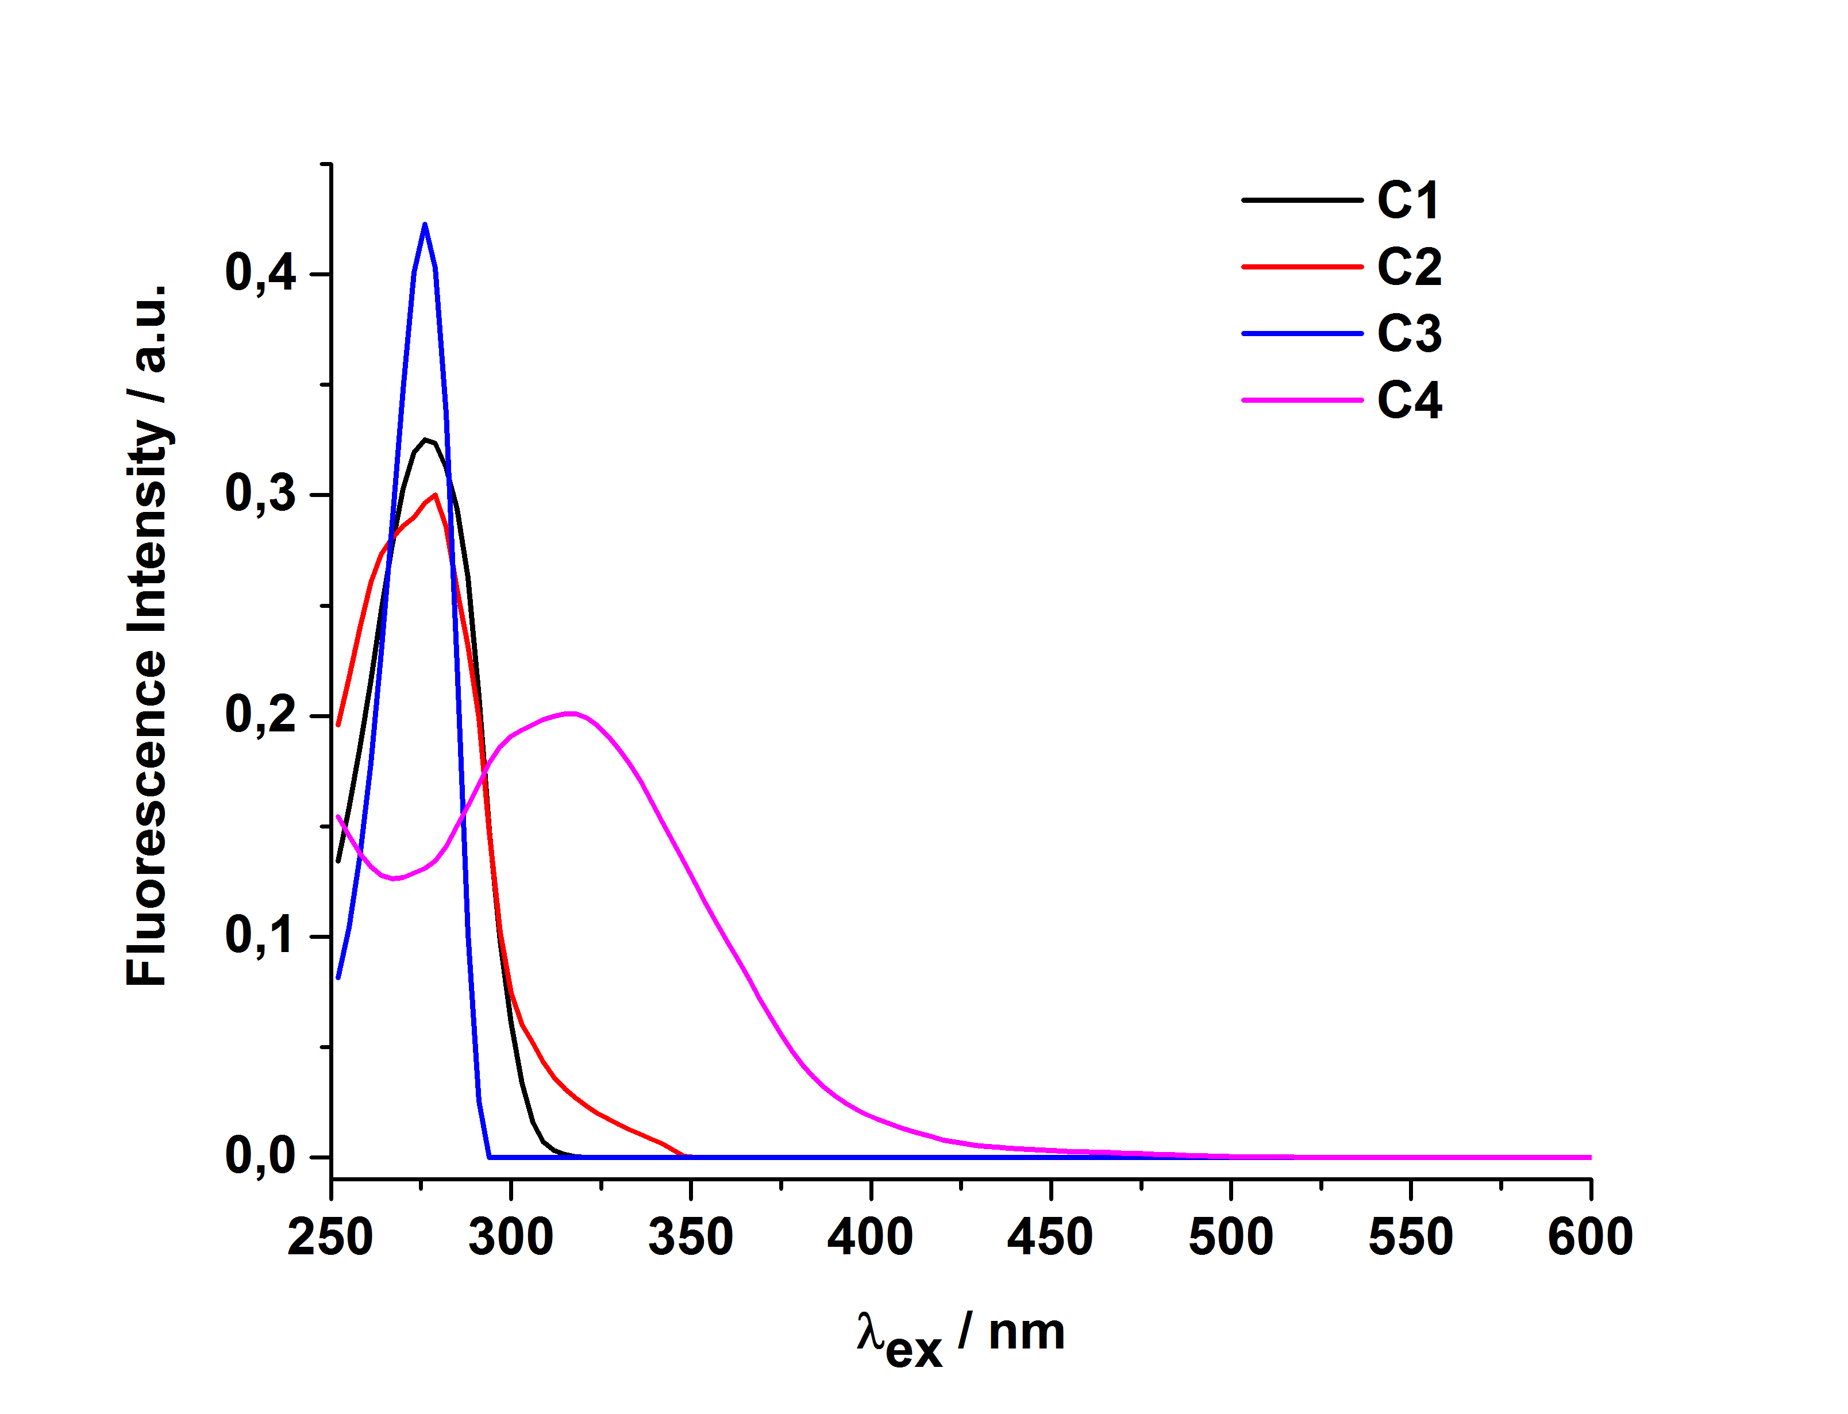 | C)
B)  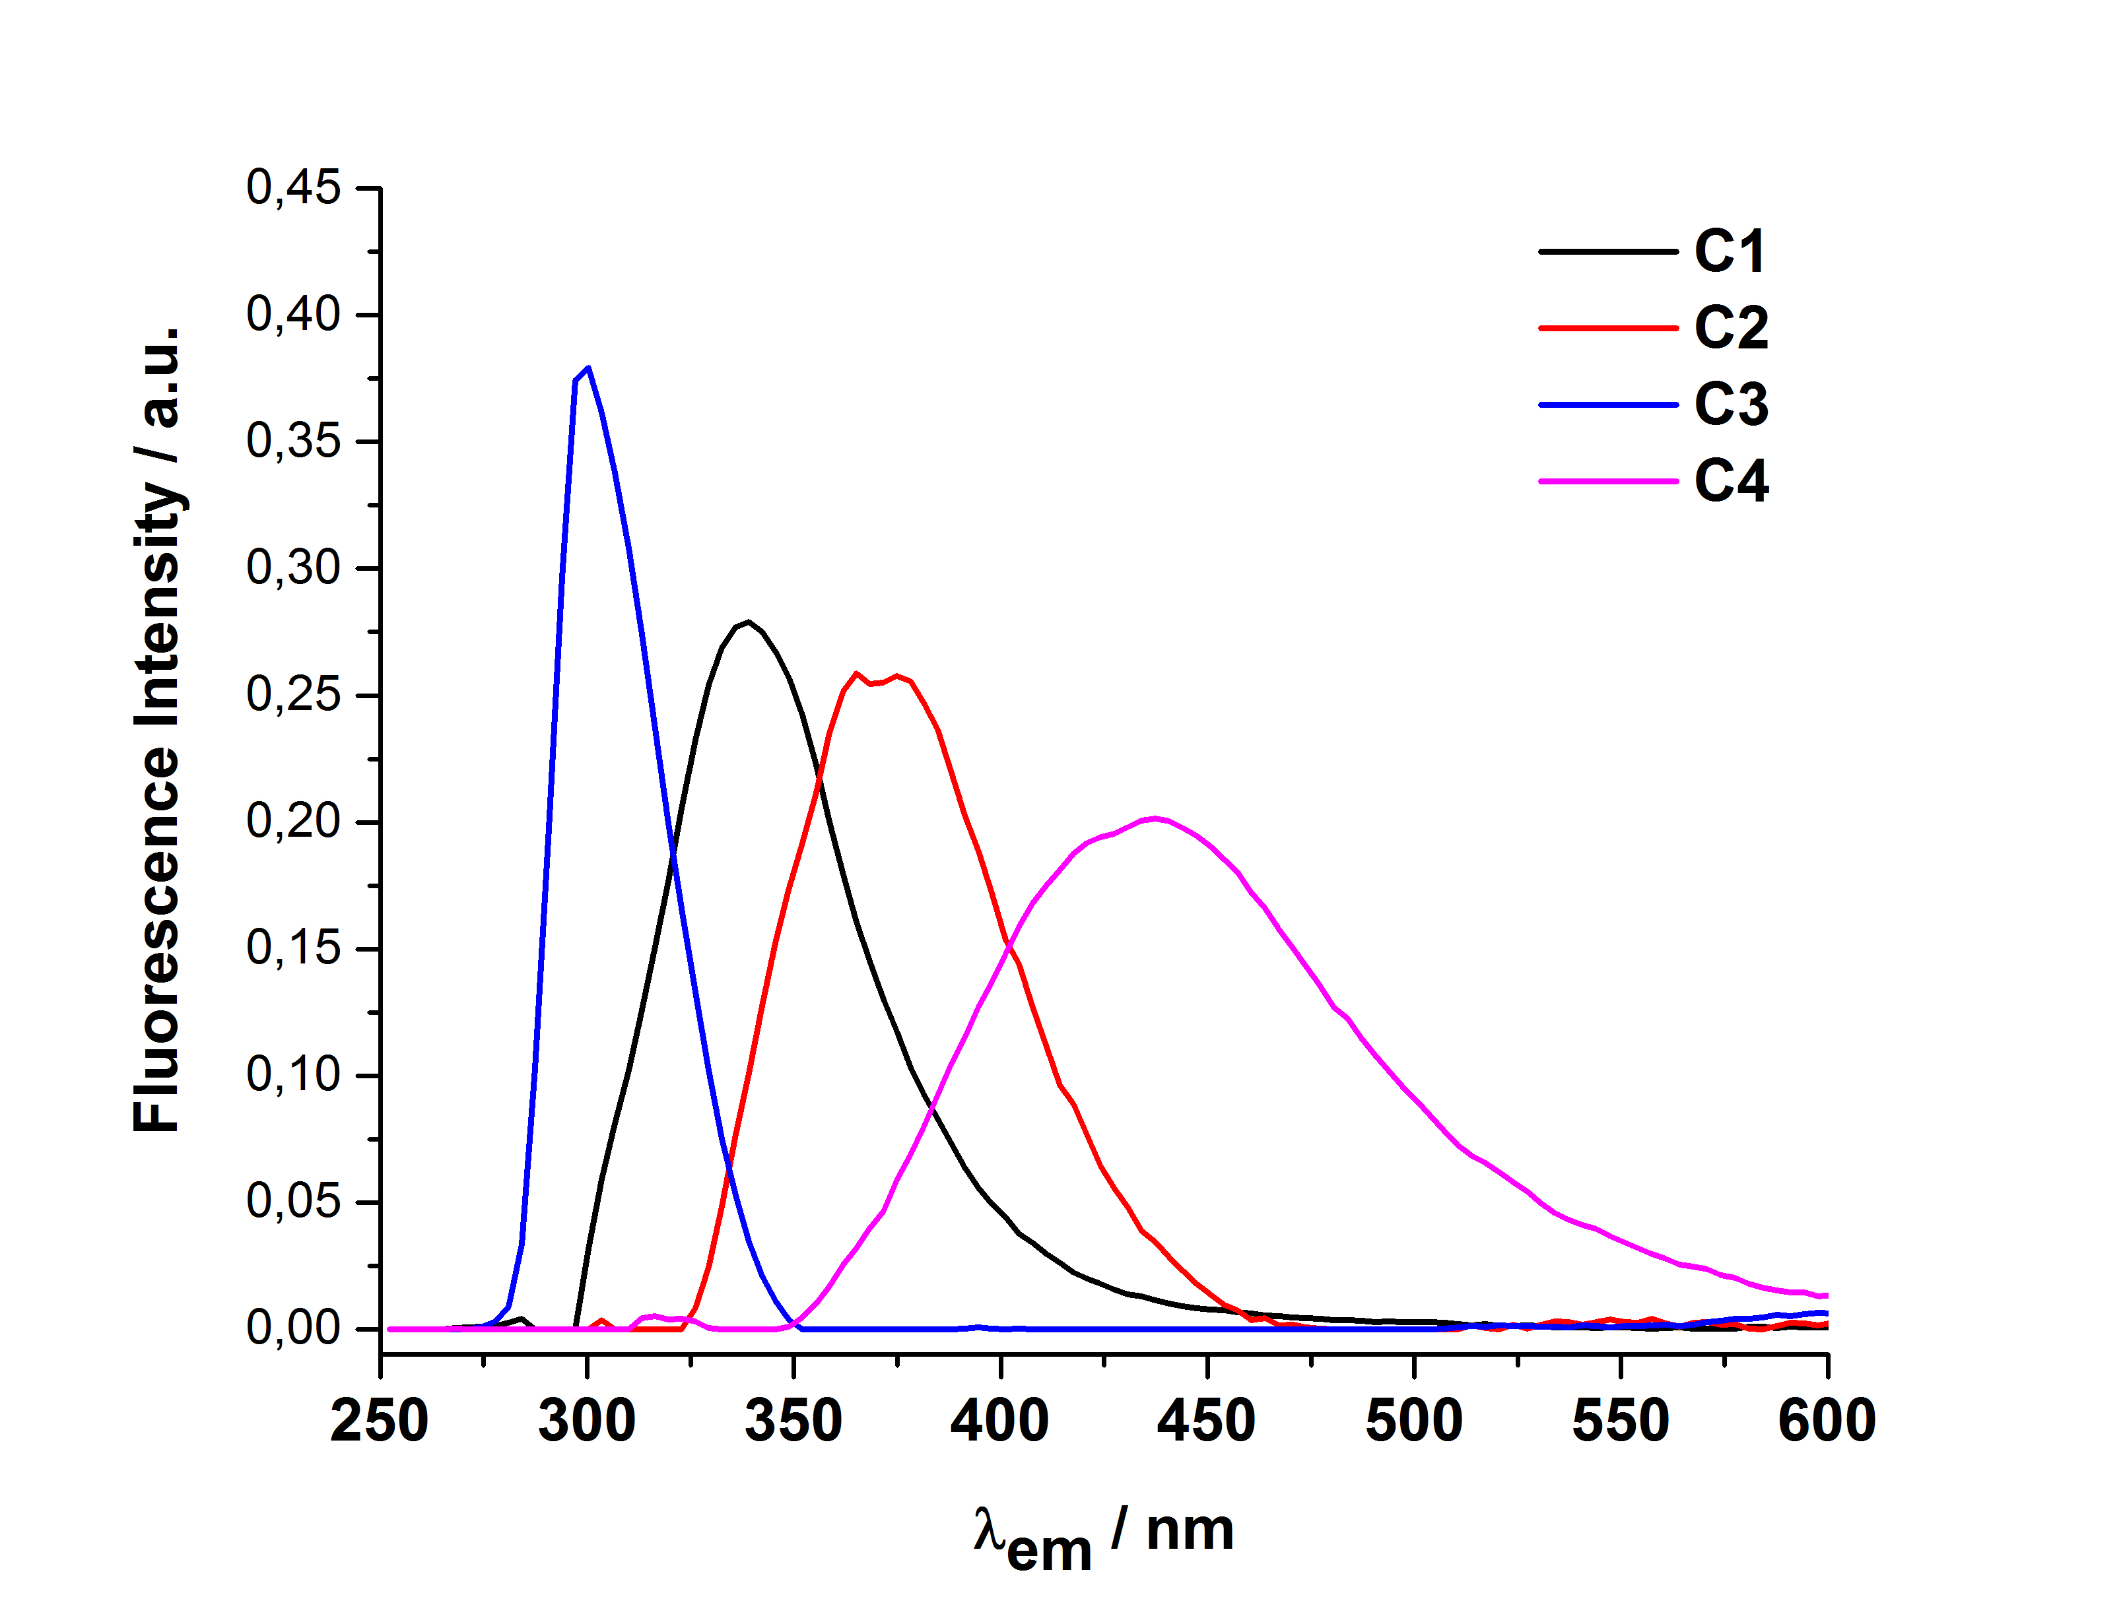 | D)

Table S.I.3 : Fmax values of the four PARAFAC components for Chardonnay white wines at the different fermentation days resulting from the wood containing BF/PAD Conditions 2 and 3.

Condition | Modality | Fermentation days | C1 | C2 | C3 | C4
Condition 2 | BF 2 | 14 | 1,346 | 1,336 | 3,131 | 0,240
 |  | 21 | 1,292 | 1,320 | 2,248 | 0,250
 |  | 26 | 1,749 | 1,734 | 3,957 | 0,279
 |  | 31 | 1,842 | 1,831 | 3,985 | 0,285
 |  | 34 | 1,991 | 1,987 | 4,230 | 0,320
 |  | 40 | 2,116 | 2,195 | 4,312 | 0,324
 | PAD2 | 14 | 1,307 | 1,297 | 3,130 | 0,232
 |  | 76 | 2,370 | 2,287 | 4,237 | 0,274
 |  | 21 | 1,329 | 1,347 | 2,187 | 0,255
 |  | 26 | 1,600 | 1,599 | 3,711 | 0,251
 |  | 31 | 1,796 | 1,771 | 3,958 | 0,268
 |  | 34 | 1,911 | 1,926 | 4,148 | 0,289
 |  | 40 | 2,072 | 2,133 | 4,227 | 0,286
Condition 3 | BF 3 | 27 | 1,492 | 1,524 | 2,587 | 0,284
 |  | 31 | 1,943 | 1,948 | 3,249 | 0,370
 |  | 1 | 1,175 | 1,421 | 0,651 | 0,216
 |  | 2 | 0,970 | 1,080 | 0,689 | 0,243
 |  | 36 | 1,873 | 1,893 | 3,015 | 0,352
 |  | 6 | 1,132 | 1,206 | 2,116 | 0,229
 |  | 41 | 1,891 | 1,983 | 2,879 | 0,340
 | PAD 3 | 79 | 2,131 | 1,995 | 2,637 | 0,321
 |  | 24 | 1,351 | 1,329 | 3,206 | 0,228
 |  | 27 | 1,430 | 1,429 | 2,336 | 0,262
 |  | 31 | 1,526 | 1,498 | 2,444 | 0,283
 |  | 1 | 1,196 | 1,441 | 0,668 | 0,220
 |  | 2 | 0,953 | 1,083 | 0,639 | 0,229
 |  | 36 | 1,644 | 1,608 | 2,562 | 0,303
 |  | 6 | 1,083 | 1,149 | 1,887 | 0,226
 |  | 41 | 1,796 | 1,821 | 2,609 | 0,319

Table S.I.4 : Individual concentrations of grape polyphenols (in mg.L⁻¹), wood volatile aromas (in µg.L⁻¹) and higher alcohols (in mg.L⁻¹) present in Chardonnay white wines resulting from the three BF/PAD conditions. Standard deviations were added for each analyte concentrations.

 | PAD1 | BF1 | PAD2 | BF2 | PAD3 | BF3
Grape polyphenols :
Gallic acid | 0,08 ± 0.02 | 0,07 ± 0.02 | 0,39 ± 0.05 | 0,26 ± 0.04 | 1,31 ± 0.06 | 0,93 ± 0.08
Protocatechuic acid | 0,36 ± 0.06 | 0,33 ± 0.08 | 0,33 ± 0.03 | 0,37 ± 0.05 | 0,42 ± 0.06 | 0,35 ± 0.05
Hydroxytyrosol | 0,69 ± 0.08 | 0,58 ± 0.06 | 0,58 ± 0.03 | 0,57 ± 0.04 | 0,59 ± 0.05 | 0,56 ± 0.08
Hydroxybenzoic acid | 1,27 ± 0.04 | 1,17 ± 0.04 | 1,33 ± 0.06 | 1,19 ± 0.04 | 1,32 ± 0.04 | 1,33 ± 0.05
Caffeic acid | 0,84 ± 0.02 | 0,99 ± 0.04 | 0,73 ± 0.03 | 1,00 ± 0.02 | 0,67 ± 0.03 | 0,95 ± 0.03
Caftaric acid | 21,59 ± 0.03 | 21,23 ± 0.03 | 22,14 ± 0.04 | 21,09 ± 0.04 | 21,34 ± 0.05 | 19,97 ± 0.04
Coutaric acid | 3,35 ± 0.02 | 3,24 ± 0.02 | 3,55 ± 0.04 | 3,56 ± 0.08 | 3,03 ± 0.03 | 2,81 ± 0.05
GRP | 7,59 ± 0.08 | 7,65 ± 0.07 | 7,91 ± 0.07 | 7,21 ± 0.07 | 7,49 ± 0.09 | 7,22 ± 0.08
Coumaric acid | 0,41 ± 0.06 | 0,41 ± 0.06 | 0,46 ± 0.09 | 0,43 ± 0.04 | 0,45 ± 0.03 | 0,35 ± 0.03
Ferulic acid | 0,07 ± 0.03 | 0,05 ± 0.04 | 0,09 ± 0.03 | 0,09 ± 0.05 | 0,10 ± 0.07 | 0,09 ± 0.07
Tyrosol | 23,46 ± 0.08 | 23,11 ± 0.07 | 25,38 ± 0.09 | 22,66 ± 0.12 | 14,64 ± 0.04 | 14,88 ± 0.06
(+) Catechine | 0,30 ± 0.08 | 0,30 ± 0.09 | 0,36 ± 0.06 | 0,23 ± 0.09 | 0,42 ± 0.08 | 0,44 ± 0.08
(-) Epicatechine | 0,29 ± 0.06 | 0,26 ± 0.05 | 0,20 ± 0.07 | 0,18 ± 0.06 | 0,23 ± 0.07 | 0,18 ± 0.06
Wood volatile aromas :
Furfural | 12,23 ± 1.28 | 17,08 ± 1.34 | 520,24 ± 1.43 | 374,12 ± 1.46 | 41,17 ± 1.45 | 5,74 ± 1.45
Guaiacol | 0,10 ± 0.04 | 0,04 ± 0,04 | 1,02 ± 0.06 | 0,61 ± 0.06 | 1,31 ± 0.06 | 0,96 ± 0.07
Cis-whisky Lactone | 3,68 ± 1.08 | 6,60 ± 1.30 | 19,39 ± 1.69 | 29,24 ± 1.80 | 21,76 ± 1.87 | 10,53 ± 1.70
Trans-whisky Lactone | 0,22 ± 0.12 | 0,50 ± 0.15 | 3,08 ± 0.44 | 1,02 ± 0.39 | 5,74 ± 0.40 | 1,83 ± 0.40
Eugenol | 0,66 ± 0.23 | 0,81 ± 0.22 | 2,31 ± 0.86 | 1,40 ± 0.76 | 5,35 ± 0.88 | 3,15 ± 0.70
Vanillin | 7,30 ± 1.20 | 33,72 ± 1.76 | 109,60 ± 1.43 | 49,30 ± 1.40 | 151,95 ± 1.90 | 99,34 ± 1.78
Higher alcohols :
phenylethanol | 7,43 ± 0.26 | 3,56 ± 0.30 | 6,71 ± 0.29 | 8,12 ± 0.29 | 4,38 ± 0.32 | 7,53 ± 0.29
methanol | 11,85 ± 0.33 | 6,57 ± 0.32 | 7,62 ± 0.23 | 8,96 ± 0.29 | 9,91 ± 0.25 | 18,90 ± 0.34
propanol | 4,26 ± 0.40 | 3,28 ± 0.23 | 2,78 ± 0.38 | 4,15 ± 0.32 | 5,83 ± 0.29 | 6,26 ± 0.30
2-methyl-propanol | 4,90 ± 0.29 | 4,30 ± 0.28 | 4,15 ± 0.19 | 5,20 ± 0.28 | 3,98 ± 0.18 | 4,33 ± 0.30
2-methyl-butanol | 8,32 ± 0.38 | 4,09 ± 0.45 | 3,58 ± 0.43 | 6,94 ± 0.41 | 3,02 ± 0.49 | 5,15 ± 0.37
3-methyl-butanol | 32,42 ± 0.29 | 28,16 ± 0.32 | 26,62 ± 0.20 | 35,55 ± 0.43 | 23,12 ± 0.30 | 26,30 ± 0.37

