Supplemental information

Immunization with Mycobacterium tuberculosis antigens encapsulated in phosphatidylserine liposomes improves protection afforded by BCG
Gil R. Diogo^{1#}; Peter Hart^{1#;} Alastair Copland^{1#}; Mi-Young Kim¹, Andy C. Tran¹; Noemi Poerio³, Mahavir Singh²; Matthew J. Paul¹, Maurizio Fraziano³ and Rajko Reljic^{1*}

¹ St George’s University of London, SW17 0RE, United Kingdom
² Lionex, Braunschweig, 38126, Germany
³ University of Rome Tor Vergata, Rome, 00133 Roma, Italy
# These authors contributed equally to this work
* Corresponding author: Dr Rajko Reljic

Fig.S1
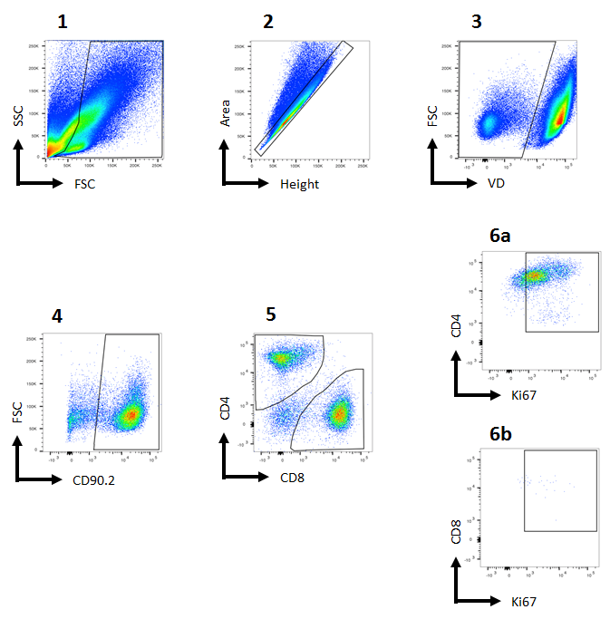

Supplemental Figure S1. Gating strategy for analysis of T cell proliferation in the splenocyte cultures of LIPO-AE immunised mice.

Fig.S2

Supplemental Figure S2. Reduced Mtb infection in LIPO-AE immunised mice. Mice were challenged with aerosolised Mtb and 4 weeks later culled and organs harvested for bacterial enumeration. Each point corresponds to log CFU value for the lungs and spleens of individual animals. (n = 5-7; some animals in the lung analysis were omitted due to tissue/plate fungal contamination). The horizontal bars represent the mean for each group ± SEM. Log transformed data were analysed using a 1-way ANOVA and a Dunnett’s multiple comparison test; * P ≤ 0.05, ** P ≤ 0.01.

