Supplementary Material

# Supplementary Figures and Files

## Supplementary Figures



**Supplementary Figure 1.** Risk of bias.

## Supplementary Files

**Supplementary File 1.** Small study bias in the overall pairwise comparison of GMFM.

 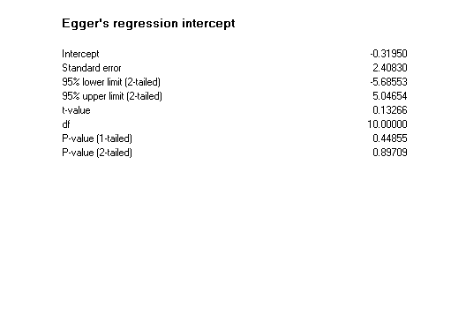

**Supplementary File 2.** GMFM Improvement (Overall).

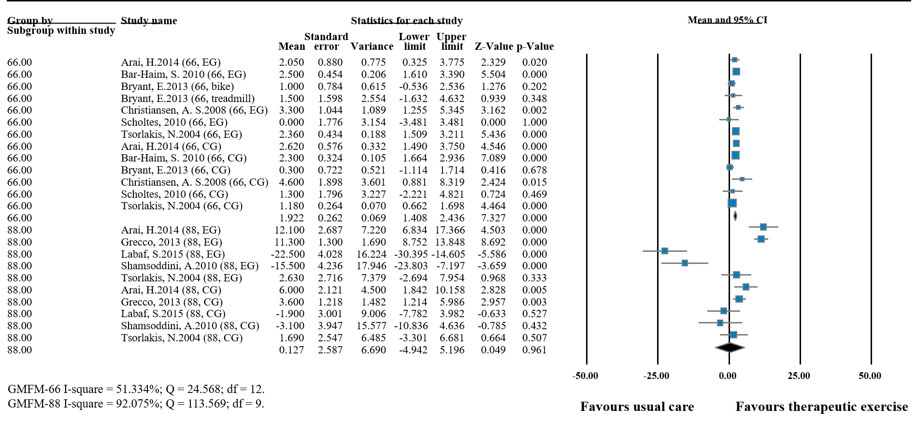(a)

 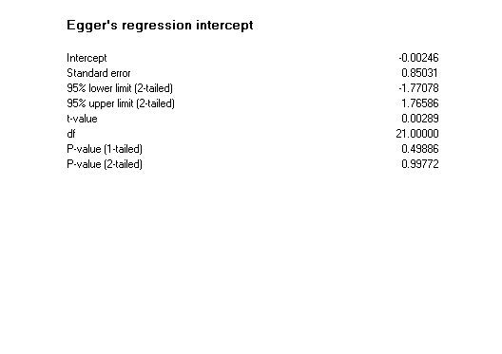(b)

**Supplementary File 3.** Meta-regression for the GMFM-66 Improvement (Overall).

 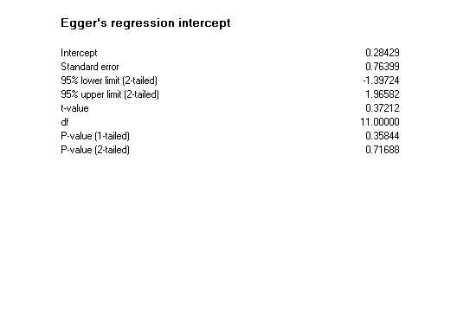(a)

 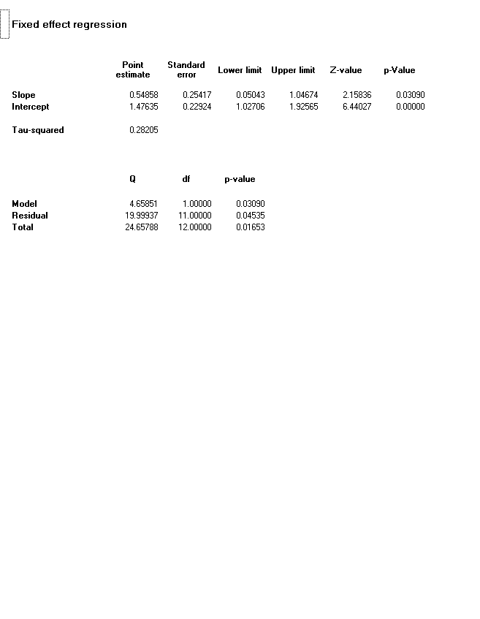(b)

 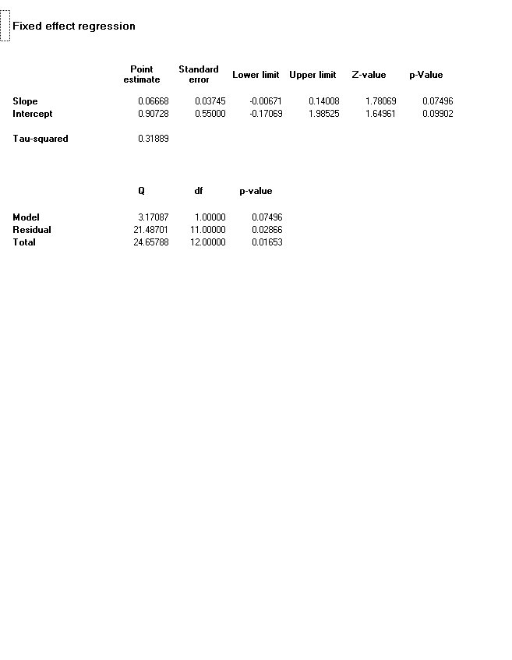(c)

**Supplementary File 4.** Meta-regression for the GMFM-66 Improvement (Therapeutic exercise).

 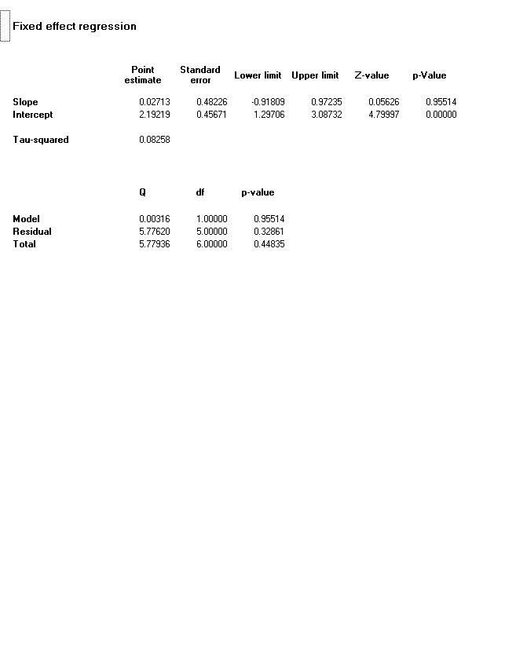(a)

 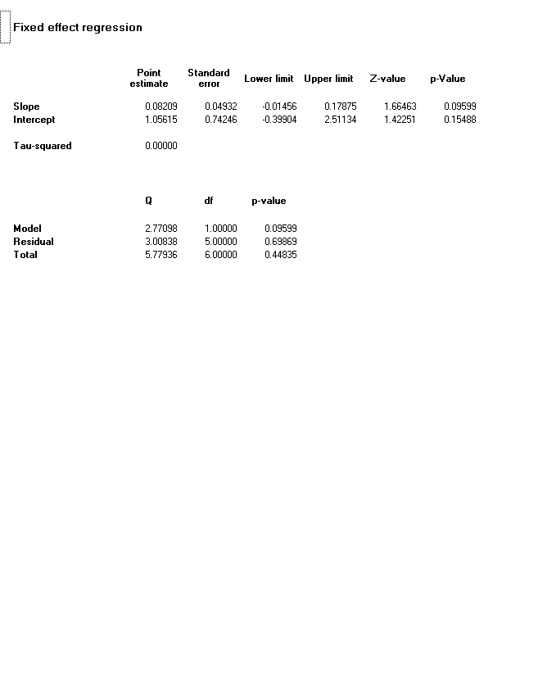(b)

**Supplementary File 5.** Meta-regression for the GMFM-66 Improvement (Usual care).

 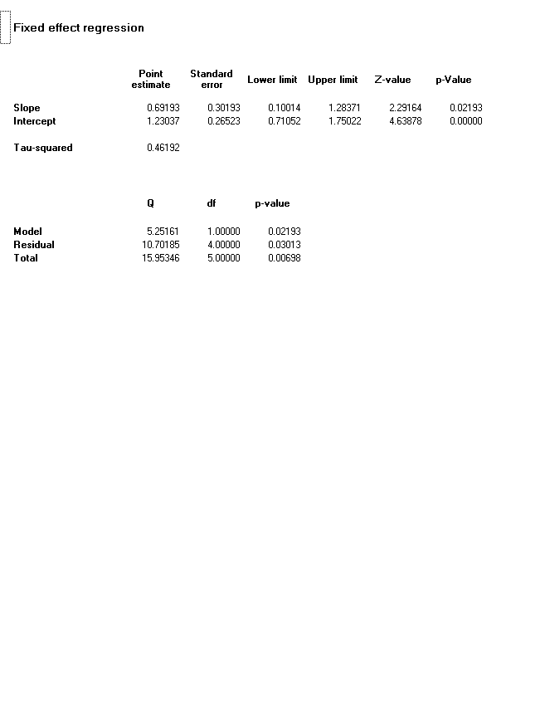(a)

 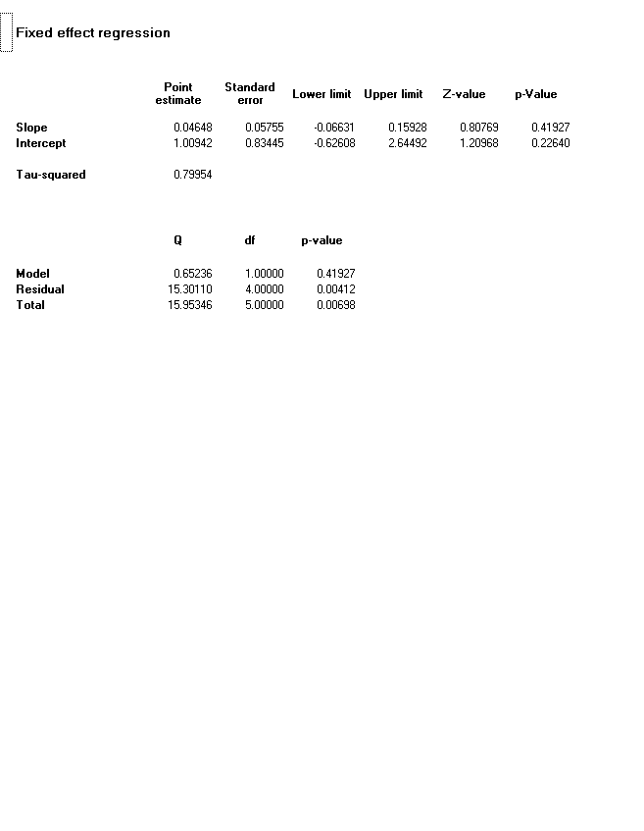 (b)