Supplemenatry materials
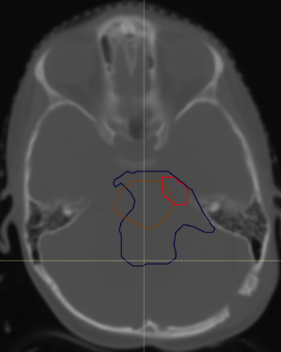
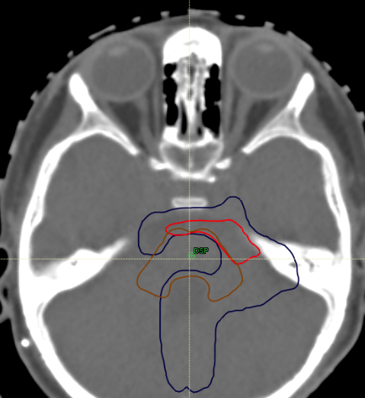
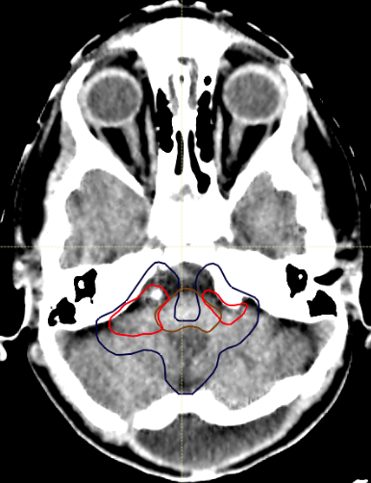
Supplementary Fig.1
Three examples of patients who were not replanned and were not eligible for dose escalation, as their tumour was too large to allow a boost to be delivered in the vicinity of the brainstem: tumour residue outlined in red, tumor bed in blue, and brainstem in brown.

Supplementary Fig.2
Dose distribution for one representative patient with VMAT (top) and one with IMPT (bottom). Red outline: PTV_{67.6}. This colour-washed figure shows the dose distribution from 25 Gy to 67.6 Gy. Better sparing of some OARs was observed with IMPT than with VMAT.
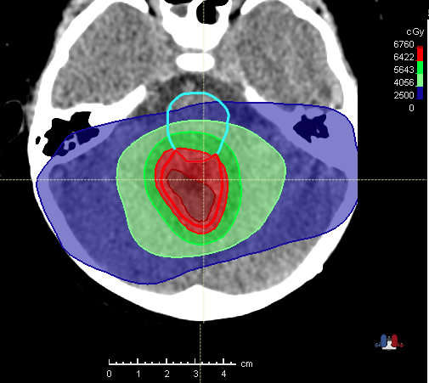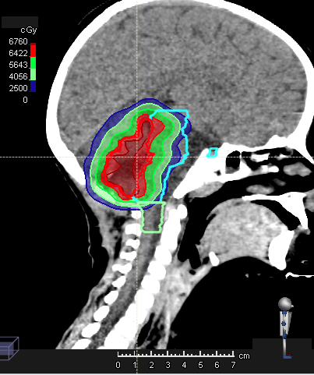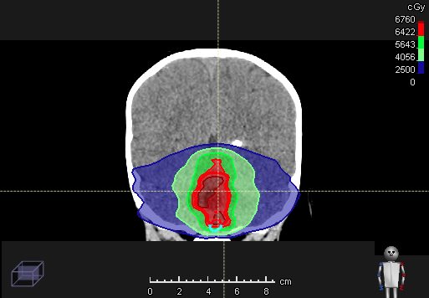
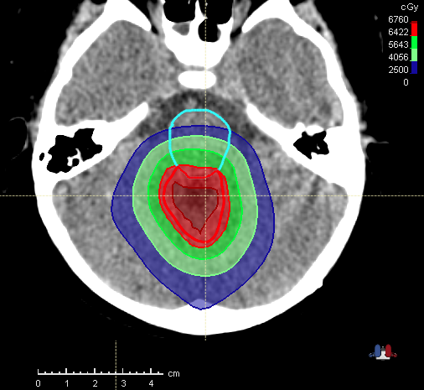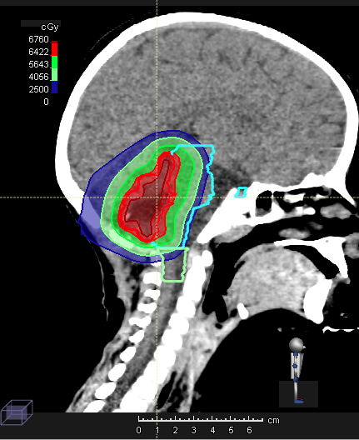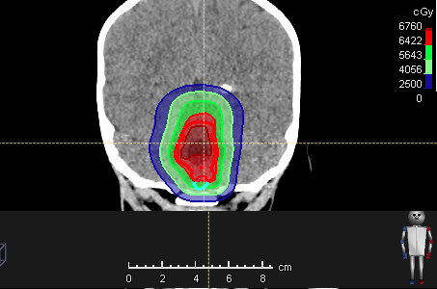

Supplementary Fig.3
Dose-volume histogram of PTV_{67.6 Gy}, PTV_{59.4} Gy, brainstem, right and left inner ear, and spinal cord, for one representative patient with VMAT or IMPT.

