Frontiers in Microbiology

Supplementary data for the manuscript:
Zooming in on butyrate-producing Clostridial consortia in the fermented grains of baijiu via gene sequence-guided microbial isolation
Li-Juan Chai^{1,4}, Zhen-Ming Lu^{1,4,5}, Xiao-Juan Zhang^{1,4,5}, Jian Ma², Peng-Xiang Xu², Wei Qian², Chen Xiao², Song-Tao Wang⁵, Cai-Hong Shen⁵, Jin-Song Shi³ and Zheng-Hong Xu^{1,2,5,*}
¹National Engineering Laboratory for Cereal Fermentation Technology, Jiangnan University, Wuxi 214122, P.R. China;
²Key Laboratory of Industrial Biotechnology, Ministry of Education, Jiangnan University, Wuxi 214122, P.R. China;
³School of Pharmaceutical Science, Jiangnan University, Wuxi 214122, P.R. China;
⁴Jiangsu Engineering Research Center for Bioactive Products Processing Technology, Jiangnan University, Wuxi 214122, P.R. China;
⁵National Engineering Research Center of Solid-State Brewing, Luzhou 646000, P.R. China;

*Corresponding author: National Engineering Laboratory for Cereal Fermentation Technology, Jiangnan University, 1800 Lihu Avenue, Wuxi 214122, P.R. China; E-mail: zhenghxu@jiangnan.edu.cn; Tel.: +86-510-85918206; Fax: +86-510-85918206.
Supplementary figure legends
Supplementary Fig. 1 Photos of Luzhou-flavor baijiu fermentation pit. Fermentation pit was covered with polyethylene cloth to keep moist during brewing.
Supplementary Fig. 2 Dynamics of physiochemical parameters in fermented grains during fermentation process. (A) Temperature; (B) Ethanol; (C) Moisture; (D) pH; (E) Lactate content.
Supplementary Fig. 3 Dynamics of Bacillaceae, Staphylococcaceae and Lactobacillaceae families, belonging to class Bacilli, in fermented grains during fermentation process.
Supplementary Fig. 4 Succession of the top 18 genera in fermented grains during fermentation process according to Clostridial specific-16S rRNA gene sequencing analysis.

Supplementary Fig. 1
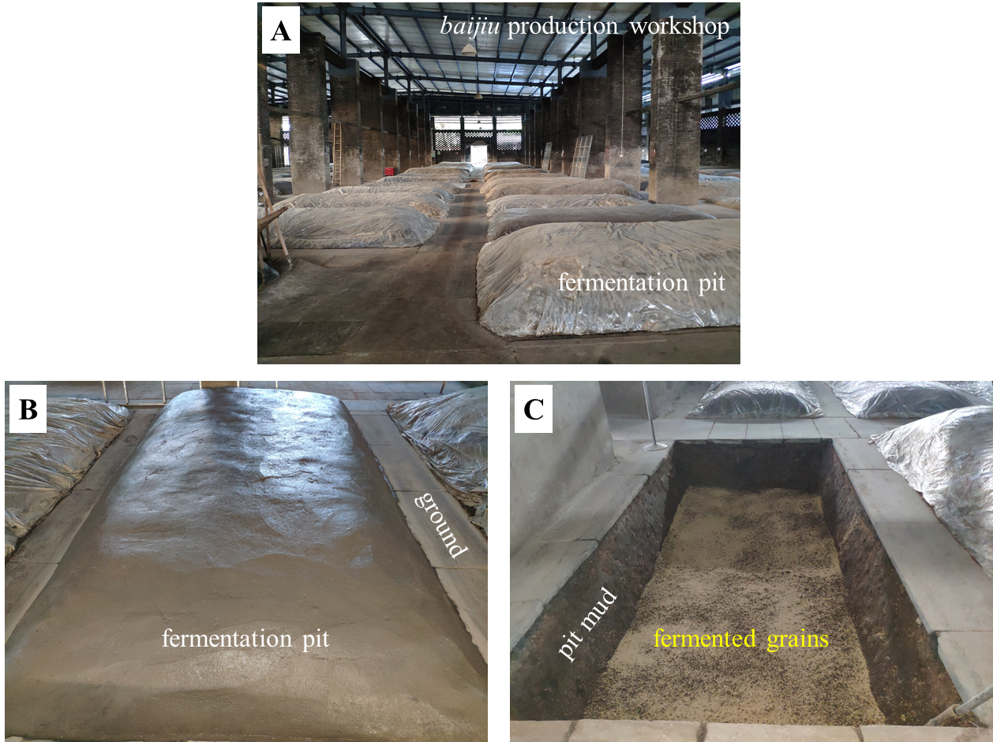

Supplementary Fig. 2
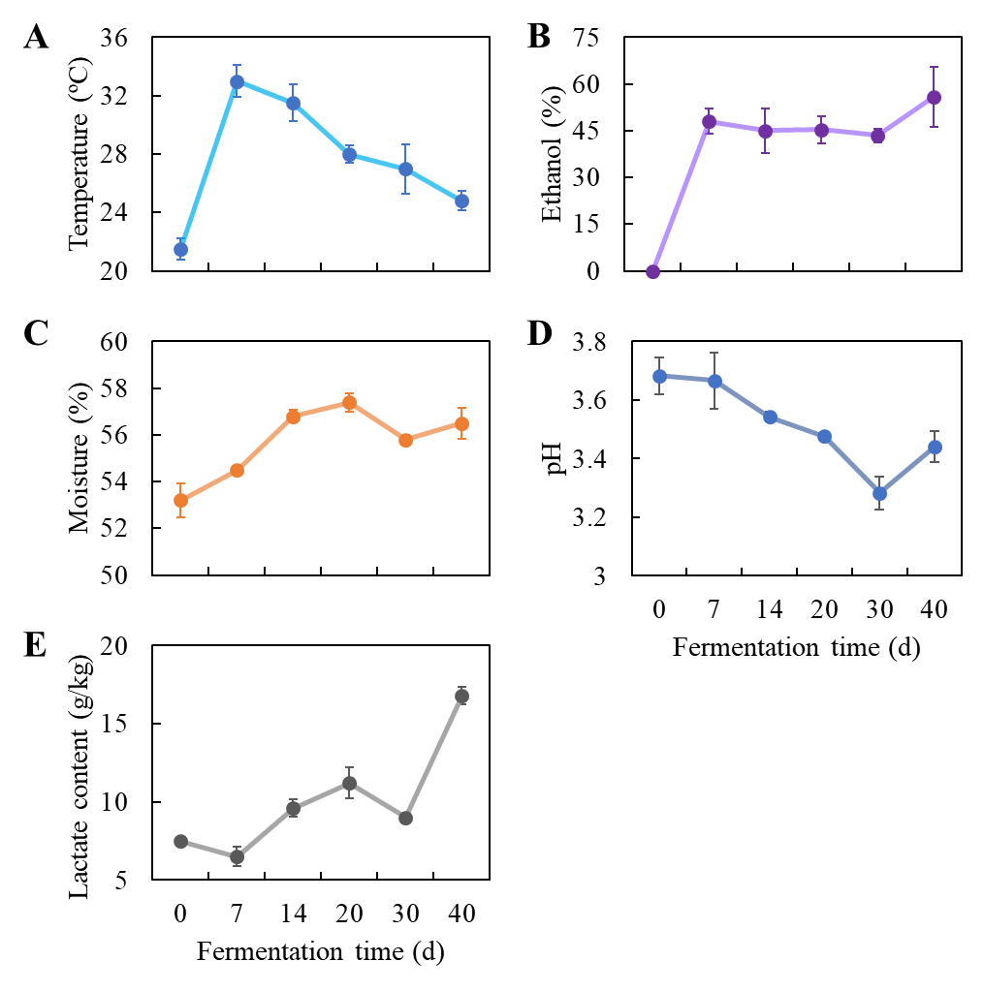

Supplementary Fig. 3
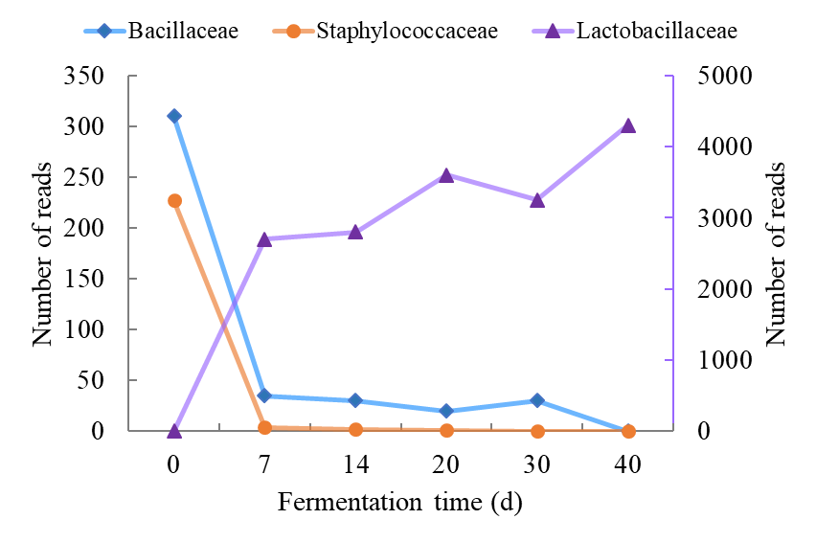

Supplementary Fig. 4
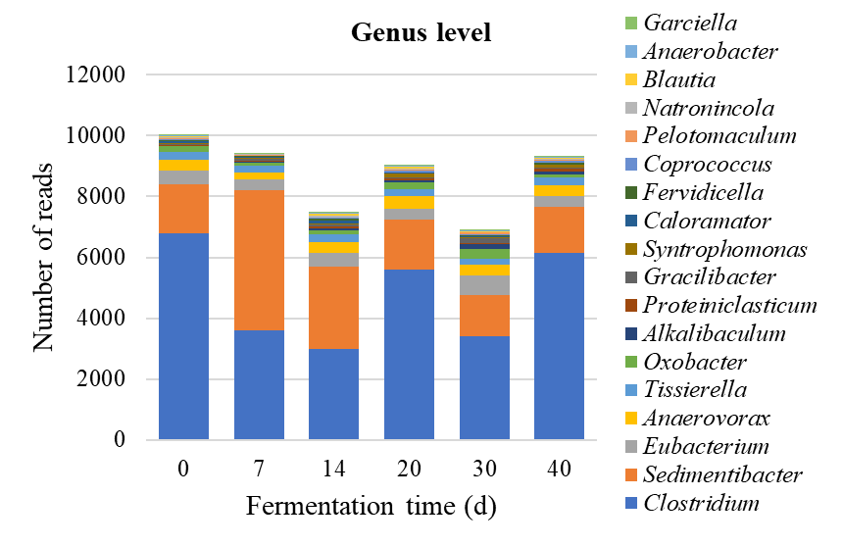
Supplementary Table 1 Primers used in this study
Primer pairs | Sequence (5’-3’) | Amplicon size (kb) | Annealing temp (°C) | Reference
but-F/but-R | ATGGGAACTAAGAANHTNTAYGA | 0.45 | 49.0 | Chai et al. (2019)
 | TAAATTTACCATTCCRWAYTCNGT
buk-F/buk-R | AAAATATTAATNATHAAYCCNGG | 0.50 | 47.0 | Chai et al. (2019)
 | GCCATTGCTTTTTGATTNARNRCRTG
P1/P2 | TGGAGAGTTTGATCCTGGCTCAG | 0.40 | 55.0 | Huang et al. (2011)
 | TACCGCGGCTGCTGGCAC
SJ-F/SJ-R | CGGTGAAATGCGTAGAKATTA | 0.27 | 56.5 | Hu et al. (2014)
 | CGAATTAAACCACATGCTCCG
27F/1492R | AGAGTTTGATCCTGGCTCAG | 1.47 | 56.0 | Zhang et al. (2014)
 | GGTTACCTTGTTACGACTT
The following sequences are targeted: buk-F/buk-R, butyrate kinase (buk) gene; but-F/but-R, butyryl-CoA:acetate CoA-transferase (but) gene; P1/P2, V1/V3 hypervariable region of 16S rRNA gene; SJ-F/SJ-R, V4/V5 hypervariable region of 16S rRNA gene in Clostridia; 27F/1492R, 16S rRNA gene.
Supplementary Table 2 The basic sequencing information and alpha diversity indices of bacterial and Clostridial communities in fermented grains during brewing
Days | Shannon | Inverse Simpson | Chao1 | Ace | Coverage
Bacterial 16S rRNA gene amplicon sequencing
0 | 5.10 | 0.864 | 1079.0 | 1076.6 | 98.8%
7 | 5.86 | 0.960 | 641.0 | 648.3 | 99.4%
14 | 4.89 | 0.865 | 780.1 | 741.4 | 99.2%
20 | 4.71 | 0.867 | 684.1 | 703.4 | 99.3%
30 | 5.99 | 0.924 | 1129.0 | 1095.0 | 98.8%
40 | 5.89 | 0.931 | 909.4 | 880.1 | 99.2%
Clostridial specific-16S rRNA gene amplicon sequencing
0 | 6.03 | 0.954 | 2215.9 | 2292.0 | 96.3%
7 | 5.72 | 0.902 | 2583.3 | 2727.1 | 88.5%
14 | 5.39 | 0.853 | 2733.5 | 2839.5 | 98.7%
20 | 5.85 | 0.914 | 1930.6 | 1945.2 | 84.2%
30 | 6.52 | 0.943 | 2842.7 | 3000.4 | 90.7%
40 | 6.35 | 0.928 | 2793.7 | 2849.3 | 88.2%

Supplementary Table 3 Clone library analysis of butyrate kinase (buk) gene
OTUs | Closest reference sequence | UniProtKB accession no. | Identity (%) | Query coverage (%) | E-value | Relative abundance (%)
OTU1 | Probable butyrate kinase (Clostridium amylolyticum) | A0A1M6HIY8 ﻿ | 98.1 | 99.0 | 4.5e-63 | 25
OTU2 | Probable butyrate kinase (Bacillus bataviensis LMG 21833) | K6DN05 | 92.4 | 95.2 | 3.1e-60 | 14
OTU3 | Probable butyrate kinase (Clostridium cadaveris) | A0A1I2L2S3 | 66.7 | 79.0 | 1.5e-39 | 13
OTU4 | Probable butyrate kinase (Clostridium carboxidivorans P7) | C6PUK0 | 70.5 | 84.8 | 3.9e-43 | 13
OTU5 | Probable butyrate kinase (Clostridium liquoris) | A0A2T0B9I2 | 94.3 | 97.1 | 1.2e-60 | 11
OTU6 | Probable butyrate kinase (Clostridiales bacterium) | A0A352IHE4 | 74.8 | 89.3 | 1.4e-46 | 8
OTU7 | Probable butyrate kinase (Porphyromonadaceae bacterium) | A0A355CA62 | 97.1 | 99.0 | 2.2e-61 | 6
OTU8 | Probable butyrate kinase (Bacillus sp. X1(2014)) | A0A077J499 | 89.5 | 96.2 | 2.0e-58 | 6
OTU9 | Probable butyrate kinase (Romboutsia hominis) | A0A2P2BV17 | 81.9 | 86.7 | 3.6e-49 | 2
OTU10 | Probable butyrate kinase (Clostridium frigidicarnis) | A0A1I0Z541 | 83.8 | 92.4 | 7.6e-53 | 1
OTU11 | Probable butyrate kinase (Anoxybacillus sp. B7M1) | A0A160FBD9 | 77.1 | 86.7 | 6.4e-48 | 1

Supplementary Table 4 Clone library analysis of butyryl-CoA: acetate CoA-transferase (but) gene
OTUs | Closest reference sequence | UniProtKB accession no. | Identity (%) | Query coverage (%) | E-value | Relative abundance (%)
OTU1 | Butyryl-CoA:acetate CoA-transferase (Clostridium sp.) | A0A353J1E1 | 61.5 | 78.7 | 1.8e-46 | 56
OTU2 | 4-hydroxybutyrate CoA-transferase (Syntrophomonas sp.) | A0A3D1QC51 | 97.5 | 98.3 | 9.2e-73 | 18
OTU3 | Butyryl-CoA:acetate CoA-transferase (Pseudoflavonifractor sp. An184) | A0A1Y4L1X1 | 85.2 | 94.3 | 2.3e-68 | 12
OTU4 | 4-hydroxybutyrate CoA-transferase (Clostridiales bacterium PH28_bin88) | A0A0M2U2G0 | 60.0 | 77.4 | 2e-40 | 5
OTU5 | 4-hydroxybutyrate CoA-transferase (Eubacterium ramulus) | A0A2V1JT81 | 82.4 | 94.1 | 2.9e-63 | 4
OTU6 | Butyryl-CoA:acetate CoA-transferase (Eubacterium aggregans) | A0A1H3Z6V0 | 99.1 | 99.1 | 5.4e-73 | 3
 | Butyryl-CoA:acetate CoA-transferase (Eubacterium barkeri (Clostridium barkeri)) | A0A1H3I8V0 | 99.1 | 99.1 | 5.4e-73
OTU7 | Butyryl-CoA:acetate CoA-transferase (Eubacterium aggregans) | A0A1H4AF70 | 96.7 | 99.2 | 3.7e-77 | 2
 | Butyryl-CoA:acetate CoA-transferase (Eubacterium barkeri (Clostridium barkeri)) | A0A1H3AUQ8 | 96.7 | 99.2 | 3.7e-77

