Supplementary Figure 1
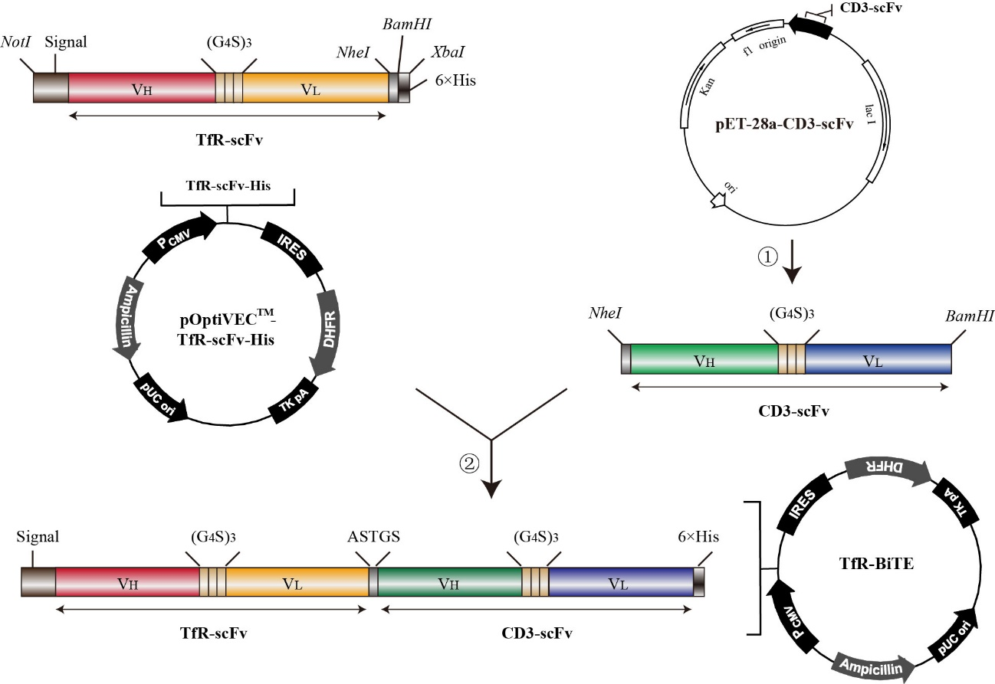
Supplementary Figure 1. Schematic diagram of TfR-BiTE construction. ASTGS or (G₄S)₃, short linker; NheI and BamHI, restriction sites. ①②, indicates the process.

Supplementary Figure 2
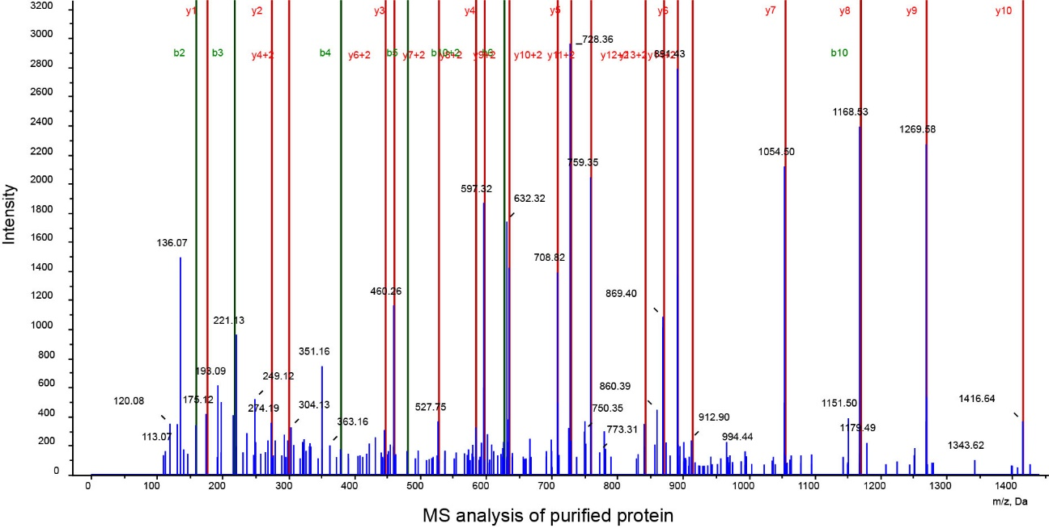
Supplementary Figure 2. Mass Spectrometry (LC-MS/MS) analysis of the unique peptide sequence “ASGYTFTNYYMHWVR” of purified protein.
Supplementary Figure 3
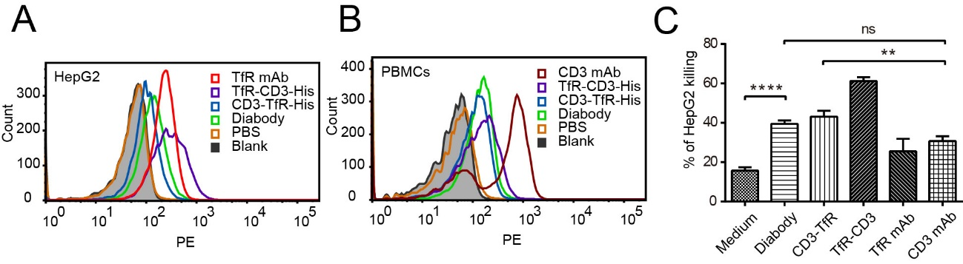
Supplementary Figure 3: (A, B) Binding of bispecific antibodies with HepG2 cells (TfR⁺) and PBMCs (CD3⁺) were detected using anti-His tag mAb by flow cytometry analysis. PBS and blank controls were set as the negative controls. (C) CFSE-stained PBMCs and HepG2 cells (E:T=10:1) were incubated with antibodies indicated for 24 h. Then cells were stained with 7-AAD. CFSE⁻ 7-AAD⁺ cells were calculated as the lysed tumor cells.

