Supplementary Material

Supplementary Figures and Tables

Supplementary Figures
Supplementary Figure S1. Significant higher PDE9 vs PDE5 mRNA expression levels in mice hippocampi. Mouse hippocampal PDE5 and PDE9 mRNA levels were analyzed by quantitative RT-PCR **p<0.01.

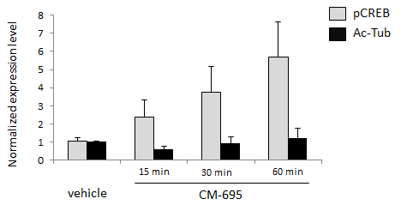

Supplementary Figure S2. Quantification of western blots showing pCREB and Ac-Tubulin (Ac-Tub) levels in hippocampal extracts from mice sacrificed 15, 30 min and 60 min after treatment with CM-695 (40 mg/kg). Actin was used as a loading control (n = 3 per group).

Supplementary Figure S3. Tg2576 mice show memory deficits in the FC and MWM test. (A) Freezing behavior from 14-16 month old Tg2576 compared to age-matched WT mice (*p ≤ 0.05). Data represent the percentage of time freezing during a 2-min test. (B) Escape latency of the hidden platform in the MWM test for 14-16 month old-Tg2576 and WT mice (*p ≤ 0.05). Results are expressed as mean ± SEM (n = 10–12 per group).

Supplementary Figure S4. Tg2576 mice show significant reduction in spine density of basal hippocampal pyramidal neurons compared to aged-matched wild type mice (WT). The histogram represents the quantification spine density of basal hippocampal pyramidal neurons from 14-16 month old Tg2576 compared to age-matched WT mice. Representative images of Golgi staining from CA1 dendrites are shown *p < 0.05.
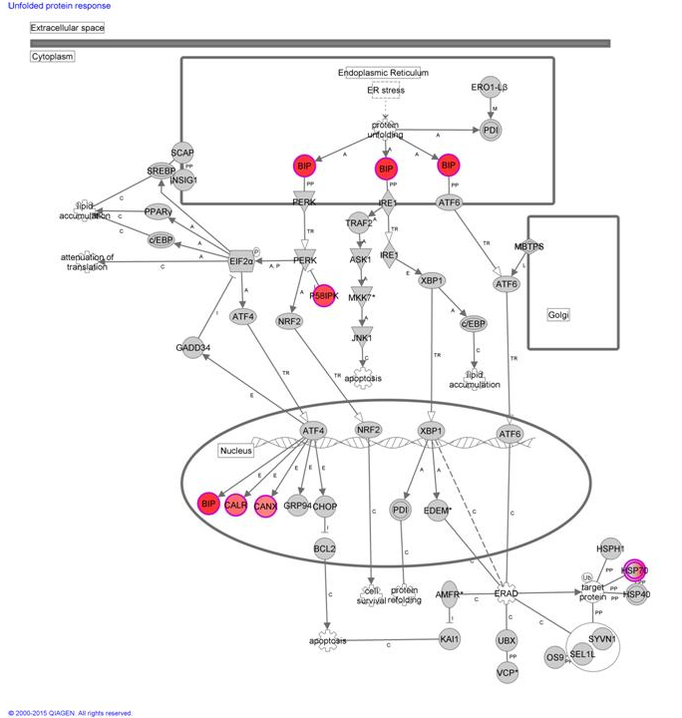
Supplementary Figure S5. Upregulation of the unfolded protein response in the hippocampus of CM-695 treated mice. Ingenuity schematic draw showing all regulated potential molecular players of the unfolded protein response. The filled (red) symbols represent the entries which are actually statistically significantly up-regulated by CM-695.

