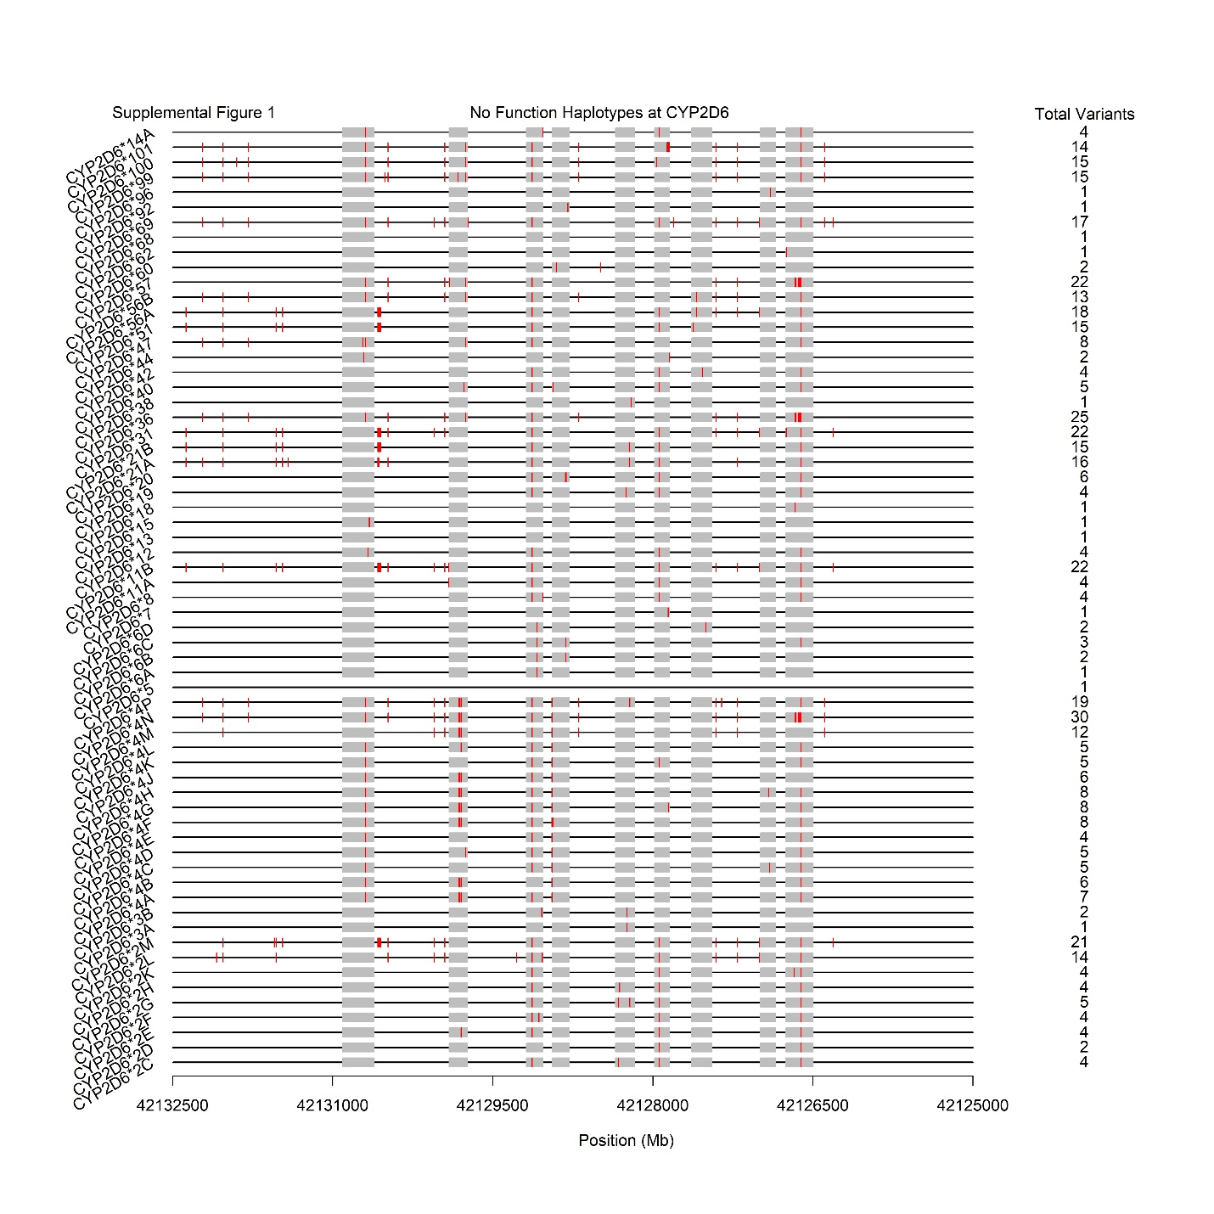
Supplemental Figure 1: Physical positions (red vertical lines) and total number of variants present on the 63 known CYP2D6 haplotypes (*alleles) predicted to produce non-functional enzymes upon transcription/translation.

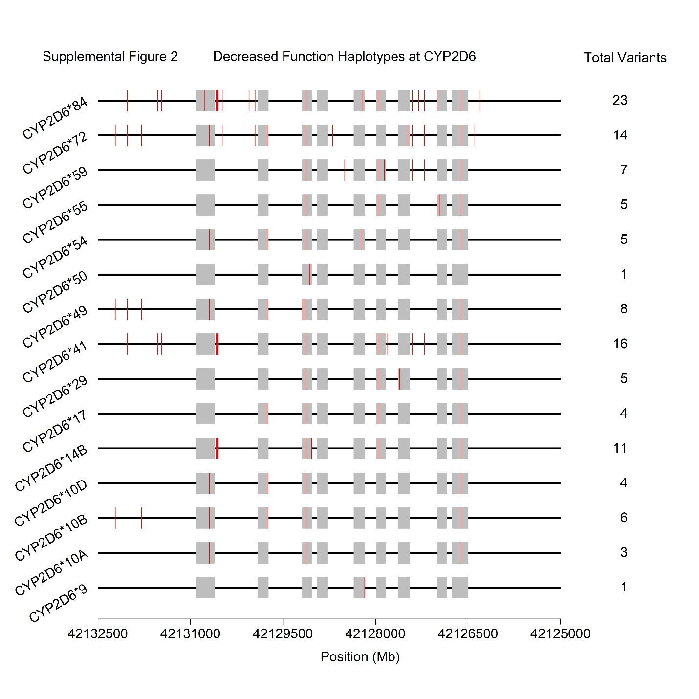
Supplemental Figure 2: Physical positions (red vertical lines) and total number of variants present on the 15 known CYP2D6 haplotypes (*alleles) predicted to produce enzymes with decreased function upon transcription/translation.

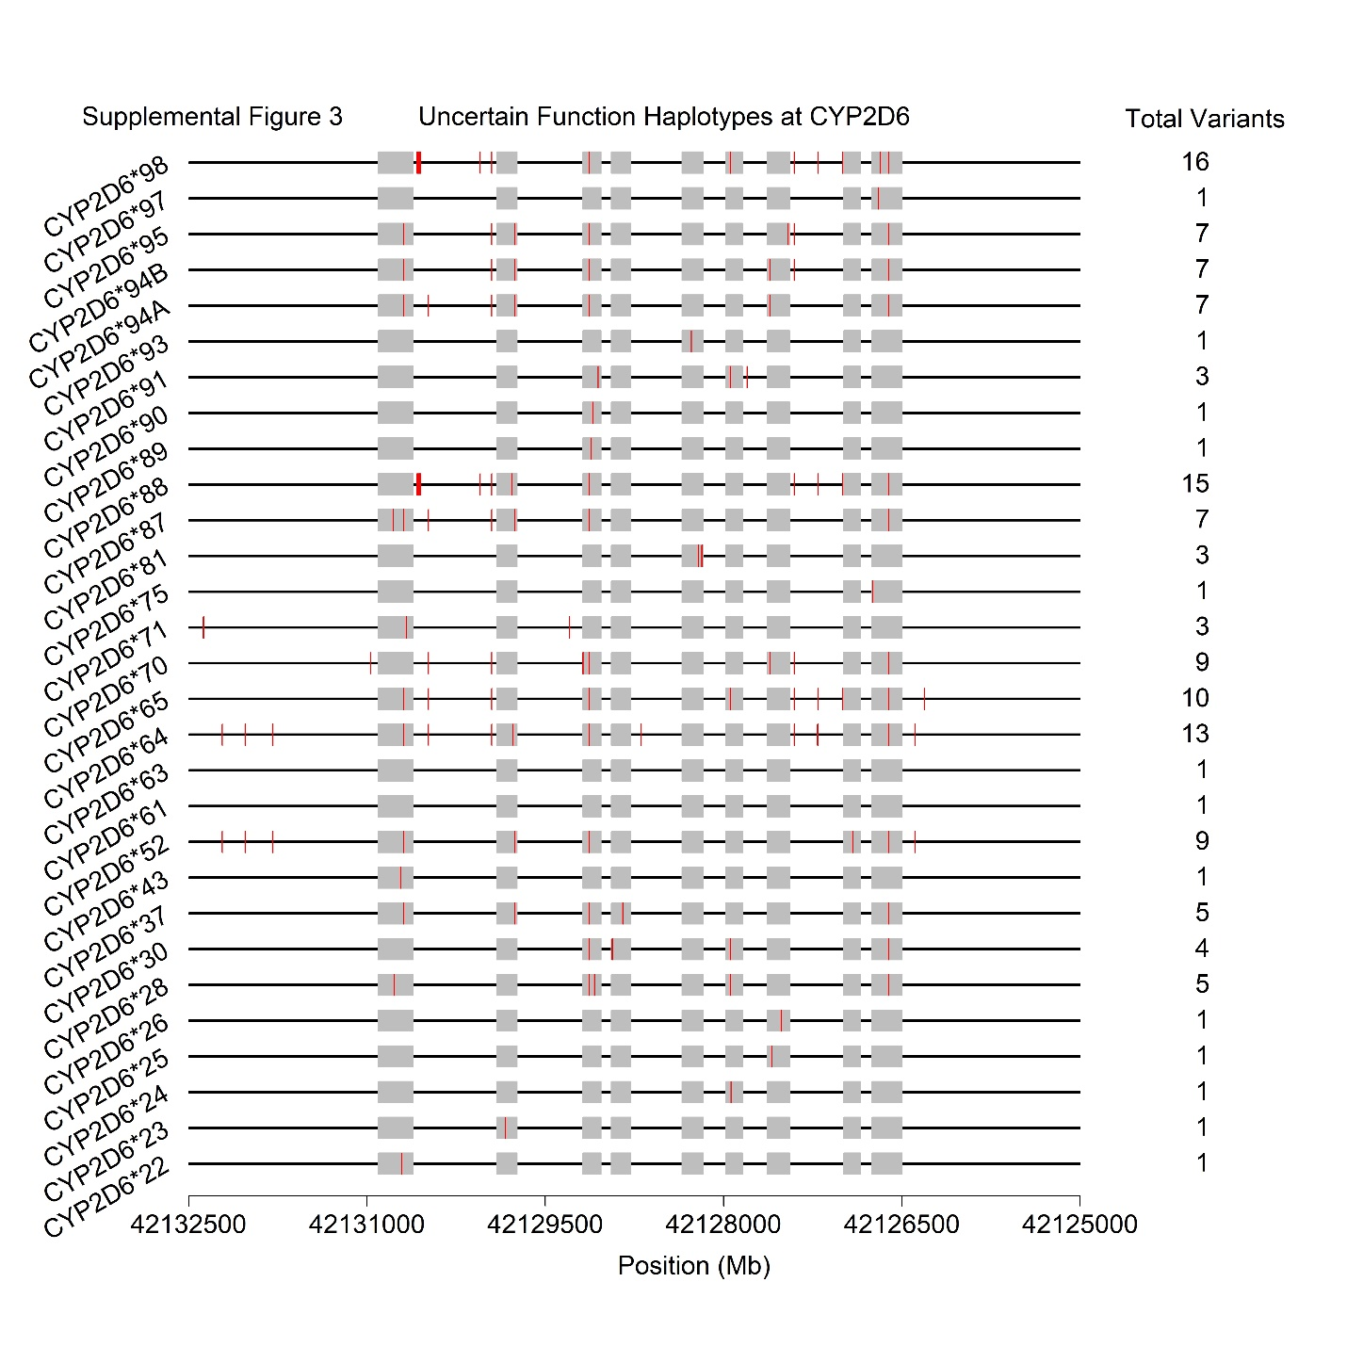
Supplemental Figure 3: Physical positions (red vertical lines) and total number of variants present on the 29 known CYP2D6 haplotypes (*alleles) that produce enzymes with uncertain functional characteristics (i.e. results and research findings are conflicting or inconclusive) upon transcription/translation.

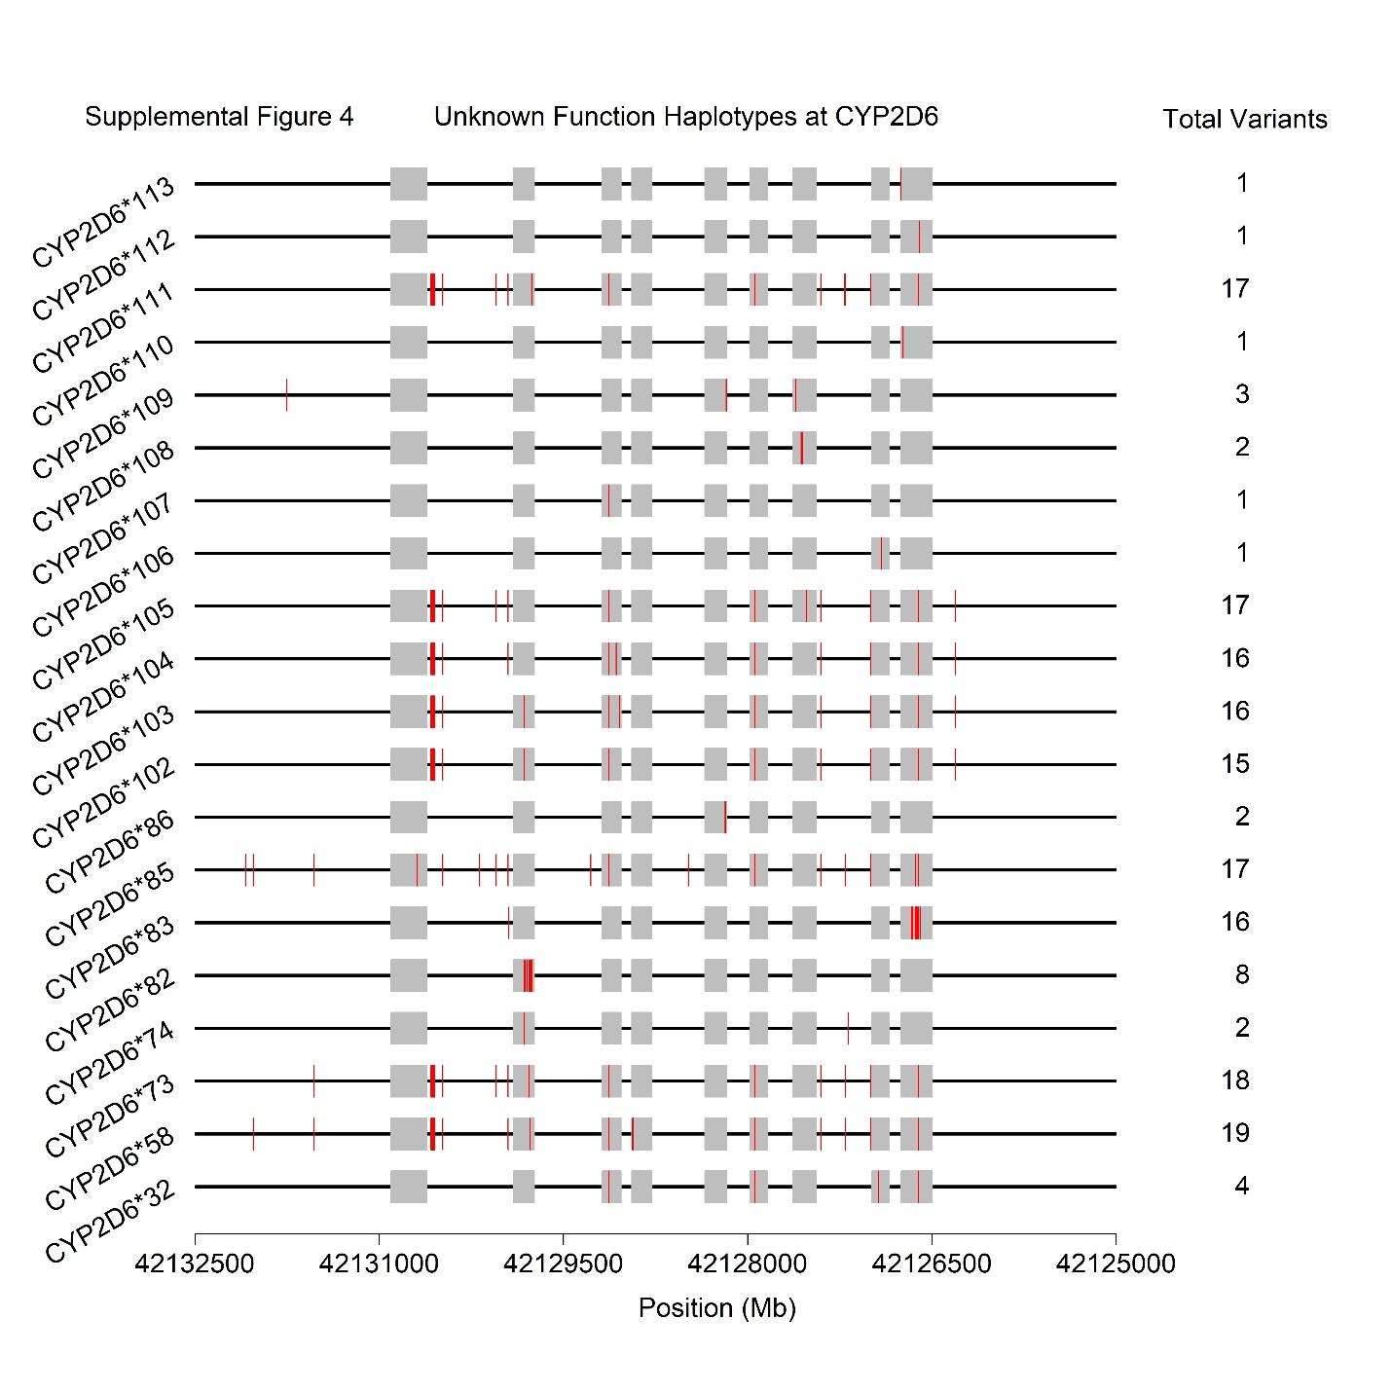
Supplemental Figure 4: Physical positions (red vertical lines) and total number of variants present on the 20 known CYP2D6 haplotypes (*alleles) that produce enzymes with unknown functional characteristics (i.e. variant combinations that are too rare to effectively interpret or which have not been adequately studied) upon transcription/translation.

