Supplementary Material

Supplementary Figures
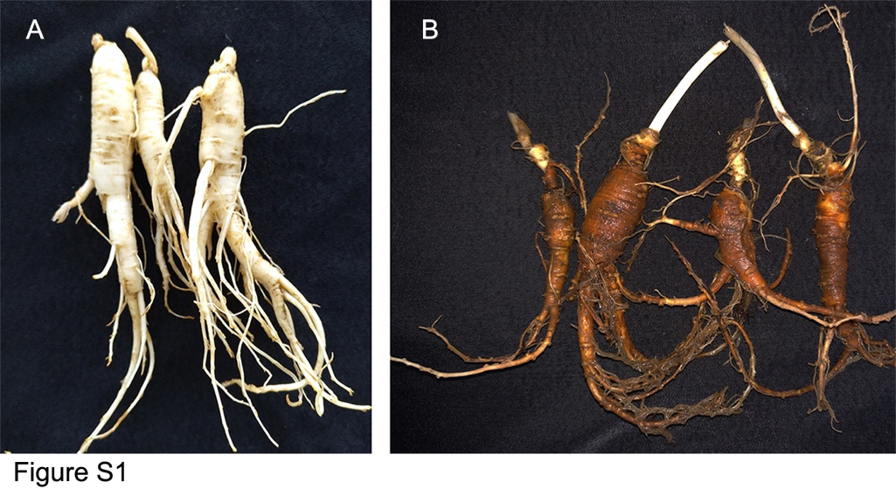
Figure S1 Typical symptoms of rusty root of ginseng: (A) healthy roots (B) rusty roots.
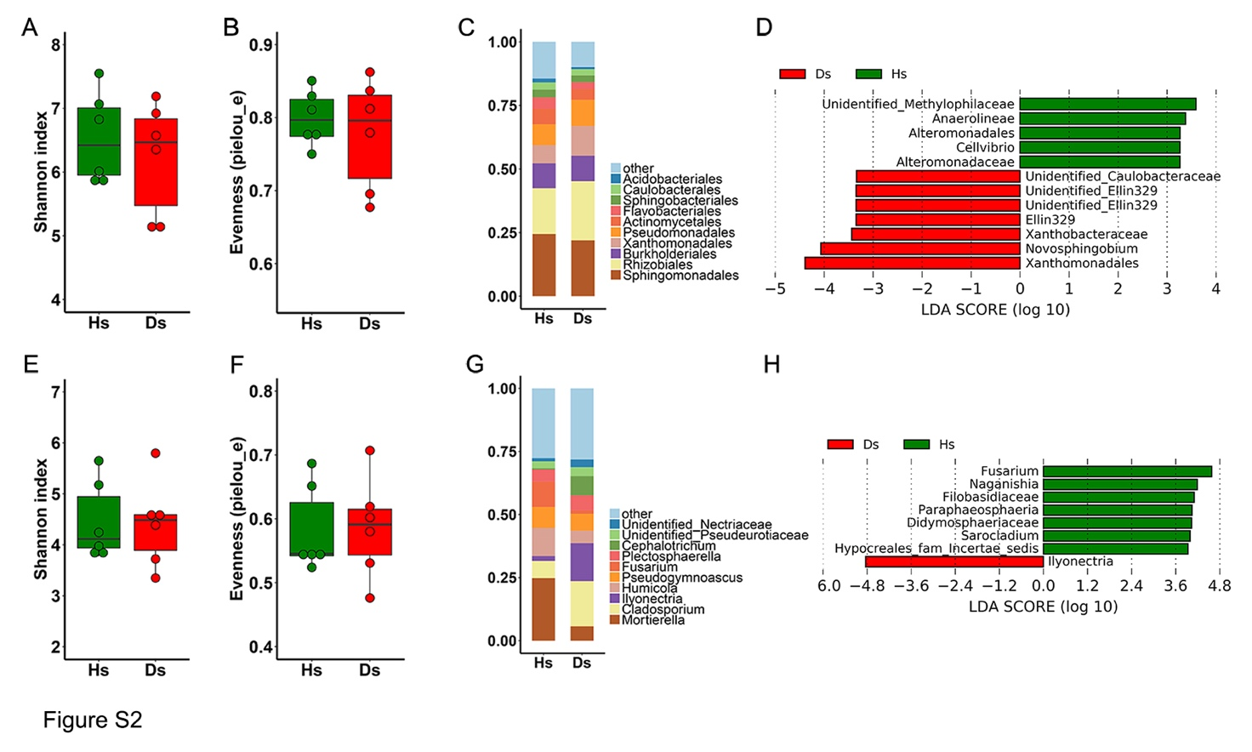
Figure S2 Bacterial and fungal microbiota composition of Healthy-soil (Hs) and Diseased-soil (Ds). Boxplot of alpha-diversity indices for 16S rRNA of Hs and Ds: (A) Shannon index; (B) Evenness (pielou_e). (C) Relative abundances of bacterial orders in Hs and Ds. (D) LDA scores of the differentially abundant taxa. Taxa enriched in bacterial microbiota from Hs or Ds are indicated with a positive or negative LDA score, respectively (taxa with relative abundance > 0.001 and LDA score > 2 are shown). Boxplot of alpha-diversity indices for ITS of Hs and Ds: (E) Shannon index; (F) Evenness (pielou_e). (G) Relative abundances of fungal genera in Hs and Ds. (H) LDA scores of the differentially abundant taxa. Taxa enriched in fungal microbiota from Healthy-soil (Hs) or Diseased-soil (Ds) are indicated with a positive or negative LDA score, respectively (taxa with relative abundance > 0.001 and LDA score > 2 are shown).
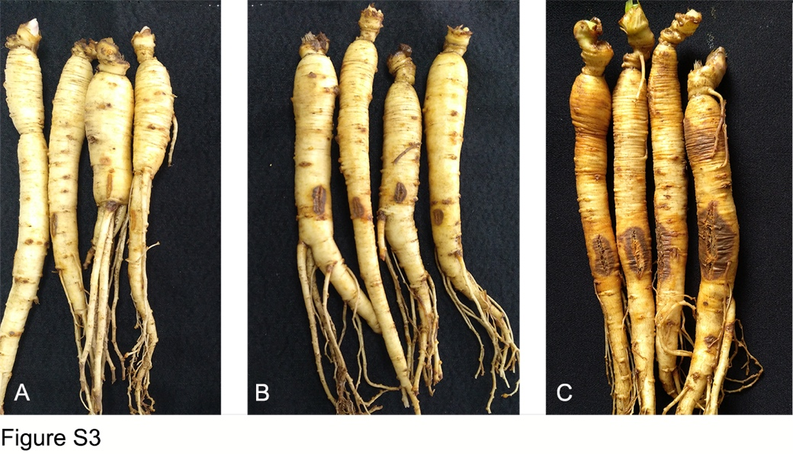
Figure S3 Symptoms observed on ginseng roots inoculated with Ilyonectria. (A) Bare-root inoculation with sterile water, (B) I. robusta 4D-1 and (C) I. mors-panacis TH5.
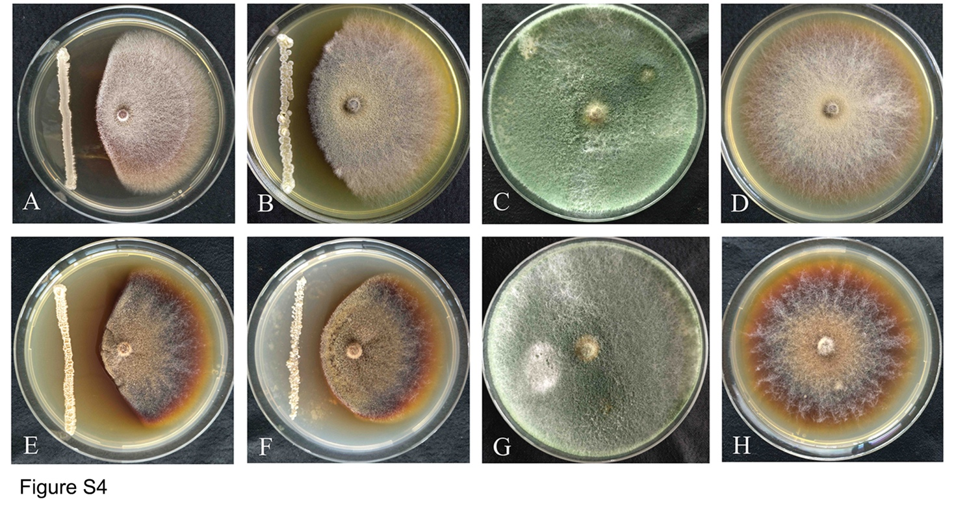
Figure S4 Antagonistic activity against I. robusta 4D-1 and I. mors-panacis TH5: (A): S-11 vs. 4D-1; (B): S6-31 vs. 4D-1; (C): S7-1 vs. 4D-1; (D): control 4D-1; (E): S-11 vs. TH5; (F): S6-31 vs. TH5; (G): S7-1 vs. TH5; (H): control TH5.
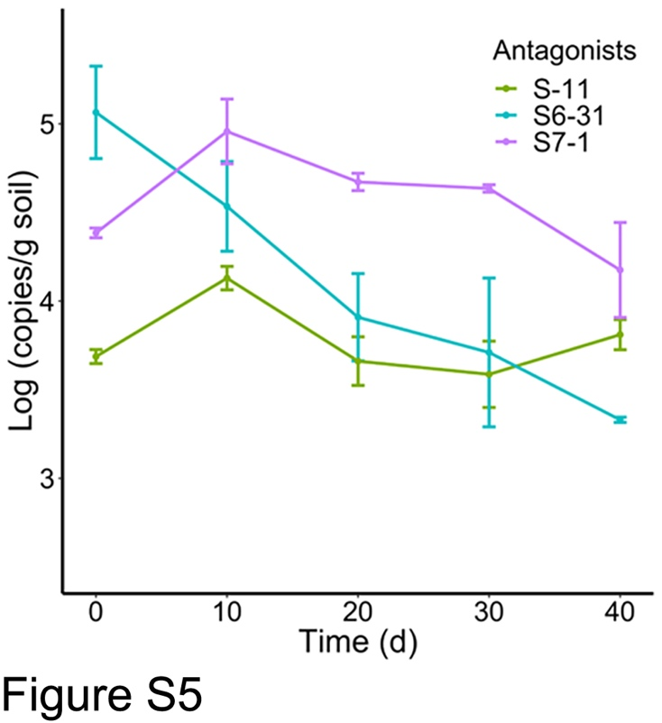
Figure S5 Population dynamics of antagonists in rhizosphere soil under pot trial.
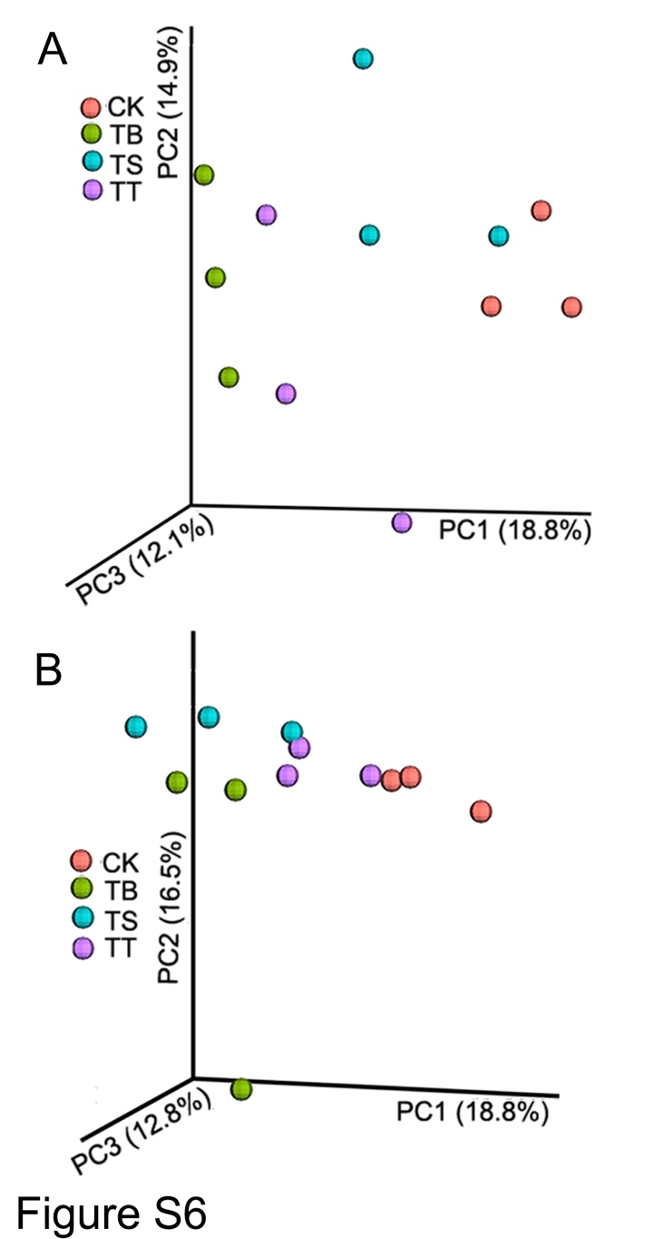
Figure S6 Principal coordinate analysis (PCoA) of Bray-Curtis distances of the bacterial (A) and fungal communities (B) in different inoculated treatments in filed trial.

