Supplementary material

Biochar amendment stimulates utilization of plant-derived carbon by soil bacteria in an intercropping system

Hongkai Liao^{1,2,3,4} ·Yaying Li^{1,2,*}· Huaiying Yao^{1,2,5,*}

¹ Key Laboratory of Urban Environment and Health, Institute of Urban Environment, Chinese Academy of Sciences, Xiamen 361021, People’s Republic of China
² Key Laboratory of Urban Environmental Processes and Pollution Control, Ningbo Urban Environment Observation and Research Station-NUEORS, Chinese Academy of Sciences, Ningbo 315800, People’s Republic of China
³ University of Chinese Academy of Sciences, Beijing 100049, People’s Republic of China
⁴ Guizhou Provincial Key Laboratory of Mountain Environment, Guizhou Normal University, Guiyang 550001, People’s Republic of China
⁵ Research Center for Environmental Ecology and Engineering, School of Environmental Ecology and Biological Engineering, Wuhan Institute of Technology, Wuhan 430073, People’s Republic of China

For correspondence. * E-mail: hyyao@iue.ac.cn; yyli@iue.ac.cn. Tel: +86-0592-6190791; Fax: +86-0592-6190791

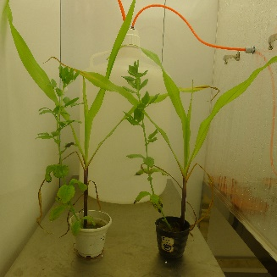

Figure S1 Plants in the pots after 35-day continuous of labeling

Figure S2 Incorporation of ¹³C-labelled rhizodeposits into the soils after 35-days of continuous labeling. Bars present means ± SE.

Figure S3 The relative abundance of rhizosphere bacterial families determined by high-throughput sequencing of the 16S rRNA gene amplicons. Statistically significant differences between group pairs were determined by the LSD at P < 0.05 level. Bars present means ± SE.

Figure S4 Effect of the biochar amendment on the alpha diversity of the soil microbial communities. Bars are means ± SE.

Figure S5 Effect of the biochar amendment on the bacterial richness as estimated by ‘breakaway’ package. Bars are means ± SE.

Figure S6 Overlap of responsive OTUs between biochar and control treatments

Figure S7 Taxonomy of the microbial communities in the light (<1.69 g ml⁻¹) and heavy (>1.70 g ml⁻¹) gradient fractions of the control and biochar treatments.

