Childhood Adversity Moderates the Effects of HTR2A Epigenetic Regulatory Polymorphisms on Rumination

Supplementary Data: Childhood adversity questionnaire used in our study

Here are some comments people have made about their childhood. We would like you to say how much each statement is true for you.
When I was growing up | Never True | Rarely True | Some-times True | Often true | Very Often True
1. I was happy
2. I believe that I was abused or neglected
3. People in my family looked out for each other
4. My parents/guardians weren’t able to take care of me

When I was growing up | YES | NO
1. I lost my mother
2. I lost my father

Supplementary Figures and Tables

Supplementary Figures

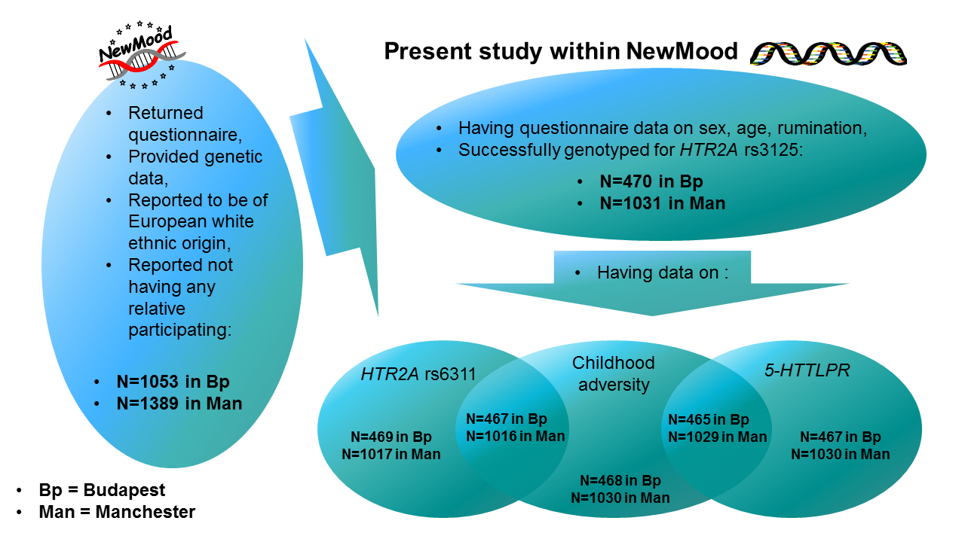
Supplementary Figure 1. Flowchart of the present study within the larger NewMood study. Sample sizes are given according to the inclusion criteria, and for specific analyses within our study. Intersects of data availability according to the different variables of interest are also displayed.

Supplementary Tables

Supplementary Table 1. Descriptive statistics of the serotonin transporter gene polymorphism 5-HTTLPR for the combined Budapest + Manchester sample and the two subsamples. 5-HTTLPR = serotonin-transporter-linked polymorphic region; S = short allele; L = long allele; χ² = Pearson χ².
 | Budapest + Manchester |  | Budapest |  | Manchester |  | Difference between Budapest and Manchester
 | Frequency | % | Frequency | % | Frequency | % | χ² | p
SS | 272 | 18.2% | 72 | 15.4% | 200 | 19.4% | 3.672 | 0.159
LS | 736 | 49.2% | 241 | 51.6% | 495 | 48.1%
LL | 489 | 32.7% | 154 | 33.0% | 335 | 32.5%

Supplementary Table 2. Effect of 5-HTTLPR as predictor, for childhood adversity as outcome, in linear regression models. Sex and age (and in the combined sample also population) were covariates. The short allele is the minor, effect allele. No significant finding emerged. 5-HTTLPR = serotonin-transporter-linked polymorphic region.
 | Additive model |  | Dominant model |  | Recessive model
 | Beta | P-value | Beta | P-value | Beta | P-value
Budapest + Manchester | -0.045 | 0.722 | -0.211 | 0.262 | 0.166 | 0.470
Budapest | 0.213 | 0.290 | 0.260 | 0.366 | 0.298 | 0.426
Manchester | -0.150 | 0.346 | -0.421 | 0.080 | 0.110 | 0.699

Supplementary Table 3. Effect of 5-HTTLPR as predictor, for each rumination variable as outcome, in linear regression models run in the Budapest + Manchester sample. Population, sex and age were additional predictors in all models. In case of brooding or reflection as outcome, the other subscale was also a predictor. In the interaction models, main effects of both the respective SNP and childhood adversity were included as additional predictors. The short allele is the minor, effect allele. No significant finding emerged. 5-HTTLPR = serotonin-transporter-linked polymorphic region.
 |  | Additive model |  | Dominant model |  | Recessive model
 | Outcome | Beta | P-value | Beta | P-value | Beta | P-value
Main effect of 5-HTTLPR | Rumination | -0.019 | 0.353 | -0.045 | 0.139 | 0.004 | 0.905
 | Brooding | -0.008 | 0.697 | -0.021 | 0.505 | 0.004 | 0.915
 | Reflection | -0.013 | 0.559 | -0.028 | 0.376 | 0.001 | 0.985
5-HTTLPR x childhood adversity interaction | Rumination | 0.004 | 0.473 | 0.014 | 0.102 | -0.007 | 0.497
 | Brooding | 0.008 | 0.197 | 0.008 | 0.347 | 0.013 | 0.232
 | Reflection | -0.003 | 0.610 | 0.008 | 0.413 | -0.021 | 0.056

