Supplementary Material

Identification of Autoreactive B cell Subpopulations in Peripheral Blood of Autoimmune Patients with Pemphigus vulgaris
Robert Pollmann, Elias Walter, Thomas Schmidt, Jens Waschke, Michael Hertl, Christian Möbs, Rüdiger Eming*
* Correspondence: Rüdiger Eming: eming@med.uni-marburg.de

Supplementary Figures

Supplementary Figure 1. (A) Staining of a IgG– T cell hybridoma (TCH) clone with fluorescently labeled Dsg3. (B) Staining of IgG⁺ B cell hybridoma (BCH) clones specific for Dsg3 (2C10) or with unknown specificity (1F12) with fluorescently labeled type VII collagen protein (ColVII).

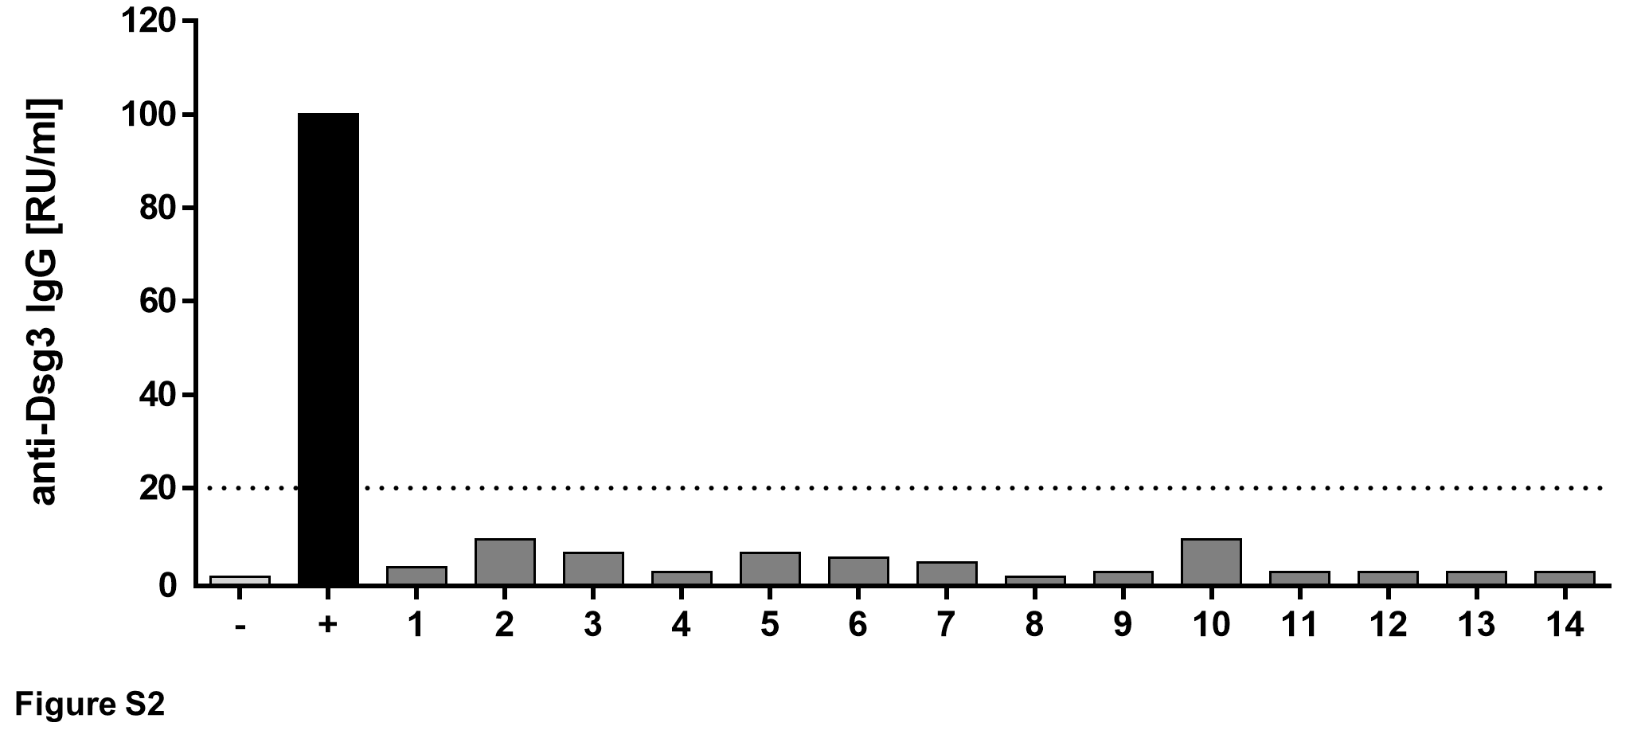
Supplementary Figure 2. Anti-Dsg3-ELISA with plasma of healthy controls (n=14). Values are shown as relative units (RU) per ml; cut-off value for positive result= 20 RU/ml (dotted line).
–: negative control, +: positive control.

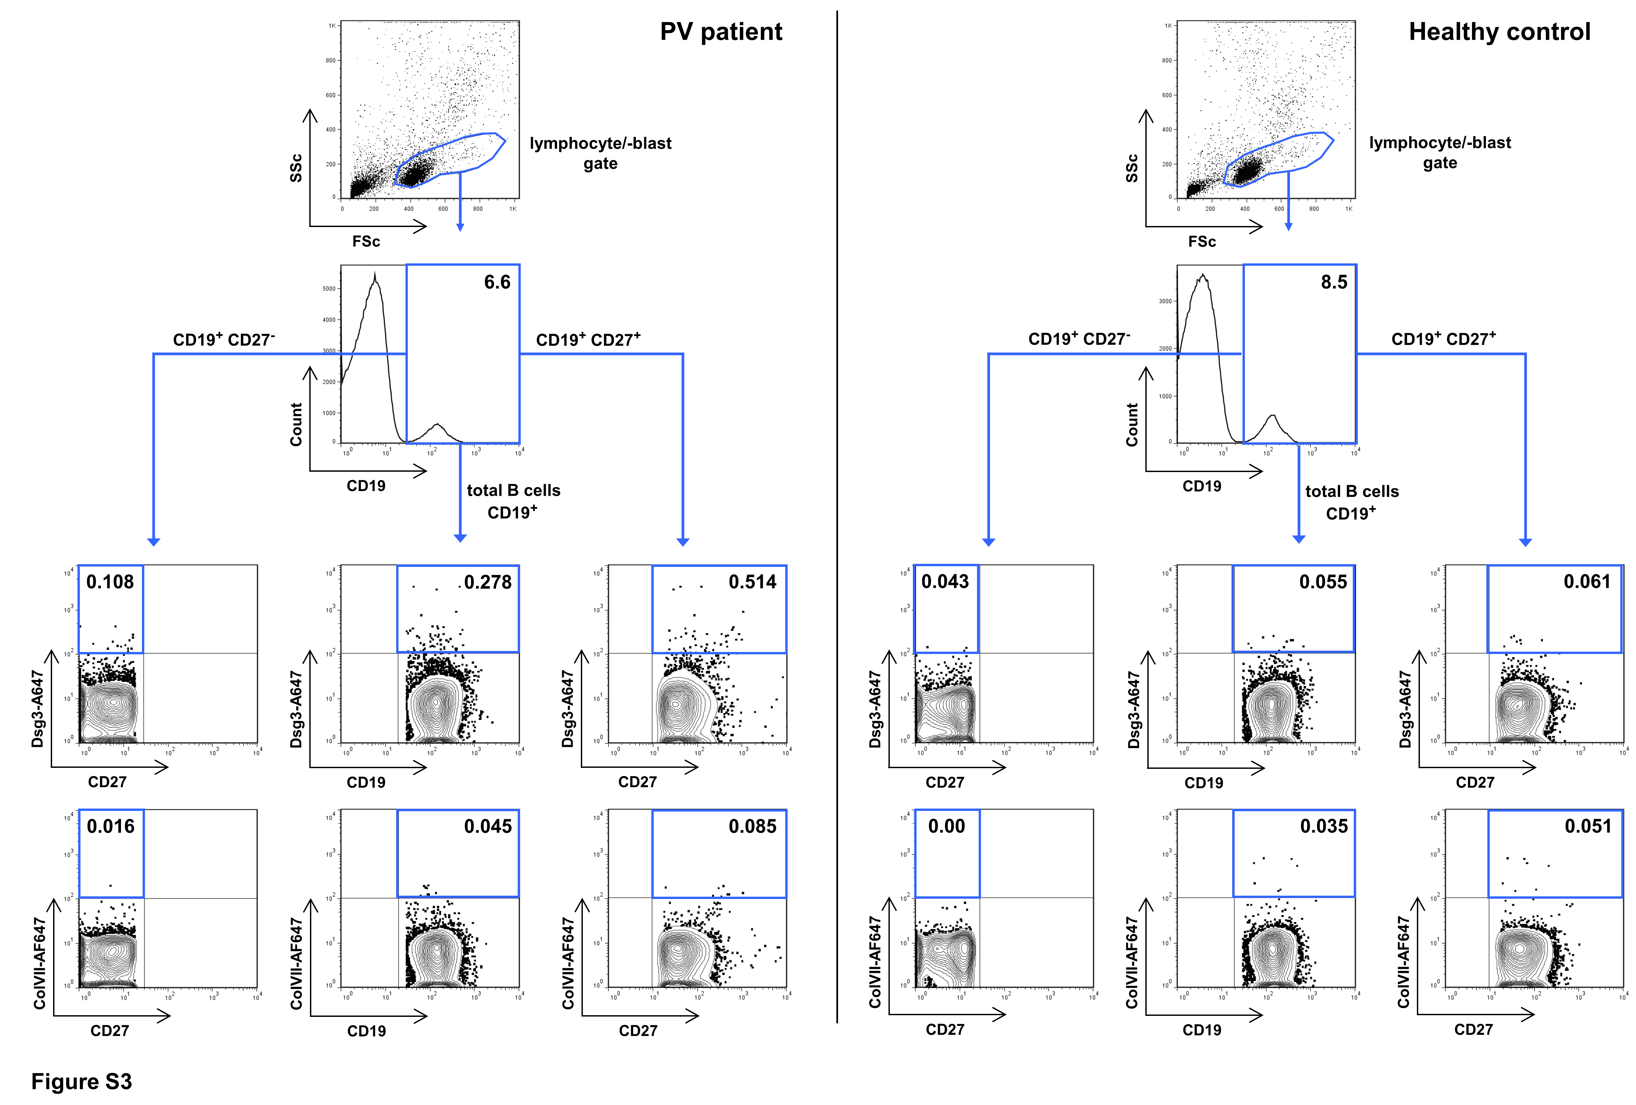

Supplementary Figure 3. Gating strategy for analysis of Dsg3-specific B cell subpopulations in human peripheral blood. Lymphocytes and lymphoblasts were gated on size and granularity. B cells were gated on CD19 expression and Dsg3-specific B cells were subdivided into total CD19⁺ B cells, CD19⁺CD27– and CD19⁺CD27⁺ (memory) B cells. Collagen VII was used as non-specific control. Shown are representative results from one PV patient and one healthy control.

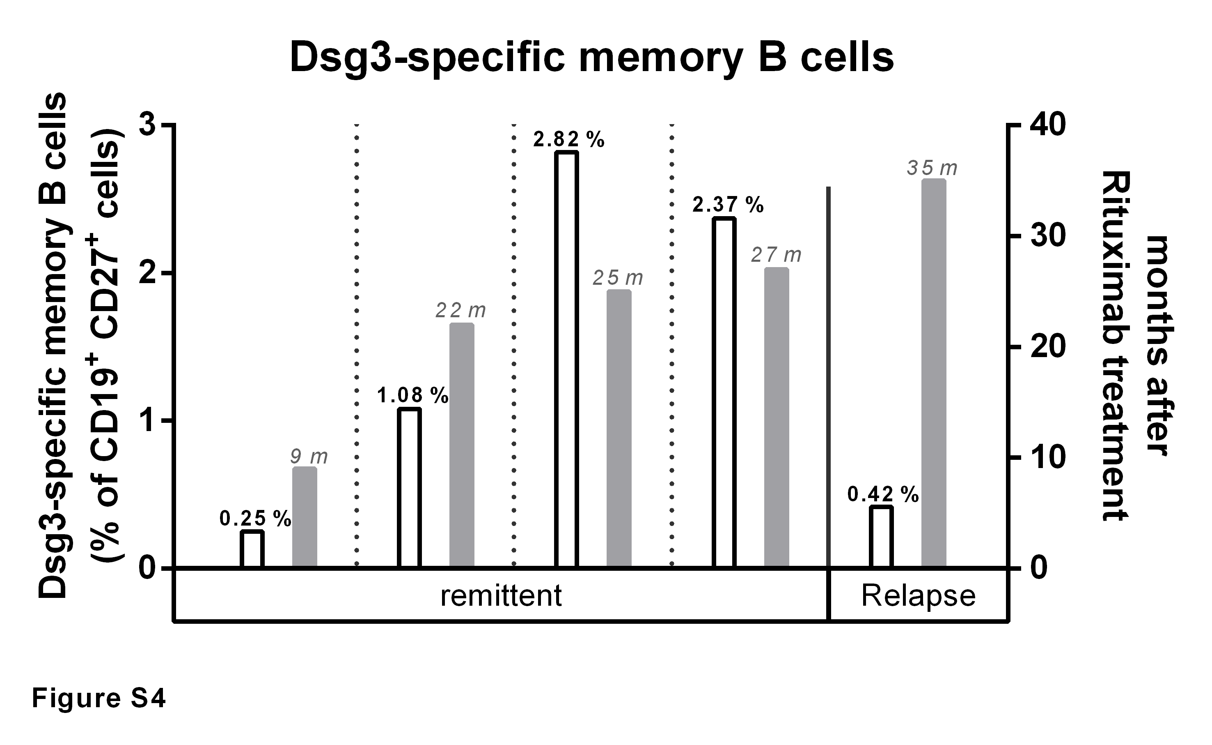Supplementary Figure 4. Frequencies of Dsg3-specific memory B cells in the five rituximab-treated PV patients included in this study (see Table S1) with regard to disease status and months (m) after end of Rituximab treatment. The highest frequencies of autoreactive memory B cells can be observed in remitting PV patients after ~2 years (22-27 months) after treatment.

Supplementary Tables

Supplementary Table 1: Disease status, treatment and auto-ab profile of patients with pemphigus vulgaris.
Patient | Status¹ | Therapy | Medication² | Clinical phenotype |  | Rituximab³ | Auto-ab (IgG)⁴
 |  |  |  | Skin | Mucosa |  | Dsg3 | Dsg1
1 | Partial Remission  (on therapy) | minimal | 10mg Pred⁵ | - | oral | - | 72 | -
2 | Complete Remission  (off therapy) | no | None | - | - | - | 176 | -
3 | Partial Remission  (on therapy) | moderate | 20mg Pred  2g MMF⁶ | - | oral | - | 72 | -
4 | Complete Remission  (off therapy) | no | None | - | - | 25 | - | -
5 | Relapse | moderate | 20mg Pred  2g MMF | head | oral, genital | - | 1445 | 122
6 | Partial Remission  (on therapy) | moderate | 20mg Pred  150mg Aza⁷ | head, trunk, legs | - | 9 | 121 | 182
7 | Partial Remission  (on therapy) | moderate | 15mg Pred  50mg Dapson | - | oral | - | 529 | -
8 | Partial Remission  (on therapy) | minimal | 5mg Pred | - | oral | 22 | 281 | 94
9 | Complete Remission  (on therapy) | minimal | 5mg Pred | - | - | - | 94 | -
10 | Relapse | moderate | 40mg Pred | trunk, arms, legs | oral | 35 | 75 | 1582
11 | Relapse | moderate | 20mg Pred  150mg Aza | head | - | - | 5619 | -
12 | Partial Remission  (on therapy) | moderate | 15mg Pred  1g MMF | trunk, arms, legs | - | - | - | -
13 | Partial Remission  (off therapy) | no | None | - | oral | 27 | 606 | -
14 | Relapse | moderate | 30mg Pred | trunk, head, feet | oral | - | 330 | 145

¹ as defined by Murrell et al. (1)
² daily medication at time of study
³ months after Rituximab treatment
⁴ as determined by ELISA with recombinant Dsg1 or Dsg3 in RU/mL. The cut-off value is 20 RU/mL
⁵ prednisolone
⁶ mycophenolate mofetil
⁷ azathioprine

PV | B cells |  |  |  | Dsg3-specific B cells |  |  |  |  |  |  | HC | B cells |  |  |  | Dsg3-specific B cells
 | all | naïve | memory |  | all | naïve |  | memory |  |  |  |  | all | naïve | memory |  | all | naïve |  | memory
 | (a) | (b) | (b) |  | (b) | (b) | (c) | (b) | (d) |  |  |  | (a) | (b) | (b) |  | (b) | (b) | (c) | (b) | (d)
1. | 7.72 | 51.33 | 48.67 |  | 0.22 | 0.04 | 0.07 | 0.19 | 0.38 |  |  | 1. | 5.48 | 85.07 | 14.84 |  | 0.15 | 0.10 | 0.11 | 0.06 | 0.42
2. | 5.27 | 38.90 | 59.66 |  | 0.53 | 0.17 | 0.45 | 0.36 | 0.57 |  |  | 2. | 10.30 | 83.28 | 16.58 |  | 0.09 | 0.07 | 0.08 | 0.02 | 0.11
3. | 5.46 | 60.89 | 39.02 |  | 0.16 | 0.07 | 0.12 | 0.09 | 0.41 |  |  | 3. | 12.70 | 64.10 | 35.75 |  | 0.15 | 0.05 | 0.07 | 0.10 | 0.29
4. | 13.30 | 95.52 | 4.411 |  | 0.32 | 0.20 | 0.21 | 0.12 | 2.82 |  |  | 4. | 8.47 | 34.74 | 64.92 |  | 0.06 | 0.03 | 0.04 | 0.09 | 0.06
5. | 5.90 | 33.32 | 65.91 |  | 0.13 | 0.04 | 0.11 | 0.09 | 0.14 |  |  | 5. | 9.19 | 55.22 | 44.91 |  | 0.13 | 0.05 | 0.09 | 0.08 | 0.17
6. | 0.75 | 73.86 | 24.20 |  | 0.37 | 0.31 | 0.42 | 0.06 | 0.25 |  |  | 6. | 14.60 | 71.80 | 28.15 |  | 0.22 | 0.14 | 0.19 | 0.08 | 0.30
7. | 5.61 | 62.26 | 37.17 |  | 0.23 | 0.15 | 0.25 | 0.08 | 0.20 |  |  | 7. | 6.95 | 57.42 | 41.89 |  | 0.22 | 0.15 | 0.26 | 0.07 | 0.16
8. | 3.97 | 94.42 | 5.178 |  | 0.40 | 0.30 | 0.33 | 0.10 | 1.08 |  |  | 8. | 6.64 | 76.31 | 23.43 |  | 0.19 | 0.11 | 0.14 | 0.09 | 0.37
9. | 8.24 | 81.60 | 18.37 |  | 0.18 | 0.12 | 0.15 | 0.06 | 0.34 |  |  | 9. | 11.10 | 74.82 | 24.20 |  | 0.14 | 0.08 | 0.11 | 0.06 | 0.25
10. | 15.90 | 95.76 | 4.24 |  | 0.23 | 0.21 | 0.22 | 0.02 | 0.42 |  |  | 10. | 9.90 | 61.30 | 38.61 |  | 0.17 | 0.08 | 0.13 | 0.09 | 0.25
11. | 6.57 | 63.60 | 35.70 |  | 0.28 | 0.07 | 0.11 | 0.29 | 0.52 |  |  | 11. | 11.60 | 60.20 | 39.70 |  | 0.24 | 0.15 | 0.25 | 0.10 | 0.24
12. | 11.00 | 61.90 | 37.89 |  | 0.17 | 0.06 | 0.09 | 0.11 | 0.28 |  |  | 12. | 9.23 | 72.40 | 27.01 |  | 0.27 | 0.19 | 0.26 | 0.08 | 0.29
13. | 18.80 | 97.46 | 2.50 |  | 0.11 | 0.03 | 0.03 | 0.08 | 2.37 |  |  | 13. | 9.39 | 74.30 | 25.24 |  | 0.14 | 0.09 | 0.12 | 0.05 | 0.19
14. | 5.15 | 84.06 | 15.94 |  | 0.17 | 0.14 | 0.16 | 0.04 | 0.23 |  |  | 14. | 8.89 | 63.50 | 36.34 |  | 0.13 | 0.04 | 0.06 | 0.09 | 0.26
PV |  |  |  |  |  |  |  |  |  |  |  | HC
Max. | 18.80 | 97.46 | 65.91 |  | 0.53 | 0.31 | 0.45 | 0.36 | 2.82 |  |  | Max. | 14.60 | 85.07 | 64.92 |  | 0.22 | 0.15 | 0.26 | 0.10 | 0.42
Median | 6.24 | 68.73 | 29.95 |  | 0.23 | 0.14 | 0.15 | 0.09 | 0.40 |  |  | Median | 9.31 | 67.95 | 31.95 |  | 0.15 | 0.08 | 0.11 | 0.08 | 0.21
Min. | 0.75 | 33.32 | 2.50 |  | 0.11 | 0.03 | 0.03 | 0.02 | 0.14 |  |  | Min. | 5.48 | 34.74 | 14.84 |  | 0.09 | 0.04 | 0.07 | 0.02 | 0.11
Supplementary Table 2: Frequencies of B cell subpopulations in patients with pemphigus vulgaris (PV) and healthy controls (HC).

(a): % CD19⁺ cells of gated lymphocytes / -blasts
(b): % of CD19⁺ B cells
(c): % of CD19⁺CD27– B cells
(d) % of CD19⁺CD27⁺ memory B cells

Supplementary Methods

Atomic Force Microscopy
Mica-sheets where freshly cleaved and coated together with Si₃N₄ MLCT Cantilevers (Bruker, Mannheim, Germany) with heterobifunctional acetal-polyethylenglycol linker (PEG, Hermann Gruber Lab, Institute of Biophysics, Linz, Austria). The PEG-linker in turn was linked to either recombinant human Dsg3 or labeled recombinant human Dsg3-AF647 functionalizing the mica-sheet and cantilever. The spring constant of the D-cantilever was determined utilizing the thermal noise calibration method (2). Force maps were generated in force mapping mode in a 10x10µm area with one measurement per µm. Five maps were generated with probing settings set to a pulling speed of 1µm/s and a pulling distance of 0.3µm with a resting time of 0.1s in HBSS buffer. Cantilever deflections were converted to force distant curves to determine the presence of binding events. After application of AK23 (Biozol, Eching, Germany) in a concentration of 75µg/ml for 1 hour the same area was measured again. Eventually the binding frequency was determined by evaluating both datasets for unbinding events.

Supplementary References

1 Murrell, D. F., Dick, S., Ahmed, A. R., Amagai, M., Barnadas, M. A., Borradori, L. and Bystryn, J.-C. et al., Consensus statement on definitions of disease, end points, and therapeutic response for pemphigus. J Am Acad Dermatol. 2008. 58(6): 1043–1046

2 Slattery, A. D., Blanch, A. J., Quinton, J. S. and Gibson, C. T., Accurate measurement of Atomic Force Microscope cantilever deflection excluding tip-surface contact with application to force calibration. Ultramicroscopy. 2013. 131: 46–55

